Year 9 History Study Guide
• Communism •

Lesson 1 – How can a right handed person be a lefty?
Task 1 – What do you think this quote means?

“All animals are created equal, but some animals are more equal than the others”
Animal Farm by George Orwell
In the space below, write down any ideas you have about the quote:

Task 2 – Definitions
Read the definitions below for fascism, communism and democracy. With a highlighter, identify any key words and in the space below identify the main differences between them.

Fascism: a political ideology [belief] that imposes strict social and economical measures to give the government total control. It is usually lead by an absolute dictator who keeps citizens controlled via acts of violence and strict laws that govern the people.

Communism Communism is when people earn the same amount regardless of their status and role. All people are equal and the state owns businesses and property and enforces control of its people.
Democracy: A system of government elected by the whole population or all the eligible members of a state, typically through elected representatives [MPs, Senators etc]

Main differences:

Task 3 – Politics ideas
Now you have an understanding of the key definitions above, you will now focus and categorise what each political ideology believed. Next to each statement, you will write down whether you think it is represents fascism, communism or democracy,

I own a three-bedroomed house. I can sell the house whenever I want and move to a different part of the country.
Under our system there is no private ownership of property. The government owns all property and uses its resources to provide for the people.
I can go on holiday whenever I like. The money I earn enables me to pay for the expensive holidays abroad.
People can vote for the one political party that will truly take care of their interests.
Our system is based on equality. The state owns all businesses and its people work hard to make the country richer. Only the greedy want to keep profits for themselves.
The government owns the newspapers, because everything belongs to the state. The newspapers tell me what the government is doing to look after the people.
Our country is ruled by those we vote for and they are accountable to us.

I work hard to make money for myself. People should be free to earn as much money as they can through their own efforts.
Laws are very harsh and the death penalty is often used to punish criminals who do not follow the political ideal.
Our government has placed controls over the economy and our social lives. This is for the greater good of the country
I can travel outside of my own country with special permission. But the government should use its resources to provide for the people. That’s more important than going on holiday.
The newspapers tell me if the government has made a mistake or done something unpopular.
Our country is ruled by one man. He has the absolute say in what happens in our country. He can be very strict
I work hard to make money for our country. People will not truly be free until they are equal. Otherwise freedom is just for the rich.
Our military plays a large part in our lives. We are a country that depends on military success to keep our leader strong.
People are free to vote for rulers of their choice. There are at least two political parties and elections are held every five years

Task 4 – Questions
Using the information you have gained, answer the questions below:

What are the similarities between all three ideologies?
____________________________________________________________________________________________________________________________________________________________________________________________________________________________________________________________________________________________________________________________________________________________________________________________________________________________________________________________________________________________________________________________________________________________________________________________________________________________________________________________________________________________________________________________________________________________________________________________________________________________________________________________

What are the key differences?
____________________________________________________________________________________________________________________________________________________________________________________________________________________________________________________________________________________________________________________________________________________________________________________________________________________________________________________________________________________________________________________________________________________________________________________________________________________________________________________________________________________________________________________________________________________________________________________________________________________________________________________________

Which two systems have the most amount of similarities and why?
____________________________________________________________________________________________________________________________________________________________________________________________________________________________________________________________________________________________________________________________________________________________________________________________________________________________________________________________________________________________________________________________________________________________________________________________________________________________________________________________________________________________________________________________________________________________________________________________________________________________________________________________
Lesson 2 – Do you always have to be ruled by a king?
Task 1 – Russian hierarchy
Below is some information on the ‘Russian wedding cake’ – essentially the way that Russian society was organised. You are to use the information below to help you create a diagram of Russian society on the next page:

The Russian ‘wedding cake’
Russia’s social structure was often depicted and lampooned in visual propaganda. For example, there were several versions of the ‘Russian wedding cake’. In these depictions, Russian society is shown as a feudal pyramid. The upper classes are propped up by the labour of the working masses, who are kept in check with work, religion and the threat of violence.

In reality, the base of this cake was significantly broader than these images suggest. The poor peasantry and the industrial working-class made up more than four-fifths of the population, while Russia’s educated and professional middle classes were tiny compared to those of Britain, France and Germany.

According to historian Michael Lynch, the 1897 census categorised the Russian people into the following classes:

Upper classes: Royalty, nobility, higher clergy: 12.5 per cent.
Middle classes: Merchants, bureaucrats, professionals: 1.5 per cent.
Working classes: Factory workers, artisans, soldiers, sailors: 4 per cent.
Peasants: Landed and landless farmers: 82 per cent.

The aristocracy
Sitting atop this metaphorical pyramid was Russia’s royalty and aristocracy, who for the most part lived lives of comfort, isolated from the dissatisfactions of the lower classes.

Noble titles and land ownership were the main determinants of privilege in tsarist Russia. The tsar himself was a significant landowner, holding the title of up to ten per cent of arable land in western Russia. The Russian Orthodox church and its higher clergy also owned large tracts of land.

Protective of their wealth and privilege, Russia’s landed aristocracy was arguably the most conservative force in the empire. The abolition of serfdom in 1861 allowed many of them to increase their landholdings, largely at the expense of the state and emancipated serfs.

Most of the tsar’s ministers and close advisors were drawn directly from the aristocracy. Once in the ministry, they often blocked or shouted down suggested reforms. Sergei Witte – himself an aristocrat, though one without large landholdings – claimed that “many of the aristocracy are unbelievably avaricious [greedy] hypocrites, scoundrels and good-for-nothings”.

The middle classes
Russia’s middle classes worked for the state (usually in the higher ranks of the bureaucracy) or the private sector, either as small business owners or trained professionals (such as doctors, lawyers and managers).

Industrial growth in the 1890s helped to expand the middle classes by increasing the ranks of factory owners, businessmen and entrepreneurs. Members of this group tended to be educated, worldly and receptive to liberal, democratic and reformist ideas.

Members of the middle-class were prominent in political groups like the Kadets (Constitutional Democrats) and, later, well represented in the State Duma.

The peasantry
The peasantry was by far the empire’s largest social class. It contained at least four out of every five Russians. Most worked small plots of land using methods of farming that had changed little since the Middle Ages.

Farming in Russia was a difficult business that was dictated by the soil, the weather and sometimes pure luck. It was generally easier in Russia’s ‘breadbasket’ southern regions, where the soil was dark and rich and the climate more temperate. Grain crops like barley, rye and oats flourished in these areas.

Further north and east, across the Urals and toward Siberia, the soil was harder and less fertile, making grain production more difficult. Peasants here relied more on tuber crops like potatoes, turnips and beets. In much of Siberia, the soil was hard, frozen and unsuitable for farming.

Russian farming was further hindered by its reliance on antiquated methods and techniques. Most peasants cleared, ploughed and sowed the land by hand, without the benefit of machinery or chemical fertilisers. Some more prosperous peasants had beasts of burden.

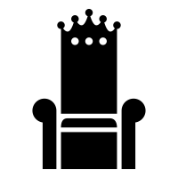
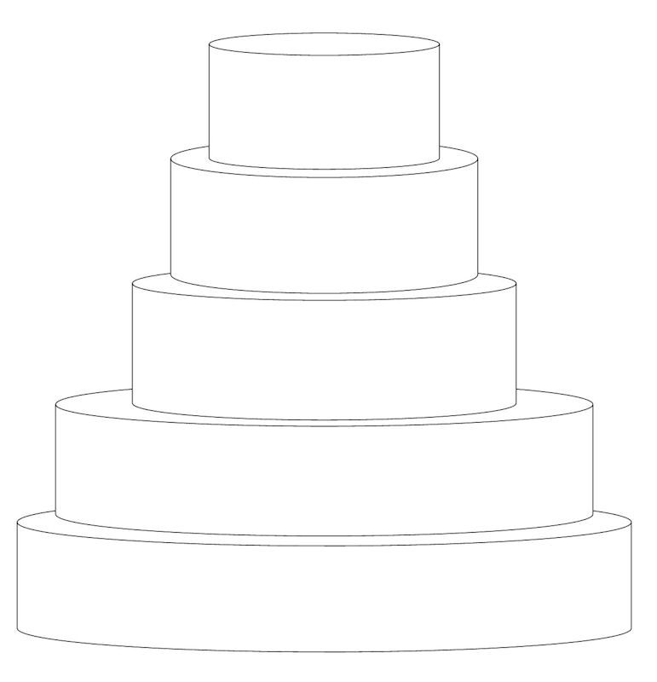
We work for you
We
eat
for
you
We shoot you
We govern you
We pray for you
We rule over you

Task 2 – Life in Russia
Look at the three sources below and think about what life would have been like for someone living in Russia before 1917.

Source A
A drawing of a rural Russian house.
Source C
From an interview with a Russian peasant found in the diary of Prince Peter Kropotkin.

“We lived in a little mud house. The straw roof contained sparrows' nests under the eaves. The walls on the outside had deep cracks which were a breeding place for adders. The low ceilings leaked during a heavy rain, especially in the hall, and pots and basins would be placed on the dirt floor to catch the water. The rooms were small, the windows dim; the floors in the two rooms and the nursery were of clay and bred fleas.”

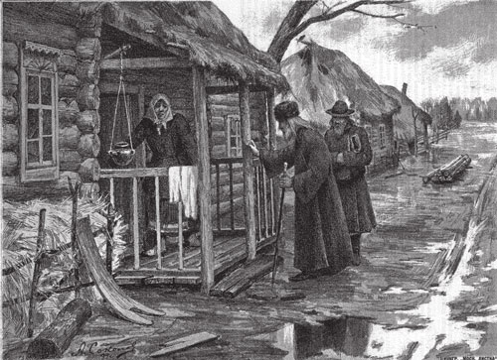
Source B
A picture taken of an urban Russian house
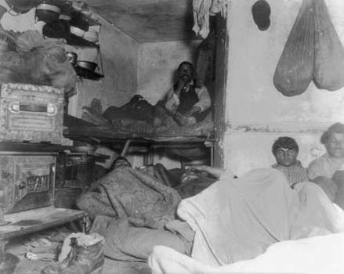

What do the three sources tell you about life in Russia before 1917?
______________________________________________________________________________________________________________________________________________________________________________________________________________________________________________________________________________________________________________________________________________________________________________________________________________________________
Lesson 3 – How does a king lose his crown?
Task 1 – Causes of the Russian Revolution
In the hexagons below, there are a number of pieces of information that need to be categorised to give you an understanding of why there was a revolution in Russia. You need to do the following:
- Read through the mystery statements, categorise/group the causes of the revolution by colouring them different colours and then choose a heading for each category.
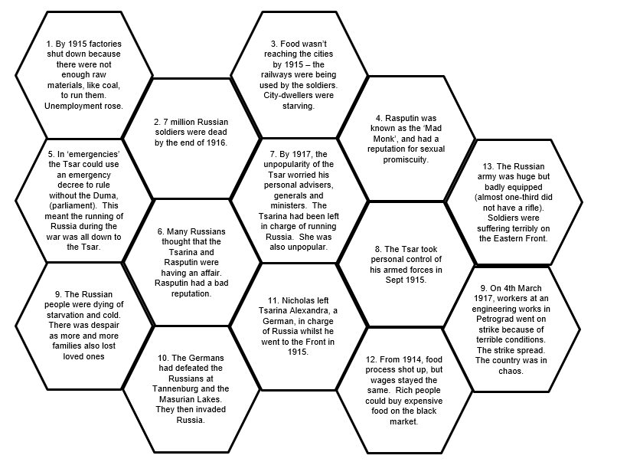

Write down the names of your categories in the space below:

Out of all of the factors, which one do you think appears to have been the most important reason for removing the king from power? Why?
_____________________________________________________________________
__________________________________________________________________________________________________________________________________________
Task 2 – The Russian Revolution
Watching the video link (https://www.youtube.com/watch?v=cV9G1QUIm7w) you are to create a timeline of the Russian Revolution in the space below. Once you have completed the timeline detailing dates and events, you are to answer the two questions at the bottom of your page.

Why was there a revolution (there were 2 in fact) in Russia in 1917?
__________________________________________________________________________________________________________________________________________
_____________________________________________________________________
How/why did the Bolsheviks (Communists led by Lenin) win the Civil War (which happened due to the revolutions) and take over Russia?
__________________________________________________________________________________________________________________________________________
_____________________________________________________________________
Lesson 4 – Can anyone be a leader?
Task 1 – Trotsky vs Lenin
Over the next few pages, you will read a number of pieces of information about Trotsky and Lenin to help complete your Trotsky/Lenin gingerbread men. If you read anything positive about Trotsky or Lenin and why they should be leader, you should write this down in their gingerbread person with a next to it. If you find any information that is negative (bad parts of their personality or if they are outwitted) label it with a .

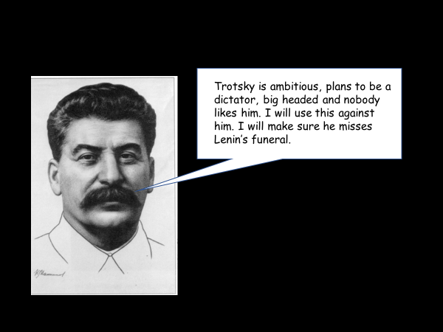
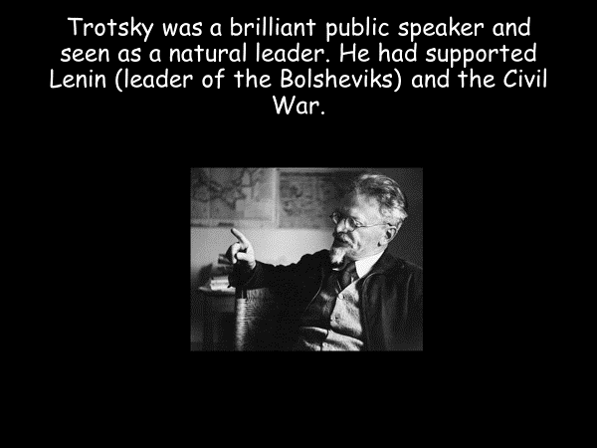
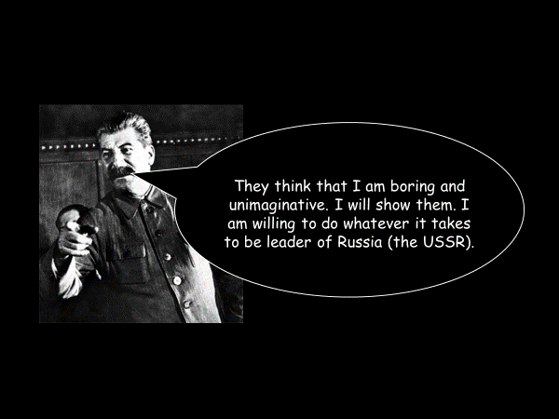
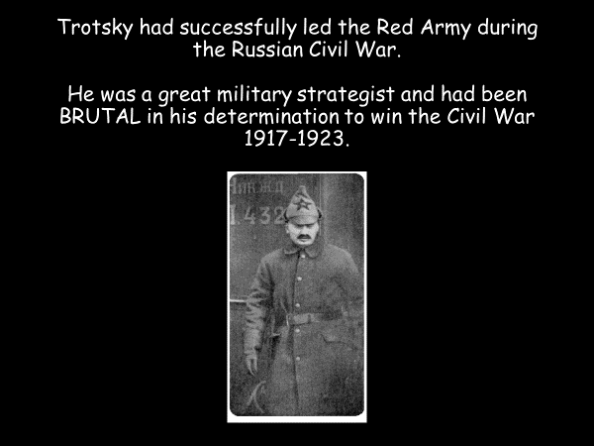
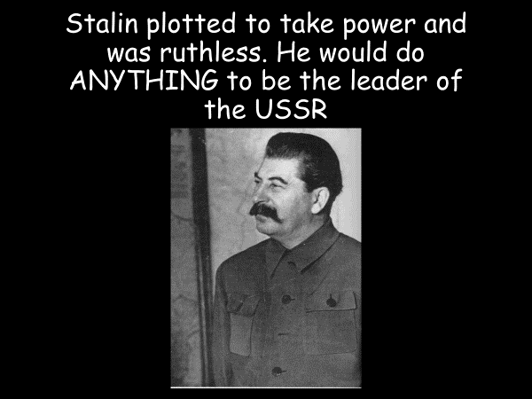
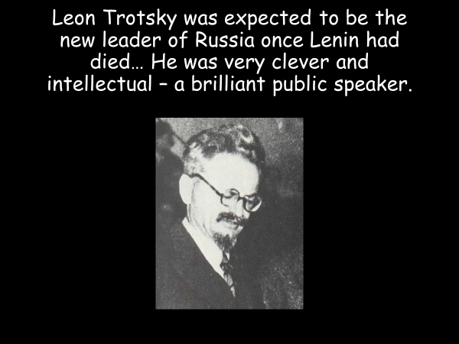

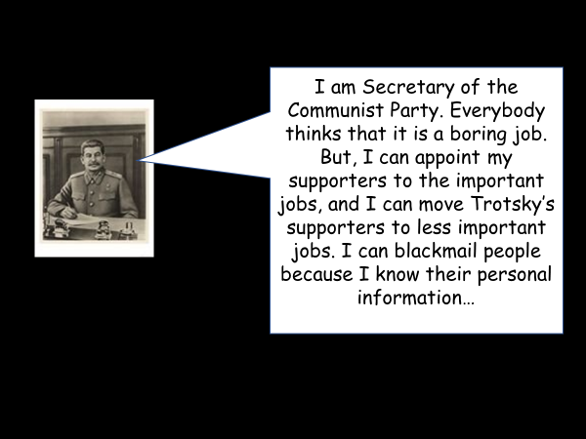
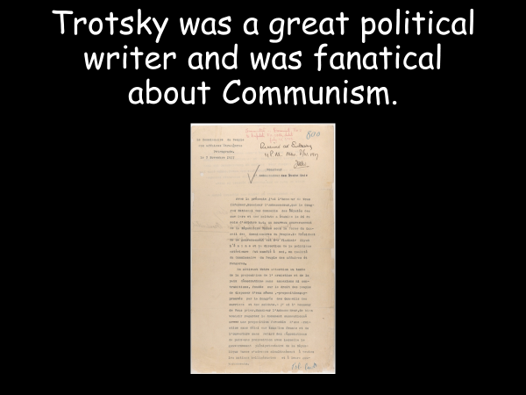

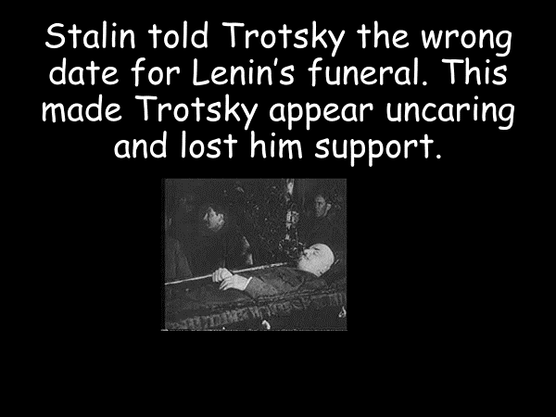
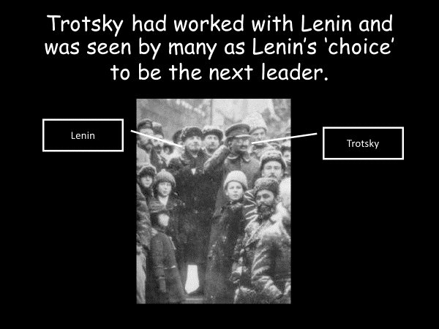

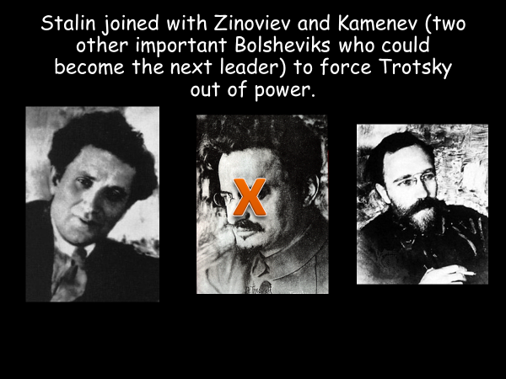
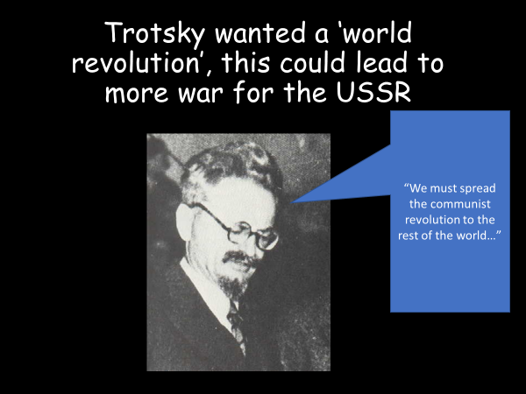

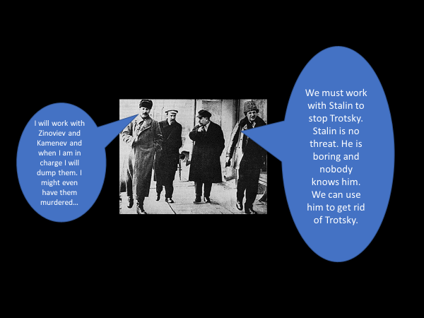

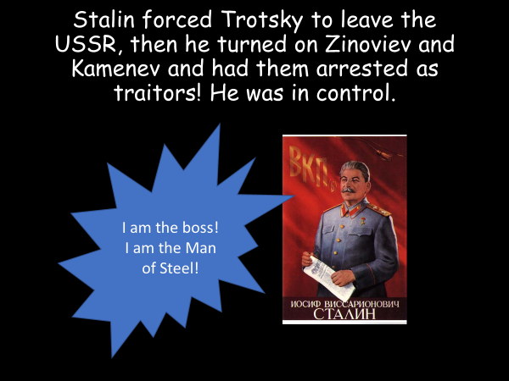
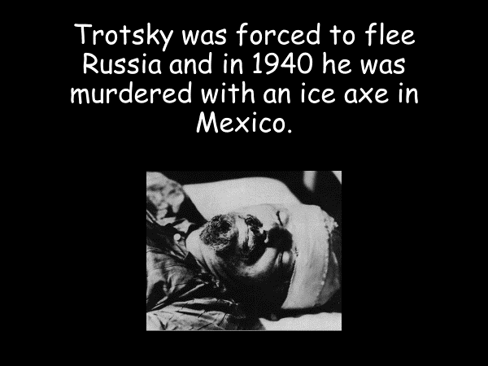

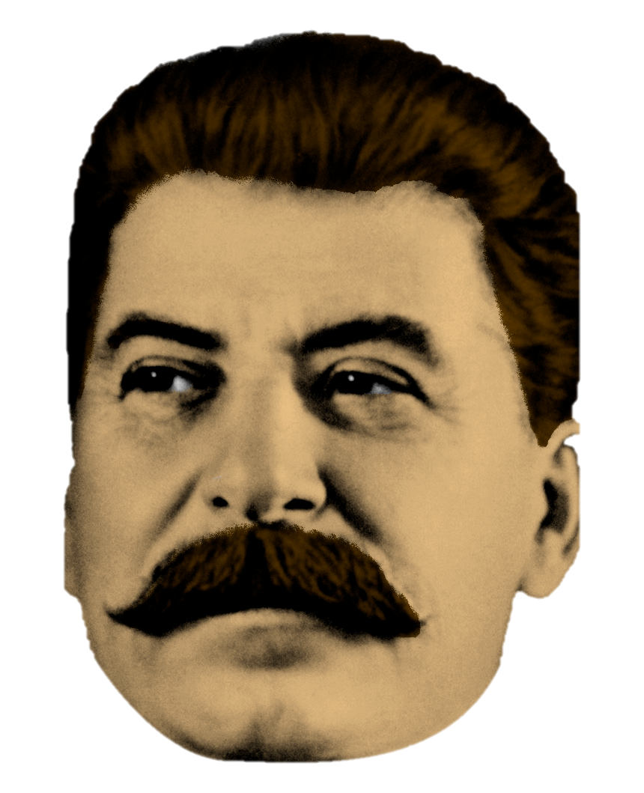
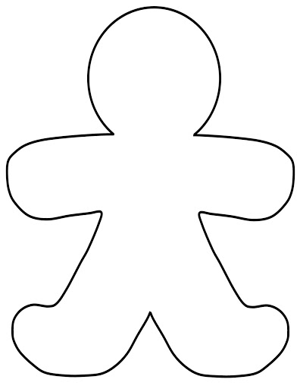

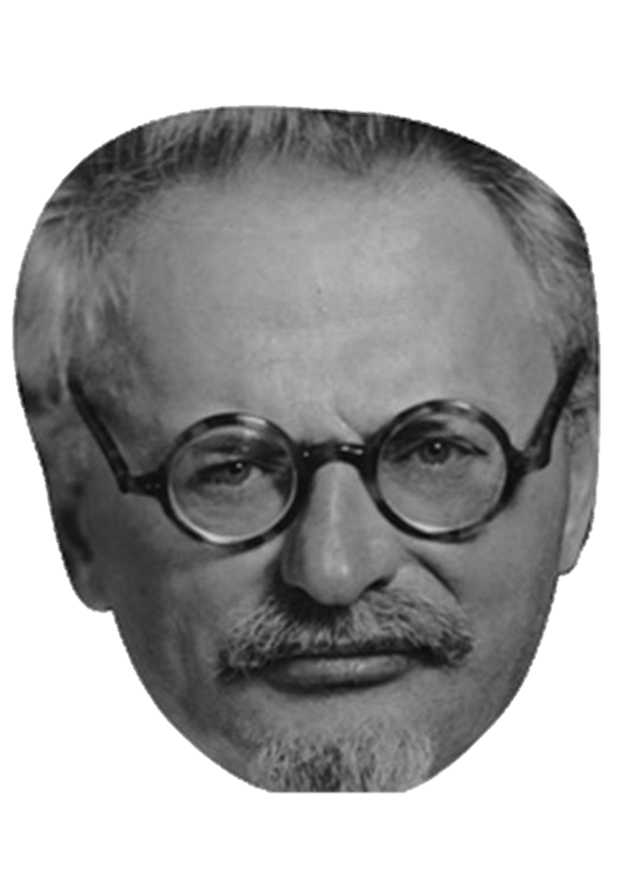

Lesson 5 – Why did Pavlik report his dad to the secret police?
Task 1 – Background
Look at the collection of pictures below. Around the pictures, write down any bad things you think happened in Russia under the communists.

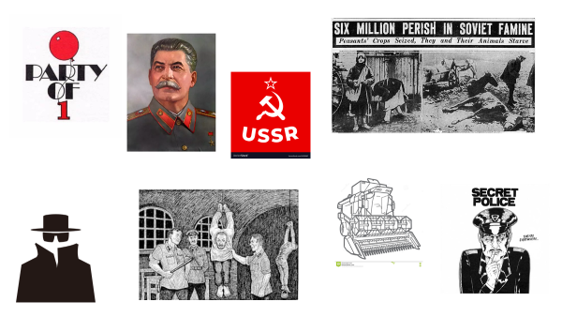
Russia in the 1920s and 1930s
By 1928, Russia had been through two revolutions and a Civil War. Joseph Stalin, the leader on the newly-named USSR, wanted to turn Russia into a modern nation in only ten years and he was willing to use any means to do so.
Russia was a one-party state, which meant there were no elections, because only one political party existed; the Bolsheviks (Communists). By 1930, Stalin had managed to remove all his political opponents. He could now focus on taking total control of the people and purging the country of any opponents to communism.
One of Stalin’s biggest challenges was turning a very old-fashioned farming system into a modern one, based on a communist system of collectivisation.
Stalin used the secret police to get rid of people he thought were causing trouble or could potentially be in the way. Farmers were treated brutally as Stalin knew he needed to feed the workers in the cities if the country was going to change. Wealthier farmers were called Kulaks and the Communists were determined to destroy them – they succeeded in killing approx. 3 million kulaks and a further 5-6 million starved to death in the Russian rural areas.

Task 2 – Why did Pavlik report his dad?
Pavlik Morozov was a 13-year old boy who was a fanatical believer in Stalin's political ideas. His father was a rich farmer; a kulak.
In 1933 Pavlik was then murdered.
Think about:
1. a possible answer (there may be many) to the question
2. how you reached your answer
3. how you can structure the cards to show your reasons

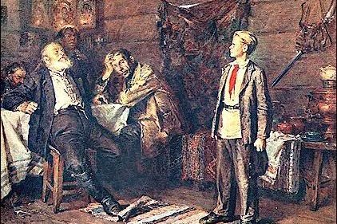
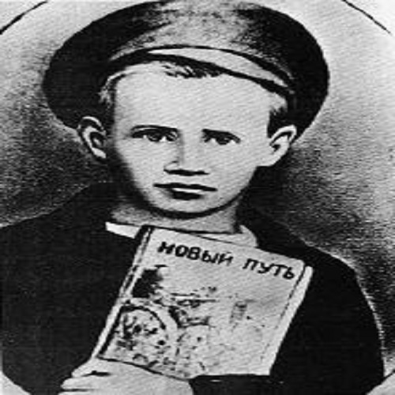
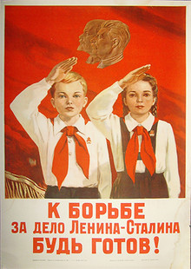
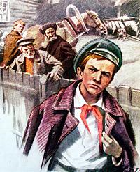
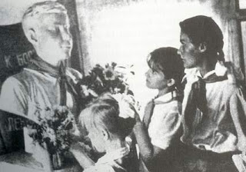

- People often kept a bag packed in case the secret police came for them. Anyone could be arrested and sent to the gulags (forced labour camps). | - Government sources said that Pavlik was forced to choose between his family and Stalin's Bolshevik (Communist) government. He chose the government because his father broke the law.
- Stalin feared that farmers would hide their grain or fight when the Red Army (Communist) soldiers came to collect. | - Reporting on your family was rare but telling on neighbors and workmates was common. The Secret Police (NKVD) encouraged people to report any ‘anti-communist’ activity.
- Stalin used 'purges' (remove something) to force people to do what he said. Millions were arrested and sent to gulags. 1 million were killed. | - Pavlik's father had been accused of hoarding (hiding) grain (which was illegal). He was sent to the gulags. Eventually he was shot.
- Pavlik had reported on his father. His uncle, grandfather and grandmother then murdered Pavlik in revenge. | - The Russian Bolshevik government, led by Stalin, showed no mercy to Pavlik's killers. His entire family was shot.
- The government made Pavlik into a hero. Statues were built, an opera, songs and children’s stories were written about him. This is a form of propaganda, which is used in Communist and Fascist states to brain-wash the public. | - Some historians say that Pavlik did not report on his parents and that he was murdered after a pointless argument.
- Some sources say that his father walked out on the family. | - The government thought that the farming village where Pavlik lived was an "enemy nest', because many people refused to cooperate.

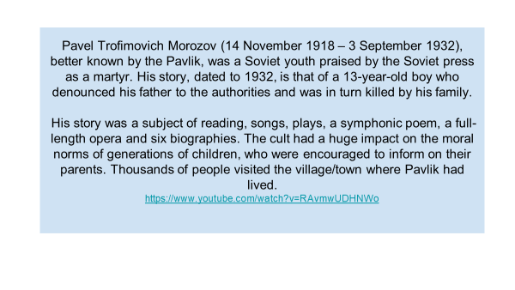

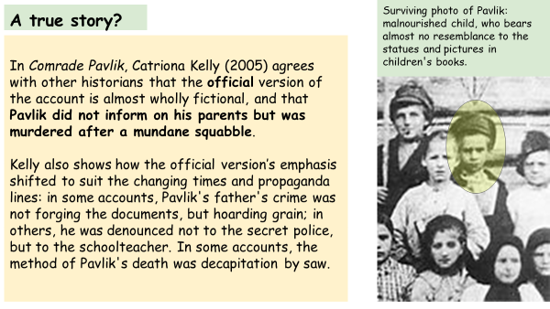

Task 3 – Summary
Based on the information you have studied, what is the real story? Use your newly acquired knowledge and write a 140 character tweet explaining your thinking.

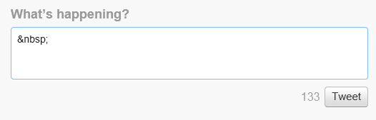

Lesson 6 – How do you rule a massive country?
Task 1 – What do you know about China?
Around the images below, write down everything that you know about China.

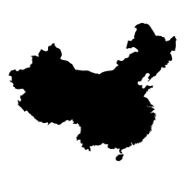
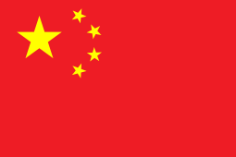

Task 2 – Words into pictures
Using the information on the left hand side of your page, you are to turn this into a series of pictures and images using as few words as possible. Names, numbers, dates, initials and abbreviations are allowed.

By 1912, China had been the same for 2000 years – and ruled by the Qing dynasty since the 1600s
In the 19th century, countries like Britain tried to force China to open their trade ports. The Chinese did not want trade with the West, they did well by themselves.

In 1895, China lost a war against Japan which showed just how behind China’s army was. Japan had managed to industrialise whereas China had not. This resulted in China suddenly becoming the weaker country in Asia.
The Qing emperor was blamed for China’s problems. People suggested that the emperors did not care about China.

By 1911 there were several large rebellions across the country, led by Sun Yat Sen​. He wanted to set up a republic – a country without an Emperor – where people could vote for who should be in charge.
This led to the end of Qing Dynasty. An amry general called General Shikai took power. He was head of the army and forced himself to the top. Shikai proved to be a dictator and was very corrupt. Sun Yat Sen took over from Shikai after his death in 1916.

In 1915, Japan tried to take control of China. In WW1 (1914-18) China joined the allies (by offering labour) in order to get help against Japan. However, Japan persuaded countries like Britain to let them keep part of China, called Shandong. This made the Chinese very angry with Britain, leading to a protest known as the May 4th Movement.

The Chinese Communist Party was founded in 1921 from the May 4th Movement and was supported by Russia.

In 1925 Chiang Kai Shek took power from Sun Yat Sen (after his death), and tried to crush the Chinese Communist Party – killing if necessary. This went on for about 10 years.

In 1937 Japan invaded China. Everyone joined together to fight them. The Japanese treated Chinese people really badly, including mass-murder, decapitation and torturing Chinese civilians.

When WW2 started, the Chinese Communist Party used guerrilla warfare against the Japanese and trained their ‘Red’ Army really well. The Japanese surrendered in 1945. Approx 20 million Chinese people died during WW2.

In 1946 a Civil War broke out in China. The Communist Party against people who wanted a democracy. The USSR supported the CCP and the USA supported the rest.

The CCP’s well trained army paid off and they took city after city. By 1949 they had won – Chiang Kai-Shek fled to the island of Formosa to create the Nationalist Chinese state of Taiwan. China was now a Communist country – and re-named itself the People’s Republic of China. The leader of the CCP, Mao, now strengthened his rule by brutally taking control of the whole of the country’. Between 20-45 million died during this era (probably more).

Task 3 – Why did the communists take control?
Go back through the story on the left hand side of your page and highlight all of the reasons or causes as to why the communists took control of China. Once you have done that, complete the sentences below:
The most important reason for the communist rise in China was ______________________
_____________________________________________________________________.
This is because _________________________________________________________
____________________________________________________________________________________________________________________________________________________________________________________________________________________________________________________________________________________.
Lesson 7 – Is there such a thing as too much power?
Task 1 – Background information
Read through the information below about Mao and China in the 20th century.

Mao’s China, c.1930–1976
His rise began in the early 1920’s as a founder member of the Chinese Communist Party.
The CCP under Mao were allied with the Nationalists against Japan, 1937-1945.
However, civil war broke out between the two shortly after Japan’s defeat.
In 1949, the Communists won the civil war. Mao became the leader of China and the Nationalist fled to Taiwan.
China under Mao was transformed. Industry fell under state control. Farms were re-organised into Collectives.
Population size was placed under control with the introduction of the one child policy.
The CCP suppressed all opposition, this was a dictatorship.
China’s new Communist leadership asserted its authority quickly.
Mao Zedong’s policies saw the execution of many landowners and the opening of the laogai camp system. Education was used to brainwash children. There ware mass campaigns to change China and the Great Leap Forward tried to make China into a fully industrialised country in 5 years.
This led to mass death – estimates range between 35-65, even as many as 84 million deaths.

Task 2 – How did Mao control China?
Using the information boxes, you are to read through how Mao controlled China and complete the spider diagram that follows. If you could limit yourself to 30 words for each branch to help summarise Mao’s control.

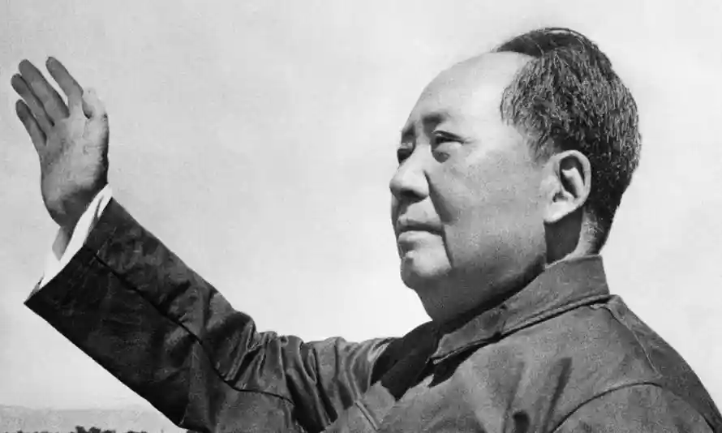
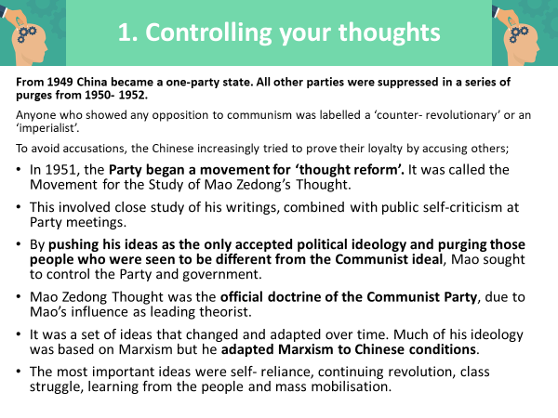

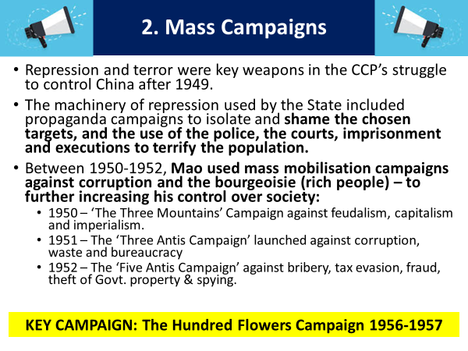

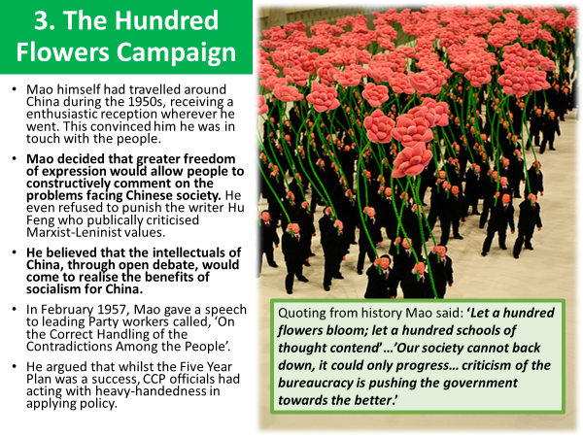

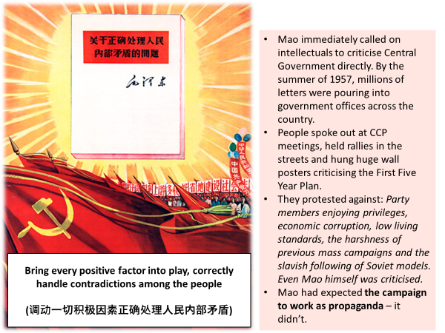

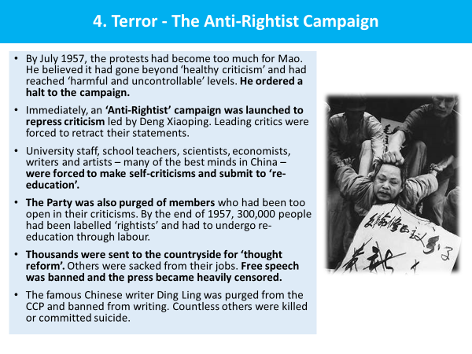

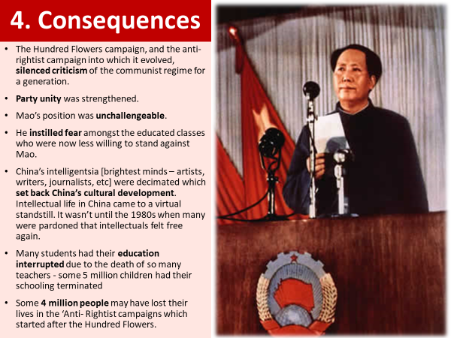

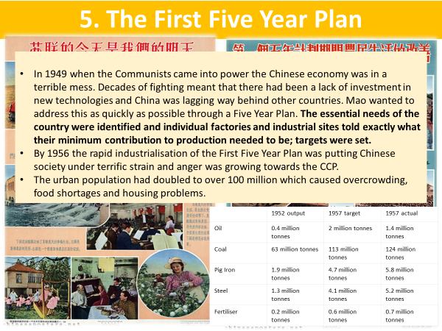

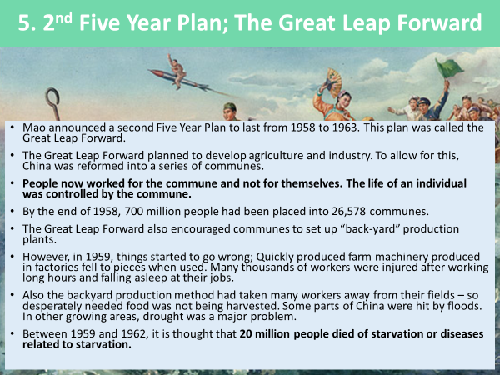

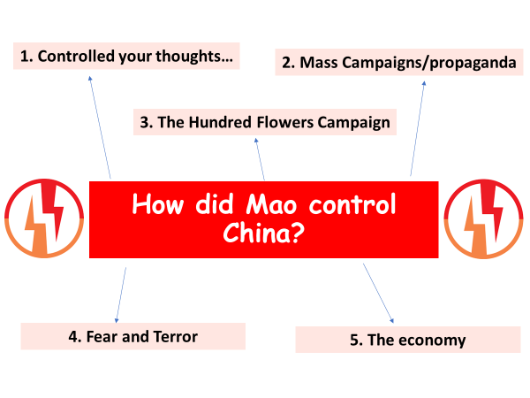

Lesson 8 – Why do countries disagree?
Task 1 – Communism vs capitalism
Read the information below on communism and capitalism after World War II
During WW2, Britain, America and the Soviet Union all had a common and shared purpose – to defeat Hitler’s Germany. America and the Soviet Union whilst not liking each other during WW2 realised they had to get on in order to beat Hitler.
However, this dislike and fear of each other began many years before WW2 and came from a big difference between how they wanted their countries to be run. The Soviet Union believed a Communist society to be the best, this meant the state (government) controlled all business and industry, unemployment was low, the rights of individuals were less important than the whole of society so there were restrictions on people’s freedoms and the press and citizens could only vote for the Communist Party. America believed their Capitalist society was much better. This meant their politicians could be freely elected, property and business could be owned by individuals and there were extremes between the very wealthy and the very poor.

As WW2 came to an end the power of Britain had declined and 2 new superpowers, both with large amounts of land, resources and wealth emerged – America and the Soviet Union. The common enemy of Hitler’s Germany was gone and both superpowers did not want to be pushed around by the other one.

What are the three key pieces of information from the text above:
- ________________________________________________________________
- ________________________________________________________________
- ________________________________________________________________

What is communism?
The Soviet Union (USSR) believed in a Communist society.
- state (government) controlled all business and industry
- unemployment was low
- the rights of individuals were less important than the whole of society so there were restrictions on people’s freedoms and the press
- citizens could only vote for the Communist Party.
What is capitalism?
America believed their Capitalist society was much better.
- their politicians could be freely elected
- property and business could be owned by individuals
rights of individuals more important than everyone being equal
- there were extremes between the very wealthy and the very poor
Task 2 – USA and USSR table
Using the information below and other resources at your disposal (internet, books etc) complete the table on the following page to build up an understanding of the differences between the United States and the USSR.

American society was based on the ideas of ‘Democracy and Capitalism’. This meant that the American President and Congress (US government) were elected in free elections (free choice to decide / no restrictions/more than 1 party). This means politicians can be voted out if people do not like them.

In the Soviet Union, it was a one party state (only the Communist party). There were elections but you could only vote for the Communist party. The leaders stayed in power until they died.

The majority of Americans believe very strongly in the American way of life and feel very threatened by communism.

Industry was run by the state (government). Unemployment and extreme poverty were rare, but the standard of living for most Soviet people was lower than most Americans.

For Americans, the rights and freedoms of individuals (i.e. free speech) were more important than everyone being equal.

Communists believed the rights of individuals were less important than the good of society as a whole. Therefore, there were many restrictions and controls of people’s freedoms.

The USA was the world’s richest country, but there were big gaps between the rich and the poor.

The state (government) keep tight controls on the press, radio, film and art.
Communism did not like any organised religions.

Capitalism meant property and businesses were owned by private individuals and companies (they can make as much money as they want to).

Soviet leaders believed other countries should follow communism. Many in the USSR were against capitalism.

 | USA | USSR
Leader in 1945
Ideology (beliefs about how a country should be run)
Elections
Business/property
Living standards
Rights/freedoms

