Year 9 History Study Guide
• The Holocaust and atrocities •

Lesson 1 – Who to vote for?
Task 1 – Election Day
You have lived in your country all your life and you love living there. You truly believe your country is great, however, because of recent events you have not felt very proud of it. There have also been a number of economic problems in your country, you are struggling to find a job and as a result, you have found it difficult to feed your family.

It is election day and you must decide who you should vote for…

Read through the information on each candidate and briefly write down what you think are their strengths and weaknesses.

Candidate One

Background  He was born in the country he wants to lead. He is 47. He had been involved in politics since the age of 17. He fought for his country in World War I.  Personal Qualities  A good speaker and devoted to making changes in the country. Not very dedicated to studying, but he was good at talking about other people’s ideas.  Beliefs  Believed that the people were the most important thing in a country. He wanted to make everyone equal and he believed that the people should be in charge. He was against war.  Experience  He had been a member of parliament for over 10 years.  He was the head of his own party.  He survived an assassination attempt in 1922. | Strengths
 | Weaknesses

Candidate Two

Background  Born in the country he wants to lead. He is 54. He represented Germany in countries such as the USA. He was an officer in World War I. He was a strong Catholic.  Personal Qualities  He was not a very strong person and was not thought to be particularly clever but he had amazing powers of persuasion and was able to get almost anyone to do almost anything.  Beliefs  He believed in tradition – that the old of way of doing things was the best way. He believed that it was important for a country to have a strong military force.  Experience  He had been a member of parliament for over 10 years.  He had been in charge of the country (Chancellor) for a few months before the election. | Strengths
 | Weaknesses

Candidate Three

Background  Born in a neighbouring country to the one he wants to lead. He is 44. He fought for his country in World War I.  Personal Qualities  An excellent speaker and a great organiser. He had real self-belief. This, with his charisma, enabled him to influence people very effectively.  Beliefs  Believed that the most important thing is a strong country that people can be proud of. He promised to make sure that all people had a job and a good standard of living. He was very proud of his country & thought that people with different beliefs were inferior.  Experience  He became the head of a small political party about 10 years earlier.  He tried but failed to take control of the country 9 years ago. | Strengths
 | Weaknesses

Candidate Four

Background  Born in the country he wants to lead. He is 59. He was from a rich family. He was a member of parliament in World War I.  Personal Qualities  A great speaker and a formidable person - he was not to be messed with and was known for being impatient with people.  Beliefs  He believed in tradition—that things should stay the same. He was very proud of his country & thought that people with different beliefs were inferior. He believed that it was necessary to stand up to other countries with force if they seemed to be a threat.  Experience  He had been involved in politics for over 20 years. He had held some important positions in government but had also been blamed for some big mistakes & was criticised for sending troops to stop a strike. | Strengths
 | Weaknesses
Election – Who will you vote for and why?
I will vote for Candidate ____ because… ____________
__________________________________________________________________________________________________________________________________________________________________________________________________________________________________________________________________
Candidate One

Candidate Two

Candidate Three

Candidate Four

Who is who? Find out more about them
1. Ernst Thalmann 2. Franz von Papen 3. Adolf Hitler 4. Winston Churchill
Lesson 2 – What is the worst that can happen?
Task 1 – SOLE based project
For this task, you are to research and find out as much about the Holocaust as possible. Below are some areas that you could focus on:
- How Jews were treated prior to 1939 – why were they targeted?
- Ghettos.
- Concentration camps/death camps.
- The experiences of survivors.

Lesson 3 – Can you judge a book by its cover?
Task 1 – Victim, killer or rescuer?
Below are pictures of real people who were involved in the Holocaust in some way. You need to categorise the pictures into either victims of the Holocaust, people who killed people during the Holocaust or people who tried to rescue people during the Holocaust.
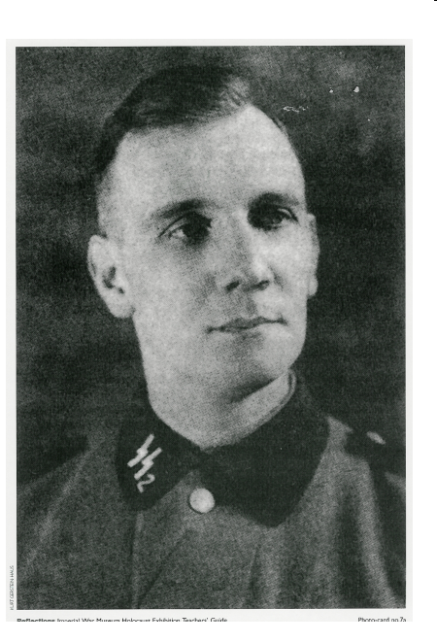
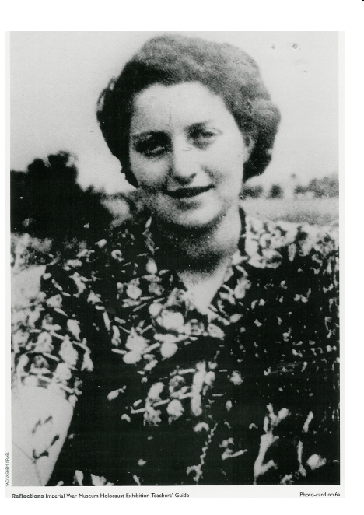
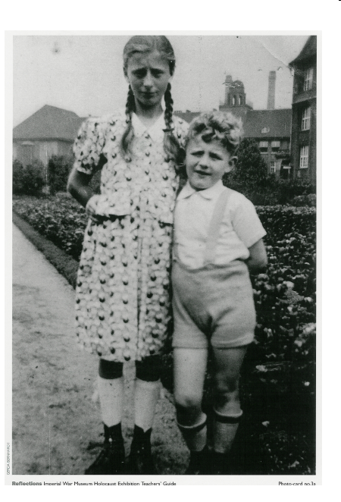
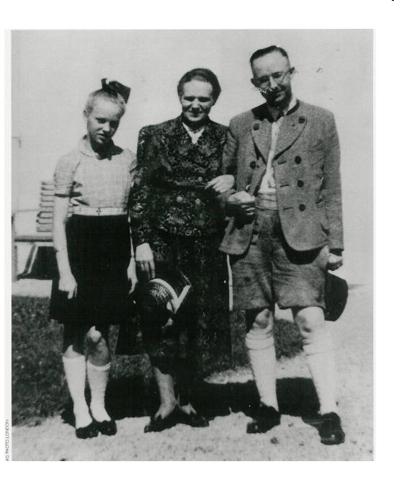
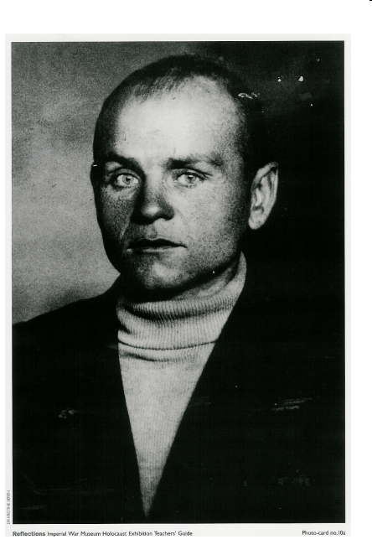
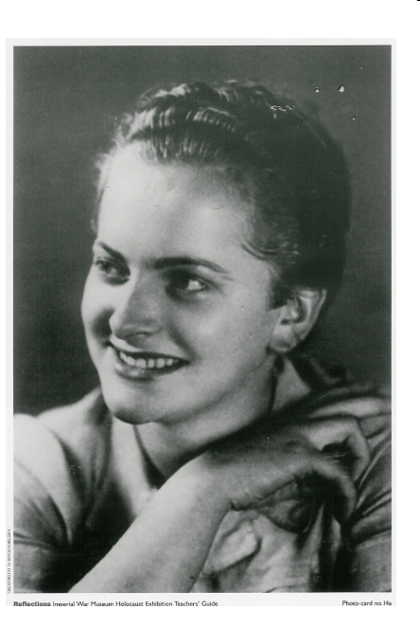

Are there times when you judge someone by the way they look? How is that similar/different to what the Nazi’s did?
1. Heinrich Himmler- leader of SS, obsessed with racial purity, in charge of and implemented the Final Solution
2. Female concentration camp guard, particularly feared and cruel in her behaviour towards prisoners at the camp.
3. Resistance worker, helped people escape via the sewers and continued to provide Jews with food and supplies.
4. Victims, little boy was mentally disabled and he was sent to a farm where it was claimed he had died of pneumonia. Children and adults who had any type of disability physical or mental were killed.
5. Hannah Senesh- member of the resistance. She was a Jewish woman originally from Hungary who joined the British Army. She was parachuted into Hungary in 1944 and captured by the Gestapo and later executed.
6. Resistance worker – this man joined the SS in order to try and find information out about what was happening (spying on the Nazis). He tried to alert the outside world to the persecution of the Jews/Holocaust but no one believed him. He committed suicide.
Lesson 4 – Who is to blame?
Task 1 – How was the Holocaust allowed to happen?
Below is an account of what happened to a Jewish family when they were taken to a concentration camp. As you read through the account, underline every person that would have bene seen or involved in what was happening.

Jews are taken from the ghettos to concentration camps. Local people see the Jews leave the ghettos and wonder whether they will ever return. Sometimes, Jewish police help to draw up the lists of who will leave the ghetto each time. They are rounded up by Nazi guards who load them into cattle trucks. These trucks are so full that people have to stand up and in summer the cattle trucks are unbearably hot and smell terrible – people say that they can often smell the trains coming.

The driver starts up the engine and the train pulls away. He does not like this part of his job. He knows who is on the train and where he is taking them and he is beginning to understand what will happen when they get there. But he doesn’t really feel he has a choice – he is too old to fight in the war and he needs a job to feed his family. If he refuses to do this, the consequences would be severe. If he was to let any Jewish people escape he is certain that he will be shot, so he doesn’t even let them out to get fresh air when the train stops.

The journey can take up to 3 or 4 days. During this time, the train will pull into stations where members of the public and railway workers can hear and smell what conditions on the trains must be like. Many choose to ignore the trains but others pass cups of water to the people inside.

As the train continues on its journey it is guarded by Nazi soldiers. It arrives at Auschwitz concentration camp after 3 days but many of the Jews have died on the journey. The camp gates close behind the train and the people get off. Everyone is lined up and must file past the camp doctor. He will decide who is fit to work and who is not. Those who are not are sent immediately to the gas chambers.

In this account alone, how many people have you counted?
_____________________________________________________________________

How has this been allowed to happen? Why has no one stopped it?
_________________________________________________________________________________________________________________________________________________________________________________________________________________________________________________________________________________________________________________________________________________________
Task 2 – Diamond 9 ranking
Diamond rank the people below to show who is responsible for the Holocaust, from those you blame the most to those you blame the least:

- People who lived in communities with Jewish people before the Holocaust began.
- Jewish Police
- Nazi Police
- People who drove the trains
- People who worked the points on the train tracks
- Concentration camp doctors
- Concentration camp guards
- Adolf Hitler
- Winston Churchill

Who is most to blame and why?

Who is least to blame and why?

Lesson 5 – How can one person save so many people?
Task 1 – Oskar Schindler
Go to the following web page (https://www.youtube.com/watch?v=ytMNr9gLqE4) to watch a 20 minute documentary on Oskar Schindler.

In the space below, you are to make notes on the life of Schindler, who he was, what he did before the war and then how he went on to save the lives of so many Jews.

Task 2 – Film poster
Using the documentary and your notes, you are to create a film poster about the life of Oskar Schindler.

Lesson 6 – Are there any positives when something bad happens?
Task 1 – What do you notice?
Watch the following video clip – in the space below, write down what you notice:
https://www.youtube.com/watch?v=-07xiaBl2vk

Task 2 – Was America right to drop the bomb?
Read through the statements below. With one colour highlight the boxes that suggest the USA was justified in dropping the bomb. With another colour highlight the boxes that suggest the USA was not justified in dropping the bomb

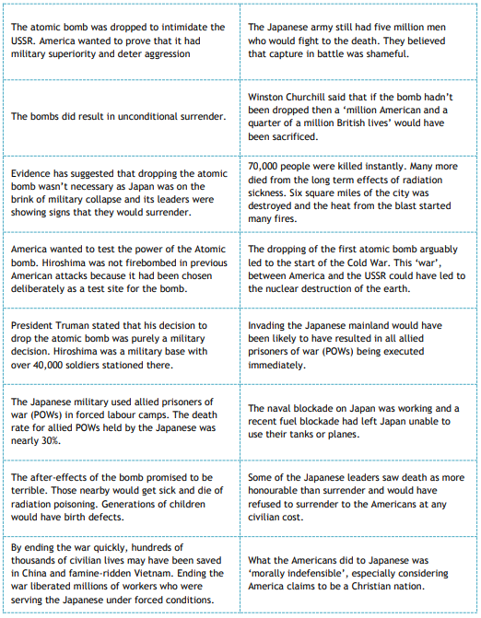
Task 3 – Written task.
Below you are going to complete a piece of extended writing around whether the United States should have dropped the atomic bombs in Hiroshima and Nagasaki.

The main reason why the United States was justified in dropping the atomic bomb in Hiroshima and Nagasaki was ________________________________________________
_______________________________________________________________________________________________________________________________________________________________________________________________________________.
This is the most important reason because _____________________________________
_________________________________________________________________________________________________________________________________________________________________________________________________________________________________________________________________________________________________________________________________________________________.
Another important reason why the United States used nuclear weapons in Japan was because _______________________________________________________________________________________________________________________________________________________________________________________________________________.
This is another important reason because ______________________________________
_______________________________________________________________________________________________________________________________________________________________________________________________________________.

However, many argue that the United States were unjustified in their bombing of Japan. The main reason why the United States was unjustified was because _____________________
_______________________________________________________________________________________________________________________________________________________________________________________________________________.
This is the most important reason because _____________________________________
_________________________________________________________________________________________________________________________________________________________________________________________________________________________________________________________________________________________________________________________________________________________.
Another important reason why the United States should not have used nuclear weapons in Japan was because _______________________________________________________
__________________________________________________________________________________________________________________________________________
This is another important reason because ______________________________________
_______________________________________________________________________________________________________________________________________________________________________________________________________________.

In conclusion, it is clear that (look to give your opinion on whether the USA should have dropped the nuclear weapons and use evidence to support your opinion) ________________
______________________________________________________________________________________________________________________________________________________________________________________________________________________________________________________________________________________________________________________________________________________________________________________________________________________________.

Lesson 7 – Do winners ever do bad things?

On 13-14 February 1945, when the Germans were retreating on all fronts, 805 RAF bombers dropped 2,600 tons of bombs on the centre of Dresden. The weather was perfect for bombing and there was no resistance from German fighter planes or anti-aircraft guns. The bombs caused an enormous firestorm. Temperatures in places rose to about 1000°C. Between 35,000 and 150,000 people were killed and 70% of the city was destroyed.

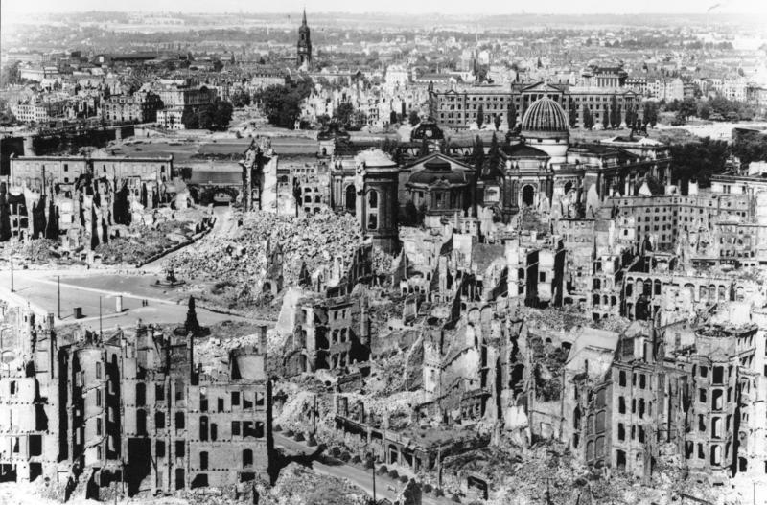

Task 1 – Was the bombing of Dresden a war crime?
What do you think you need to know to answer this question? Write some ideas down below that will help you in your investigation.
Task 2 – Source work
Read through the information below about the bombing of Dresden. In one colour, highlight all of the information that suggests that the bombing of Dresden was a war crime. In another colour, highlight information that suggests the British bombing of Dresden was justified.

In 1940 Churchill believed that ‘The bombers’ alone provide the means of victory.’ He was convinced that raids of sufficient intensity could destroy Germany’s morale. He planned a campaign that abandoned the accepted practice of attacking an enemy’s armed forces & instead made civilians the main target. Night after night, RAF bombers in ever-increasing numbers struck throughout Germany, usually at working-class housing because it was more densely packed.  Written by a modern historian | The Americans claim that Dresden was bombed, on Russian instructions, to stop the movement of troop reinforcements through Dresden, is clearly untrue. It would have been simple for the RAF to have destroyed the railway between Dresden & the Czech frontier.  From a German newspaper, 1953
Both the British & the Germans were engaged in destroying cathedrals & hospitals & killing civilians of all ages. Some of these attacks were meant for industrial & military areas. However, they also thought built-up areas were military targets & that any course of action which shortened the war was justified.  An account by an official historian appointed by the British government | The attack on Dresden was the product of a carefully laid plan. Every day that the war went on cost the lives of countless more Jews, Slavs & Poles. So the numbers killed at Dresden, dreadful as they were, were nothing like so dreadful as the numbers that Hitler was killing. The Germans already had rocket-propelled fighters. What else might they produce? A decisive blow was needed to end the war quickly.  Dr Frankland – a historian – in 1985
Type of target Tons of bombs dropped during the war  Oil depots 224,000  Transport (road & rail) 319,000  Aircraft industry 57,000  German cities 674,000  Statistics about the bombing of Germany | The Americans have proved that they can hit precise targets whenever they please. It would therefore have been possible to have spared the residential districts of Dresden & the historic town centre. The use of incendiaries (fire bombs) proves that residential districts were being deliberately attacked. It is pointless to drop incendiaries on railways.  A radio broadcast by German foreign information services
It seems to me that the moment has come when the question of bombing German cities simply for the sake of increasing the terror, though under other pretexts, should be reviewed. Otherwise we shall come into control of an utterly ruined land. I feel the need for more concentration upon military targets such as oil & communications, rather than on mere acts of horror & destruction.  A letter from Winston Churchill to his army commanders, March 1945 | I saw people clinging to the railing, burnt to cinders. I kicked what I thought was a big tree stump – but it was a person, burnt to death. There was a big heap of arms, legs, bodies, everything – I tried to piece together a leg, arm, fingers, body - to recognise one of my family – but I passed out.  An eye-witness account, by a woman interviewed in 1985
The raid on Dresden was an immoral act. The city at the time was full of refugees. It had no military, strategic or industrial importance. It was simply bombing civilians as civilians & that was wrong. The government said that the military targets were being bombed. This was done in part to reassure church leaders that nothing immoral was happening. In fact, they knew civilians were being bombed. Dresden remains as a reminder to us that in wars we have to think very carefully about targeting. Simply to massacre is always a violation of the ‘just war’ tradition.  A statement from a clergyman on a TV programme in 2005 | By 12 February, with the arrival of the refugees from the East who were fleeing to escape the advancing Russian army, the city was nearing its maximum population. The idea of Dresden as a target for attack came as a surprise to the RAF Intelligence Staff. There was very little to show that Dresden was of much industrial importance or that it was being used for large-scale troop movements. RAF commanders queried the decision. It was understood that the attack was part of a programme in which Churchill was personally interested & that the Russians had asked for the attack. The Russians deny this.  David Irving, a British historian, in a book called ‘The Destruction of Dresden’, 1963

Was the bombing of Dresden justified?
_________________________________________________________________________________________________________________________________________________________________________________________________________________________________________________________________________________________________________________________________________________________
Watch the following video clip https://www.youtube.com/watch?v=suOBgOk1SgY&t=410s
Has it changed you mind?
_______________________________________________________________________________________________________________________________________________________________________________________________________________

