Year 9 History Study Guide
• Fascism •

Lesson 1 – Can you ever predict what is going to happen?
Task 1 – Who is this?
Below is a picture of an individual that you will study in this unit on fascism. Around the picture, annotate who he is and what you know about him:

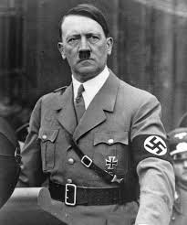

Task 2 – Key words
Below are some key terms that will be important for you to understand. Using a dictionary or the internet, identify what these key words mean:

Government ____________________________________________________________
_____________________________________________________________________
Nazi_______________________________________________________________________________________________________________________________________

Fascism _______________________________________________________________
_____________________________________________________________________

Task 3 – Germany in the 1920s.
Below you are going to complete an enquiry into Germany in the 1920s and work out how whether the events in Germany were good for Hitler, bad for Hitler or a bit of both. Circle how Hitler might have viewed the situation, and then in the lines below explain why.

- The Effects of the War

After World War 1 Germany faced many problems. The Kaiser had abdicated (run away). The Weimar govermnet were thought to have stabbed the German Army in the back and were known as the ‘November Criminals’.

Good for Hitler A bit of both 😕 Bad for Hitler

Because _______________________________________________________________
__________________________________________________________________________________________________________________________________________.

- Treaty of Versailles

Germany were treated really harshly at the end of the war. They had to cut down their army to 100,000 men and were not allowed an airforce. They had to give up lots of land and accept total blame for the war (war guilt). Taking the blame meant they had to pay the whole cost of the war to France and England.

Good for Hitler A bit of both 😕 Bad for Hitler

Because _______________________________________________________________
__________________________________________________________________________________________________________________________________________.

- Political Problems

There was a President and a Chancellor. The President could hire and fire the Chancellor. This would usually be the person with the most seats in the Reichstag, but there were a lot of political parties and the voting system made it really difficult for just one party to get lots of seats.

Good for Hitler A bit of both 😕 Bad for Hitler

Because _______________________________________________________________
__________________________________________________________________________________________________________________________________________.

- Unrest

Lots of different people tried to take power by force, including Adolf Hitler and the Nazis. Hitler ended up going to jail in the 1920s, where he wrote a book called ‘Mein Kampf’ which set out all his ideas. In 1923, the German currency collapsed due to hyperinflation. Money became worthless.

Good for Hitler A bit of both 😕 Bad for Hitler

Because _______________________________________________________________
__________________________________________________________________________________________________________________________________________.

- Recovery under Stresemann

Stresemann helped Germany. He introduced a new currency called the Rentenmark and he borrowed money from America so that Germany could pay France and England again. Other countries began to respect Germany again and they were allowed to join the League of Nations in 1926.

Good for Hitler A bit of both 😕 Bad for Hitler

Because _______________________________________________________________
__________________________________________________________________________________________________________________________________________.

During the 1920s, do you think Hitler was in a good position to take power? Why?
________________________________________________________________________________________________________________________________________________________________________________________________________________________________________________________________________________________________________________________________________________________.

So… what changes?

Task 4 – The Wall Street Crash
Read the information below on the Wall Street Crash and answer the following question.

In October 1929 the Wall Street Crash hit America which led to worldwide depression. By 1932, almost 6 million people in Germany were unemployed. Many others were suffering from the effects of low wages or part-time working: they could not afford to pay rent and became homeless. The German government was powerless. As a result of having several small parties in government most decisions could not be agreed on and were therefore not passed. Weimar policies became unpopular. Taxes were raised, unemployment benefit was cut and salaries were cut. Hitler was becoming more popular and by 1932 President Hindenberg was under pressure to appoint him Chancellor. Initially, Von Papen was appointed Chancellor but he did not have enough support. Von Schleicher followed but again struggled to gain enough support. Hindenberg was forced to do what he had been trying to avoid – to ask Hitler to become Chancellor.

Was the Wall Street Crash:

Good for Hitler A bit of both 😕 Bad for Hitler

Why?
_________________________________________________________________________________________________________________________________________________________________________________________________________________________________________________________________________________________________________________________________________________________.

Task 5 – Rank order
Rank the reasons why Hitler came to power from most to least important, and in the space below, give an explanation as to what you have as your most and least important reasons:

World War I & the Treaty of Versailles
Money problems
Government could never agree on anything
Hindenburg thought he could control Hitler

Most important ____________________________________
____________________________________
____________________________________
Least important ____________________________________

Why most important?
____________________________________________________________________________________________________________________________________________________________________________________________________________________________________________________________________________________

Why least important?
____________________________________________________________________________________________________________________________________________________________________________________________________________________________________________________________________________________

Lesson 2 – Can one person really make a difference?
Task 1 – How did Hitler rise to power
Below is some information that represents five things that Hitler did that helped him rise to power in 1933. From the information, you are to summarise each section into 5 words and a picture.

Information | 5 key words | Picture
Nazi Party organisation
Hitler worked hard to rebuild the Nazis Party. He re-launched the Party at a meeting in Munich in March 1925. He also started holding yearly rallies (big meetings) in Nuremberg in 1927. Hitler was successful in rebuilding the Nazis.

Hitler also made sure he was the only leader of the Party. He forced other leaders out of the Party and formed a private bodyguard, separate from the SA. These new bodyguards were the SS, who were loyal to Hitler, not to the Nazis Party.

By 1929 Hitler had a well-organised Party, a clear set of ideas in Mein Kampf, but he needed something else to happen before the people would vote for him.

Nazi Ideas

Hitler and the Nazis were against communism (where businesses and people’s possessions are taken off them and given to the government to re-distribute). The Nazi’s were also very nationalist, wanting to rebuild Germany’s army, gain more territory and make people proud of their country. The Nazis were also racist and blamed a lot of Germany’s problems on those considered ‘un-German’ – groups like Jews were targeted. The Nazis also gained support for offering to give older people more money to spend and to provide farmers and workers with greater help.

Hitler himself

Nationalism. Hitler promised to get rid of Versailles and make Germany great again, like it had been before WW1

Strong Leadership. Vital in a crisis like the Depression.

Solve The Great Depression.
Hitler promised to solve the Depression helping farmers, unemployed and businesses

Order and Stability.
The well organised SA and Nazis seemed the only well ordered thing in Germany.

Hatred of Communism. Hitler seemed the only person able to stop the communists. His SA seemed the only people who would stand up to them.

Scapegoats. Hitler also provided someone to blame for Germany’s problem, communists and Jews.

Propaganda

“As I walked through the Berlin streets, the Nazis Party flag was everywhere. Huge posters and Nazis slogans screamed from the windows. Passers-by wore tiny badges, uniformed SA pushed through the crowd, a swastika band around their arms. By the time night came more than 100,000 people filled the field, with another 100,000 at a nearby racetrack listening on loudspeakers. And at home millions were waiting by the radio. Suddenly a wave swept the crowd, “Hitler is coming!”. A blare of trumpets filled the air. All eyes turned to the stage. There was a low rumble then the entire crowd put their arms up in the Nazis salute and shouted ‘Heil Hitler’.
A leading Nazis describes a rally in 1932

As well as this, the Nazi’s used film, radio, newspapers, books, posters, schools, youth groups among many other things to make people think in a certain way about Hitler, the Nazi Party and their ‘enemies’.

The SA

These were the Nazis private army. They were known as ‘Brown shirts’ because of their uniforms. They grew bigger during the 1930’s until it had 2,500,000 members. It was led by Ernst Roehm and organised on military lines, with marching, uniforms etc.

The SA helped Hitler in two vital ways. Firstly they used violence to break up other party’s meetings and to scare other party’s members, especially the communists. This led to regular violence and fights in towns across Germany in the early 1930’s. At night during elections towns would regularly be unsafe places to be as Nazis brown shirts fought with communists and attacked Jews and other Nazis opponents. This gained support for Hitler as it made the other parties weaker.

The SA also gained Hitler support because they seemed a force of order, strength and stability during the chaos of the Great Depression. Many people looked at the smart SA men marching down the street and saw a sign of the order Hitler would bring to Germany; an order the Weimar Government were unable to achieve. Look at the pictures on this and the next page and read the sources to get an idea of what it was like.

What do you think was the most significant reason why Hitler rose to power? Why?
______________________________________________________________________________________________________________________________________________________________________________________________________________________________________________________________________________________________________________________________________________________________________________________________________________________________.
Lesson 3 – How do you know who is to blame?
Task 1 - The Reichstag Fire
Read the following information and watch the video in the link and complete the task below
On the 31 January 1933, Hitler, conscious of his lack of a majority in the Reichstag, immediately called for new elections to try and strengthen his position. The Nazis aimed to increase their share of the vote so that they would have a majority in the Reichstag. This would allow them to rule unopposed and unhindered by coalition governments. Over the next two months, they launched themselves into an intense election campaign. On 27 February 1933, as the campaign moved into its final, frantic days, the Reichstag, the German Parliament building, was set on fire and burnt down. An atmosphere of panic and terror followed the event. This continued when a young Dutch communist, Van der Lubbe was arrested for the crime. The Nazi Party used the atmosphere of panic to their advantage, encouraging anti-communism. Göring declared that the communists had planned a national uprising to overthrow the Weimar Republic. This hysteria helped to turn the public against the communists, one of the Nazis main opponents, and 4000 people were imprisoned. The day after the fire, Hindenburg signed the Emergency Decree for the Protection of the German People.
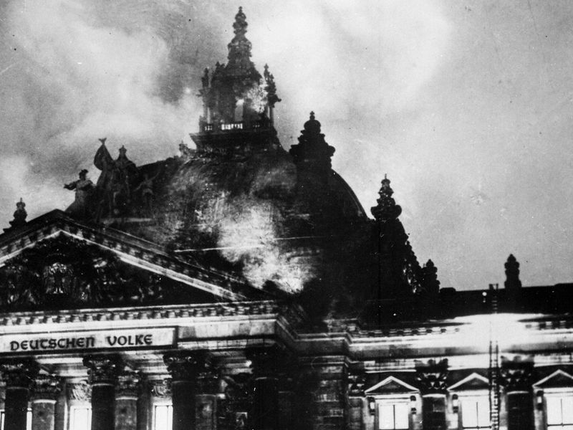
Video link - https://www.youtube.com/watch?v=ASiK8s1s8BU

Summarise the events of the Reichstag Fire in 30 words.
____________________________________________________________________________________________________________________________________________________________________________________________________________________________________________________________________________________.

Task 2 - Reichstag Fire sources
Below are a number of sources on the Reichstag Fire. Read through the sources then complete the tasks below:

Who Was To Blame For The Reichstag Fire?

Source 1:
When I arrived a few police officers were already talking to van der Lubbe. He was naked from the waist upwards, smeared with dirt and breathing heavily. He panted as if he had completed a tremendous task.

That night I listened to his story several times. I read the communist pamphlets he had on him and his confessions convinced me that he had acted alone. He had laid dozens of fires and then ran through the corridors with his burning shirt, setting fire to old leather furniture.

Shortly after my arrival on the scene of the fire Goering and Hitler arrived. Goering declared “This is the beginning of a communist revolution, not a moment must be lost in stopping them.” Hitler shouted uncontrollably “There will be no mercy. Every communist official will be shot. Every one supporting communists will be arrested.”

I reported to Hitler that all the evidence suggested van der Lubbe was a crazy maniac who had worked alone. Hitler disagreed, “This was something planned along time ago. The criminals have thought about this revolt carefully, but they have miscalculated badly.” Goering declared “Put police on an emergency footing, shoot to kill.”

When I returned to headquarters after midnight it was very busy. Teams of detectives jumped into cars with lists of communists for arrest. Other cars drew up full of communists already arrested.

From an account written in 1950 by Rudolf Diels, Head of Police.

Source 2:
An underground passage ran from Goering’s palace into the Reichstag. Through this tunnel Karl Ernst, the leader of the Berlin SA, led a group of SA thugs into the Reichstag building. They poured petrol throughout the building and set it on fire.

At the same time a half crazed man called van der Lubbe made his through the building. Earlier that week he had been heard saying how much he enjoyed setting fires and that he planned to set fire to the Reichstag next. He may have set one or two fires, but to set so many at the same time was impossible for one man. He was used by the SA and the Nazis as a means of framing the communists for the fire.

An account of the fire by Karl Ernst, published in a communist newspaper in Paris in 1934.
Source 3:
When I heard it never occurred to me that the Reichstag fire was caused by communists. I thought it was caused by an electrical fault. Only when I arrived at the building did I hear about van der Lubbe. It was then that I realised that the Communist Party was the culprit. I only wish the rest of the world could see this as clearly as I can.
What Goering said at van der Lubbe’s trial.

Source 4:
At a party to celebrate Hitler’s birthday in 1942 the conversation centred on the Reichstag building. I heard with my own ears when Goering shouted “The only one who really knows about the Reichstag fire is me, because I set it on fire”.

Said by General Halder speaking at the Nuremburg War Crimes trial in 1945

Source 5:
That evening Hitler himself was not sure if the fire was a communist plot. As we walked about the building he said, “God grant that this be the work of the communists.”

From a letter written by a British journalist who saw the Reichstag fire.

Source 6
The Nazis had nothing to do with the burning of the Reichstag. The young Dutchman, van der Lubbe, did it alone, exactly as he claimed. Hitler and the other Nazis were taken by surprise. They genuinely believed that the Communists had started the fire.

Taken from Taylor, A.J.P (1961) From The Origins of the Second World War

Write down all the Reichstag Fire suspects
__________________________________________________________________________________________________________________________________________

Who was actually arrested for the crime?
_____________________________________________________________________

How was Hitler able to use the Reichstag Fire to his own advantage?
_______________________________________________________________________________________________________________________________________________________________________________________________________________
Lesson 4 – How can you get what you want?
Task 1 – How did Hitler gain more control between 1933 and 1934
Below are series of statements that relate to how Hitler gained more control in Germany. You are to decide how significant each event was while justifying your reason.
More significant because…
Less significant because…

Joining of Nazis and Nationalists
In the Election of March 1933, although the Nazis were by far the largest party, they did not have an overall majority – just 44% of the seats. Hitler was therefore disappointed with the result, but he used the state of emergency declared by the President to stop the Communists taking over seats. He won over the Centre Party with promises to protect the Catholic Church in Germany. The Nationalists were prepared to support him as well.
Enabling Act
The Enabling Act was passed, which gave Hitler the power to make his own laws without the Reichstag. Germany now ceased to be a democracy.
Banned other political parties
Hitler acted swiftly to get rid of all Political opposition to the Nazi Party. Between May and July 1933 all other Political Parties were banned, even those that had helped him become Chancellor. In addition, using the power of the Enabling Act, Hitler passed a law against the formation of parties. This meant that the Nazi Party was the only political organisation allowed in Germany.
Shutting down of trade unions
Trade Unions (groups that stood up for workers’ rights) were closed down in May 1933.
Concordat
In July 1933, Hitler signed an agreement with the Pope, known as the Concordat. Catholics agreed to support Hitler and it gained him international prestige.
Night of the Long Knives
On 30th June 1934 Hitler used his SS (personal Police force) to round up the SA (personal Army). They were either arrested or shot. The event removed any opposition to Hitler from within his own party.

Lesson 5 – How can you convince someone to do what you want?
Task 1 – Nazi use of terror
Below are a number of ways the Nazi Party controlled the German population. You are to plot and justify the effectiveness of each method to control and instil terror that allowed the Nazis to maintain a grip on power.

The Gestapo.
This was Germany’s secret police from 1936 and was run by Reinhard Heydrich. Its job was to search out opponents to the Nazis. Members of the Gestapo tapped telephones, intercepted mail, spied on people, carried out arrests and used torture to get information and confessions. They had a network of informers all over Germany. They did not have a uniform so no-one knew who they were. They were probably the most feared Nazis because they arrived at people’s houses in the middle of the night and took them away.

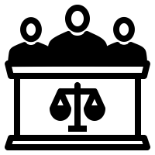
Police and judges
The ordinary police were placed under the command of the SS. The Nazis got rid of the right to trial before imprisonment. Judges had to make an oath of loyalty to Hitler. Slowly judges who opposed Hitler were replaced by those who supported him so it became easy for them to get someone convicted. The number of serious crimes increased, for example in 1933 only 3 crimes could be punished by death, by 1945 that number had increased to 46.

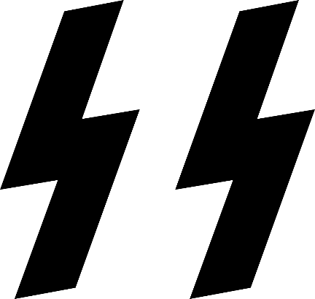
The SS.
The SS had started out in 1925 as Hitler’s private bodyguard, but had become a powerful force in Germany when they were used during the Night of Long Knives. After this they were built into a force of 50,000 and became Hitler’s own police force. They were supposed to be an elite force, and you had to be an Aryan to get in (tall, blond, blue eyed). They were led by Heinrich Himmler. They had almost unlimited powers to arrest and imprison people without trial, search houses and confiscate property.

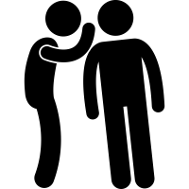
Informers.
The Gestapo had a huge network of informers. Formally each town was divided into groups of houses called ‘Blocks’. Each Block had a Nazis ‘Block Warden’ who kept an eye on the people. They wrote regular reports on the people in their block, including anything that suggested that people were not good Nazis. These reports could affect someone’s chances of getting a job or could lead to arrest by the Gestapo. It was not unknown for people to inform on their own families, even for children to inform on their parents.

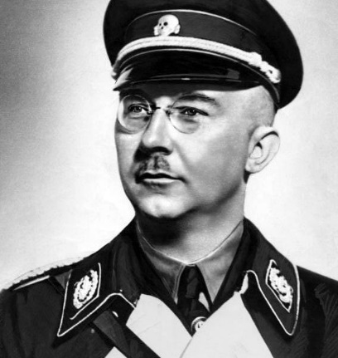
Heinrich Himmler.
By the mid-1930’s the system of terror was all run by Himmler. He became one of the most powerful people in the country. He was very loyal to Hitler and was rewarded for this when he became head of Hitler’s personal bodyguard (the SS) in 1929. The SS was ruthless in dealing with potential opposition to Hitler and was also responsible later on for setting up concentration camps.

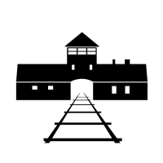
Concentration Camps.
These were camps run by groups in the SS called Death’s Head Units. Opponents to the Nazis and persecuted minorities like the Jews were sent there. People could be kept there, without trial, forever. The first prisoners were political opponents of the Nazis, especially communists. Soon ordinary people who were thought to oppose the Nazis were also sent there. During the 1930’s there were no ‘death camps’ with gas chambers, these came after 1941. However, conditions in the camps were awful: beatings were common for small offences and execution without trial was common for any big offences. The prisoners were used as slave labour on building projects like the Autobahns (motorways).

Ineffective

Very effective

Task 2 – Propaganda
Propaganda was used by the Nazis to shape the opinion and views of German people on a range of issues from national pride to the discrimination of Jewish people. Below are a series of propaganda pictures produced by the Nazis. For each poster identify:
- What do you notice?
- Who do you think the poster targets?
- What is the message of the poster?

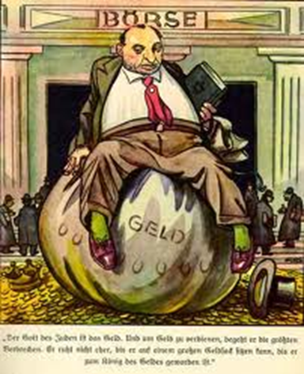
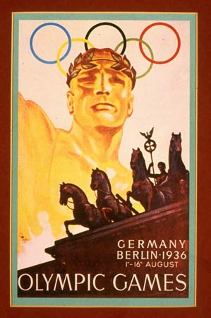
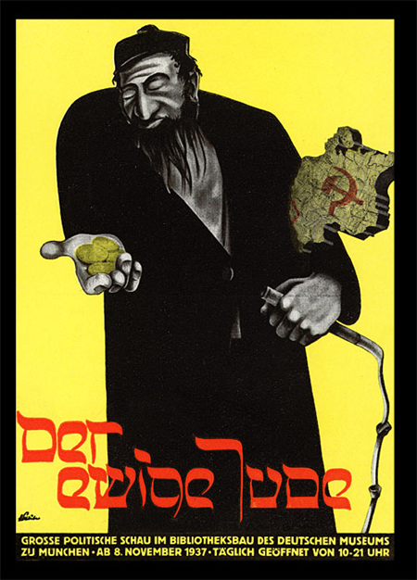
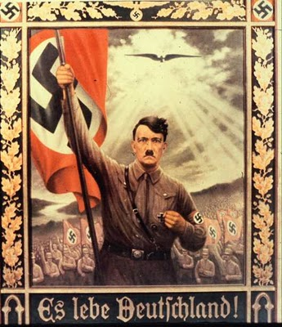

Lesson 6 – Is it ever right to target people?
Task 1 – Video
Watch the video in the following link (https://www.youtube.com/watch?v=8Os9tQCztaA) and answer the questions below:
What do you notice about Nazi treatment of minority groups such as Jewish people?
____________________________________________________________________________________________________________________________________________________________________________________________________________________________________________________________________________________
What did the Nazis believe about race?
____________________________________________________________________________________________________________________________________________________________________________________________________________________________________________________________________________________

Task 2 – What was it like to be Jewish in Nazi Germany up to 1939?
In the table below, you will see the series of anti-Jewish, discriminatory laws that were put in place to restrict their lives.

 | Laws | How would these laws affect your life and how would you feel?
1933 | - Jewish people who worked for the government lost their jobs.  - Kosher butchering became illegal  - Boycott of Jewish shops, businesses, lawyers and doctors was organised by the SA. Members of the SA would stand outside shops and scare anyone who wanted to go inside.
1934 | - All Jewish newspapers were shut down  - Anti-Jewish propaganda increased  - All Jewish shops had to be marked with a yellow star or the word ‘Juden’ to remind people not to shop there  - In parks, on buses and trains Jewish people had to sit on separate seats.  - Children were taught at school anti-Semitic ideas
1935 | - September 1935 the Nuremberg Laws were passed saying:-  - Jews could no longer call themselves German citizens but subjects. This meant they could not be employed in any public position or be protected by law. They were given new passports that said they were Jewish  - All marriages between Jewish people & non-Jews were made illegal  - A new crime called ‘racial shame’ was introduced – this meant you could be put in prison for having a Jewish boyfriend or girlfriend
1936 | - Jews were banned from voting
1937 | - Jews had to get a special passport from the Nazi government before they were allowed to travel abroad  - Many Jewish businesses were taken off them by the Nazis
1938 | - Jews were forced to carry identity cards everywhere they went  - Jewish children were sent to separate schools & were forbidden to mix with other children  - Jews were banned from going to university  - Jews were forced to give all their savings & jewellery to the Nazi  - Jewish doctors, lawyers and dentists were forbidden to treat non- Jews  - ‘J’ stamped on passports  - November 1938 – Kristallnacht (Night of Broken Glass) In revenge for the shooting of a Nazi official the SS leader Himmler, ordered a week of terror against the Jewish population. Over 10,000 shops were smashed and looted. Jewish homes and synagogues were burned down, about 100 were killed and 20,000 arrested and sent to concentration camps. Afterwards Jewish people were forced to clear up the mess and pay for all the damage.
1939 | - Jews were put under curfew so they could not stay out after 7pm  - Jews had to give the Nazis their radios  - Jews were forced to wear a yellow Star of David on their coats  - March- mass arrests of Jewish men and boys to send to concentration camps

If you were a Jewish person living between 1933 and 1939, which year for you personally, would be the worst year?

____________________________________________________________________________________________________________________________________________________________________________________________________________________________________________________________________________________

What were the three most important turning points for Jews in Germany between 1933 and 1939?

_______________________________________________________________________________________________________________________________________________________________________________________________________________

Why have you chosen these particular points?

______________________________________________________________________________________________________________________________________________________________________________________________________________________________________________________________________________________________________________________________________________________________________________________________________________________________

Lesson 7 – Is what you do outside of school important?
Task 1 – Sources and placemat consensus
Below are a number of sources based on the Hitler Youth – an organisation that was set up to instil Nazi values in children from an early age. You are to use the sources to help fill in the table on the page after to help give yourself a comprehensive overview.

Sources on Hitler Youth

Source 1
“In our eyes the German youth of the future must be slim and slender, swift as a greyhound, tough as leather, and as hard as Krupp steel.”
Speech by Hitler in 1938

Source 2
All German young people …. will be educated in the Hitler Youth physically, intellectually, and morally in the spirit of National Socialism to serve the nation and community.
Nazi Youth Law, 1936

Source 3
The activities consisted of almost entirely of military drill…….Why didn’t we complain to teachers and parents?........we wanted to impress our sub-leaders
Book called ‘Youth in the Third Reich’ by A.Klonne (1982)

Source 4
…the Hitler Youth allowed themselves to be dressed in uniform…….. Every unit wanted to have the best group. The most interesting expedition log, the biggest collect for the Winter Relief Fund…In musical competitions Hitler Youth choirs, fife and drum bands, chamber orchestras and amateur theatrical groups competed.
From book ‘Account Rendered’ by M. Maschmann (1964)

Source 5

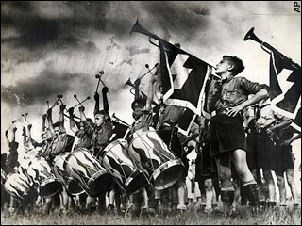
Hitler Youth band
Source 6

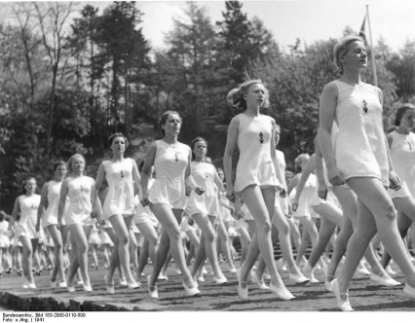
League of German Girls, that aimed to make girls for to become strong mothers

Source 7

Hitler Youth movement
Age | Boys | Girls
6-10 | The Pimpfen  (The Little Fellows)
10-14 | The Jungvolk  (The Young Folk) | The Jungmadel  (Young Girls)
14-18 | The Hitlerjugend  (Hitler Youth – HJ) | The Bund Deutsche Madchen  (The German Girls League)

After 1935 it was compulsory to join. By 1939, 8 million young Germans belonged to the Hitler Youth movement.

Source 8
‘A twelve mile march was considered nothing for boys who are trained until they can make a march of fifty miles without food other than the concentrated rations they carry in their packs’

A mother describing the training her son had to do in ‘Hitler’s Germany’ by J.Brooman

Source 9
Hitler Youth members had to go on training camps where they learned how to read maps, did sports and gymnastics, and were taught Nazi ideas….Every youngster had a ‘performance book’…….Those with the best marks were sent to special schools to be the leaders of the future. The Adolf Hitler Schools took boys..at the age of 12 and gave them 6 years of tough training before sending them onto university or the army. The very best of these pupils went on to schools called Order Castles where they were stretched to the limits of endurance.

Extract from ‘Hitler’s Germany’ by J.Brooman

Different groups | Activities  How were Hitler Youth Movements used to control the minds of young people?
Adolf Hitler Schools and Order Castles | Appeal to young people

Lesson 8 – Can equality really ever exist?
Task 1 – How were women’s lives affected in Nazi Germany
Below are eight statements that detail what life was like for women in Nazi Germany and how it was affected. You are to use the statements to draw eight pictures that help represent the information. On the next page you are to them plot each of the statements/effects on the continuum, while making sure you justify your decision.

The Nazis wanted women to follow very ‘traditional’ roles of wives and mothers. ‘Kinder, Kirche and Kuche’ summed up the Nazi attitude (Children, church and kitchen) | The Nazis wanted to promote what they considered their ‘racially pure’ Aryan race. Women were encouraged to have lots of children and laws against abortions were strictly followed. | Law for the Reduction of Employment, 1933 gave interest free loans to a young married couple if the wife gave up work. A ¼ of the loan would be cancelled each time a child was born. | Women who produced the most children were awarded a Motherhood Cross, a special medal at a ceremony held every year on the birthday of Hitler’s mother, 12th August.
From 1936, special maternity homes were opened designed to be breeding grounds for the production of ‘Aryan’ children. The Lebensborn – Spring of Life. Racially approved women could go there to become pregnant by SS men. | Even at home the Nazis discouraged women from following fashions. Make up and wearing trousers were frowned upon. Hair had to be plainly arranged in a bun or plait. Dieting was discouraged as being slim was considered bad for childbearing. | German women who held positions of responsibility were sacked. In 1933, 1,000s of women doctors and civil servants lost their jobs. The number of women teachers gradually reduced. From 1936 women could no longer be judges or be on a jury. | The Nazis focused so much on building up their armed forces that these newly married couples struggled to find homes as new houses were not built. As the 1930s progressed the shortage of workers meant some women returned to work.

Absolutely awful
Almost alright
Effects of Hitler’s Germany on women

Lesson 9 – Is power received or seized?
Task 1 – Who was Benito Mussolini
A great influence to Adolf Hitler, Benito Mussolini can be recognised as the first fascist dictator in 20th century Europe. Below is a story about the early life of Mussolini – you are to use two colours to highlight/underline two factors about Mussolini’s life:
- The problems he encounters
- The skills he develops
With both you are to then think about how these problems and skills helped shape the person he became.

Mussolini’s early life

Mussolini was the first child of the local blacksmith. In later years he expressed pride in his humble origins and often spoke of himself as a “man of the people.” The Mussolini family was, in fact, less humble than he claimed—his father, a part-time socialist journalist as well as a blacksmith, was the son of a lieutenant in the National Guard, and his mother was a schoolteacher—but the Mussolinis were certainly poor. They lived in two crowded rooms on the second floor of a small flat; and, because Mussolini’s father spent much of his time discussing politics in taverns and most of his money on his mistress, the meals that his three children ate were very poor.

A restless child, Mussolini was disobedient, unruly, and aggressive. He was a bully at school and moody at home. Because the teachers at the village school could not control him, he was sent to boarding school. He proved himself more troublesome than ever, attacking a fellow pupil and a teacher. He was expelled and sent to another school, from which he was also expelled after assaulting yet another pupil. Attending another school, he passed his final examinations without difficulty and became a teacher but soon realized that he was totally unsuited for such work! He soon left Italy to live and work in Switzerland.

At the same time, he was gaining a reputation as a young man of strangely drawn to, who was charismatic and was able to speak and write very well. He read many books that philosophers wrote, making a note of things he liked, ignoring things he didn’t like. People started to see Benito as a revolutionary as he became a journalist, public speaker and produced propaganda for trade unions (organisations that protect the rights of workers). Repeatedly, he called for a day of vengeance. More than once he was arrested and imprisoned. When he returned to Italy in 1904, even the Roman newspapers had started to mention his name. He became a teacher again but then soon turned to journalism, and to extreme politics, which led yet again to arrest and imprisonment.

Mussolini married and soon afterwards was imprisoned for the fifth time; but by then Mussolini had become recognised as one of the most gifted and dangerous of Italy’s younger socialists. He founded a newspaper of his own, La Lotta di Classe (“The Class Struggle”). In 1912, he then became editor of another newspaper called Avanti! (Forward! In English). This newspaper doubled in popularity, later opposing Italy’s involvement in World War One.

Soon, however, he changed his mind he began writing articles and making speeches as violently in favour of war! He resigned from Avanti! and was expelled from the Socialist Party. He assumed the editorship of Il Popolo d’Italia (“The People of Italy”), in which he unequivocally stated his new philosophy: “From today onward we are all Italians and nothing but Italians. Now that steel has met steel, one single cry comes from our hearts—Viva l’Italia! [Long live Italy!]” It was the birth cry of fascism. Mussolini went to fight in the war.

Task 2 – Mussolini’s rise to power
Below are a number of traccia (Italian for ‘sign’ or ‘hint’) – you are to use these sources to help complete the spider diagram on the next page to give yourself an understanding of how Mussolini rose to power in Italy.
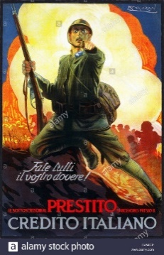
Traccia A
Mussolini believed that war was the best way to make a country great. As leader of Italy, he would seize every opportunity to become involved in wars. This led to the glorification of violence.

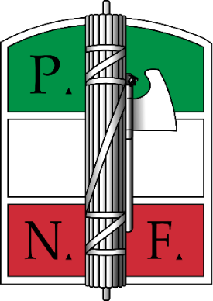
Traccia B
After World War I, Mussolini started the Italian Fascist Party. Lots of ex-soldiers joined this party. Mussolini said that all Italians should unite and overcome their differences. People believed that this new Fascist Party offered the best hope for Italy.

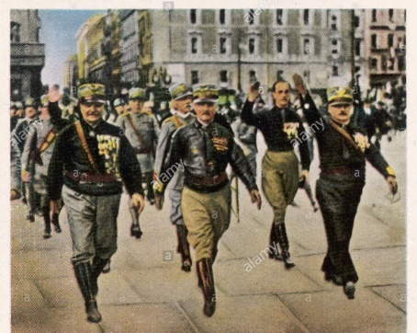
Traccia C
Many ex-soldiers were unemployed after the war, and they were angry that they had been to fight but now had nothing. Mussolini made them into a Fascist army, saying that they were against the enemies of Italy. This army became known as the ‘Blackshirts’.

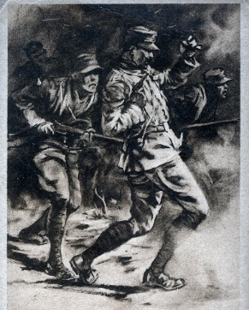
Traccia D
Italy’s army did not do well during the war. They had lots of deaths and injuries and there were mass desertions (running away). Many people and especially soldiers thought that Italy’s leaders were personally responsible for the country doing badly during the war.

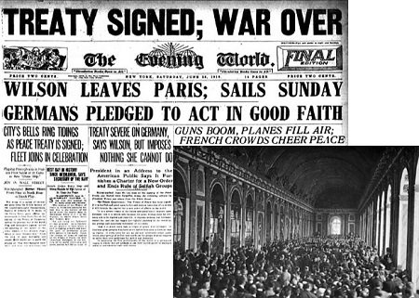
Traccia E
After the Treaty of Versailles, the Italians, though technically on the winning side, were not seen as being as important as the other winning countries such as France and the UK. Although Italy was promised some new land in the treaty, they did not get it. Many felt that their sacrifices during the war had been pointless.

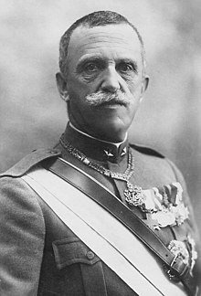
Traccia F
The end of the war led to an economic crisis in Italy. There was a lot of unemployment and many people were starving. This made the King, Victor Emanuelle III, extremely unpopular. By 1920, many Italians believed that something drastic was needed to save the country.

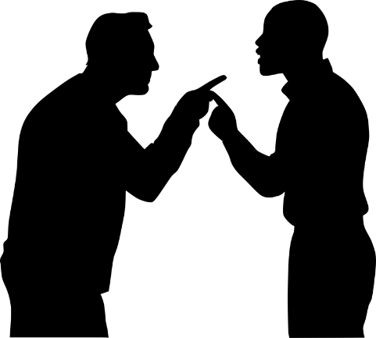
Traccia G
Mussolini and his Fascist Party used violence and terror to gain control. The Black Shirt Squads used violence to intimidate (scare), torture or even kill those who were against Mussolini. Many people were scared of them, but others saw them as a source of stability and security.

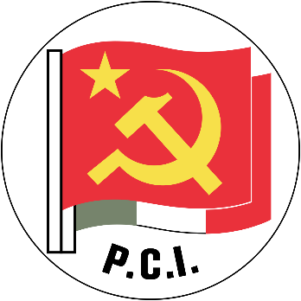
Traccia H
After the First World War, communism was popular in Italy. This scared many wealthy (rich) Italians.

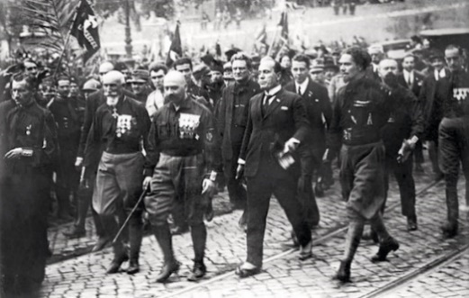
Traccia I
From 1919, Mussolini’s Black Shirts fought with other political parties in the streets of Italy. This made them very popular among those who feared a revolution. This meant that many Italians began to see the Fascists as capable of saving Italy from Communism.

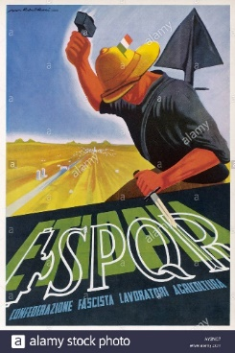
Traccia J
The Fascists used propaganda to show themselves as the people who would save Italy. Mussolini was a very good public speaker - Adolf Hitler modelled his public speaking on Mussolini.

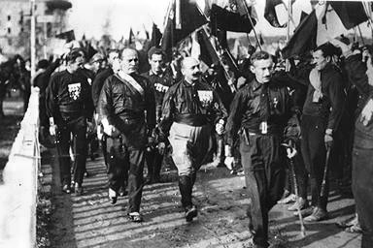
Traccia K
Although Mussolini was popular his party did not win many seats in the election of 1921. He organised a march to Rome. His supporters arrived in Rome in their thousands, to demand the resignation of the Prime Minister. Some 30,000 Blackshirts travelled from all over Italy. This became known as the ‘March on Rome’.

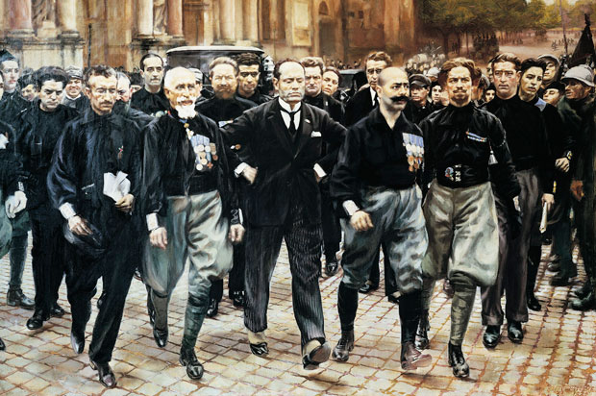
Traccia L
The March on Rome was well organised. The Black Shirts were disciplined. This seemed to show that the Fascists supported law and order and were the opposite of the Communists. During the March on Rome, Mussolini made sure he was photographed with the marchers and made many speeches saying that Italy was in danger and that only he and his party could save the country.

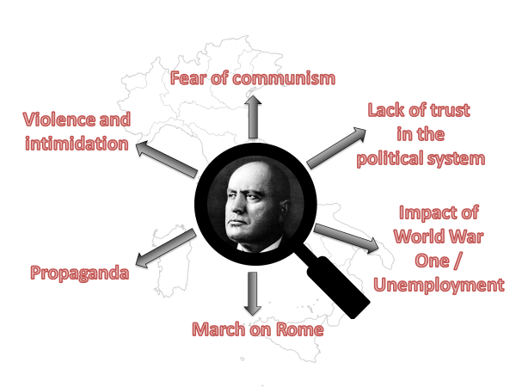

Lesson 10 – Are there two sides to every story?
Task 1 – Life in fascist Italy
Watch the video clip below that captures Italy in the 1930s. As you watch the video, answer the following questions - https://www.youtube.com/watch?v=ZtTCHQCDlNU

How does the clip describe/present Mussolini?

Write down all the positives you hear about life in 1930s Italy. What might life be like in Mussolini’s Italy?

The video makes references to Italian greats such as Michelangelo and the Romans – what effect does this have on the viewer?

Why might this American clip be complementary of Italy?

Task 2 – Life in fascist Italy case studies
Below are three case studies about life in fascist Italy in terms of children, women and propaganda. Once you have read the case studies, in the table, write down any similarities or differences between life in Mussolini’s Italy and Hitler’s Germany.

Case Study 1 - Education in Fascist Italy
Adults who opposed Mussolini were dealt with harshly. However, the children were the Fascists of the future and Mussolini took a keen interest in the state’s education system and the youth organisations that existed in Italy. Hitler used the same approach in Nazi Germany.
Mussolini wanted a nation of warriors. Boys were expected to grow into fierce soldiers who would fight with glory for Italy while girls were expected to be good mothers who would provide Italy with a population that a great power was expected to have.
Children were taught at school, that the great days of modern Italy started in 1922 with the March on Rome. Children were taught that Mussolini was the only man who could lead Italy back to greatness. Children were taught to call him “Il Duce” and boys were encouraged to attend after school youth movements. Three existed.
Organisation | Age Group | Uniform
Sons of the She Wolf | 4 to 8 | Black shirt
Balilla | 8 to 14 | Black shirt, black cap, shorts, grey socks
Avanguardista | 14 to 18 | Same as Balilla except knickerbockers instead of shorts.
Boys were taught that fighting for them was a natural extension of the normal male lifestyle. One of the more famous Fascist slogans was “War is to the male what childbearing is to the female.” Girls were taught that giving birth was natural – while for boys, fighting was the same – natural.
Members of the Balilla had to remember the following:
“I believe in Rome, the Eternal, the mother of my country……I believe in the genius of Mussolini…and in the resurrection of the Empire.”
The glory of the old Roman Empire always lurked in the background of much of what children did. A child in a youth movements was a “legionary” while an adult officer was a “centurion” – a throw back to the days of when the Ancient Roman army dominated much of western Europe.

Case Study 2 - Women in Fascist Italy
As in Nazi Germany, women were seen as having a specific role in Fascist Italy. The task of young girls was to get married and have children – lots of them. In 1927, Mussolini launched his Battle for Births.
Mussolini believed that his Italy had a smaller population than it should have. How could it possibly be a power to reckon with, without a substantial population and a substantial army? Women were encouraged to have children and the more children brought better tax privileges – an idea Hitler was to build on. Large families got better tax benefits but bachelors were hit by high taxation.
Families were given a target of 5 children. Mothers who produced more were warmly received by the Fascist government. In 1933, Mussolini met 93 mothers at the Palazzo Venezia who had produced over 1300 children – an average of 13 each!
Mussolini wanted Italy to have a population of 60 million by 1950. In 1920, it stood at 37 million so his target was a tall order. However, the Battle for Births was a failure. Though the population grew as people were living longer due to better medical care, the birth rate actually went down between 1927 and 1934.

Case Study 3 - Propaganda in Fascist Italy
The Fascist regime made heavy use of propaganda, which was used to inspire the nation into the unity that would obey. Il Duce was the centre of Fascism and portrayed as such. Endless publicity revolved about Mussolini with newspapers being instructed on exactly what to report about him. He was generally portrayed in a macho manner, although he could also appear as a Renaissance man, or as military, family, or even common. Legends of Mussolini defying death during the First World War and surviving assassination attempts were circulated to give the dictator a mythical, immortal aura.
Reviving the glories of the Roman Empire in modern Italy was a common theme. This called for the control of Mare Nostrum—'our sea', as the Mediterranean was called in Rome. France, Britain, and other powers were denounced as having held Italy back from potential greatness. Efforts were made to drum up enthusiasm for colonialism in the 1930s.
Authorities were allowed to confiscate newspapers on the grounds they published false information. Meanwhile, pro-Fascist journals received money for their support of Mussolini.
With the spread of ownership of radio units during the Fascist regime, radio became the major tool for propagandizing the population. It was used to broadcast Mussolini's open-air speeches, and as an instrument for propagandizing youth.

 | Similarities between Italy & Germany | Differences between Italy and Germany
Children/
education
Women
Propaganda
Lesson 11 – Does the rain in Spain fall mainly on the plane?
Task 1 – Franco’s Spain
Our last fascist dictator we will look at is Francisco Franco, who ruled as dictator over Spain from 1939 till 1975. You are to use the space below to create a biography of Franco, making sure you add information on the following:
- How he became dictator of Spain
- The Spanish Civil War
- Life in Franco’s Spain (terror and control, society and culture, the economy)
- Any similarities or differences between Franco and Hitler/Mussolini.

