Year 8 History Study Guide
• World War I and inter-war years •

Lesson 1 – Can one country alone cause a war?
Task 1 – World War One causes video
Watch the video clip (www.youtube.com/watch?v=24i4ncHuf6A) and use the information to write about some brief notes on each section:

Task 2 – What happened in the Balkans and how did this trigger WWI?
Watching this second video clip, you are to write down an answer to the question above in the lines below – (https://www.youtube.com/watch?v=anwPsESzrF0)

_______________________________________________________________________________________________________________________________________________________________________________________________________________________________________________________________________________________________________________________________________________________________________________________________________________________________________________________________________________________________________________________________________________________________________________________________________________________________________________________________________________________________________________________________________________________________________________________

Task 3 – What would you do?
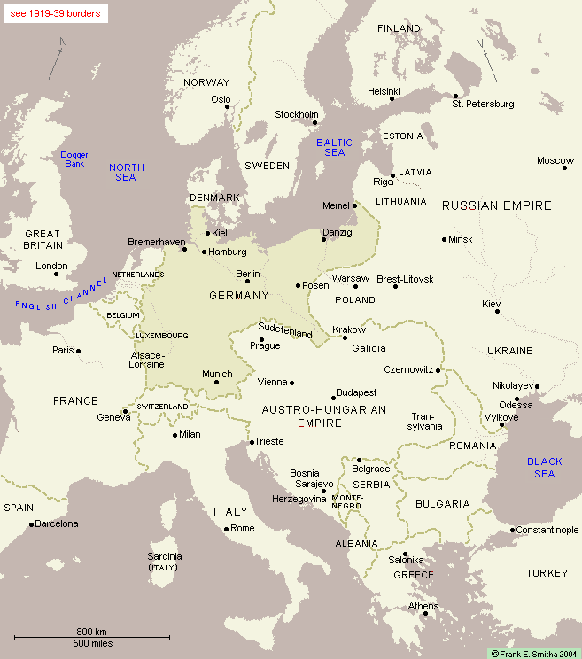
If you were Germany and you need to prepare a war plan to invade France and Russia, what would you do? Use the information and the map below to draw arrows and give a rough idea of your plans.
Remember, Germany are free to use the resources of their allies (Austria Hungry and Italy)
• Germany: 2,200,000 soldiers, 97 warships
• Austria-Hungary: 810,000 soldiers, 28 warships.
• Italy: 750,000 soldiers, 36 warships
• France: 1,125,000 soldiers, 62 warships
• Russia: 1,200,000 soldiers, 30 warships
• Great Britain: 711,000 soldiers, 185 warships
Reserve soldiers
• Germany: 8.5 million men
• Russia: 4.4 million
• France: 3.5 million
• Austria-Hungary: 3 million
Lesson 2 – Are new methods of fighting always better?
Task 1 – Trench warfare
Below is a cross-section of a trench on the western front in Northern France. See if you can label the parts of the trench:

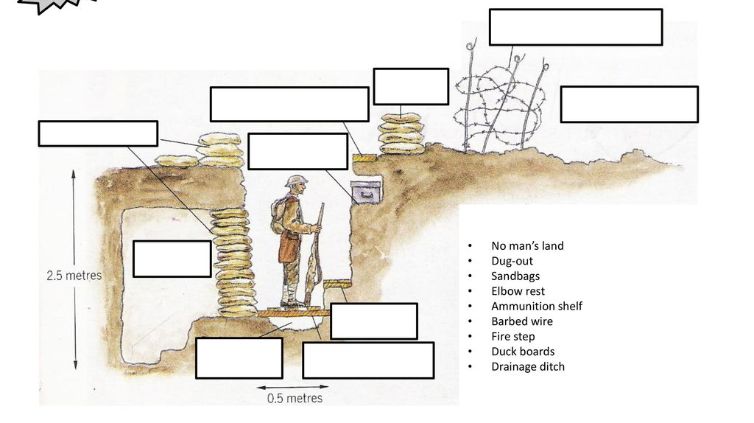
Task 2 – Why trenches?
Using the video clip (https://www.youtube.com/watch?v=XqIhpYlhZKQ) try and answer the question why trenches were used during WWI?
___________________________________________________________________________________________________________________________________________________________________________________________________________________________________________________________________________________________________________________________________________________________________________________________________________________________________________________________________________________________________

What were the advantages of trench warfare? | What were the disadvantages of trench warfare?
Task 3 – Attacking and defending
Using your knowledge and the images below, annotate around the page how you think you would attack or defend from a trench?
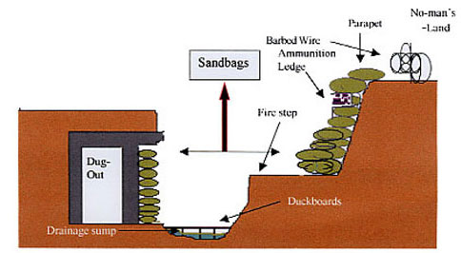
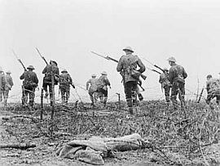

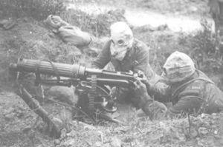
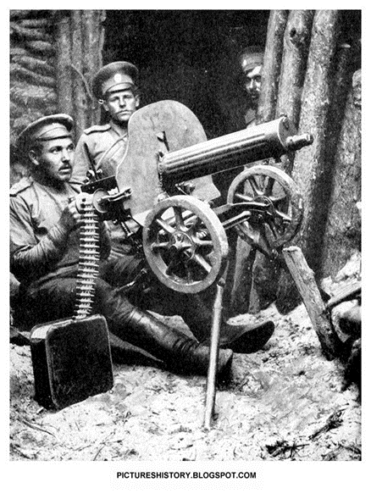
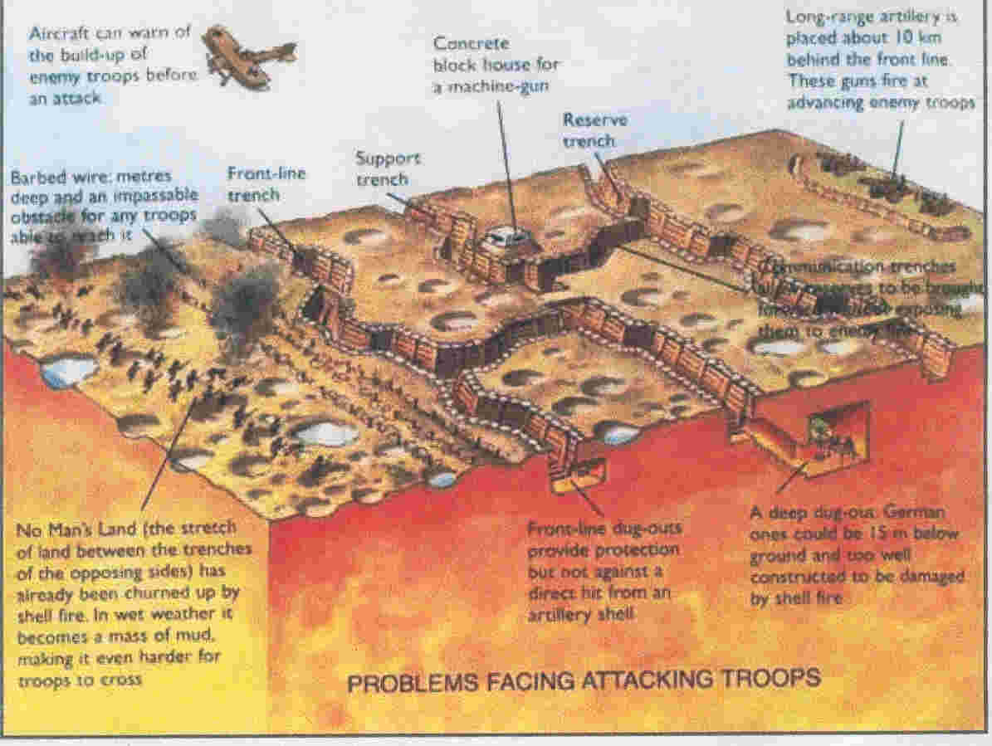

Lesson 3 – Was life in the trenches all bad?
Task 1 – Life in the trenches
In the space below, you are to document what you can find/research about what life was like in the trenches. While you’re doing that, think about what you believe were the worst parts of being in a trench, and whether there were any positives about it too!
Key areas to research: flies, diseases, food, health and hygiene, weather, jobs/boredom, body lice, rats, friendship.

Life in the trenches

Lesson 4 – Is winning always a good thing?
Task 1 – The Battle of the Somme
Below is some information about the Battle of the Somme. You are to read that information, and with one colour, underline or highlight the successes. With another colour you are to highlight the failures.

General Haig was the man in charge of the British army December 1915. Lots of men had volunteered to join the army and he was going to use these men to attack the Germans around the river Somme (northern France) in the summer of 1916. The British began to equip and train over 100,000 men.

The French (GB’s friends) were under attack at the town of Verdun, the Germans needed to be distracted away otherwise the French army would collapse.

The bombardment (bombing) of the German trenches began on 24th June and lasted a week. Never before was bombing so heavy and long, it was believed everything would be destroyed by the bombing. Tunnels were built underneath no man’s land towards the German trenches and filled with explosives. However the Germans planes had spotted what was happening. To protect themselves the Germans:-
- Added more barbed wire
- They built deep concrete dug outs 12 metres deep underground and hid in them when the bombing started.
This meant the British were bombing empty German trenches.

On 1st July 1916 the allied troops got ready for ‘going over the top’. Many soldiers were very excited as they thought the Germans would be dead. However, when the bombing stopped, the Germans got out of their dug outs and got their machine guns ready to fire. As the British went over the top they were fired at by the Germans. Tommies (nickname for British soldiers) said that the British commanders should have known that bombing doesn’t destroy barbed wire but makes it worse.

By the end of the first day of the Battle of the Somme 57,470 soldiers were dead or injured. For the next 4 months General Haig continued to send men over the top to weaken the Germans.

In September 1916, tanks were used for the first time. They scared the Germans but did have problems, for example, the tanks initially got stuck in the mud and broke down. Tanks would improve and be used successfully later in WW1.

By November 1916 both sides were exhausted and over a million soldiers had been killed or wounded. General Haig was called the “Butcher of the Somme” after his tactics and plan led to such a huge loss of life. However, the British had helped the French keep control of Verdun, the Germans had lost their confidence and the British had taken 15km of land (quite a lot of land considering neither side moved ever moved far).

Task 2 – A success or failure?
Watch the attached video clip (https://www.youtube.com/watch?v=XqvALkpsfRo&t=332s) and as you watch, write down any other successes or failures that are not mentioned in the passage of text above

Success | Failure

Overall, do you believe the Battle of the Somme was a success or a failure? Use the space below to write a paragraph organising the research you have carried out and the thoughts you have. Make sure that your points are supported by evidence and that you make a clear judgement.

___________________________________________________________________________________________________________________________________________________________________________________________________________________________________________________________________________________________________________________________________________________________________________________________________________________________________________________________________________________________________________________________________________________________________________________________________________________________________________________________________________________________________________________________________________________________________________________________________________________________________________________________________________________________________________________________________________________________________________________________________________________________________________________________________________
Lesson 5 – Can you blame someone for a crime if they weren’t there?
Task 1 – Haig on trial
The focus of this lesson is about making a judgement on whether you believe Field Marshall Haig was to blame for the manslaughter of men at the Battle of the Some. You will read through the evidence below, and using different coloured pens, identify information that Haig was guilty/to blame or that Haig was not guilty/not to blame for the large loss of life and casualties at the Somme.
Background information

- Sir Douglas Haig was born in 1861
- He was Scottish born and a member of the a famous family of whisky distillers.
- On the 10th December 1915 he took command of the British Army.
- The war was by this stage a stalemate, the German and allied troops were well “Dug in”.
- In 1915 Haig was 54 years old with a long and successful military career behind him.
- Haig faced a problem “How could the deadlock be broken?”
1907
Success in
battle depends mainly on
morale and determination
1915 The way to capture
machine gun is grit and determination.
1916 We must wear the enemy down as much as possible.
1916 The machine gun is a much over stated weapon.

Stage One

- Haig decided that given enough men and enough guns a breakthrough was certain.
- More British troops died than in any other battle before.
- Haig was not to know the German troops were so well “dug in”.

Stage Two

- The Allies advanced 10 miles during the 5 month campaign. They suffered 600,000 casualties.
- At the end of the first day of battle the British had suffered 60,000 casualties.
- Trench warfare was a new way of fighting and no one really knew how to overcome it.

Stage Three

- Haig bombarded the Germans with the biggest shell attack in history to wear the Germans down.
- The shell bombardment let the Germans know that an attack was coming.
- The German losses by the end of the battle in November were nearly as much as the Allies.

Stage Four

- After the first day of fighting on 1st July the British morale went down, the troops felt betrayed by the Generals.
- Haig had the British interests at heart. Who won the war?
- The bombardment made it almost impossible to cross “No man’s land” as it was full of craters and tangled barbed wire.

Stage Five

- In November 1916 the Germans commander Ludendorff said his troops were “fought to a standstill”.
- If Haig had not attacked the Germans in July 1916 the French slaughter at Verdun would have continued. The French army may have been destroyed completely.

Stage Six

- Despite the huge casualties on the day! Haig continued to order wave after wave of British troops to their deaths.
- Haig never visited the Front line as a General.

Stage Seven

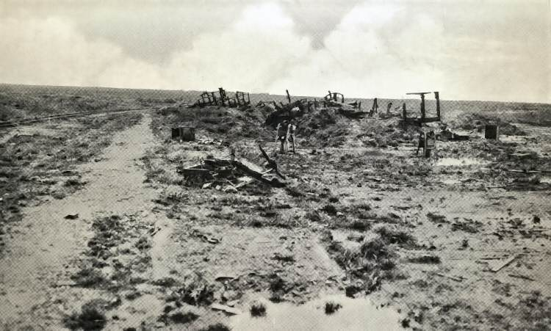

The ruins of Guillemont station – taken over by the British at the Somme.

Stage Eight
Extract from the diary of General Haig, written on 30th June 1916.
The men are in splendid sprits. Several have said that they have never been so
instructed and informed of the nature of the operations before them. The wire never been so well cut, nor the artillery preparation so thorough.
Written by George Coppard, a soldier who fought on the Somme in July 1916.
Quite as many died on the enemy wire as on the ground. The German must have been reinforcing the wire for months. It was so dense that daylight could barely be seen through it. How did the planners imagine that Tommies (British Soldiers) would get through the German wire? Who told them that artillery fire would pound such wire to pieces, making it possible to get through? Any Tommy could have told them that shell fire lifts wire up and drops it down, often in a worse tangle than before.

Task 2 – Was Haig to blame?
Using the information that you have read and categorised above, you should now look to make a judgement on whether Haig was to blame for the slaughter at the Battle of the Somme. Remember to state whether you think Haig is to blame, and then use three or more pieces of evidence to support your judgement.

______________________________________________________________________________________________________________________________________________________________________________________________________________________________________________________________________________________________________________________________________________________________________________________________________________________________________________________________________________________________________________________________________________________________________________________________________________________________________________________________________________________________________________________________________________________________________________________________________________________________________________________________________________________________________________________________________________________________________________________________________________________________________________________________________________________________________________________________________________________________________________________________________________________________________________________________________________________________________________________________________________________________________________________________________________________________________________________________________________________________________________________________________________________________________________________________________________________________________________________________________________________________________________________________________________________________________________________________________________________________________________________________________________________________________________________________________________________________________________________________________________________________________________________________________________________________________________________________________________________________________________________________________________________________________________________________________________________________________________________________________________________________________________________________________________________________________________________________________________________________________________________________________________________________________________________________________________________________________________________________________________________________________________________________
Lesson 6 – How do we know if something is useful?
Task 1 – Source utility
In this lesson, you are going to watch three different video clips that present different views of a soldiers’ experience of fighting during World War One. After you have watched the video clip, you are to fill in the relevant boxes in the table below.
The War Game - https://www.youtube.com/watch?v=jIW8DxwNmZ0 – watch from 21:05 to 24:30
The Last Tommy - https://www.youtube.com/watch?v=0bt1ycpezn0 – watch up to 9 minutes
Blackadder Goes Forth - https://www.youtube.com/watch?v=vH3-Gt7mgyM

 | What does the source show us about living or fighting in the trenches? | In what ways in the source useful? (what it shows that is correct) | In what ways in the source not useful?  (what is missing or is there anything that is incorrect?)
The War Game

The Last Tommy

Blackadder Goes Forth

Which source did you find most useful? Why?
_________________________________________________________________________________________________________________________________________________________________________________________________________________________________________________________________________________________________________________________________________________________________________________________________________________________________________________________________________________________________________________________________________________________________________________________________________________________________________________________________________________________________________________________________________________________________________________________________________________________________________________________________________________________________________________________________

Which source did you find least useful? Why?
_________________________________________________________________________________________________________________________________________________________________________________________________________________________________________________________________________________________________________________________________________________________________________________________________________________________________________________________________________________________________________________________________________________________________________________________________________________________________________________________________________________________________________________________________________________________________________________________________________________________________________________________________________________________________________________________________

Which source do you think was the most reliable? Why?
(Think about the type of source it is, when it was written and also what the purpose is)
____________________________________________________________________________________________________________________________________________________________________________________________________________________________________________________________________________________________________________________________________________________________________________________________________________________________________________________________________________________________________________________________________________________________________________________________________________________________________________________________________________________________________________________________________________________________________________________________________________________________________________________________
Lesson 7 – Can war ever be good?
Task 1 – World War One inventions
Using the internet, see if you can find five, non-medical things) that were invented during World War One.
- ________________________________________
- ________________________________________
- ________________________________________
- ________________________________________
- ________________________________________

Task 2 – Medical developments in World War One
With each development, identify what the problem was and how it was solved:

Blood transfusions  Although blood transfusions had been tried for centuries, it wasn’t until 1900 that scientists worked out how to do them successfully. Karl Landsteiner discovered blood groups, which helped doctors to work out that a transfusion only worked if the donor’s blood type matched the receiver’s.  Even then it wasn’t possible to store blood for long because it clotted so quickly. As a result, many people still died of blood loss, a solution was desperately needed. In 1914, Albert Hustin discovered that glucose and sodium stopped the blood from clotting on contact with the air. Other advances meant blood could be bottled, packed on ice and taken to where it was needed by the surgeons operating on soldiers (an early version of a portable blood bank). | Problem?  How it was solved?
Plastic Surgery  During WW1, the hard work of Harold Gillies, a London based army doctor, led to the development of what we now call plastic surgery. He set up a special unit to graft (transplant) skin and treat men suffering from severe facial wounds. Many men had suffered horrific facial injuries with shell explosions and had to have large parts of their faces reconstructed. Gillies is recognised as one of the first surgeons to consider a patient’s appearance when treating wounds. Queen’s Hospital in Kent opened in 1917 and by 1921 provided over 1,000 beds for soldiers with severe facial wounds. Gillies and his colleagues had treated over 5,000 service men by 1921. | Problem?  How it was solved?
X-Rays  X-rays were discovered in 1895, and soon hospitals were using them to look for broken bones and disease. However, it was during WW1 that X-rays became really important. Mobile X-ray machines were used near battlefields to find out exactly where in the wounded soldier’s body the bullets or pieces of shrapnel had lodged. This avoided having to cut open the soldier. | Problem?  How it was solved?
Repairing broken bones  New techniques were developed during WW1 to repair broken bones. For example, the Army Leg Splint (or Keller-Blake Splint) was developed, this elevated and extended the broken leg ‘in traction’. This helped the bones to knit together more securely. The splint is still in use today. | Problem?  How it was solved?

What do you think was the most important medical development of WWI? Why?
______________________________________________________________________________________________________________________________________________________________________________________________________________________________________________________________________________________________________________________________________________________________________________________________________________________________
Lesson 7 – What is a fair way to treat people who have done something wrong?
Task 1 – The Treaty of Versailles
In January 1919, delegates from 32 countries met at the Palace of Versailles near Paris to make peace after the First World War - the peace they hoped would 'end all wars'. The conference was dominated by David Lloyd George, Georges Clemençeau and Woodrow Wilson: the leaders of Britain, France and America, often known as the 'Big Three'. No Germans were invited and this later made them come to resent the treaty because they felt that decisions were made about them, not with them.

Below are a number of problems that the leaders at Versailles had. Read through the problems and complete the table on the following pages:

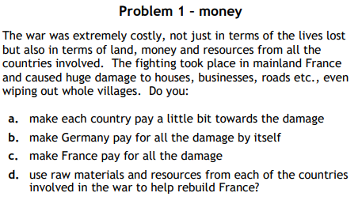
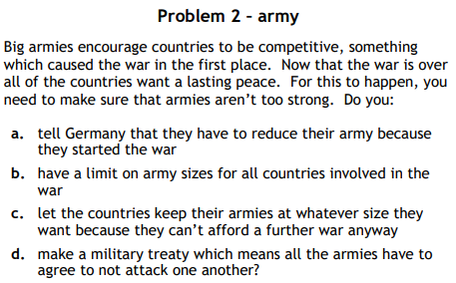

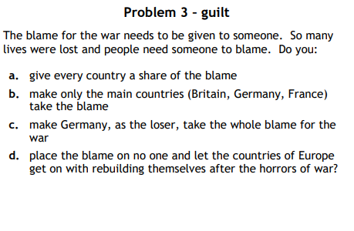

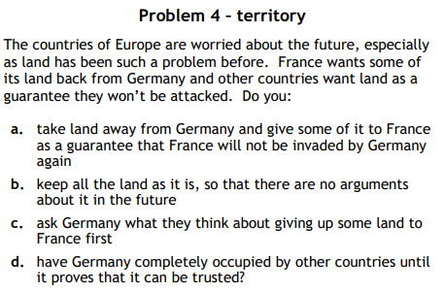

Problem | Answer | Why have you chosen this option? | What actually happened? | Was this fair?
Money
The war cost all sides a lot of money in terms of funding the war effort and damaged caused.
Who should pay?

Army
Now the war is over, how much of an army should the countries in Europe be allowed?

Guilt
Who should be blamed for the war?

Territory
Lots of arguments occurred over territory before the war. How can we make sure this doesn’t happen again?

Answers:
1. Money: b) Make Germany pay for all the damage by itself. Germany was forced to agree to pay an initial sum of £22bn.
2. Army: a) Tell Germany that they have to reduce their army because they started the war. Germany had to reduce its army to 100,000 men, six ships, no tanks, no submarines, no airforce.
3. Guilt: c) Germany was the loser so it must take the whole blame for the war. The war guilt clause stated Germany had to accept the blame.
4. Territory: a) Take land away from Germany; give to France so that Germany can’t attack France again. Germany lost Alsace-Lorraine and had to demilitarise the Rhineland, an area which bordered France and Germany.

Lesson 8 – Is it possible to keep the peace?
Task 1 – The League of Nations
Click on the link to watch the clip (https://www.youtube.com/watch?v=MWc5-thIkEQ) and answer the following questions:

What was the League of Nations?
_______________________________________________________________________________________________________________________________________________________________________________________________________________

Why is it called ‘the first world organisation’?
_______________________________________________________________________________________________________________________________________________________________________________________________________________

Task 2 – Strengths and weaknesses
Keeping the peace was always going to be a difficult task, especially after World War I and the Treaty of Versailles. Many countries from around the world created the League of Nations to work together and try and keep world peace. This was a great ideas but ultimately it didn’t work.

Below are a list of strengths and weaknesses of the League of Nation – categorise them by writing ‘strength’ or ‘weakness’ in the box:

The League had no army of its own. | The USA did not join the League. This undermined the League from the start. | Most major powers joined the League.
The USSR did not join the League until 1934. | Most countries began supporting the League when it was set up in 1919-20. People wanted to avoid conflicts. | The League solved some political disputes in the 1920s.
In 1921 the League settled a dispute between Sweden and Finland over the Aaland Islands. | In 1925, a Greek army invaded Bulgaria. The League persuaded the Greeks to leave. | In the 1930s the League could not stop the rise of dictators in Japan, Germany and Italy. It was not strong enough.
Better communications by 1920s (international flights & the telephone) helped the League to work efficiently. It made it easier to act when conflict threatened. | The disarmament Committee’s attempts to get members to reduce the size of their armies had no success. France regarded disarmament a threat to national security. The failure of other nations to disarm allowed Germany to claim the right to re-arm to protect themselves. | The League had very little real power to get people to obey it. The League relied on goodwill and persuasion. Goodwill was not enough to keep the peace.

What do you think was the strongest aspect of the League of Nations? Why?
___________________________________________________________________________________________________________________________________________________________________________________________________________________________________________________________________________________________________________________________________________________________________________________________________________________________________________________________________________________________________

What do you think was the weakest aspect of the League of Nations? Why?
___________________________________________________________________________________________________________________________________________________________________________________________________________________________________________________________________________________________________________________________________________________________________________________________________________________________________________________________________________________________________

What do you think is the ultimate sign that the League of Nations failed?
_______________________________________________________________________________________________________________________________________________________________________________________________________________

