

Year 8 History Study Guide

•Twentieth Century Britain •

**Lesson 1 – Was Britain a better place by the year 2000?**

**Task 1 – What do you notice?**

Below are three pictures taken in various places in Britain during the 20th century. Look carefully at each picture and write down what you notice, and also the differences between what is going on in each photograph.

|  |  |
| --- | --- |
| **1900** | |
| What do you notice? | |
| **1950**  Piccadilly Circus: 1950 | This is a Photo Greetings Card pos… | Flickr | |
| What do you notice? | What is different from the previous photograph? |
| **1999**  Description: http://www.google.co.uk/url?source=imgres&ct=img&q=http://www.sciencephoto.com/image/182699/large/E7801434-View_of_London,_UK-SPL.jpg&sa=X&ei=vDhSTtKdDcyo8QPi4ISwBw&ved=0CAQQ8wc4Cw&usg=AFQjCNHKYnh9RNNrc4_mCnoL3AXUO09mTw | |
| What do you notice? | What is different from the previous photographs? |

**Task 2 – Categorising**

Can you categorise any of the changes you notice (e.g. changes in style of building could be categorised under architecture)

___________________________________________________________________________________________________________________________________________________________________________________________________________________________________________________________________________________________________________________________________________________________________________________________________________________________________________________________________________________________________

**Lesson 2 – What makes one thing better than another?**

**Task 1 – Most to least useful.**  
Rank the items below from most to least useful – explain your most and least useful item placing:

1. ___________________ because______ _________________________________

2. ___________________

3. ___________________

4. ___________________

5. ___________________ because______ _________________________________

**Task 2 –** **Diamond 9 Rank**

Below is a list of technological development that emerged during the 20thcentury. Out of the 13, you are to choose the 9 most useful and then you are to rank them from most useful to least useful in the diamond formation on the next page.

|  |  |
| --- | --- |
| Lie detector test (1902)  E=mc2 (1905)  Penicillin (1928)  Cats eyes (1934)  Atom bomb (1945)  First satellite in space (1957)  Personal computers (1971) | Airplanes (1903)  Television (1925)  First test tube baby (1978)  Revolver (1936)  Heart transplant (1967)  The internet (1992) |

Most useful

Least useful

**Task 2 – Ranking criteria**

Look at your diamond 9 and think about what you have placed in the top half. What criteria have you used for deciding what is the most useful or important developed in the 20th century?   
  
(For example, if you have heart transplant, first test tube baby and penicillin in your top 6, it means you believe medical developments have been the most useful – why might this be?)

___________________________________________________________________________________________________________________________________________________________________________________________________________________________________________________________________________________________________________________________________________________________________________________________________________________________________________________________________________________________________

**Lesson 3 – How do you know what happened if you weren’t there?**

**Task 1 – What do you know about the Titanic?**

In the space below, and without looking at the next task, write down everything you already know about the Titanic:

|  |
| --- |
| Titanic Facts For Kids | What Was The Titanic? | DK Find Out |

**Task 2 – Titanic story words into pictures**

Using the information on the left hand side of the page, you are to translate that into a series of pictures and images (try to use a maximum of 7 words – names, initials, numbers and dates are allowed though)

|  |
| --- |
| When the Titanic was launched in 1912 it was the biggest moving object ever built. She was 885 feet long, weighed 46,000 tons & could carry over 3,000 people including passengers and crew.  The Titanic had ten decks – seven for the passengers and three for the crew and cargo. The passengers were divided into three classes. First class provided luxury accommodation in very comfortable cabins. The ship included a swimming-pool and was seen by passengers as a kind of floating palace!  The Titanic’s first voyage began on April 10th 1912 when she set off from Southampton on her journey to New York, carrying 2,223 people. On the evening of April 14th the sea was calm & the sky was clear. The night watch were pacing the Bridge of the ship on the look out for icebergs following warnings earlier in the day.  At 11.40pm they suddenly saw a towering iceberg right in their path. The ship’s helmsman swerved to avoid hitting it but was unable to miss it altogether – three fifths of the iceberg lay under the water & the bottom of the ship brushed against it, cutting open the side of the ship 300 feet below. The ship quickly began to take on water – it had been designed to be ‘unsinkable’ & it could continue to float if up to 4 of the 16 watertight compartments took on water. However the collision had damaged 6 of the compartments so there were was no way it could survive.  The crew immediately began to put people into lifeboats – priority was given to women & children & to first class passengers first. There were twenty lifeboats on board, enough to carry 1,178 people, but many lifeboats were lowered to the water before they were full – for example the first lifeboat could take about 40 people but it left carrying only 12. The ship took two hours & 40 minutes to sink. Out of the 2,229 people on board only 713 survived. |

**Task 3 – Did the band keep playing?**

Read through and answer the questions below:

How do we know what happened on board the Titanic?

____________________________________________________________________________________________________________________________________________________________________________________________________________________________________________________________________________________

Hopefully one of your answers was the very famous Titanic (1997) film. In the film, as the ship is sinking, the band continue to play as they face little chance of being able to get off the ship. However, how do you think this actually happened OR do you think it was put into added into the film.

Below are a number of sources for you to look at and read through to help you decide:

|  |
| --- |
| One of the most famous stories of Titanic is of the ship's band. On 15 April the eight-member band, led by Wallace Hartley, had assembled in the first-class lounge in an effort to keep passengers calm and upbeat. Later they moved on to the forward half of the boat deck. The band continued playing, even when it became apparent the ship was going to sink, and all members perished.  ***Source taken from:*** [***http://en.wikipedia.org/wiki/Titanic#Final_minutes***](http://en.wikipedia.org/wiki/Titanic#Final_minutes) |
| "From aft came the tunes of the band. It was a ragtime tune, I don't know what...then they finished with ‘Autumn’. I went to the place I had seen the collapsible boat on the boat deck, and to my surprise I saw the boat and the men still trying to push it off. I went up to them and was just lending a hand when a large wave came awash of the deck. The big wave carried the boat off. I had hold of an oarlock and I went off with it. The next I knew I was in the boat and the boat was upside down and I was under it. And I remember I realised I was wet through, and that whatever happened I must not breathe, for I was underwater.”  ***Source taken from Harold Bride’s account of the sinking, as produced in the New York Times on 19th April 1912. Bride had been the wireless operator on board Titanic.*** |
| "As the steamship went down the band was up forward and we could hear the start of 'Nearer My God to Thee.' There was no evidence of panic while we were on board and I first laughed at the idea of the Titanic sinking. We were to the open boat for more than six hours, but had bread and water with us. We thought aid was never coming and we suffered from the cold."  ***Vera Dick was a 1st class passenger who survived Titanic sinking & who was interviewed immediately afterwards. She was put in a lifeboat 1 hour & 20 minutes before the ship finally sank.*** |
| Survivors had, in some cases, completely contradictory details about whether the band was playing, where they were playing and what song they were playing. If the band was playing on the deck, it’s not known how the two pianists would’ve participated, as there weren’t pianos on deck. And once the boat began to list, it would’ve been difficult for the cellists to continue to play seated.  ***Steve Turner (a historian), ‘Did the Band Play On?’ 2010*** |

Questions:

Did the band really carry on playing while the Titanic was sinking?

_________________________________________________________________________________________________________________________________________________________________________________________________________________________________________________________________________________________________________________________________________________________

Which sources can you use to prove this? Why?

_________________________________________________________________________________________________________________________________________________________________________________________________________________________________________________________________________________________________________________________________________________________

Which sources are not very trustworthy? Why?

_________________________________________________________________________________________________________________________________________________________________________________________________________________________________________________________________________________________________________________________________________________________

**Task 4 – Reflection**

Does the tale of the Titanic suggest that Britain was a good place ot live at the start of the 20th century? Why?

_________________________________________________________________________________________________________________________________________________________________________________________________________________________________________________________________________________________________________________________________________________________

**Lesson 4 – Are all journeys the same?**

**Task 1 – Titanic pictures**

Look at the pictures of the Titanic below. What do you notice? Write down your ideas in the box at bottom of the next page. *Hint* - Think about which parts of the ship look better than others, and whether there was a class system on board the Titanic.

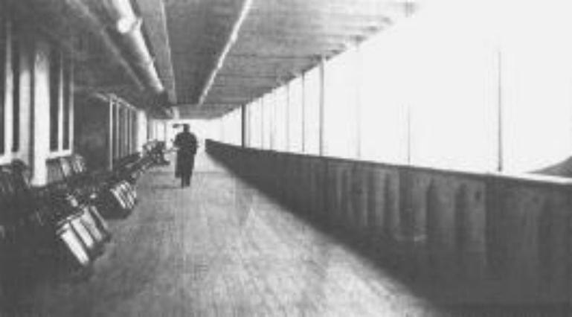

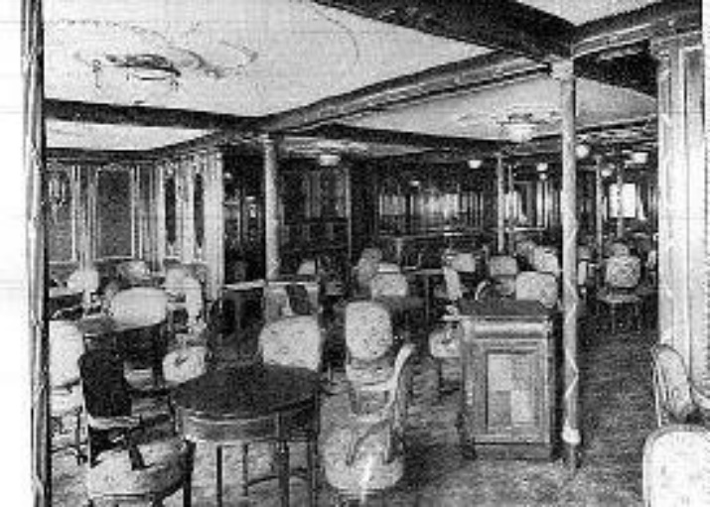

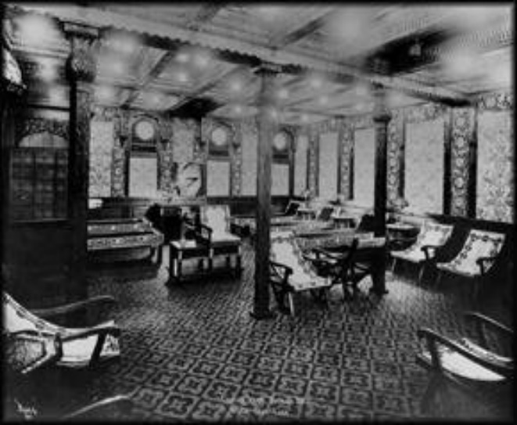

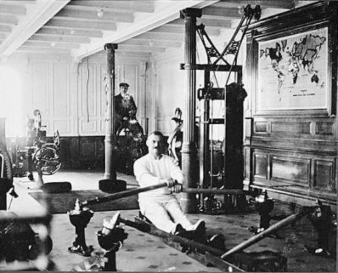

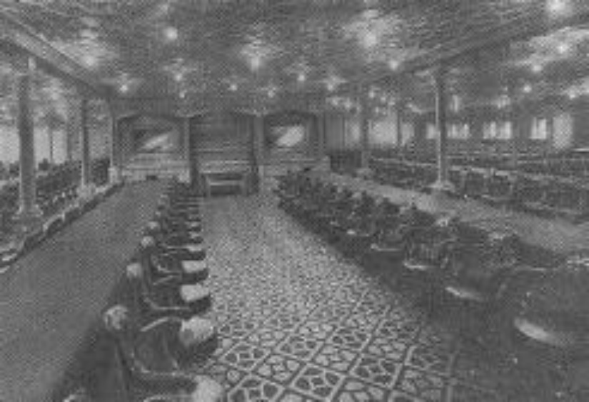

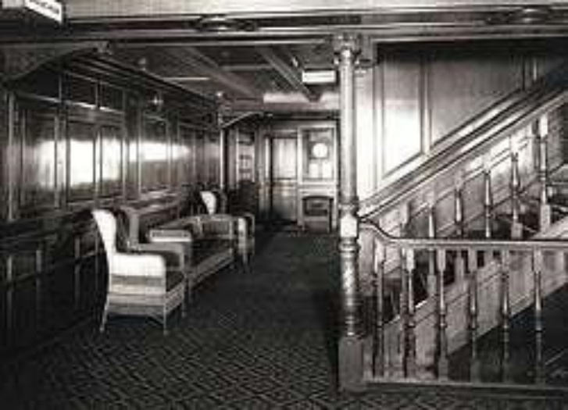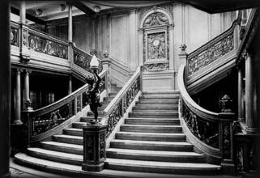

|  |
| --- |
| What do you notice? |

**Task 2 – People on board the Titanic**

Look through the information (there is LOTS – try your best to go through them) about the different people on board the Titanic. How can you categorise them into first, second and third class? Also, think about what they people have in common and what differences they have. Use this information to fill the Venn diagram on the page that follows:

**JOHN JACOB ASTOR**

The richest passenger aboard was multi-millionaire John Jacob Astor. He was travelling with his second wife, Madeleine, who was five months pregnant. JJ Astor did not survive but his wife did.

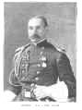

**BENJAMIN GUGGENHEIM**

Millionaire Benjamin Guggenheim was travelling on the Titanic with a lady friend. His wife and family were at home in New York. Guggenheim and his manservant helped women and children into lifeboats. When all the boats had gone they changed into their best clothes and prepared to "Die like gentlemen."

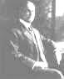

### SIR COSMO & LADY DUFF GORDON Lady Duff Gordon was a notable dress designer whose clientele included Isadora Duncan, Oscar Wilde and the British royal family. The Duff Gordons both survived but were called to testify at the court of inquiry and explain why their boat contained only twelve people. During the inquiry they were accused and cleared of bribing crew members not to allow more people into the boat.

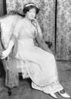

### THE ‘UNSINKABLE’ MOLLY BROWN

Molly was the daughter of a poor Irish immigrant family whose husband struck rich when mining for silver. She was travelling home to America aboard the Titanic. She survived the disaster in lifeboat number 6 and earned her nickname because she took control of the boat, kept the women rowing for seven hours and gave her furs to keep others warm.

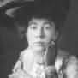

### A first class parlour suite cost £870 while a first class berth cost £30.

### There were 325 first class passengers on board - 175 men, 144 women and 6 children

### 202 first class passengers survived - 57 men, 140 women and 5 children

### LAWRENCE BEESLEY

Lawrence Beesley was a public school teacher travelling to America for a holiday. He survived the disaster in lifeboat 17 and was one of the first people to publish an account of the sinking and rescue

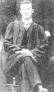

### EVA HART

Seven year old Eva Hart was travelling to America with her parents. Eva's mother had a premonition and refused to sleep at night during the voyage. Eva and her mother were saved in lifeboat 14. Eva never saw her father again.

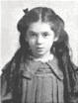

### JUOZAS MONTVILA & THOMAS BYLES

These two men were Roman Catholic priests who conducted services for second class passengers. After the sinking they both helped other passengers to safety, heard confessions and prayed. Both died in the tragedy.

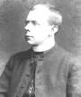

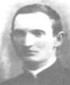

**A second class ticket cost about £13**

### There were 285 second class passengers on board - 168 men, 93 women and 24 children

### 118 second class passengers survived the disaster - 14 men, 80 women and 24 children

### SWEDISH

 There were about 26 Swedish passengers on board the Titanic most of whom were travelling third class. Many did not reach their destination. Mrs Hjalmar Sandstr, (Agnes Charlotta Bengtsson ) was travelling with her two daughters. They all survived the disaster in lifeboat 13.

### IRISH

There were around 120 Irish passengers on the Titanic most of whom were emigrants hoping for a better life in America. Most of them did not make it. However, Anna Kelly who had gone up on deck to investigate what had happened, survived in lifeboat 16. She later became a nun.

### BELGIANS

 There were 24 Belgians on board the Titanic, 23 in third class. Two lucky Belgians, Emma Duyvejonck and Henri Van der Steen were turned away at Southampton. Only 4 Belgians, all men, survived the disaster.

### FINNISH

 There were 63 Finnish passengers on the Titanic of whom only 20 survived. Mathilda Backstr was travelling to New York with her husband and brothers. She survived in one of the last lifeboats to leave - collapsible D. Her husband and brothers died.

**A second class ticket cost between £3 & £8**

### There were 706 third class passengers on board - 462 men, 165 women and 79 children

### 178 third class passengers survived the disaster - 75 men, 76 women and 27 children

### CAPTAIN EDWARD JOHN SMITH

 Monthly wage £105. The maiden voyage of the Titanic was to be 62 year old Captain Smith's last voyage before he retired. Smith was married with a young daughter. Very little is known about his actions on the Titanic after the collision - he was last seen on the bridge of the sinking ship. Captain Smith went down with his ship and his body was never recovered.

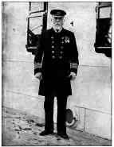

### CHIEF OFFICER HENRY WILDE

Monthly wage £25. Henry Wilde was serving as Chief Officer on the Olympic but was transferred to the Titanic for her maiden voyage. Wilde was off duty when the ship hit the iceberg. He took control of the even numbered lifeboats and was last seen trying to free the collapsible lifeboats. Wilde's body has never been recovered.

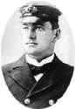

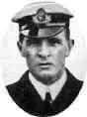

### FIRST OFFICER WILLIAM MURDOCH

William Murdoch, 39 years old, had served on a number of White Star ships. He joined the Titanic as first officer and was on the bridge at the time of the collision and gave the order to turn the ship. He helped to load women and children into the lifeboats. He did not survive the disaster and his body was not recovered.

### SECOND OFFICER CHARLES LIGHTOLLER

Charles Lightoller began his sailing career at the age of 13 and had been involved in a shipwreck before. Lightoller was keen to load the lifeboats as quickly as possible and was still trying to free the collapsible lifeboats when Titanic sank. He was sucked under the sea but blown to the surface by air escaping from a vent. He managed to climb onto the overturned collapsible lifeboat B. He survived the disaster and as the most senior surviving officer testified at both inquiries.

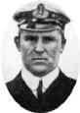

### THIRD OFFICER HERBERT PITMAN

Herbert Pitman was in his bunk when Titanic hit the iceberg. After helping to uncover lifeboats he was put in charge of lifeboat number 5 by William Murdoch. After Titanic had sunk, Pitman wanted to return for more passengers but others in the boat persuaded him that they would swamp the boat and they would all die. Pitman was called to give evidence during the inquiry into the disaster.

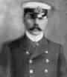

### FOURTH OFFICER JOSEPH BOXALL

Joseph Boxall, aged 28, had been at sea for 13 years. After the collision Boxall helped to fire the distress rockets and to signal the nearby ship with a morse code lamp. Boxall was put in charge of lifeboat number 2 and like Pitman was persuaded not to return for more survivors after the ship had sunk. Boxall also gave evidence at the inquiry.

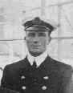

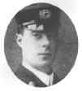

### FIFTH OFFICER HAROLD LOWE

Lowe was fast asleep when the Titanic hit the iceberg. When he eventually woke the ship was already at an angle. Lowe helped to load women and children into the lifeboats and took charge of lifeboat 14. After the cries and screams from the water had died down, Lowe put passengers from his lifeboat into others nearby before returning to pick up survivors. Lowe only found 4 people alive and one died before being rescued by the Carpathia.

**Radio Operators Jack Phillips and Harold Bride**

Monthly wage £2.2s.6d. The two radio operators' received 7 iceberg warnings from other ships on the 14th of April. After the collision they were asked to send the distress signal CQD (Come Quick Disaster). The signal was changed to the new distress code SOS. After contacting the Carpathia both operators stayed at their post until water poured into the Marconi room. Bride survived by climbing onto the overturned hull of collapsible B. Phillips also reached collapsible B but died before dawn.

**BANDSMEN**

Monthly wage £4.00

 There were two bands on the Titanic. After the collision they grouped on the deck and played to keep the spirits of the passengers up. Some survivors state that the band played until the end and many claim that the hymn 'Nearer my God to thee' was the last song played. None of the bandsmen survived.

1st Class

2nd Class

3rd Class

**Task 3 – Britain in the 20th century**

From what you have learned about the Titanic so far, what inferences or assumptions can you make about Britain at the start of the 20th century? Try to give five:

1. ________________________________________________________________
2. ________________________________________________________________
3. ________________________________________________________________
4. ________________________________________________________________
5. ________________________________________________________________

**Lesson 5 – Why can’t you always save everyone?**

**Task 1 – Statistics**

Look at the statistics below. In the space underneath, write down what you notice and any questions you have:

|  |  |  |  |  |  |  |  |  |
| --- | --- | --- | --- | --- | --- | --- | --- | --- |
| ​ | 1st Class On Board​ | 1st Class Survived​ | 2nd Class On Board​ | 2nd Class Survived​ | 3rd Class On Board​ | 3rd Class Survived​ | Crew on board​ | Crew Survived​ |
| Men​ | 175​ | 57​ | 168​ | 14​ | 462​ | 75​ | ​ | 192​ |
| Women​ | 144​ | 140​ | 93​ | 80​ | 165​ | 76​ | ​ | 23​ |
| Children​ | 6​ | 6​ | 24​ | 24​ | 79​ | 27​ | ​ | ​ |
| Total​ | 325​ | 202​ | 285​ | 118​ | 706​ | 178​ | 913​ | 215​ |
| ​ | | | | | | | | |
| ​ | Total Passengers = 1316​ | | | ​ | Total Crew = 913​ | | | ​ |
| ​ | Total Survived = 498​ | | | ​ | Total Survived = 215​ | | | ​ |
| ​ | Total On Board Titanic = 2229​ | | | | | | | ​ |
| ​ | Total Survivors = 713​ | | | | | | | ​ |

|  |  |
| --- | --- |
| What do you notice? | What questions do you have? |
|  |  |

**Task 2 – Why did so many people die on the Titanic?**

Using the boxes on the next pages, categorise them into one of the four reasons:

1. The White Star Line cared more about money than they cared about people.
2. Riche people did not care about poor people.
3. The crew did not do enough to save people.
4. The ship was badly designed.

The nearest ship to Titanic at the time was called The Californian.

The Californian turned its radio off at 11.15 so did not hear Titanic’s distress messages.

3rd class passengers were locked below deck as the ship began to sink so that 1st class passengers could be put into the lifeboats first.

There were 325 first class passengers on board Titanic. 202 of them survived.

There were 285 2nd class passengers on board Titanic. 118 of them survived.

There were 706 3rd class passengers on board Titanic. 178 of them survived.

The crew of Titanic were in charge of putting people into lifeboats. They were worried that they might not be able to lower full lifeboats into the sea safely.

Titanic was originally designed to carry 32 lifeboats but the owners believed that this would make the first class deck too cluttered so they lowered the number to 20

People believed that Titanic was unsinkable.

Titanic had 20 lifeboats on board, enough for 1,178 people.

Regulations about how many lifeboats should be on each passenger ship had not been updated since 1896.

The Californian saw the distress flares from Titanic but they thought they were just having a party.

3,000,000 rivets holding Titanic together were found to be made out of a poor quality of iron.

Captain Smith was due to retire after this voyage. He wanted to set a new world record by travelling to New York in the fastest ever time.

Captain Smith ignored the iceberg warnings that he received – they were very common at that time of year – so he did not slow Titanic down.

Crew on board Titanic thought they saw a ship in the distance around the time they hit the iceberg. They therefore believed that a ship would arrive to help quickly.

The Californian did not respond to Titanic’s distress signal.

Lifeboats were not filled to capacity before they were lowered into the sea – for example lifeboat number 6 was designed to hold 65 people but it left with only 40 on board.

Weak rivets can break apart more easily than those made out of stronger material.

The White Star Line wanted to attract more passengers, therefore they were keen for the voyage to be completed in 6 days so that they had the fastest ship.

Bruce Ismay, the Managing Director of the White Star Line was on board Titanic for its maiden voyage.

Titanic had 16 watertight compartments. If 4 of these filled with water the shop could stay afloat. If any more filled with water than the ship would definitely sink.

The 16 watertight compartments on Titanic did not reach as high as they were meant to on the first design.

White Star Line would not allow the watertight compartments to reach as high as they were meant to because this would make the 1st class compartments smaller.

**Task 3 – PEA Paragraph**

Using the information above about why so many people on board the Titanic died, you are to write a PEA paragraph explaining which reason you think was the most to blame:

|  |  |
| --- | --- |
| POINT  *State argument* | The reason why so many people died on board the Titanic was _________ _______________________________________________________. |
| EVIDENCE  *Support your point with numerous pieces of evidence in the hexagons.* | This is because ____________________________________________ ________________________________________________________ ________________________________________________________ ________________________________________________________ ________________________________________________________ ________________________________________________________ ________________________________________________________ ________________________________________________________ ________________________________________________________  ________________________________________________________ ________________________________________________________ |
| ANALYSIS  *Why do you think this reason was more the blame than the other factors?* | This reason is the most important and more to blame than other factors as to why so many people died on board the Titanic because _____________ ________________________________________________________ ________________________________________________________ ________________________________________________________ ________________________________________________________ ________________________________________________________ ________________________________________________________ ________________________________________________________ ________________________________________________________ ________________________________________________________ ________________________________________________________ |

With this information in mind, do you think people in Britain today are treated differently depending on how much money they have?  
____________________________________________________________________________________________________________________________________________________________________________________________________________________________________________________________________________________

**Lesson 6 – How can you get people to give you what you want?**

At the beginning of the 20th century, women could not vote to decide who would run the country, nor could many men. Many women wanted to change this and formed groups dedicated to winning the vote. These groups sometimes had very different ideas about the best way to get what they wanted.

Draw picture on the right hand side of your page that best represents the information on the left hand side. Underneath, explain how effective you think this person, event or organisation was in helping women get the vote.

|  |  |
| --- | --- |
| **MILLICENT FAWCETT**  Millicent Fawcett formed the National Union of Women’s Suffrage Societies (NUWSS) in 1897.  She believed in peaceful protest and felt that any violence or trouble would persuade men that women could not be trusted to have the right to vote. Her plan to get the vote was to use patience and logical arguments. Fawcett argued that women held responsible posts in society and had to pay taxes if they worked, just like men had to, and she argued that if parliament made laws which women had to obey, then women should be part of the process of making those laws. Fawcett converted some MPs (members of Parliament) and got their support but most men in Parliament believed that women simply would not understand how Parliament worked and therefore should not be able to vote.  Despite this, Fawcett was very respected by many. |  |
| How important do you think Fawcett was in helping women get the vote? | |
| **EMMELINE PANHKURST**  Emmeline Pankhurst formed the Womens Social & Political Union (WSPU) in 1903 – the women in this movement became known as suffragettes.  She was angry that women had not been given the right to vote and she was prepared to use violence to help get what she wanted, the WSPU motto was ‘Deeds, not words.’  Members of the WSPU undertook many violent acts in the early 20th century – they burned down churches because the Church of England was thought to be against women having the vote and they vandalised places such as Oxford Street where they smashed shop windows.  They also chained themselves to the railings outside Buckingham Palace and attacked politicians as they went to work in the House of Commons.  Some also refused to pay their taxes.  Suffragettes were prepared to go to jail if necessary and would even refuse to pay fines sometimes so that they had to be sent to jail instead. |  |
| How important do you think Pankhurst was in helping women get the vote? | |
| **HUNGER STRIKES**  Many suffragettes were sent to prison for the violent acts they carried out.  In prison they would go on hunger strike which meant refusing to eat anything at all in protest at how they were being treated.  This was a real problem for the government because it would look very bad for them if these wealthy, well-educated women died in prison.  At first prison guards were told to force feed women but this was a really painful and unpleasant process and it caused a huge public outcry.  So the government introduced the Cat and Mouse Act instead – women were sent to prison where they went on hunger strike.  No-one force fed them so they got weaker and weaker.  When they were very ill they were released from prison, but they were unable to take part in any violent protests because they were too weak.  Once they had recovered from the hunger strike they would be arrested again for a really small thing and put back into prison. |  |
| How effective do you think Hunger Strikes were in helping women get the vote? | |
| **NUWSS**  The NUWSS (National Union of Women’s Suffrage Societies) were a group of women who wanted the vote and believed that they should try to get it using peaceful methods.  They campaigned by writing letters to MPs, holding public meetings to raise awareness, sending petitions to the government and holding peaceful demonstrations.  In 1908 they were invited to talk to the Prime Minister and in 1910 they sent a petition to Parliament with 280,000 signatures on it of people who supported women gaining the vote.  The NUWSS had a lot of success, for example they had 500 local branches which gained them the support of a lot of MPs and the violent protests of other women actually made a lot more people join the peaceful NUWSS. By the outbreak of World War I in 1914 the NUWSS had persuaded half of all the MPs in Parliament to support giving women the vote. |  |
| How important do you think the NUWSS were in helping women get the vote? | |
| **BLACK FRIDAY**  In 1910 there was a general election to decide which political party would run the country.  The suffragettes wanted to make sure that women’s getting the vote was an important issue in the election.  They organised a march to the Houses of Parliament to get lots of publicity.  The march was peaceful until, near to Parliament, they found a big group of policemen waiting for them.  As the women tried to march forwards, the police pushed them back and the encounter became violent.  The women refused to give in and kept moving forward but they were pushed to the ground by the policemen and some were beaten, trampled on and had limbs dislocated.  At the end of the demonstration over 100 women had been arrested and were sent to jail.  The following day a photograph of a woman thrown to the floor was published in a newspaper under the headline ‘Black Friday’. |  |
| How important do you think the events of Black Friday were in helping women get the vote? | |
| **FIRST WORLD WAR 1914-1918**  When war was declared, most women realised that it was more important to support their country than continue to fight for the vote.  The WSPU made a deal with the British government agreeing that if all suffragettes were released from prison (about 1,000 women) they would stop their violent protests while the war was on.  During the war so many men went away to fight that for the first time ever large numbers of women had to go out to work.  This played a vital role in Britain winning the war as women worked in munitions factories making the weapons that men needed to fight.  After the war some women were given the right to vote and this is usually seen as being a reward for their contribution to the war effort – not just in going out to work but because so many of their sons were killed in the fighting. |  |
| How important do you think the First World War was in helping women get the vote? | |

When do you think women would have been **most** likely to have support for getting the vote?  
_______________________________________________________________________________________________________________________________________________________________________________________________________________  
  
When do you think women would have been **least** likely to have support for getting the vote?

__________________________________________________________________________________________________________________________________________  
_____________________________________________________________________

**Lesson 7 – How do you know whether something is deliberate?**

**Task 1 – Video clip**

Watch the video clip (<https://www.youtube.com/watch?v=-W_URTWjgR0>) and answer the questions below:

|  |
| --- |
| What happened to Emily Wilding Davison? |
| What evidence is presented that suggests her death was intentional (that she deliberately wanted to die?) |
| What evidence is presented that suggests her death was accidental? |

**Task 2 – Source work**

Using the sources on the next page, complete the table below, filling it with information that either suggests that Davison’s death was deliberate or accidental.

|  |  |
| --- | --- |
| Accidental death | Deliberate death |
|  |  |

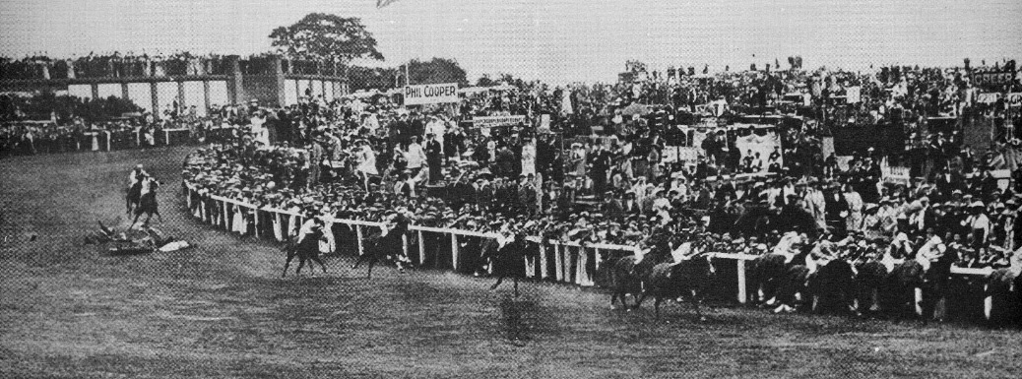

**Source A**: Emily Davison is fatally injured after being trampled by Anmer. Pictures show that Davidson ran onto the course and stood sideways waiting for the Kings horse to come by.

**Source B:** The Police found the following items on Miss Davison’s person:

1. A return ticket from Epsom to London
2. A ticket to a Suffragette event later that day
3. A race card which she had marked up showing which horses she expected to win.
4. Two enormous Suffragette banners pinned to the inside of her jacket

**Source C:** In previous weeks Emily Davison had been seen stopping horses on the common in her home town of Morpeth and pinning Suffragette pennants to them

**Source D    Emmeline Pankhurst ‘My Own Story’ (1914)**

Miss Davison went to the races at Epson, and breaking through the barriers which separated the vast crowds from the course, rushed in the path of the galloping horses and caught the bridle of the King’s horse, which was leading the others. The horse fell, throwing the jockey and crushing Miss Davison in such a shocking way that she was carried from the course in a dying condition. She died four days later. Members of the Union were beside her bed when she breathed her last. On June 14th she had a great public funeral as crowds lined the streets watching the funeral car followed by thousands of women.

Emily Davison had graduated from Oxford University with a first class degree, yet she chose to join the struggle to get women the vote. She suffered many imprisonments and was forcibly fed. She barricaded herself in her cell and could only be taken from the door as icy water was hosed in from outside. **She believed the vote for women would only arrive when someone sacrificed their life**. On one occasion she threw herself headlong from the balcony in prison and gained cruel injuries.

Which source do you think is **most** reliable/trustworthy? Why?

_________________________________________________________________________________________________________________________________________________________________________________________________________________________________________________________________________________________________________________________________________________________

Which source do you think is **least** reliable or trustworthy? Why?

_________________________________________________________________________________________________________________________________________________________________________________________________________________________________________________________________________________________________________________________________________________________

Overall, do you think Emily Davison intended to kill herself on Derby day? Why do you have that opinion?

__________________________________________________________________________________________________________________________________________________________________________________________________________________________________________________________________________________________________________________________________________________________________________________________________________________________________________________________________________________________________________________________________________________________________________________________________________________________________________________________________________________________________________________

Below are four statements about Emily Davison. Which one do you agree with the most and why?

Emily Davison’s death was the fault of the British government

Emily Davison behaved foolishly

Emily Davison was a brave woman

Emily Davison was a terrorist

____________________________________________________________________________________________________________________________________________________________________________________________________________________________________________________________________________________

**Lesson 8 – How can you tell whether people are equal?**

**Task 1 – ‘Women are still not equal to men in Britain today’**

How can you measure whether this statement is true? Try and think of as many questions as you can in the space below:

|  |
| --- |
|  |

**Task 2 – Continuum plotting**

Below in the boxes is information about the equality of women in Britain today. You are to read through the information and plot the boxes on the continuum that follows the information. This will then help you make a judgement on whether women are equal to men in Britain today.

1928 EQUAL FRANCHISE ACT

This gave women the same right to vote as men have.

1970 EQUAL PAY ACT

This made it illegal to pay men & women different amounts of money for doing the same job.

The rising number of female doctors is "bad for medicine", and universities should recruit more men, a GP warns.

*(BBC Website, April 2008)*

In 2018 the World Economic Forum said it would take 217 years for differences in the pay and employment opportunities of men and women to end.

Of 100 highest paid consultants (doctors) across England, only five are women

From an article in ‘The Independent’ newspaper – Feb 2018

June 2018 - it was reported Harry Kane, captain of the male England football team would be earning £200,000 a wk before bonuses.

Aug 2016 - it was reported Steph Houghton, captain of the female England football team was earning £65,00 a yr.

UK gender pay gap narrows to lowest for 20 years – but is still 9.1%

Headline from ‘The Guardian’ newspaper – Oct 2017

At the start of the recession the UK from 2010 to 2011, 4.5% women lost their jobs compared to 3% of men.

Almost eight in 10 companies and public-sector bodies pay men more than women it was revealed.

(The Guardian newspaper - 2018)

In 2016, the UK came 15th out of 144 countries for gender gap. (Research based on economic, health, education and political indicators). In 2006, it was ranked 9th.

A 2016 [study](http://visual.ons.gov.uk/the-value-of-your-unpaid-work/) found that women did almost 40% more chores around the home whilst men offered more in terms of transport i.e. driving family members

In 2018, the total UK prison population was 83,620.

Men= 79,750 Women= 3,870 Men are 22 times as likely as women to be imprisoned.

The only 2 women on the list of top 10 richest people in the UK in 2018 (one was on the list with her brother).

Men are entitled to 2 weeks of paid paternity leave if their partner has a baby. Women are entitled to up to 1 year’s paid maternity leave. From 2015, parents have been allowed to share this leave.

Margaret Thatcher and Theresa May are the only 2 females to have been Prime Minister of Britain.

There are 650 MPs in Parliament. 208 of these are women (approx. 32%)

(2018)

99% if women in the UK can read & write compared to 98% of men.

Life expectancy in the UK is 79 years old for men & 82 years old for women.

(2017 figures)

85% of men do DIY around the house compared to about 50% of women.

An official report in 2016 said when it came to housework, women were doing almost 40% more than men on average. Men = 16 hrs a wk. Women =26 hrs week

How equal are women in the UK today compared to men?

No improvement

at all

Total   
improvement

**Lesson 9 – Is progress always a good thing?**

**Task 1 – How did warfare change over the 20th century?**

Below are four video clips about different styles of fighting in the 20th century. For each video, write down the different methods of fighting you see.

|  |  |
| --- | --- |
| World War One <https://www.youtube.com/watch?v=P92guhd7d-8> | World War Two  <https://www.youtube.com/watch?v=0wg5x5WaZPo> |
| Atomic Bomb <https://www.youtube.com/watch?v=L434sdb74eY> | Iraq War   <https://www.youtube.com/watch?v=0yr-LaMhvro> |

**Task 2 – Is progress in weapons good?**  
Was progress in warfare during the 20th century a good thing? Answer this question in exactly 16 words  
__________________________________________________________________________________________________________________________________________

**Lesson 10 – Does having a weapon make you safer?**

**Task 1 – Attitudes to weapons**

Taking on the role of news reporters in three different, fictional countries, you are going to write a short report to show how each country would react as the news comes in. What will your country do? How do you and the other citizens feel?

|  |  |  |  |  |
| --- | --- | --- | --- | --- |
| Newsflash | Panem | Genovia | Atlantis | Freedonia |
| **2021**  Panem has developed a brand new weapon called the Desrtoinator. It is the most powerful, destructive bomb ever made. They have already used it to destroy the cities of their enemies. They don’t want anyone else to know how to make this weapon but they are good friends with Genovia so they are going to tell them. They are DEFINTELY NOT going to tell Atlantis or Freedonia as they are enemies. |  |  |  |  |
| **2023**  Panem and Atlantis have been getting on less and less in the last few years. Many people are worried that they might actually go to war and Atlantis has just developed their own Destroyinator. They have successfully tested it in a desert and it works perfectly. |  |  |  |  |
| **2025**  Panem and Atlantis have still not gone to war, but they really do still dislike each other. Panem have just developed an even better version of the Destroyinator, called the even-more-destroying-anator. Its much smaller than the original bomb but its 2,000 times more powerful. |  |  |  |  |

Does developing new weapons make the world a safer place? Do you agree or disagree – if so, why?

__________________________________________________________________________________________________________________________________________________________________________________________________________________________________________________________________________________________________________________________________________________________________________________________________________________________________________________________________________________________________________________________________________________________________________________________________________________________________________________________________________________________________________________

Do you think changes in warfare have made Britain a better place? Why?

_________________________________________________________________________________________________________________________________________________________________________________________________________________________________________________________________________________________________________________________________________________________