Year 8 History Study Guide
• The British Empire •

Lesson 1 – What makes a country great?
Task 1 – How did Britain take over so much of the world?
Read the information below and answer the questions on the following page.
The British Empire comprised the territories ruled by the United Kingdom. It started with the overseas colonies (land captured) and trading posts established by England in the late 16th and early 17th centuries. By 1815 Britain, France, Russia, Ottoman Turkey and China were seen as the worlds’ great imperial powers (have lots of land overseas). In 1805 Britain’s navy had secured her global supremacy at sea and this would prove very valuable in gaining and maintaining overseas colonies (land captured overseas). Overseas colonies would provide markets to trade and valuable raw materials.
At its height, it was the largest empire in history and, for over a century, was the biggest global power. By 1922 the British Empire had about 458 million people living in its empire, one-quarter of the world's population at the time and covered more than 33,700,000 km² (13,012,000 sq miles), almost a quarter of the Earth's total land area. It was said at its peak that “the sun never sets on the British Empire” as it had so many areas overseas.
Beyond the 'British Isles', Britain's empire consisted of very different areas.

British Empire at its most powerful:
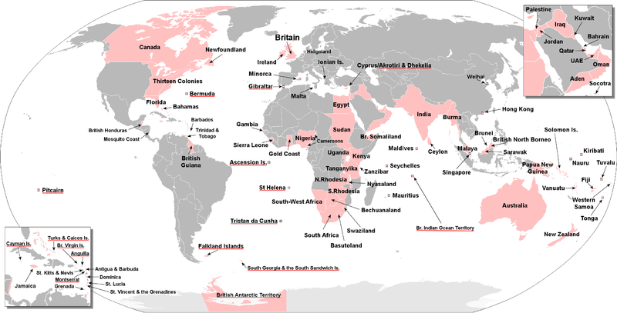

British Empire questions
What was the British Empire?
______________________________________________________________________________________________________________________
What is a colony?
______________________________________________________________________________________________________________________
Why was Britain able to capture so many colonies?
____________________________________________________________________________________________________________________________________________________________________________________________________________________________________________
Why was Britain interested in colonies oversea?
____________________________________________________________________________________________________________________________________________________________________________________________________________________________________________
How could it be argued that Britain was successful in its Empire?
__________________________________________________________________________________________________________________________________________________________________________________________________________________________________________________________________________________________________________________________________________________________________
Predict what problems Britain may have experienced in keeping her Empire.
__________________________________________________________________________________________________________________________________________________________________________________________________________________________________________________________________________________________________________________________________________________________________

Task 2 – Territories of the British Empire
On the left hand side of you page, read through the information on each of the territories taken over by the British Empire. On the right hand side, you are to complete the triangle, writing down when that particular territory was taken over, how it was taken over and why that land/territory was valuable.
West Indies
Value?
When?
How?
How?
When?
Value?
North
America
North America
British colonization of the Americas began in 1607 in Jamestown, Virginia. England also took over the Dutch colony of New Netherland which was renamed the Province of New York in 1664.
Relations between the colonists (British) and native Americans varied from actively trading to armed conflict. Trade with native Americans was an important part of British colonial policy. Slaves were brought over from Africa and sold to plantation owners in North America, traders then bought goods (sugar and cotton) to take back to Britain. It was called triangular trade.
West Indies
Settlements were successfully established in St. Kitts (1624), Barbados (1627) and Nevis (1628). The colonies soon adopted the system of sugar plantations which depended on slave labour, to sell the slaves and buy the sugar. Slaves were brought over from Africa and sold to plantation owners in the West Indies, traders then bought goods (sugar and cotton) to take back to Britain. It was called triangular trade.
In 1655, England took over the island of Jamaica from the Spanish, and in 1666 succeeded in colonising the Bahamas.

Africa
Between 1800 and 1900 most of Africa was controlled by different European powers. Britain took over 16 colonies including Egypt, the Sudan, Nigeria and Rhodesia.
Since ancient times slaves had been bought and sold in Africa however when the white Europeans joined in the slave trade changed dramatically. They wanted to make their slaves work in the new lands of America and the West Indies. The British traders made friends with the African chiefs then they took goods (cloth, metal, guns, gunpowder and alcohol) to Africa. In exchange for these goods they bought men, women and children from Africa as slaves. These British traders then took the slaves to the West Indies and North America to be sold. Slaves would often work on plantations growing sugar and cotton working and living in awful conditions with no rights of their own. With the money gained the British traders then bought goods such as tobacco and sugar to sell back in Britain. This was called triangular trade.
When?
How?
Value?
Africa

Canada
Great Britain acquired part of Canada in 1759. Cattle and wheat production made this a very prosperous area and many Britons emigrated (moved) to Canada.
Value?
In the north, the Hudson's Bay Company actively traded for fur with the indigenous peoples.
Canada
The colonies of Vancouver Island, founded in 1849, and the Colony of British Columbia, founded in 1858, were combined in 1866 with the name Crown Colony of British Columbia until joining Confederation in 1871.
When?
How?
In 1867, the colonies of New Brunswick, Nova Scotia, and the Province of Canada (the southern portion of modern-day Ontario and Quebec) combined to form a self-governing dominion, named Canada, within the British Empire.
India
How?
When?
Value?
Britain gradually took control of India and it was to become in the 19th century the main example of the strength, power and trade of the British Empire. By 1820 more sub areas of India had been overtaken by the British.
India
The expansion continued and in 1857 the Indians tried to stop the British but the revolt was put down. By 1900 India was firmly under Britain’s control. Britain gained many things from India, such as cheap goods (cotton), taxes and even soldiers for the British army. India was called Britain’s ‘Jewel in the Crown’ for all it provided Britain with – money, trade and power.
Australia/New Zealand
Captain Cook sailed in his ship The Endeavour and discovered New Zealand and Australia. With only one ship Cook had put more than 5,000 miles of previously unknown coastline on the map.
The British used Australia as a convict colony from 1788-1852. Convicts outnumbered free settlers until 1830. Farming prospered and in 1851 gold was discovered. Emigration from Britain increased; by 1914 Australia had a population of 5 million people and 100 million sheep.
New Zealand became a British colony in 1840. Farming prospered there too. Cheap meat and wool was exported from Australia and New Zealand to Britain.

How?
When?
Value?
Australia/NZ
Task 3 – Reflection
Thinking about the information covered, which statement do you agree with most and why?

‘Britain was great because it controlled so much territory across the world’
or
‘Britain wasn’t really great as those territories never really belonged to them’

_______________________________________________________________________________________________________________________________________________________________________________________________________________________________________________________________________________________________________________________________________________________________________________________________________________________________________________________________________________________________________________________________________________________________________________________________________________________________________________________________________________________________________________________________________________________________________________________________________________________________________________________________________________________________________________________________________________________________________________________________________________

Lesson 2 – What is happiness?
Task 1 – Important India
Read the information below about India and the British Empire – using three different colours, identify the three benefits India provided for the Empire:
- Economic
- Military
- Power/prestige

British Empire and India
Britain gradually took control of India. Robert Clive gained Bengal from the French with a private army of the East India Company. Many of the employees in this company lived in luxury and took fortunes in wages and bribes. At the start of the 18th century cloth woven by Indian weavers was being imported into Britain in huge quantities to supply a worldwide demand for cheap, washable, lightweight fabrics for dresses and furnishings. The Company's main settlements, Bombay, Madras and Calcutta were established in the Indian provinces where cotton textiles for export were most readily available. Gradually the British government took over the powers of the company. In 1857 there was a rebellion started by Indians in the British Army, it was soon put down and control over India tightened.
British Raj was the British rule in the Indian subcontinent between 1858 and 1947. After 1876, the country was officially called the Indian Empire and issued passports under that name.
The Raj began in 1858, when the rule of the British East India Company was transferred to the Crown, and lasted until 1947, when the British Indian Empire was partitioned into two sovereign states, India and the Pakistan. Britain built itself a large base of men and their families with experience or connections in India. Winston Churchill, who knew little about India except that without it the great British Empire would fail.
Mohandas Karamchand Gandhi was an Indian lawyer who was educated in England, worked in South Africa and returned to India in 1915. He struggled for independence encouraging the use of non-violent resistance to British rule. Gandhi is often referred to as Mahatma. Gandhi led nationwide campaigns for easing poverty and expanding women's rights. He wanted India to be free from foreign domination. Gandhi famously led Indians in protesting against the British-imposed salt tax with the Dandi Salt March in 1930, and later in calling for the British to Quit India in 1942. In his struggle for better rights and Indian independence he was imprisoned for many years.

In 20 words, summarise why India was so important to the British Empire.
_________________________________________________________________________________________________________________________________________________________________________________________________________________________________

Task 2 – How positive was British rule in India?
Below are a number of sources on British rule in India. Read through the sources and then place them on the ripple graph that follows the sources.

Source 1
The British built roads and roads across India promoting trade and communication links. Schools and postal systems were set up with the hope of educating the Indian population in the way of English life. The better-off Indians were educated in English schools. They served in the British army or in the civil service.
Source 2
The Empire brought trading benefits to Britain as India provided raw materials such as cotton. India's huge population made it an attractive market for British industry. In the 1880s, for example, about 20% of Britain's total exports went to India. By 1910 these exports were worth £137 million. India also exported huge quantities of goods to Britain, especially tea.
Source 3
The Indian army was probably Britain's single greatest resource. This army was used by Britain all over the world, including the wars in South Africa in 1899-1902 and the First and Second World Wars. It was the backbone of the power of the British empire. In 1901, for example, the British viceroy (governor) of India, Lord Curzon, said 'As long as we rule India, we are the greatest power in the world. If we lose it we shall straightway drop to a third rate power'.

Source 4 Lace making in India
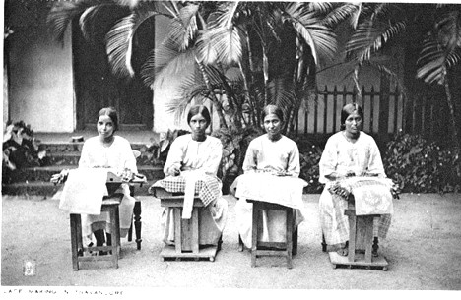

Source 5
Admirers of British rule point to the economic developments, the legal and administrative system, the fact that India became the centre of world politics…During this period a tiny number of British officials and troops (about 20,000 in all) ruled over 300 million Indians. This was often seen as evidence that most Indians accepted and even approved of British rule. There is no doubt that Britain could not have controlled India without the co-operation of Indian princes and local leaders, as well as huge numbers of Indian troops, police officers, civil servants etc.
National Archives website, accessed February 2012
Source 6 Indian and British army polo team
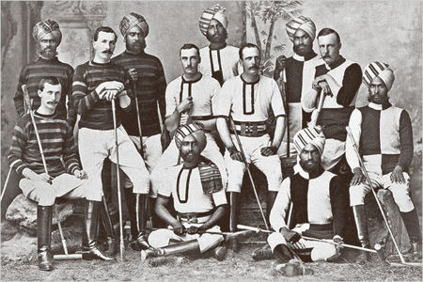
Source 7
Lord Dalhousie worked hard to improve the way the Indians lived. He took over land ruled badly by Indian princes and tried to get them to follow the British way of life.
Source 8
For most of the Nineteenth Century, India was ruled by the British. India was considered the jewel in the crown of the British Empire. Queen Victoria had been made Empress of India and the British had a major military presence in India.

Very positive
Not very positive

Lesson 3 – Is control always a good thing?
Task 1 – Indian control reflection
Using the sources and ripple chart from last lesson, how positive do you think British rule in India was?
____________________________________________________________________________________________________________________________________________________________________________________________________________________________________________________________________________________________________________

Task 2 – Negative aspects of British control in India

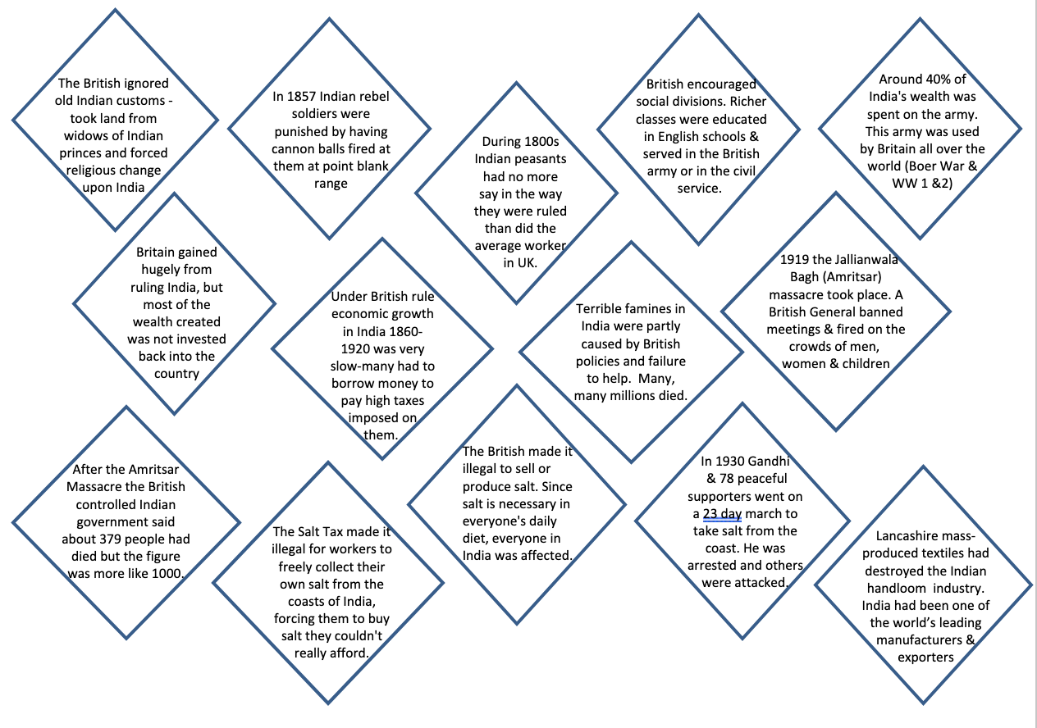
Using the negatives of British control in India, choose the nine worst acts carried out by the British and order them from worst to least worst in the diamond nine below. You will not be able to fit all of the words into the box, so think about how you can shorten the sentence down to a few words:

Task 3 – How negative was British control in India
Circle the number you think best fits how negative British control in India was, and explain your placing on the lines below:

1  Not  so  bad | 2 | 3 | 4 | 5 | 6 | 7 | 8 | 9 | 10  Absolutely  terrible

_______________________________________________________________________________________________________________________________________________________________________________________________________________________________________________________________________________________________________________________________________________________________________________________

Lesson 4 – Is freedom always a good thing?

Task 1 – Positive or negative?
Below is information of Indian independence. Read through the information in both columns, and at the bottom of the page, try and summarise the positives and negatives of Indian independence.

POSITIVE | NEGATIVE
After 1918, nationalism (wanting to be free from British rule) within India increased  Many MP’s in Britain were against the whole idea of giving India independence as it would break up the British Empire. The British took their time in giving India independence. This just made the Indian population want their independence even more. Different Indian leaders came together to try and put pressure on the British government.  Gandhi wanted peaceful non-violent refusal to follow British instructions whereas others were less willing to be peaceful. Soon talks of independence slowed down as discussions about what would happen to the Muslim and Hindu populations took over. Leaders such as Gandhi wanted Indian Muslims and Hindus to be united, others disagreed.  After WW2 the British PM wanted to try and solve the problem of Indian independence. He appointed Lord Mountbatten as a new viceroy in India to oversee independence. Mountbatten wanted to avoid any further religious battles and brought the date for independence forward. In August 1947 the Indian Independence Act was signed- it separated the Muslims into newly formed Pakistan and the Hindus into India. India was now free from foreign domination and allowed to rule themselves. | Many MP’s in Britain were against the whole idea of giving India independence as it would break up the British Empire. Britain’s power and reputation would be gone and its wealth would decline.  The British took their time in giving India independence and this annoyed Indian people who felt the British were deliberately delaying independence to keep their power. During this time many were killed (at the likes of the Amritsar Massacre), injured and imprisoned. This just made the relationship between the British and Indians become more tense. Indians at first felt excluded from any real discussions on independence.  Soon talks of independence slowed down as discussions about what would happen to the Muslim and Hindu populations took over. Leaders such as Gandhi wanted Indian Muslims and Hindus to be united, others disagreed.  After WW2 the British PM wanted to try and solve the problem of Indian independence. Violence broke out between the Muslims and Hindus and thousands were killed.  In August 1947 the Indian Independence Act was signed- it separated the Muslims into newly formed Pakistan and the Hindus into India. Thousands had to move from their homes to new areas depending on their religion. Tensions increased and violence broke out again. In the Punjab area it is thought that 250,000 were killed in clashes. Gandhi tried to fast (stopped eating) in order to get the 2 religions to get along. He was assassinated in 1948.
Summary | Summary
Task 2 – Who was most responsible for Indian independence?
Below, on the left hand side of your page, there is information about four key individuals who helped India gain independence. Fill in the gingerbread person with facts/images that represent the information.

Lord Mountbatten
Mountbatten was a British naval officer. He was appointed the last viceroy (in charge) of British India and first governor general of independent India.
Lord Mountbatten shared close links with the British royal family (his great grandmother was Queen Victoria and he himself was uncle to Prince Philip).
Mountbatten joined the Royal Navy in 1916 and saw action in World War One, then briefly attended Cambridge University for a year after the war.
In March 1947, Mountbatten became viceroy of India, his main task was to oversee the British withdrawal from India. He got on well with leading politicians, particularly with Jawaharlal Nehru, but he couldn’t convince the Muslim leader Mohammad Ali Jinnah that India should stay together after Britain had left (e.g Muslims and Hindus living together).
Mountbatten soon gave up hope of a united country and on 14-15 August 1947, British India was separated into the new states of India and Pakistan. There was lots of violence between the Hindus and Muslims. There were huge population movements as 3.5 million Hindus and Sikhs fled from the areas that had become Pakistan and around five million Muslims went to Pakistan.

Muhammed Jinnah
Jinnah is considered to be the founding father of Pakistan and was Muslim.
Jinnah joined the Indian National Congress (INC) but didn’t like the fact that it was filled with mainly Hindus. He didn’t support Gandhi's belief in the use of civil disobedience (refusal to do as you are told and not use violence).
In 1934, he left the INC and organised a rival to it - the Muslim League. In 1935, those Muslims who were in the INC joined Jinnah's Muslim League. Indian politicians were now separated by religion.
After elections in 1937 the split between the Muslim League and Congress became worse. It was a sign of the bad feeling and violence that would appear when India was divided into Pakistan and India in 1947.
In 1940, Jinnah called for the creation of an independent state to be called Pakistan in which Muslim could live away from Hindus. Jinnah supported the British in WW2 but Congress failed to support them, this meant the British may be happy to give Jinnah what he wanted.
At the end of World War 2 elections took place in India. The Muslim League did well in Muslim areas while Congress (mainly Hindus) did well in Hindu areas. Jinnah wanted a separate Pakistan for the Muslims and encouraged violence if necessary. Between 1945- 1947, many millions of Indians were killed in the violence as Muslims moved to the new Pakistan and Hindus moved into India.
In August 1947 Pakistan was created & he became Governor-General.

Jawaharlal Nehru
Nehru was an Indian nationalist leader (wanted freedom for India) and became the first prime minister of India in 1947.
Jawaharlal Nehru was educated in England, at Harrow School, and then at Cambridge. He studied Law and returned to India in 1912 where he practised law for some years.
In 1919, Nehru joined the Indian National Congress which was fighting for greater freedom from the British. He was very influenced by the organisation's leader Mohandas Gandhi. During the 1920s and 1930s Nehru was sent to prison many times by the British for civil disobedience (refusing to do what they wanted). In 1928, he was elected president of the Congress.
He played a big role in the talks about Indian independence. He was against the Muslim League’s idea to divide India into two – a section for the Muslims and a section for the Hindus. Louis Mountbatten, the last British viceroy argued the division was the best option and Nehru reluctantly (didn’t really want to but felt he had to) agreed.
On 15 August 1947, Nehru became the first prime minister of independent India
Mohandas Gandhi
Known as 'Mahatma' (great soul). Gandhi was the leader of the Indian nationalist movement (wanting India to be free from British rule). He believed in non-violent protest to help gain freedom.
Mohandas Gandhi was born on 2 October 1869. After university, he went to London to train as a lawyer. In 1893 he accepted a job at an Indian law firm in South Africa. Gandhi was shocked by the treatment of Indian immigrants there and he tried to gain better rights for them. During his 20 years in South Africa he was sent to prison many times.
Gandhi returned to India and started to protest about the way the Indian people were treated by the British. A peaceful demonstration against new British laws resulted in the Amritsar Massacre by British troops, lots of men, women and children were shot by British troops. By 1920, Gandhi was a big figure in Indian politics and became leader of the Indian National Congress (INC). He led a programme of peaceful non-cooperation with the British which included boycotts (refusing to buy) of British goods, leading to arrests of thousands.
In 1922, Gandhi was sentenced to 6 years' in prison. He was released after two years and he spent his time trying to improve relations between the Hindu and Muslim communities. In 1930, Gandhi led a protest at a tax on salt by the British, leading thousands on a 'March to the Sea' to make their own salt from seawater (banned by the British).
In 1934 Gandhi was replaced as leader of the INC by Jawaharlal Nehru.
In 1947 India stopped being controlled by the British and became two new independent states of India and Pakistan. New India would be Hindu and Pakistan would be Muslim. Tensions between Hindu and Muslim became so bad there was massive violence in the months before and after independence, many died. Gandhi was against the dividing of India and Pakistan. He hated seeing his country fight and fasted (refused to eat anything) in an attempt to bring calm across the country. On 30 January 1948, he was killed.

Who do you think was the most important person for Indian independence? Why?
__________________________________________________________________________________________________________________________________________________________________________________________________________________________________________________________________________________________________________________________________________________________________________________________________________________________________________________________________
Lesson 5 – What affects you the most?
Task 1 – Reflecting on the British Empire
Below are a number of statements relating to the effects of the British Empire on Britain and the rest of the world. Firstly, go through the statements, decide whether they are positive or negative, and then plot them on the ripple chart on the page after.
Tip – As there is a lot of information for you to plot, you might want to number the statements and plot the number on the ripple chart.

Money made from the slave trade was used in Britain to build magnificent public building such as museums, libraries and art galleries- these would be free for the British public to use | Mary Calvert worked to stop cruel customs in Fiji such as children’s fingers being cut off if their father stole anything. Or women being strangled as soon as their husbands died | Lord Dalhousie tried to stop the Indian custom of ‘suttee’ – a widow would burn herself to death on the funeral bonfire of their dead husbands. He also built roads and railways and set up a postal system | Some people in GB hated slavery (Anti-Slavery Society) and fought very hard to ban it (abolish). Slavery in the British Empire ended in 1833
Mary Calvert worked as a missionary in Fiji – she wanted to make the population Christian | Slaves used in sugar plantations were fed and housed | Some native populations were taught English and sent to schools funded by the British Empire | Native populations adopted some of the pastimes of the British such as cricket (India, South Africa and the West Indies)
Britain was the greatest power in the World – the rest of the world admired the amount of land they had and the navy they possessed | Edward Gibbon Wakefield suggested good, hard-working British families to settle in Australia and New Zealand to farm the land and trade with Britain | Native populations were taught about Christianity and many missionaries went to live in various parts of the Empire to convert people | In Canada the Mounted Police (Mounties) treated the native population well- gave them land, food, tools, animals and teachers

In Canada Chief Crowfoot refused to rebel against the British settlers building a railway. As a result more white settlers arrived and the numbers in his tribe declined massively | A slave’s existence was awful – constant threat of violence and assault, no freedom to move or do as you please, forced to work hard in terrible conditions, given little food and poor housing | Even after slavery was abolished (banned) people’s attitudes towards black people was very racist and they were very low paid and still treated badly | Bessy Cameron was from an Aborigine family in Australia. She was taught in a Christian school, forgot her Aboriginal beliefs and became a teacher.
British settlers and traders such as Cecil Rhodes made a fortune from mining gold and diamonds in South Africa. He and his men would crush any tribes who tried to stop them taking their land as they did | At first the white settlers in Africa asked permission to take the land and gave tools and guns to chiefs in payment. Soon afterwards more white settlers poured in and started to take any land they wanted without permission | Bessy Cameron (an Aborigine) started to teach other Aborigine girls how to count, read, wash, sew and cook for white people. She turned against this, she felt angry that Aborigine (native Australians) should be trained for the lowest jobs only | Many native populations resented (hated) the interference that the British brought with them. Why should they follow British religion, customs and laws? The British were on their land!
Rani Lakshmi was an Indian princess who hated the British taking her husband’s land after his death | Indians who were fighting on the side of the East India Company got so fed up with their poor treatment in 1857 they tried to rise against the British and drive them out. They failed and the British punished survivors by firing cannon shots at them at point blank range. | Slaves’ ancestors were kidnapped from Africa and taken to the West Indies/America to be sold. Many ended up working in cotton and sugar plantations | Slaves were treated like animals- transported by the thousands on ships, crammed into tiny spaces for the long journey. If a slave was suspected of being ill they would be thrown abroad to drown. Once working punishments included whipping, .being branded& noses being slit

Absolutely amazing!
Totally terrible

Lesson 6 – Should people always be allowed to look after themselves?
Task 1 – The Decline of the British Empire
Below is a table that contains information about how different parts of the British Empire gained their own independence and freedom. As you read information about each territory (try to only spend around 5 minutes on each one) identify, when did they gain their independence, how did they gain their independence and what was the impact of this?

Impact?
When?
How?
India

British rule in the Indian subcontinent, under the British Raj, lasted between 1858 and 1947. During this period a tiny number of British officials and troops (about 20,000 in all) ruled over 300 million Indians. This was often seen as evidence that most Indians accepted and even approved of British rule however there is also evidence of rebellion and resentment of British rule.
Ruling India brought huge benefits to Britain. India's huge population made it an attractive market for British industry. In the 1880s, for example, about 20% of Britain's total exports went to India. By 1910 these exports were worth £137 million. India also exported huge quantities of goods to Britain, especially tea. The Indian army were also used all across the world by Britain.
There were early attempts at independence and the Indian National Congress was formed (INC). From the 1920s the struggle for independence saw Congress adopt Mohandas Gandhi's policy of non-violent resistant to the British. India's two independence movements—the Indian National Congress and the Muslim League—had been campaigning for independence for decades. The threat of civil war increased so the date for independence was brought forward to 1947. Hindus were to live in India and Muslims in Pakistan. The ‘Jewel in Britain’s Crown’ was now independent but the human cost was a lot, at least 250,000 people were killed and about 14.5 million lost their homes as a result of the partition of India and Pakistan.

West Indies
The British West Indies was a term used to describe the islands in and around the Caribbean that were part of the British Empire. The Caribbean initially provided England's most important and lucrative colonies. The colonies soon adopted the system of sugar plantations which depended on slave labour. In the British Caribbean, the percentage of the population of African descent rose from 25% in 1650 to around 80% in 1780. For the slave traders, the trade was extremely profitable, and became a major economic mainstay for such western British cities as Bristol and Liverpool. However under much pressure the Slavery Abolition Act was passed in 1833 and this abolished (got rid of) slavery in the British Empire on 1 August 1834. The dependence on the sugar trade continued and a desire for sugar from Europe continued to be supplied from the West Indies.

Impact?
When?
How?
As of 1912, the British West Indies were divided into eight colonies: The Bahamas, Barbados, British Guiana, British Honduras, Jamaica (with its dependencies the Turks and Caicos Islands and the Cayman Islands), Trinidad and Tobago, the Windward Islands and the Leeward Islands. Between 1958 and 1962 most of the island territories were organised into the West Indies Federation. It was hoped that the Federation would become independent as a single nation, but it had limited powers and the West Indies Federation was dissolved. Most of the territories, including all the larger ones, are now independent as separate countries.

Africa
West Africa had provided the British Empire with the slaves that were to be sold in the West Indies and America, thus creating the triangular trade. Native populations were kidnapped and sold to work on plantations. For the slave traders, the trade was extremely profitable, and became a major economic mainstay for such western British cities as Bristol and Liverpool. However under much pressure the Slavery Abolition Act was passed in 1833 and this abolished (got rid of) slavery in the British Empire on 1 August 1834.
The British wanted to control South Africa because it was one of the trade routes to India. However when gold and diamonds were discovered in the 1860s-1880s their interest in the region increased. This brought them into conflict with the Boers (descendants of Dutch settlers). The Boers disliked British rule and wanted a simple farming life. Tensions between Boers and British led to the Boer War of 1899-1902, the British won but by 1910 the Boers ruled a South Africa that was virtually independent from Britain.

Impact?
When?
How?
The British Prime Minister in 1960 Macmillan wanted to avoid war in Africa and was aware of the desire for British colonies there to be given their freedom. Under his leadership de-colonisation (giving colonies their freedom) proceeded rapidly. The Sudan, the Gold Coast and Malaya had already been given independence in 1950s. Britain's remaining colonies in Africa, except for Southern Rhodesia, were all granted independence by 1968. British withdrawal from the southern and eastern parts of Africa was not a peaceful process. There had been uprisings. In Rhodesia, racial tensions became worse and it remained in a state of civil war between its black and white populations until 1979. The following year Robert Mugabe became the Prime Minister of the newly independent state of Zimbabwe.

The American Colonies

Before 1775, American colonists (people who were living in colonies – areas taken over) were reasonably happy to be ruled by the British. The British took land from the Native Americans and started farms and businesses. Trade was prospered as slaves kidnapped from Africa were taken to be sold and once sold often worked on plantations farming cotton, tobacco and sugar. Liverpool the main British port for Atlantic trade made millions of pounds each year from the slave trade alone. However by 1775 many American colonists were unhappy about being ruled from afar and having no one to represent them in the British Parliament. They had to pay taxes to Britain and new laws interfered in American trade.

In 1775 the quarrel between the colonists and King George III turned into open war- American War of Independence. George Washington (later became the first American President) led the colonists and by 1783 their army had beaten the British. The colonies now free from British control joined together to make the United States of America.

The British were stunned: some feared that the power of Empire was toppled for ever. However rapid population growth in 18th-century North America provided a large market for British exports.

Impact?
When?
How?

Which territory was the biggest loss to Britain? Why?
________________________________________________________________________________________________________________________________________________________________________________________________________________________________________________________________________________________________________________________________________________________________________________________________________________________________________________________________________________________________________________________________________________________________________
Lesson 7 – What makes you belong somewhere?
Task 1 – Where did British people come from/what does it mean to be British?
Over the thousands of years, many groups and civilisations have played a role in defining what it means to be British today. They include the Celts, the Romans, the Anglo-Saxons, the Vikings and the Normans.
In the space below and on the next page, you are to research and write down what you find out about each of the groups

- Who were they?
- When were they around/in Britain?
- Where did they come from?
- What was Britain like living under that group?
- What did they bring to Britain? (e.g. the Romans brought the Latin language)

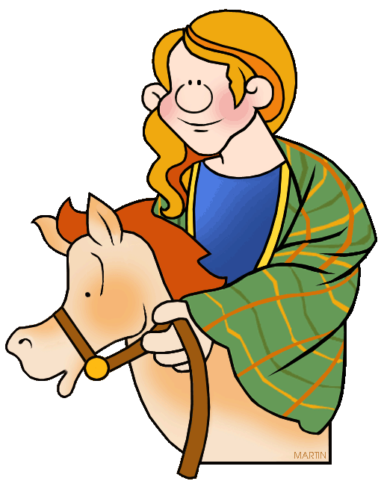
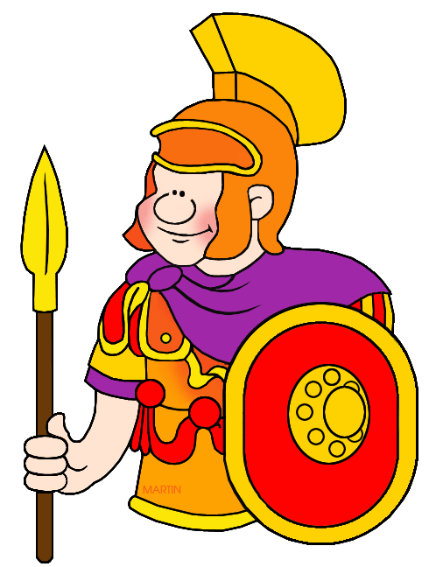

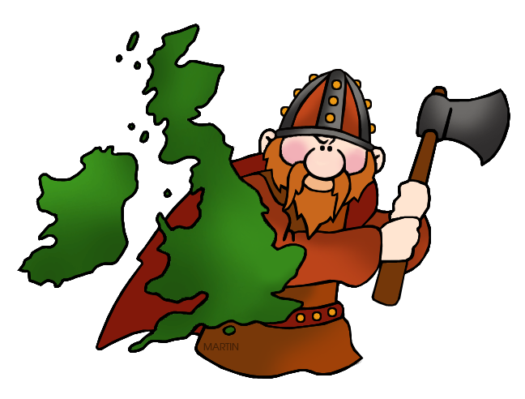

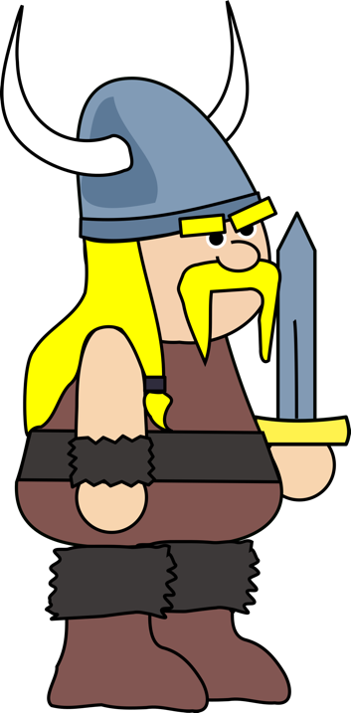

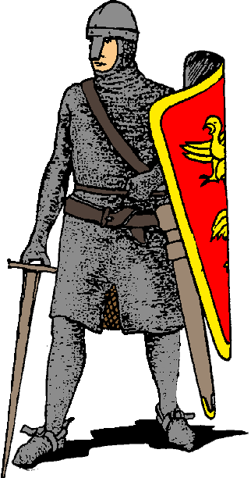

Lesson 8 – Why do people move around?
Task 1 – Why have people come to Britain?
Over the next few pages, you will be able to read a number of sources that go into detail about why people have moved to Britain. As you read the sources, try to complete the web of inference below in as much detail as possible
What do the sources miss out? How reliable do you think they are?
What do the sources tell you?
What can you infer (assume) from the sources?

SOURCE A

“I write to inform you that, following your request for workers from Jamaica, more than 350 tickets for the Empire Windrush have been booked by men looking for work. This number is likely to increase by 100 before the ship leaves. Most of them have no real skill and few will have much money when they arrive in Britain.”

Telegram from the Acting Governor of Jamaica to the Minister For the Colonies, 11th May 1948

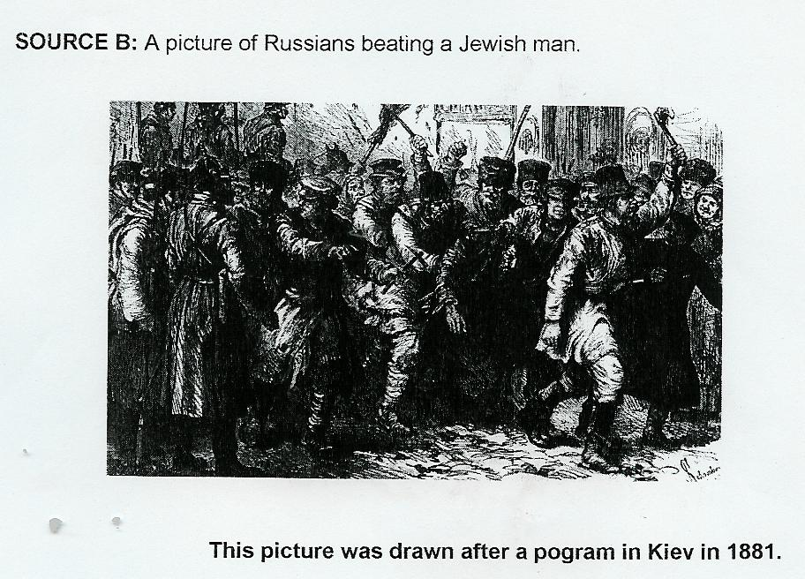

SOURCE C
We always felt British. England was ‘the mother country’, as they used to say, and anything the English or the British did was always right, you know. Even people like my grandmother, if it was said by the BBC and it was from England, therefore it was right and you had to agree to it and support it. It’s as simple as that.

Adapted from ‘Windrush’ be Mike Philips nd Trevor Philips, HarperCollins, London 1998, page 12.

SOURCE D

Number of Irish immigrants to England in 19th century
1841 | 289,404
1851 | 519,959
1861 | 601,634
1901 | 426,565

In 1845 a ‘potato blight’ led to famine in Northern Ireland. At this time Ireland was very agricultural (people made their living from farming) whereas England was experiencing the Industrial Revolution which led to lots of jobs being created in factories.

SOURCE E
The Telegraph newspaper, March 2011
A new Department of Health report says: “The free and high-quality healthcare in Britain means there is a risk that some visitors will come to use healthcare without paying. This is known as ‘health tourism’.”
Figures suggested that one in five beds in a London hospital was taken by a foreigner, as people were able to step off a plane and take a taxi straight to a hospital without proving that they would pay for their treatment afterwards. A Nigerian woman was said to have flown to Britain and given birth to a baby girl prematurely, needing care costing an estimated £1,195 a day in the hospital, then returned home without paying her bills.
SOURCE F
From the CBeebies news website, 2010.

Many asylum seekers flee their own country and come to Britain because there is a civil war there or because their human rights are not being respected.

The top five countries that people came to the UK from in 2007 were:
- Afghanistan (2,500)
- Iran (2,210)
- China (2,100)
- Iraq (1,825)
- Eritrea (1,810)
In some countries, people can be arrested, sent to prison or even tortured for their religious or political beliefs. If the situation in a country changes for the better then there are often fewer asylum seekers from there.
SOURCE G
Concentrations of people born outside British Isles.
Map on right shows country as if areas with roughly equal populations were the same size. So, densely populated London takes up much more space than sparsely populated Scottish Highlands.
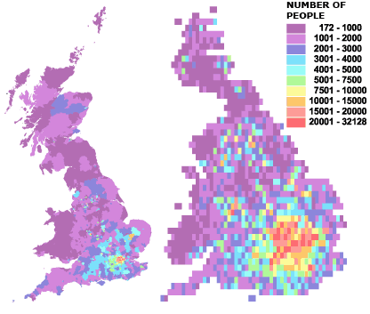

Taken from the BBC news website, 2012.

Task 2 – Britain’s appeal
Considering all of the information covered in today’s lesson, why do you think Britain would have been an attractive and appealing place to move to?
______________________________________________________________________________________________________________________________________________________________________________________________________________________________________________________________________________________________________________________________________________________________________________________________________________________________
How and why have some people had no choice other than to come to Britain?
____________________________________________________________________________________________________________________________________________________________________________________________________________________________________________________________________________________
Lesson 9 – How do you know if someone is treated well?
Task 1 – How tolerant a country is Britain?
Below is information on tolerance, or lack of, in Britain towards different groups of people. Read through the information and categorise the points into tolerant and intolerant
Laws
1962 Commonwealth Immigration Act.
This law limited the immigration of non-white people from the Commonwealth countries. No-one saw the immigration of white people from places like the Republic of Ireland, Canada and Australia as a problem. People thought Britain had a problem welcoming Commonwealth immigrants.
1971 Immigration Act
This only allowed two groups to immigrate to Britain-
· Citizens of Britain and colonies who had been born or adopted in Britain or whose parents or grandparents were born in Britain (i.e. most white people living in places like Canada).
· Citizens of Britain who had been in Britain for at least 5 years.
All other people who wanted to enter Britain needed a work permit. These had to be renewed every year. This meant the immigrant could be forced to leave after a year.
1965 Race Relations Act.
This said it was against the law to stop people of different races using the same shops, buses, swimming pools. The law did not include jobs and housing, therefore it was not against the law to refuse to employ or house people of certain races.
1976 Race Relations Act.
This set up a system for taking people who discriminated against people because of their skin colour to court.

- During the early 1900’s the slogan ‘England for the English’ was popular. And people campaigned to get business to only employ ‘white’ workers.
- Big race riots took place in Nottingham and Notting Hill in 1958. These began when whites attacked black people.
- Black footballers like Luther Blissett and Garth Crooks in the 1970’s and 1980’s had to put up with racist chants and acts like bananas being thrown onto the pitch.
- In the 1990’s the worst forms of racism against black football players began to end when football clubs supported the ‘Give Racism the Red Card’ scheme.
- Black sports stars like Marcus Rashford and Anthony Joshua have become very popular.
- Police Forces have tried to stop being racist but after the murder of Stephen Lawrence in the 1990’s it was clear that the police did not investigate some parts of the murder properly because Stephen was black. Studies also show that black people are much more likely to be stopped by the police than whites.
- Some black people have had success at politics including M.P.s like Bernie Grant and Paul Boetang.
- The 1980’s saw huge race riots in places like Brixton. The 1990’s saw similar riots in Bradford and the North-West.
- Several racist groups have appeared. In 2011 the English Defence League began violent protests in a number of cities across England, arguing that England should just be for English people.
- In the latest election the BNP (British National Party) had some success, gaining many votes in some areas of England although they did not win any of the votes. Britain elected the leader of the BNP to the European Parliament in 2009.
- Recent statistics from the UK Home Office and Ministry of Justice show:
  - In 2018 to 19, black people were more than nine times as likely to be stopped and searched by police as white people.
  - They were over three times as likely to be arrested as white people.
  - They were more than five times as likely to have force used against them by the police as white people.
  - A quarter of the prison population comes from BAME (Black, Asian, Minority Ethnic) backgrounds, despite representing just 14% of the population. In young offenders’ institutions, this increases to 50%.
- Players, officials and staff at Premier League and English Football League games have been ‘taking the knee’ since the 2019-20 season restarted in June 2020. This is to show their support for the movement for racial equality.
- The BLM (Black Lives Matter) movement and taking the knee has grown in prominence in Britain since the death of George Floyd, in May 2020. George Floyd was a 46-year-old black man in America, he was unarmed and died after a white police officer held his knee on his neck for nearly 9 minutes. His death sparked protests across the world, including Britain, where protesters took the knee to show their support for racial equality.
- Equality Act 2010
  - This replaced the older Sex Discrimination Act (1975), Race Relations Act (1976) and the Disability Discrimination Act (1995). It is to protect people from unlawful treatment in Britain, such as discrimination, harassment and victimisation based on race, gender, disability, gender reassignment, sexual orientation and age amongst others.
- The Marriage Act 2013
  - This allowed same sex marriage in England and Wales. The first same sex marriage took place in March 2014.

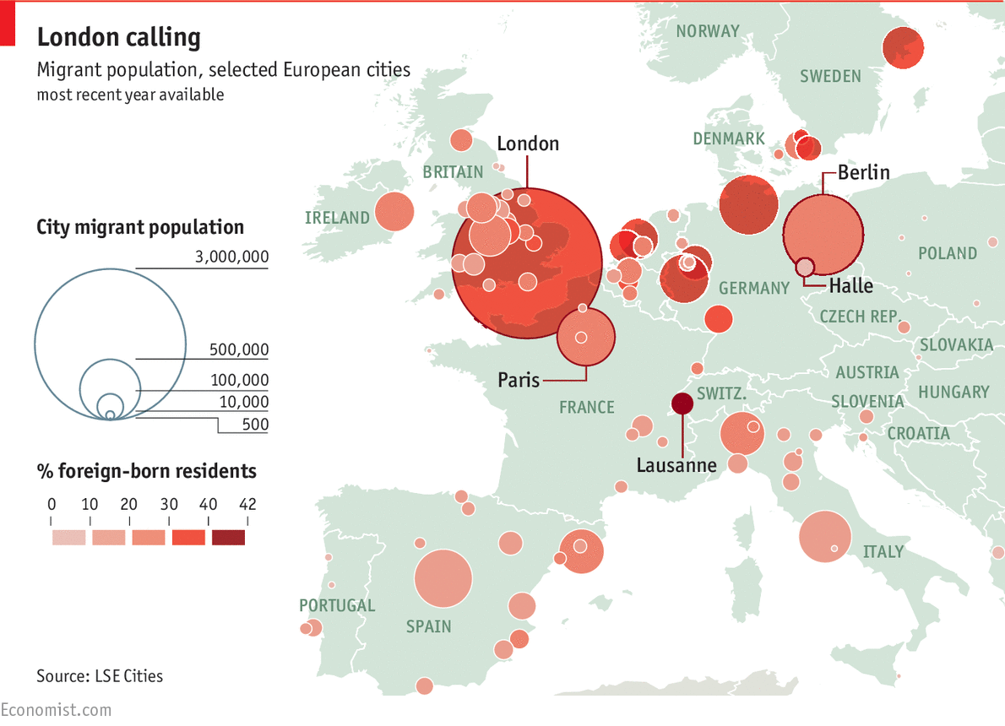

 | Tolerant | Intolerant
Pre-1980
1980 to 1999
2000 to present day

