

Year 8 History Study Guide

• Witchcraft, Science and Crime •

**Lesson 1 – Why do people treat each other badly?**

**Task 1 – Why was Mrs Device hanged?**

Read through the hexagons below and answer the question the question above.

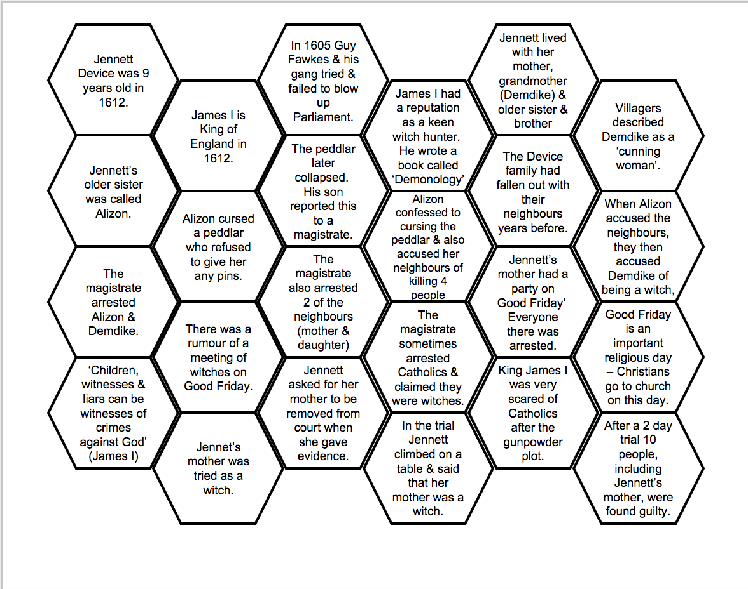

In as much detail as possible, explain why was Mrs Device hanged?

_____________________________________________________________________________________________________________________________________________________________________________________________________________________________________________________________________________________________________________________________________________________________________________________________________________________________________________________________________________________________________________________________________________________________________________________________________________________________________________

**Task 2 – What do you think?**

Do you think people in Britain today would behave like the people in 17th century Pendle (the place where Mrs Device was from)?

*Hint* - this question isn’t necessarily about how people in Britain today would react to witchcraft, but more about whether people in Britain today are discriminated or treated differently because of their beliefs, how they act or how they look.

__________________________________________________________________________________________________________________________________________________________________________________________________________________________________________________________________________________________________________________________________________________________________________________________________________________________________________________________________________________________________________________________________________________________________________________________________________________________________________________________________________________________________________________________________________________________________________________________________________________________________________________________________________________________________________________________________________________________________________________________________________________________________________________________________________________________________________________________________________________________________________________________________________________________________________________________________________________________

**Task 3 – Pendle continuum**

On the continuum below, plot and explain where you would place your view on whether the Pendle Witch Trials made people in the past less clever than we are today:

Cleverer

Less clever

**Lesson 2 – Why would people believe in witches?**

**Task 1 – Why were people accused of being witches**

Read through the sources below and then answer the questions in the grid afterwards.

|  |
| --- |
| **Source 1**  Timeline  Middle Ages 1066-1485  Witches were put on trial but punishments were light and they were never put to death. In fact very few witches were punished at all.  Henry VIII’s Reign  Henry VIII suspected witches were involved in a plot to kill him. In 1542 a law was passed that stated that witches should be punished by death. This law ended when Henry died in 1547.  Elizabeth I’s Reign 1558-1603  Protestants persuaded Elizabeth I that tougher new laws against witches were needed. In 1563 a new law was passed which brought back the death penalty for any witch who used magic to kill someone. Witches who harmed people were put in prison.  James I’s reign 1603 – 1625  Some of James’ ministers were strict Puritans and they persuaded the King to introduce an even harsher law against witches. From 1604 anyone who was shown to have contacted evil spirits could be hanged for witchcraft, whether or not they had done any harm. James even wrote a book about witchcraft. |
| **Source 2**  There seem to have been more witchcraft trials in years where people were living in times of great hardship or upheaval. In the 1580s and 1590s when there were poor harvests, famine and a rebellion, the number of witchcraft trials went up dramatically. During the English Civil War witch fever broke out again. |
| **Source 3**  Accusations made against witches in the seventeenth century:  “My cow fell sick and died”  “My Baby died”  “My brother had such terrible fits that six men could not hold him down”  “My beer went sour in the barrel” |
| **Source 4**  Witchcraft Tests  Test 1: Tie the woman’s hands and lower her into the water. If she floats she is a witch, if she sinks she is innocent.  Test 2: Look for a witch mark, where familiars sucked blood. Stick a large pin into the mark. If she feels no pain and does not bleed then she is a witch. |
| **Source 5**  In 1582 13 women from the village of St Osyth in Essex were accused of witchcraft. One of the accused was Ursula Kemp. It was claimed that she had used witchcraft to kill several of her neighbours. Her own 8-year-old son gave evidence against her. When the judge promised Ursula a light sentences she burst out crying, fell on her knees and said;  “Yes I had the four imps my son has told of. Two of them, Tilly and Jack, were hees whose job was to kill people. Two, Tiffin and Piggin were shes, who punished, made people lame and destroyed goods and cattle. I confess that I killed my brother’s wife, and Grace Thurlow’s child I made it fall out of its cradle and break its neck).”  During the witch-craze there were many women like Ursula who confessed to being witches. |
| **Source 6**  Henry Cockcroft was a clothworker from Heponstall Yorkshire. In 1646, he told how Elizabeth Crossley, a poor woman, came to his house begging for money. Elizabeth was not very pleased with the small amount Henry gave her, but she went away. The next night Henry’s one-year-old son began to have fits. Three months later he was dead. Henry accused Elizabeth of bewitching his child. At her trial other people reported that members of their family had also been bewitched by Crossley. Elizabeth Crossley was found guilty of witchcraft and hanged. |
| **Source 7**  Four General Findings of Historians from Witchcraft Trials:  It was often richer people who accused people of being witches  Nearly all of the people accused of witchcraft were female, old and poor  Often the problem began with a quarrel between neighbours  Witches were nearly always accused of causing harm to their neighbours rather than worshipping the devil. |
| **Source 8**  People believed that witches obtained their power from meeting the devil in person at a Sabbath. The devil gave witches evil powers to use during their lifetime in return for their souls when they died. After worshipping the devil witches were given a familiar – an evil spirit which often took the form of a small animal. People believed that the witch fed her familiars on her blood. A witch would have a witch mark on her, such as a wart or a mole where the familiar sucked her blood. |

**Questions**

|  |  |
| --- | --- |
| Who was accused of being a witch? | Who accused them? |
| When were people accused? | When did people believe more strongly in witches? |
| What was done about witches? | What was done to protect people against them? |
| Why were people accused of being witched? | Why did some people confess to being a witch? |
| How did people know if people were witches or not? | How were witches treated? |

Do you think people *really* believed in witches? Or you think people used it as an excuse to get rid of people they didn’t like?

**Lesson 3 – How can you measure how important someone is?**

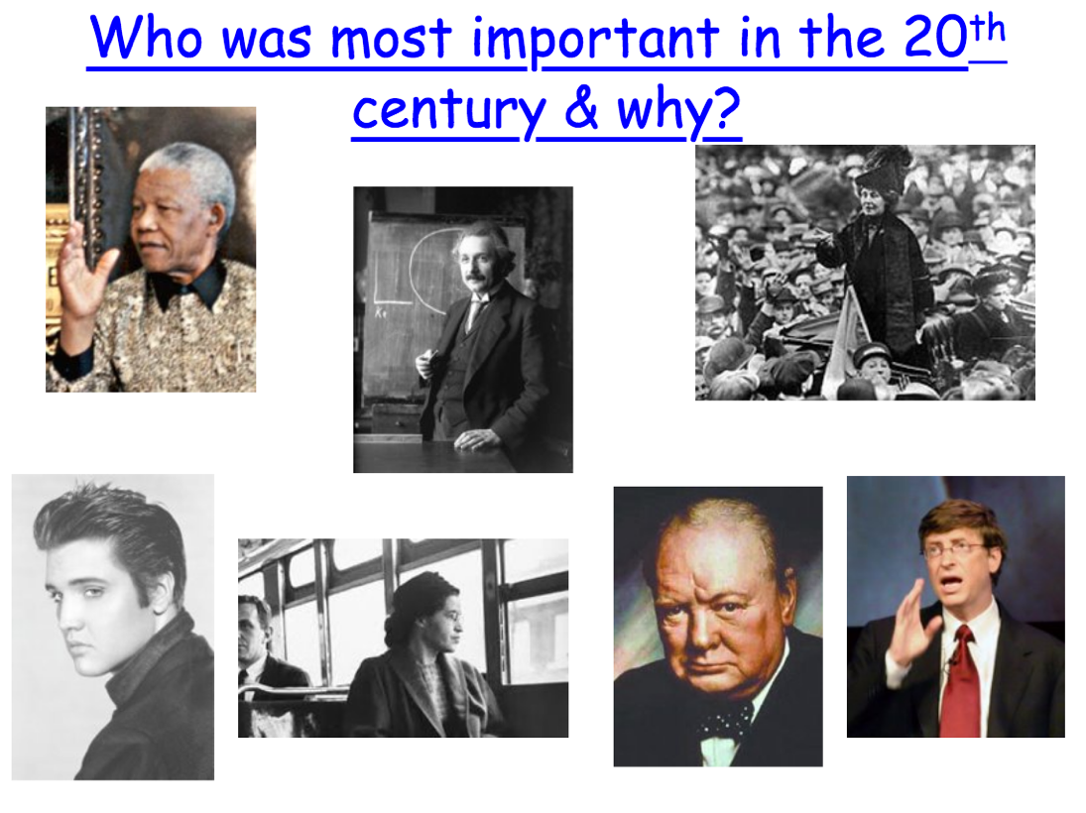

Who?  
  
  
  
Why?

**Task 1 – 16th – 18th century scientists**

Read through the information on the six very important scientists. Once you have done that you are to plot the importance of each scientist on the grid and explain their placing.

|  |
| --- |
| **Isaac Newton (1642-1727).** A mathematician and scientist. One of Newton’s most important discoveries happened when he was trying to work out why some things like an apple fell to earth but other things, like the moon, did not. He understood that there was a force which keeps things on the earth and holds the planets together in space. He decided to call the force gravity. He In 1687 he wrote a book of his most important ideas called Principia. This was the most important book about science for over 200 years. |
| **Robert Boyle (1627 –1691).** In Medieval times people believed that everything was made of four elements; earth, air, fire and water or three principles; salt, sulphur or mercury. Boyle said that this was incorrect as all substances were made of chemical elements which were so small they could not be broken down any further. Although he did not find any of these elements himself, later scientists were able to do so. |
| **Thomas Newcomen (1663-1729**). Invented the first steam engine. These engines were used throughout England & Europe, mainly for pumping water out of coal mines - they were used in Newcastle mines very early on. These machines were very basic but provided the basis of later steam engines and steam trains. |
| **Galileo (1564-1642) –** an Italian who developed a practical telescope which made astronomy (looking at the planets) really popular. He also helped prove that the sun and not the earth was the centre of our solar system, which is only one of many of such systems. This went against the Catholic Church at the time which led to him being arrested and spending the last 9 years of his life under house arrest. |
| **Christopher Wren (1632-1732)** was an architect who designed the new St Paul’s Cathedral after the Great Fire of London. This cathedral had the first dome ever built in the city of London. His design for St Pauls used geometry to create a dome that would carry the sound of human voices clearly through the air. He also invented a number of things such as a pen which wrote two copies at one time. |
| **Robert Hooke (1635-1702)** used a new powerful microscope to study plants & in 1665 he published a book of drawings of things seen through his microscope. He was astonished to see that plants were made up of thousands of tiny sections & he decided to call these cells. It was only later that scientists found out how important cells are in the life of plants and humans. |

|  |
| --- |
|  |

Little

importance

Hugely

important

**Lesson 4 – What makes something useful?**

**Task 1 – Diamond 9 Rank**

Below is a list of things that were invented or developed during the 16th and 18th centuries. Out of the 14, you are to choose the 9 most important and then you are to rank them from most useful to least useful in the diamond formation at the bottom of the page.

|  |  |
| --- | --- |
| Telescope  Geometry  Submarine  Method for blood transfusion  Microscope  Pendulum clock  Pocket watch | Piano  Fire extinguisher  Hot air balloon  Parachute  Bi-focal glasses  Carbonated (fizzy water)  Steam engine |

Most useful

Least useful

**Task 2 – Most/least useful and why?**

What did put as the most useful? Why?

______________________________________________________________________________________________________________________________________________________________________________________________________________________________________________________________________________________________________________________________________________________________________________________________________________________________

What did you put as the least useful? Why?

______________________________________________________________________________________________________________________________________________________________________________________________________________________________________________________________________________________________________________________________________________________________________________________________________________________________

**Task 3 – Describe question**

Answer the following question below by giving two separate points followed by some evidence/explanation to support the point(s) you have made.

Describe two ways that people were clever in the past.

________________________________________________________________________________________________________________________________________________________________________________________________________________________________________________________________________________________________________________________________________________________________________________________________________________________________________________________________________________________________________________________________________________________________________________________________________________________________________________________________________________________________________________________________________________________________________________________________________________________________________________________________________________________________________________________________________________________________________________________________________________________________________________________________________________________________________________________________________________

**Lesson 5 – How do you cure an ill person?**

All the conditions were right for an epidemic. Doctors were powerless against infectious disease. People were weakened by war and harvest failures. Germs, the fleas which carried them, and the rats which carried the fleas, flourished in the dirty towns. Busy trade routes carried the plague from one place to another.

The plague arrived at Melcombe Regis in Dorset in June 1348 and it spread throughout the south of England. In 1349 it reached Wales, Ireland and the north of England. By 1350, it had made it to Scotland. Estimates suggest as much as half the population died.

The Black Death affected the way people thought about life in many different ways. Some lived lives perceived to be wild or immoral, others fell into deep despair, whilst many chose to accept their fate. (BBC Bitesize).

Medieval doctors were not certain what caused the plague, but believed it could be the result of:

1. the movements of the planets
2. a punishment from God
3. bad smells and corrupt air
4. enemies who had poisoned the wells
5. staring at a victim
6. wearing pointed shoes
7. strangers to villages too were blamed

**Task 2 – Stopping the Black Death.**

On the next page are a number of things that people did to try and stop the plague. Which ones do you think would work and which ones would not work? Why?

Carry a bunch of herbs & hold it to your nostrils at all times.

Force all the sick people to leave the village.

Pray to God & ask him for forgiveness.

Take a live frog & put its belly on the buboe. It will swell up & burst. Keep doing this with more frogs until they stop bursting.

Go on a pilgrimage to Canterbury, Walsingham & other holy places.

Burn sweet-smelling wood in your house.

Bury or burn the clothes of the plague victims.

Don’t go near stagnant water, slaughter houses or rubbish heaps.

Walk through the streets singing hymns & whipping yourself to show how sorry you are.

Cook some onions & figs in butter & put them onto the buboes (swellings). Then cut the buboes open.

Put a live hen next to the plague sufferer. Then give them a cup of their own urine to drink twice a day.

Cut open the veins leading to the heart to let some of the plague sufferer’s blood out.

**Task 3 – Effects of the Black Death**

There were many different results of the Black Death. They can be grouped into sets called factors:

Below are a number of consequences related to the Black Death. Using the guide above, categorise each of the consequences into either social, political, economic, religious or military factors.

|  |  |
| --- | --- |
|  |  |
|  |  |
|  |  |
|  |  |
|  |  |
|  |  |
|  |  |
|  |  |

**Task 4 – Biggest impact?/PEA paragraph**

Which of the factors do you think the Black Death had the biggest impact on? You are to choose whether the Black Death had the biggest impact on society, the economy, politics, religion or the military using the space and guidance below.

|  |  |
| --- | --- |
| **Point** – choose the factor which the BD had the biggest impact on | The Black Death had the most significant impact on ______________________. |
| **Explanation/evidence** – use the information you categorised in Task 3 to support your view. Remember to only use evidence that directly relates to the factor you are focusing on. | This is because the Black Death led to_________________ ______________________________________________ ______________________________________________ ______________________________________________ ______________________________________________ ______________________________________________ ______________________________________________ ______________________________________________ ______________________________________________ ______________________________________________ ______________________________________________ ______________________________________________ ______________________________________________ |
| **Analysis** – explain why this was such a bad thing or had such a bad effect | This had a big impact because________________________ ______________________________________________ ______________________________________________ ______________________________________________ ______________________________________________ ______________________________________________ ______________________________________________ ______________________________________________ ______________________________________________ |

How would both have these people reacted to the Black Death? Was it *all* bad for everyone?  
  
The peasant: ___________________________________________________________  
_______________________________________________________________________________________________________________________________________________________________________________________________________________  
The lord: ______________________________________________________________  
____________________________________________________________________________________________________________________________________________________________________________________________________________________________________________________________________________________

**Lesson 6 – Do people get cleverer over time?**

Two time periods in the past had a tremendous impact on medical developments. They are the Ancient Egyptians and Islamic civilizations. Ancient Egypt existed from around 3,000 BC to around 400 BC while various Islamic civilizations and countries have existed from around 500 AD. Islamic civilizations still exist today, however, we are only looking at them up to around 1300 AD.

**Task 1 – Not clever at all or genius?**

Below is a list of statements that focus on medicine in the two time periods. You are to read the statements and then plot them on your continuum somewhere between ‘Not clever at all!’ and ‘Genius!’. Once you have complete the continuum task, make a decision on which civilization you believe was the most genius!

**Ancient Egypt**

|  |
| --- |
| A group of pyramids in a desert  Description automatically generated with medium confidenceThe Egyptians had developed writing so they could write about illnesses & treatments & keep a record of those treatments that worked & those that did not. Records show that if a treatment worked, they kept using it. |
| The Egyptians believed that many diseases were caused by an evil spirit entering the body so they often wore charms to keep these spirits away. If they still became ill, they used magic & the gods to make them well. |
| The ‘Papyrus Ebers’ is a book from 1500BC which gives clear instructions on how to treat illnesses, including the exact words to be spoken by doctors as well as medicine or treatment to be given. If a doctor did not follow the book & the patient died, the doctor was executed |
| The Egyptians developed the first herbal cures. Some of their remedies include – inhaling steam for chest diseases & ointments for skin conditions. Many of their drugs are still used, in different forms, today. |
| The Egyptians believed that after death the soul leaves a person’s body but after a while it returned & the person had an afterlife. So they believed it was important to keep dead bodies in good condition for when their souls returned. |
| Anatomy is the study of the structure of the human body. Knowing what is inside the body & how it works is an important part of medicine. To keep people’s bodies in the best condition after death, the Egyptians mummified them – this included cutting open the body & taking out its organs. |
| Surgery, like all jobs in Egypt, was passed down from father to son. There is no evidence that the Egyptians did major operations on each other, but there are records of some simple procedures such as treating dislocated arms & legs & removing cysts or tumours. |
| Egyptian operations probably had quite a good survival rate because after operating the wounds were treated with willow. We now know that willow leaves & bark produce a kind of antiseptic which would have protected the wound from infection. |

**Islamic Civilizations**

|  |
| --- |
| Muslims believed that illnesses were caused by evil spirits. It was important to live a good, religious life to make sure that you stayed away from evil and therefore kept healthy. |
| Muslims followed the method of observation. They believed it was important to watch a sick patient closely to monitor their skin colour, cough, temperature & so on. One Muslim doctor followed this so closely he was the first person to see the difference between smallpox & measles. |
| The first hospital ever built was in Baghdad in 850. By 931 people in Baghdad had to pass exams before they were allowed to work as doctors. Other hospitals were soon set up throughout the Muslim world, for example in Cairo. |
| In the early Muslim hospitals, patients were separated depending on what was the matter with them, just as they are in hospitals today. For example eye patients were kept separate from those with fever. |
| Dissecting bodies was forbidden in Islamic law so they did not gain a particularly good understanding of anatomy. |
| Muslims made lots of progress in the area of chemistry. For example they invented processes such as distillation which is used in the preparation of medicines. They also identified a number of drugs which we still use today such as camphor. |
| A picture containing outdoor, person, crowd  Description automatically generatedThe records of one Muslim surgeon – Albucasis (born in 936) – show that he did operations such as amputation, lithotomy (removing gall stones from the bladder) & dentistry (putting in artificial teeth made from bone). He also described how to sew up wounds, set fractures & deal with dislocations. |
| Muslims believed that the body was made up of four humours – blood, phlegm, yellow bile & black bile. They thought these humours were connected to the four seasons. They believed that, to be healthy, these four humours had to be kept in perfect balance. These ideas were first developed in Ancient Greece. |

Islamic Civilizations

Ancient Egypt

Genius

Not clever at all

**Lesson 7 – Can faith heal?**

**Task 1 – Primary source work**

What does the source below tell us about Islamic medicine? Is there anything you can link back to the previous lesson or are there any educated guesses or inferences you can make?

**Task 2 – Ibn Sina/Avicenna**

Below is a short biography of Ibn Sina, a very important Islamic doctor who made a large contribution to medical science. Using the information, you are to draw 4/5 images or symbols around the text that represent his life.

**Task 3 – Islamic medicine**

Below is a list of statements that tell us about the contributions of Islamic medicine to the general field of medicine.

Choose the top nine contributions and complete the   
diamond 9 rank activity, ordering them from most   
to least important contribution

**Lesson 8 – How do you survive injury?**  
**Task 1 – Doodle map/storyboard**

Read through the information on the left hand side of the page. Using the space on the right hand side of your page, draw a series of pictures that help best represent the information.

|  |
| --- |
| Surgery in medieval times was very RISKY!  Surgeons had no idea about bacteria and infections – (some thought pus was good). Operations were often carried out using NO real painkillers.  Patients would often die from; PAIN, SHOCK or INFECTION  Many Medieval surgeons were barbers who cut hair and also offered minor surgery. These barber surgeons were of a lower class than trained surgeon doctors – who trained by watching other doctors or on the battlefields.  The most common procedure was BLOODLETTING – to restore the balance of humours. Amputation or cutting off a painful part of the body was another common surgery. Surgeons might also ‘trepan’ you – drill a hole in your skull to let out demons. Cauterising wounds was also common (using a heated iron to seal a wound).  Most surgery took place on the battlefield – and as a LAST RESORT in everyday life as it was so dangerous.  Patients had to be tied down, although surgeons did try to knock people out with mandrake root, opium and hemlock. |

**Lesson 9 – How do you get someone to admit to a crime?**

**Task 1 – Link the torture**

Read through the types  
of torture to the right  
and link it to the   
description.