Year 7 History Study Guide
British History: 1066-1688
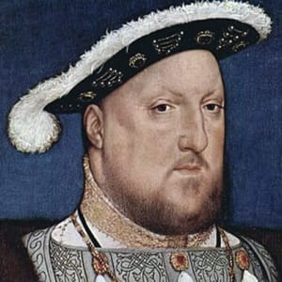
• The Tudors •

Contents

The Tudors
Lesson 1 – How can you rate something? | pg. 3
Lesson 2 – Why might you leave something? | pg. 7
Lesson 3 – Can you fail and succeed at the same time? | pg. 10
Lesson 4 – How can you measure success? | pg. 12
Lesson 5 – What is the worst problem you can have? | pg. 14
Lesson 6 – Why do people marry? | pg. 17
Lesson 7 – Why do people fight? | pg. 20
Lesson 8 – Why do teams win? | pg. 21
Lesson 9 – What is failure? | pg. 23
Assessed Task 2 | pg. 25

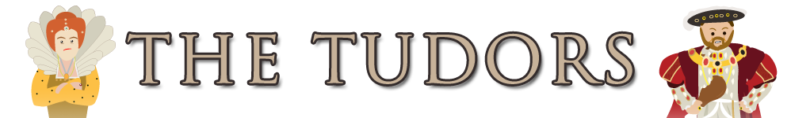
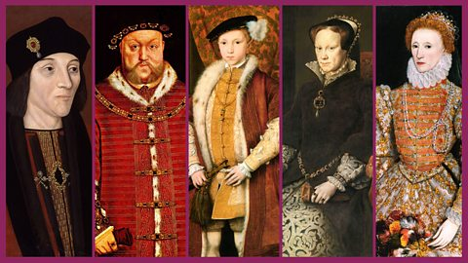

Lesson 1 – How can you rate something?
Task 1 – Tudors cartoon
Watch the following cartoon (https://www.youtube.com/watch?v=fAmRSHRwADE) about the Tudors – write down everything you learn about the Tudors from the video in the box below:

Task 2 – Henry’s gingerbread wives
On the left-hand side of your page is information about Henry VIII’s wives. Using the information, you are to draw pictures and symbols onto the gingerbread people on the right-hand side of the page to represent each of Henry’s wives.
Catherine of Aragon

Born: 16th December 1485 in Spain (Henry VIII was born 1491)
Married Henry VIII: 11th June 1509
Religion: Catholic
Previously married to: Arthur (Henry’s elder brother but he died)
Characteristics: Well educated, spoke many languages (she was very well liked by educated people at court), devoted to Henry (embroidering his shirts and making sure he had clean linen when away)
Children: Catherine was pregnant many times but only 1 child survived past infancy – a girl Mary.
Problems: She had not produced the male heir Henry really wanted. Henry fell in love with a new women and wanted to marry her. The pope (Head of the Catholic Church) refused to let him divorce Catherine.
Divorced/annulled: 1533
Died: 7th January 1536

Anne Boleyn
Born: approx. 1500 in England (Henry was born in 1491)
Married Henry VIII: January 1533
Religion: Protestant
Children: When they married Anne was pregnant and gave birth to a girl – Elizabeth. Despite miscarriages she had no more children.
Characteristics: Very attractive and Henry gave her lots of expensive gifts. She had 6 fingers on one hand. Very witty and charming. Loved fashion, dancing and lots of attention.
Problems: Henry was excommunicated (thrown out) of the Catholic Church for marrying her. The public were not happy about him divorcing Catherine. She produced a girl not a boy for Henry. She was accused of being unfaithful against Henry, having sex with her own brother and plotting to kill Henry.
Died:19th May 1536 – executed (beheaded on Henry’s orders).

Jane Seymour

Born: approx. 1509 in England (Henry was born in 1491)
Married Henry VIII: 30th May 1536
Religion: Protestant
Children: Gave birth in 1537 to Edward, Henry’s only male heir to the throne. She had no other children.
Characteristics: She was quiet, shy and tried not to upset Henry. She agreed to marry Henry the day after his last wife died.
Died: 24th October 1537, 2 weeks after giving birth to Edward. She had suffered complications during the birth.

Anne of Cleves

Born: 1515 in Germany (Henry was born in 1491)
Married Henry VIII:6th January 1540
Religion: Protestant
Children: None
Characteristics: She came from a wealthy protestant German family. Her upbringing in Cleves had concentrated on domestic skills and not the music and literature so popular at Henry's court.
Problems: Henry decided to marry her after seeing this picture of her. When he saw her in person he said she was ugly and called her the ‘Flanders mare’. Anne said she and Henry never slept together.
Divorced: July 1540
Died: 1557

Katherine Howard

Born: 1521 in England (Henry was born in 1491)
Married Henry VIII: 28th July 1540
Religion: Catholic
Children: None
Characteristics: Considered very beautiful. She was only very young when she married Henry (19). She was Henry’s 2nd wife’s cousin. She had previously been in relationships with others. Whilst she could read and write she was not very well educated.
Problems: Henry had hoped she would bear him children but he was overweight and had ulcers on his legs. His young wife is said to have an affairs with others.
Died: 13th February 1542, beheaded for being unfaithful to Henry.

Katherine Parr
Born: 1512 in England (Henry was born in 1491)
Married Henry VIII: 12th July 1543
Religion: Protestant
Children: None with Henry
Characteristics: When she married Henry she had been widowed twice. She was outspoken about the new reformed religion (Protestantism) and this upset some at court. She had a life-long passion for learning. She was fluent in French, Latin and Italian and began learning Spanish when she was Queen. She became step mother to Henry’s children and made kept a close eye on the education of Elizabeth and Edward. She cared for Henry who was old and ill at this time, she acted as a nurse as well as a wife.
Problems: She was outspoken about the new reformed religion (Protestantism) and this upset some at court. There was almost an attempt to arrest the Queen.
Henry died: 28th January 1547 leaving Katherine a widow for the third time.

Task 3 – Henry’s perspective
Who do you believe was Henry’s best wife? Why?
Write between 30 and 50 words to justify your answer.
_________________________________________________________________________________________________________________________________________________________________________________________________________________________________________________________________________________________________________________________________________________________________________________________________________________________________________________________________________________________________________________________________________________________________________________________________________________________________________________________________________________________________________________________________________________________________________________________________________________________________________________________________________________________________________________________________

Lesson 2 – Why might you leave something?
Task 1 – Break with Rome storyboard
Using the information in the caption boxes, draw some pictures to represent how and why Henry broke with the church in Rome.
When Henry came to the throne in 1509 he was a supporter of the Church of Rome. By the end of his reign he had broken with the Roman Church and set up the Church of England. Many believe he broke with the Catholic Church for love. | He was married to Catherine of Aragon but she hadn’t given birth to a boy. He wanted to divorce Catherine and marry Anne Boleyn but the Pope wouldn’t allow it. Henry married Anne in 1533 and the Pope banned Henry from the Catholic Church. In 1534 Henry became the head of the Church of England.
Another reason for the break was power. Henry wanted to be the most powerful man in England and he hated the Pope’s control over England. Some people also felt the Catholic Church was too rich and that the priests didn’t lead very holy lives. Monasteries were very wealthy and Henry needed money for wars. | The final reason for the break with Rome was that some people thought the Catholic Church was not teaching the Bible properly.
Task 2 – The most important reason is…?
Below are the four main reasons why Henry VIII broke with the church in Rome, alongside some additional information.
You are to read through the information, and below, decide which reason YOU think was the most important reason why Henry separated with the Catholic church in Rome.

POWER  The Pope had refused to let Henry divorce his first wife Catherine. Henry was also very worried about the increasing control the Pope seemed to have over England.  The Pope took taxes from the English church and Henry had seen other rulers in Germany break away from the Catholic church and the Pope and become Protestant instead. Henry was a King of England and hated anyone telling him what to do.  Why should a foreign leader have so much control over England? In 1532 Henry made the Church of England (which was Protestant) and put himself in charge. The Pope in Rome no longer had any power in England. | LOVE  In 1509 Henry married Catherine of Aragon, a Spanish princess. Both of them were Catholics and the Catholic Church would not allow divorce. Henry was desperate to have a son to become King when he died but after many years of marriage Catherine and Henry had only one surviving child, a girl called Mary. Henry thought God might be punishing him for marrying his brother’s widow.  Henry had grown tired of Catherine and Anne Boleyn had caught his attention. Henry claimed to really love Anne Boleyn and was desperate to have an affair with her but Anne wanted to be married. Henry knew this would be very difficult as only the Pope (Head of the Catholic Church) could grant them a divorce from Catherine.  Anne Boleyn fell pregnant in 1532 so Henry began the process of setting up his own Church of England so that the Pope no longer had control. This would mean that he could divorce Catherin and marry Anne instead.  In 1534 the Pope announced that Catherine was still the rightful queen of England. Whilst Henry’s love for Anne wouldn’t last he had broken links with the Church of Rome (Catholic Church) and set up a new religion in order to marry her.
FAITH / BELIEFS  Henry VIII could not have broken with the Catholic Church if there had not been support for a change.  In England there was unhappiness with the corruption (dishonesty) within the Catholic Church. Monks in particular were seen as very greedy at a time when many were starving. They also did not behave in a very Christian way, for example priests and bishops had mistresses and children when they were not allowed to. Bishops and Archbishops were very rich and lived in luxury and Catholic churches and monasteries had lots of money and fine possessions. People in England really resented this.  Some in England followed a newly reformed religion called ‘Protestantism’. | WEALTH  As King of England, Henry had to spend a lot of money defending / running his country and a lot of money was spent fighting wars with other countries. Henry desperately needed money to pay for wars he had been fighting in France.  The Catholic Church was very rich. Church tithes (taxes) had made it a wealthy organisation. Monasteries had lots of treasures made from gold, silver and jewels. If Henry broke with the Catholic Church he could take over the monasteries, land and tax collection and make a lot of money from them.  From 1536-40 the Dissolution of the Monasteries (closing them down) took place. Two thirds of all their land was sold and the money was spent on wars against France. There is no doubt that Henry gained a lot of money from the break with Rome but his new-found wealth was quickly spent.

The most important reason why Henry VIII broke with the Catholic church in Rome is _______________. This is because _________________________________________
_______________________________________________________________________________________________________________________________________________________________________________________________________________________________________________________________________________________________________________________________________________________________________________________________________________________________________________________________________________________________________________________________________________________________________________________________________________________________________________________________________________________________________________________________________________________________________________________

Lesson 3 – Can you fail and succeed at the same time?

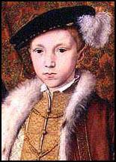
Edward VI (12 October 1537 – 6 July 1553) was King of England and Ireland, from 28 January 1547, until his death on 6 July 1553.
Edward was the son of Henry VIII of England and Jane Seymour. His mother died 12 days after his birth. He became king at the age of 9 when his father died.
When their father died, Edward's half-sister Elizabeth was 13 years old. His other half sister, Mary was 31. Despite being the youngest, Edward was the heir apparent because he was male. Because he was such a young king, the realm was governed by a Regency Council. He died when he was 15 and a half years old. His successor was his cousin, Lady Jane Grey.

Task 1 – Super success or definitely doomed?
Below are a number of statements about Edward VI and on the next page is a ripple graph. Use the statements and plot them on the ripple graph, depending on whether you think Edward VI was a success or whether he was doomed from the beginning.
Edward was given a very strong education and was intelligent

Edward was given a very strong education and was intelligent

Edward was given a very strong education and was intelligent

Edward was given a very strong education and was intelligent

Edward was given a very strong education and was intelligent

Edward was given a very strong education and was intelligent

Edward was given a very strong education and was intelligent

Edward was given a very strong education and was intelligent
Henry VIII had arranged that a council of regency should rule on Edward’s behalf when he was too young to rule. Edward's uncle, Duke of Somerset took power and established himself as protector.

Edward’s health was never strong and in 1553 he was clearly suffering from tuberculosisHenry VIII had arranged that a council of regency should rule on Edward’s behalf when he was too young to rule. Edward's uncle, Duke of Somerset took power and established himself as protector.

Edward’s health was never strong and in 1553 he was clearly suffering from tuberculosis

In 1549 the French declared war on England.Edward’s health was never strong and in 1553 he was clearly suffering from tuberculosisHenry VIII had arranged that a council of regency should rule on Edward’s behalf when he was too young to rule. Edward's uncle, Duke of Somerset took power and established himself as protector.

Edward’s health was never strong and in 1553 he was clearly suffering from tuberculosisHenry VIII had arranged that a council of regency should rule on Edward’s behalf when he was too young to rule. Edward's uncle, Duke of Somerset took power and established himself as protector.

Edward’s health was never strong and in 1553 he was clearly suffering from tuberculosis

In 1549 the French declared war on England.Edward’s health was never strong and in 1553 he was clearly suffering from tuberculosis

In 1549 the French declared war on England.

His short reign saw the full-scale introduction of Protestantism.In 1549 the French declared war on England.Edward’s health was never strong and in 1553 he was clearly suffering from tuberculosis

In 1549 the French declared war on England.Edward’s health was never strong and in 1553 he was clearly suffering from tuberculosisHenry VIII had arranged that a council of regency should rule on Edward’s behalf when he was too young to rule. Edward's uncle, Duke of Somerset took power and established himself as protector.

Edward’s health was never strong and in 1553 he was clearly suffering from tuberculosisHenry VIII had arranged that a council of regency should rule on Edward’s behalf when he was too young to rule. Edward's uncle, Duke of Somerset took power and established himself as protector.

Edward’s health was never strong and in 1553 he was clearly suffering from tuberculosis

In 1549 the French declared war on England.Edward’s health was never strong and in 1553 he was clearly suffering from tuberculosisHenry VIII had arranged that a council of regency should rule on Edward’s behalf when he was too young to rule. Edward's uncle, Duke of Somerset took power and established himself as protector.

Edward’s health was never strong and in 1553 he was clearly suffering from tuberculosisHenry VIII had arranged that a council of regency should rule on Edward’s behalf when he was too young to rule. Edward's uncle, Duke of Somerset took power and established himself as protector.
Edward’s health was never strong and in 1553 he was clearly suffering from tuberculosis

In 1549 the French declared war on England.Edward’s health was never strong and in 1553 he was clearly suffering from tuberculosis

In 1549 the French declared war on England.

His short reign saw the full-scale introduction of Protestantism.In 1549 the French declared war on England.Edward’s health was never strong and in 1553 he was clearly suffering from tuberculosis

In 1549 the French declared war on England.Edward’s health was never strong and in 1553 he was clearly suffering from tuberculosis

In 1549 the French declared war on England.

His short reign saw the full-scale introduction of Protestantism.In 1549 the French declared war on England.

His short reign saw the full-scale introduction of Protestantism.

His short reign saw the full-scale introduction of Protestantism.In 1549 the French declared war on England.

His short reign saw the full-scale introduction of Protestantism.In 1549 the French declared war on England.Edward’s health was never strong and in 1553 he was clearly suffering from tuberculosis

In 1549 the French declared war on England.Edward’s health was never strong and in 1553 he was clearly suffering from tuberculosis

In 1549 the French declared war on England.

His short reign saw the full-scale introduction of Protestantism.In 1549 the French declared war on England.Edward’s health was never strong and in 1553 he was clearly suffering from tuberculosis

In 1549 the French declared war on England.Edward’s health was never strong and in 1553 he was clearly suffering from tuberculosis
In 1549 the French declared war on England.

His short reign saw the full-scale introduction of Protestantism.In 1549 the French declared war on England.

His short reign saw the full-scale introduction of Protestantism.

His short reign saw the full-scale introduction of Protestantism.In 1549 the French declared war on England.

His short reign saw the full-scale introduction of Protestantism.In 1549 the French declared war on England.

His short reign saw the full-scale introduction of Protestantism.

His short reign saw the full-scale introduction of Protestantism.

His short reign saw the full-scale introduction of Protestantism.

His short reign saw the full-scale introduction of Protestantism.In 1549 the French declared war on England.

His short reign saw the full-scale introduction of Protestantism.In 1549 the French declared war on England.

His short reign saw the full-scale introduction of Protestantism.

His short reign saw the full-scale introduction of Protestantism.In 1549 the French declared war on England.

His short reign saw the full-scale introduction of Protestantism.In 1549 the French declared war on England.
His short reign saw the full-scale introduction of Protestantism.

His short reign saw the full-scale introduction of Protestantism.

His short reign saw the full-scale introduction of Protestantism.

His short reign saw the full-scale introduction of Protestantism.

His short reign saw the full-scale introduction of Protestantism.

His short reign saw the full-scale introduction of Protestantism.

His short reign saw the full-scale introduction of Protestantism.

His short reign saw the full-scale introduction of Protestantism.
Edward became king at the age of nine, when his father died in January 1547.

Edward became king at the age of nine, when his father died in January 1547.

Edward became king at the age of nine, when his father died in January 1547.

Edward became king at the age of nine, when his father died in January 1547.

Edward became king at the age of nine, when his father died in January 1547.

Edward became king at the age of nine, when his father died in January 1547.

Edward became king at the age of nine, when his father died in January 1547.

Edward became king at the age of nine, when his father died in January 1547.
Edward was born on 12th October 1537 at Hampton Court Palace, the only legitimate son of Henry VIII.

Edward was born on 12th October 1537 at Hampton Court Palace, the only legitimate son of Henry VIII.

Edward was born on 12th October 1537 at Hampton Court Palace, the only legitimate son of Henry VIII.

Edward was born on 12th October 1537 at Hampton Court Palace, the only legitimate son of Henry VIII.

Edward was born on 12th October 1537 at Hampton Court Palace, the only legitimate son of Henry VIII.

Edward was born on 12th October 1537 at Hampton Court Palace, the only legitimate son of Henry VIII.

Edward was born on 12th October 1537 at Hampton Court Palace, the only legitimate son of Henry VIII.

Edward was born on 12th October 1537 at Hampton Court Palace, the only legitimate son of Henry VIII.
A new Prayer book was issued in 1549. Peasants in the West Country revolted in protest against the Prayer Book.

A new Prayer book was issued in 1549. Peasants in the West Country revolted in protest against the Prayer Book.

A new Prayer book was issued in 1549. Peasants in the West Country revolted in protest against the Prayer Book.

A new Prayer book was issued in 1549. Peasants in the West Country revolted in protest against the Prayer Book.

A new Prayer book was issued in 1549. Peasants in the West Country revolted in protest against the Prayer Book.

A new Prayer book was issued in 1549. Peasants in the West Country revolted in protest against the Prayer Book.

A new Prayer book was issued in 1549. Peasants in the West Country revolted in protest against the Prayer Book.

A new Prayer book was issued in 1549. Peasants in the West Country revolted in protest against the Prayer Book.
Realising he was dying Edward declared his sister Mary illegitimate and passed the throne to a distant relative of Henry’s, Lady Jane Grey.

After the Duke of Somerset, John Dudley took over the role of protector for Edward.Realising he was dying Edward declared his sister Mary illegitimate and passed the throne to a distant relative of Henry’s, Lady Jane Grey.

After the Duke of Somerset, John Dudley took over the role of protector for Edward.Realising he was dying Edward declared his sister Mary illegitimate and passed the throne to a distant relative of Henry’s, Lady Jane Grey.

After the Duke of Somerset, John Dudley took over the role of protector for Edward.Realising he was dying Edward declared his sister Mary illegitimate and passed the throne to a distant relative of Henry’s, Lady Jane Grey.

After the Duke of Somerset, John Dudley took over the role of protector for Edward.Realising he was dying Edward declared his sister Mary illegitimate and passed the throne to a distant relative of Henry’s, Lady Jane Grey.

After the Duke of Somerset, John Dudley took over the role of protector for Edward.Realising he was dying Edward declared his sister Mary illegitimate and passed the throne to a distant relative of Henry’s, Lady Jane Grey.

After the Duke of Somerset, John Dudley took over the role of protector for Edward.Realising he was dying Edward declared his sister Mary illegitimate and passed the throne to a distant relative of Henry’s, Lady Jane Grey.

After the Duke of Somerset, John Dudley took over the role of protector for Edward.Realising he was dying Edward declared his sister Mary illegitimate and passed the throne to a distant relative of Henry’s, Lady Jane Grey.
After the Duke of Somerset, John Dudley took over the role of protector for Edward.
Edward died on 6 July 1553. Lady Jane Grey was only queen for a few days until, with overwhelming popular support, Mary took the throne.
A new Prayer Book of 1552 was very Protestant. Altars were turned into tables and religious imagery destroyed by a new Act of Uniformity.

SUPER SUCCESS
DEFINITELY DOOMED

Lesson 4 – How can we measure success?
Task 1 – Mary I song
Watch the following video (search Horrible Histories – Mary Tudor song on YouTube)– write down everything you learn about Mary I:

Task 2 – Mary I: success or failure?
Below are a number of statements relating to whether Mary I was a success or a failure. Read through the statements and then plot them on the continuum depending on how much of a success or a failure this meant Mary was.
1. Mary pressed Parliament to try and push new bills through. However, these were often rejected and resulted in a real term defeat for Mary.
2. Mary made sure that the crown finances were addressed. She introduced plan to bring in new coins. It was her thoroughness which allowed these reforms to be introduced which then allowed Elizabeth to bring in a lot of money in form abroad
3. She failed to choose her advisors well or to understand the feelings of her subjects.
4. She had 6 new scripts built and had many repaired and improved. It was this reorganisation of the Navy ultimately helped future success like the Spanish Armada.
5. She brought relief to the poor and those in need during times where lots of people were dying.
6. Towns and cities began to get more say about how they should be run under Mary.
7. In the course of three years 300 Protestant heretics died at the stake for their beliefs. This gave her the nickname ‘Bloody Mary’.
8. Mary lost support of many of her subjects by marrying Philip II of Spain.
9. Mary was responsible for getting England involved in a war assisting the Spanish against the French which they eventually went on to lose and had to give Calais back to the French.
Failure
Success

Lesson 5 – What’s the worst problem that you can have?
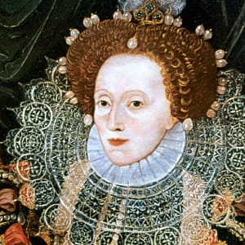
Elizabeth I is one of England's greatest monarchs – perhaps the greatest. Her forces defeated the Spanish Armada and saved England from invasion, she reinstated Protestantism and forged an England that was a strong and independent nation.
But she had a very difficult childhood and was fortunate to make it to the throne at all. When she was young, her father Henry VIII executed her mother Anne Boleyn. She was stripped of her inheritance and was imprisoned in the Tower of London.
Once she became queen, she encountered many other problems…

Task 1 – Elizabeth’s problems
In the table below are a list of problems that Elizabeth encountered when she became queen and while she was on the throne. You are to read each of the problems and write down a potential solution.
Problem | Solution
Religion  Mary I and her husband Philip II of Spain had made England Catholic again after Edward’s Protestant reign. Elizabeth is Protestant, the same as her mother Anne Boleyn, and wants to make England Protestant again but this would cause issues with the Catholics. | What should Elizabeth do?
Marriage  Elizabeth is in her mid-20’s when she becomes Queen. England desperately needs an heir as not having one may lead to a war. However, the next King has to be the right person as the wrong choice could lead to even greater problems. | What should Elizabeth do?
Mary Queen of Scots  Mary Queen of Scots is Elizabeth’s cousin and is next in line to the throne. She fled Scotland after the murder of her husband and some people might support her claim to the throne as she is Catholic. This might put Elizabeth’s life in danger. | What should Elizabeth do?
Starvation  When Elizabeth became Queen there were large food shortages. The population is growing, there have been a number of poor harvests & there is a lot of inflation. All of this is ultimately leading to people dying. | What should Elizabeth do?
War with France  When Elizabeth became Queen England was at war with France which was costing a huge amount of money which England simply did not have. | What should Elizabeth do?

Task 2 – Speech
Pick the two most important problems that you think Elizabeth needs to solve. Write a speech to convince someone that these issues are more important than the others
____________________________________________________________________________________________________________________________________________________________________________________________________________________________________________________________________________________________________________________________________________________________________________________________________________________________________________________________________________________________________________________________________________________________________________________________________________________________________________________________________________________________________________________________________________________________________________________________________________________________________________________________
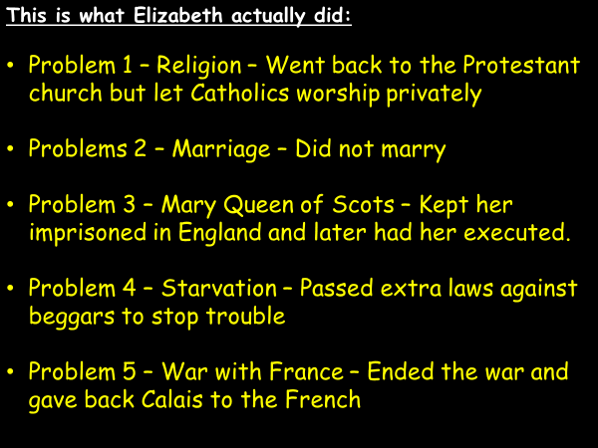

Task 3 - Compare what Elizabeth did to your suggestions.

Were you the same or different?
____________________________________________________________________________________________________________________________________________________________________________________________________________________________________________________________________________________

Was she right to do what she did?
____________________________________________________________________________________________________________________________________________________________________________________________________________________________________________________________________________________

Lesson 6 – Why do people get married?
Task 1 – Who should Elizabeth marry?
Below is information about five individuals that Elizabeth could marry. Read through the information on each candidate and complete the table on the next page:

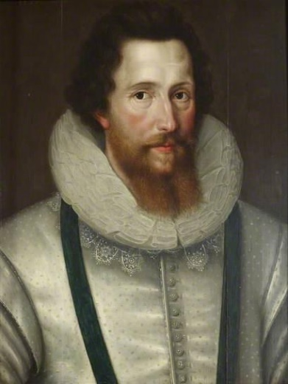
Robert Devereux, Earl of Essex.
Religion : Protestant
Wealth: Most gained from being the
only person allowed to import
sweet wine.
Land: Had a great deal of land and
different estates around
England.
Info: Fought in a lot of wars for
Elizabeth. He also advised
her at court. He was on the
Privy Council.
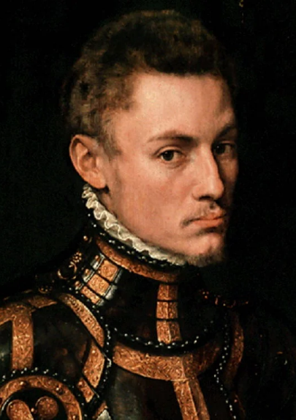
Prince William of Orange.
Religion: Protestant
Wealth: The Son of the Queen of
Holland. He had a large family
fortune, and would be an ally
against Spain.
Land: He owned a lot of what is called
Holland today.
Info: He was fighting a war with Spain
who controlled his country at
the time. He wanted Holland to
Robert Dudley, Earl of Leicester
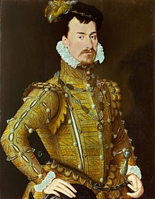
Religion: Protestant
Wealth: Made Earl of Leicester by Elizabeth.
He was one of the Queens
favourites. He made most of his
money trade and through activities
of the Elizabethan Court.
Land: Elizabeth gave Dudley a great deal
of land and country estates around
Britain.
Info: Dudley had known Elizabeth since
childhood. He was her Master of
Horse. Dudley’s young wife
Amy Robsart met her death in
suspicious circumstances. He was on
the Privy Council.

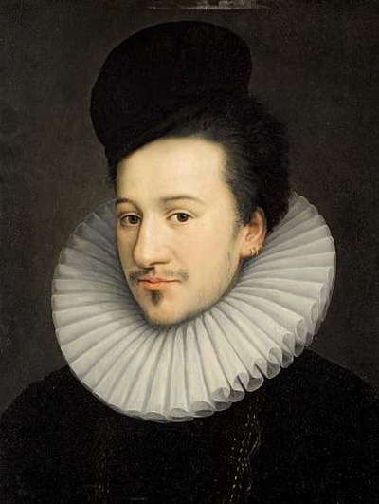
Francis, Duke of Alencon
Religion: Catholic
Wealth: He was the brother of the French
King. His family were wealthy. He
could create a powerful alliance
with France against Spain.
Land: His family were wealthy and he had
a title and many estates in France.
Info: French was a Catholic country but
did not hate Protestant England as
much as the Spanish. Some people
In England would be very angry if
Elizabeth married a Catholic. An
information leaflet against the
marriage was published in England.

Philip II of Spain.
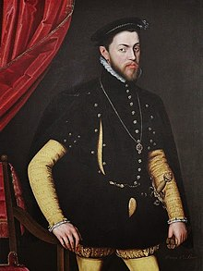
Religion: Catholic
Wealth: Spain was a very rich country. It
owned a lot of foreign countries and
brought back goods (including Gold) f
from South America.
Land: Philip was the King of Spain he
controlled Spain and some other
areas around the world.
Info: Spain had a large army. The Pope
was keen for Spain to fall out with
Protestant Countries. Philip had
ruled in England when he was married
o Mary 1st. Some people in England
would not like Elizabeth to marry a
Catholic.

Who should Elizabeth marry?
Name | Reasons she should marry him? | Mark out of 10
Robert Deveraux, Earl of Essex
King Philip II of Spain
Prince William, Duke of Orange
Robert Dudley, Earl of Leicester
Francis, Duke of Alencon

Elizabeth never married as there was always an issue that made the candidates unsuitable.
How well do you think Elizabeth dealt with the problem of marriage? Do you think she should have married?
____________________________________________________________________________________________________________________________________________________________________________________________________________________________________________________________________________________

Lesson 7 – Why do people fight?
Task 1 - Read through the information below and underline key reasons why Spain wanted to attack England.
Spain attacks England

In 1587, Francis Drake sailed on his cheekiest and most daring raid. He attacked ships being assembled for the invasion of England at Cadiz harbour. It was so successful it delayed Spain’s invasion for a year. Drake boastfully stated that he had ‘singed the King of Spain’s beard’.
Since 1570 Drake was raiding Spanish treasure ships. Elizabeth on his return received gifts such as emeralds, diamonds cloth of gold and silver tableware. Philip said that Drake should be handed as a pirate. Elizabeth, however, went on board the Golden Hind and knighted Drake with a sword.
Additionally, Elizabeth had been interfering with Spain’s affairs in Portugal and the Netherlands. In addition, Elizabeth was seeking friendships with other countries as she felt that Spain was becoming involved in plots against her. Finally, Elizabeth had turned down Philip’s marriage proposals and when Mary Queen of Scots was executed by Elizabeth in 1587, Philip decided to teach Elizabeth a lesson. He had become sick of Elizabeth’s attitude towards him and launched his Armada in 1588.

What are the key reasons why Spain wanted to attack England?
- __________________________________________
- __________________________________________
- __________________________________________
- __________________________________________
- __________________________________________

Now rank the reasons from most important to least important as to why Spain attacked England:
- __________________________________________ (most important)
- __________________________________________
- __________________________________________
- __________________________________________
- __________________________________________ (least important)
Think about and write below why have you ordered them in that particular way:
Lesson 8 – Why do teams win?
Task 1 - Reading
Read through the information on the Armada below:
Story of the Armada

On 12 July 1588 the Spanish Armada set sail determined to teach Elizabeth a lesson. After a week the Armada reached England and began sailing up the English Channel towards Calais in France. The English ships chased the Spanish up the Channel. The Armada anchored off Calais where they were waiting for Soldiers from the Netherlands. The English sent in Fireships and the Spanish scattered. The Spanish tried to sail around Scotland but storms wrecked many Spanish ships. Only two-thirds of the Spanish ships made it back to Spain.

With only the information above, can you identify three reasons why the Armada failed?
- ___________________________________
- ___________________________________
- ___________________________________

Task 2 – Videos
Watch the two videos below on YouTube about the Spanish Armada. As you watch the videos, complete the table below either writing down general facts about the Armada or reasons why it failed (you do not need to fill the table, just write down what you can)
Clip 1 – Failure of the Spanish Armada https://www.youtube.com/watch?v=34XrdXiOQTY
Clip 2 – Armada Doc (History Channel) https://www.youtube.com/watch?v=p5grtV_56rM

Facts about the Spanish Armada | Reasons why the Spanish Armada failed
Lesson 9 – What is failure?
Task 1 – Reasons for the failure of the Spanish Armada.
In the table below are a list of reasons why the Spanish Armada failed. On the right-hand side of the table, explain why each of the factors was a big or small reason why the Armada failed and then give it a mark out of 10 (10 being very important reason and 1 being not an important reason)

Cause of the Armada’s failure | Explain why it was important and /10
Tactics
The English sailed in a line of stern formation firing the cannons from range whereas the Spanish sailed in the crescent formation and relied on grappling hooks to board the opposition ships from close range
Ships
The English ships were sleeker and more manoeuvrable than the Spanish boats which were mainly just used to ferry men and as a result were slower and more cumbersome.

Sailors vs Soldiers
As the Spanish plan was to invade England, the men they had on board were soldiers and not sailors like the English. This meant they could not fire the cannons and were left open to an English bombardment.
Spanish failed plan
The Spanish plan was to meet with troops coming from the Netherlands at Calais. This never happened meaning that their plan ultimately failed.

Knowledge of the seas
As the Spanish attacked England, much of the fighting was in the English Channel. The English local knowledge of the seas meant that they could guide the Spanish into trouble meaning they were able to gain an advantage.

Leader
The leader of the English Royal Navy were the experienced Francis Drake and John Howard who were seasoned Pirates who knew the seas. On the other hand, the leader of the Spanish fleet was Medina Sidonia who had little / no experience at sea and was appointed because of his position in society
Spanish missed opportunities
The Spanish could have changed their plan to invade England at Plymouth while the English ships were trapped in port. They could have invaded and taken over. However, they stuck to their original plan of meeting up with troops at Calais
Fireships
The English set some of their fleet on fire and sailed them into the Spanish at Calais. This caused confusion and panic, the Spanish cut anchor and fled into the open seas allowing the English to pick off individual Spanish ships that were out of formation.
Weather
The storms blew and the Spanish ships could not cope, they were blown into the rocks and many boats were shipwrecked

Task 2 – English Skill or Spanish Mistakes?
Which was a more important factor for the failure of the Armada? Was it the skill of the English or was it the mistakes made by the Spanish?
___________________________________________________________________________________________________________________________________________________________________________________________________________________________________________________________________________________________________________________________________________________________________________________________________________________________________________________________________________________________________
Assessed Task 2
Finish off the sentence starters to complete your second assessed task of Year 7.
Compare two differences between the reigns of Henry VIII and Elizabeth I.
In this question, you are to identify two differences and explain the differences in detail. For example, with the question above, one difference could be their attitude towards marriage, with Henry being married six times, while Elizabeth never married at all. Try and think of another difference between Elizabeth and Henry to help answer your second paragraph

One difference between the reign of Henry VIII and Elizabeth I is marriage. Marriage is a difference because Henry VIII___________________________________________________
__________________________________________________________________________________________________________________________________________________________________________________________________________________________________________________________________________________________________________________________________________________________________________________________________________________________________________________________________. On the other hand Elizabeth I never married _________________________________________
__________________________________________________________________________________________________________________________________________________________________________________________________________________________________________________________________________________________________________________________________________________________________________________________________________________________________________________________________.

Another difference between the reigns of Henry VIII and Elizabeth I is ____________________.
____________________________________________________________________________________________________________________________________________________________________________________________________________________________________________________________________________________________________________________________________________________________________________________________________________________________________________________________________________________________________________________________________________________________________________________________________________________________________________________________________________________________________________________________________________________________________________________________________________________________________________________________________________________________________________________________________

Source A supports the Parliamentarians during the English Civil War? How do you know?
Explain your answer using Source A and your own knowledge.
One way that Source A supports the Parliamentarians during the civil war is ____________
___________________________________________________________________________________________________________________________________________________________________________________________________________________________________________________________________________________.
Another way that Source A supports the Parliamentarians is shown by _________________
___________________________________________________________________________________________________________________________________________________________________________________________________________________________________________________________________________________.

