Year 7 History Study Guide
British History: 1066-1688
• The Normans •
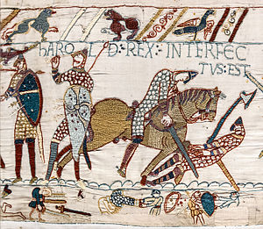

Contents

The Normans
Lesson 1 – Who should be in charge? | pg. 3
Lesson 2 – How do you become king? | pg. 6
Lesson 3 – Why do people build things? | pg. 9
Lesson 4 – Does it matter if people like you? | pg. 11
Lesson 5 – How do you get what you want? | pg. 12
Lesson 6 – What makes something useful? | pg. 15
Lesson 7 – Can you be a hero and villain at the same time? | pg. 16
Assessed Task 1 | pg. 18

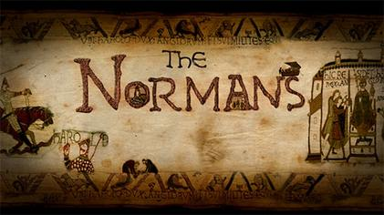

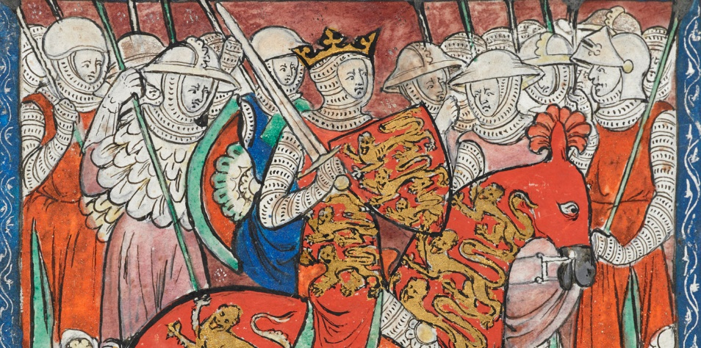

Lesson 1 - Who should be in charge?
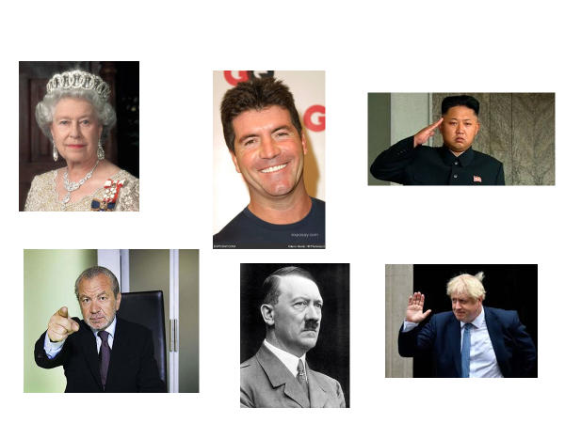
Task 1 - Starter activity

Task 2 - Leadership qualities
Complete the spider diagram below on the qualities, characteristics and traits a leader of a country should have:
A good public speaker

It’s 1066 and the King of England, Edward the Confessor, has just died. This is a very sad day. Especially as the King had no children – so who should be the next King of England?! There are 3 possible contenders…
Harald Hardrada - King of Norway
He was a powerful King and this would make him even stronger.
His grandfather, King Canute, had been King of England.
He wanted England’s wealth and riches.
He was supported by Tostig Godwinson, Harold’s brother. Tostig had fallen out with his brother and supported Hardrada to get revenge.
He had the biggest army, believed to be a massive 10,000 men (about 3,000 more than either of the other contenders).
William - Duke of Normandy
He said that Edward the Confessor had promised that he could be King.
In Normandy he was only a Duke, in England he would be King.
He could reward his followers with land and money.
He said that Godwinson had sworn an oath promising to help him become King. The Bayeux Tapestry shows this happening. When Godwinson then became King, William claimed that he was an ‘oath-breaker’ which was a very serious thing to be accused of at the time.
The Pope (the most important religious person on earth at this time) supported William against Harold ‘the oath-breaker’ and announced that he was fighting in the name of God. William received a lot of support from people who wanted to please God.
Harold Godwinson - Earl of Wessex
He was an important noble (rich man who owned lots of land) and leader of the English army.
His sister was married to Edward the Confessor
He was banished from England in 1051 after staging a rebellion against King Edward. When he returned to England in 1052 he received a lot of popular support so the King was forced to welcome him back in 1053.
He was shipwrecked near Normandy in 1064 and became a ‘guest’ of William of Normandy. Before he could leave he was made to swear an oath saying that he would marry William’s daughter and support William as the future King of England.
He was chosen as King by the Witan (English Parliament) when Edward died.
He was English and chosen by Edward.

Task 3 – Who should be king?
Using the information on the previous page, complete the table below detailing the positives and negatives of each contender to the English throne.

 | Positives | Negatives
William, Duke of Normandy
Harold Hardrada, King of Norway
Harold Godwinson, Earl of Wessex

Task 4 – Who do YOU think should be king?
Rank the contenders to the throne in order which YOU think they should be king
1. 2. 3.
I believe that _______________________ should become king because _____________
_______________________________________________________________________________________________________________________________________________________________________________________________________________
Lesson 2 – How do you become king?
Task 1 – Words into pictures/storyboard
Below on the left-hand side is a story about the Battle of Hastings. As you read the story, on the right hand of your page, draw a picture that describes that particular part of the story.

Battle of Hastings Story

Just after Harold Godwinson became King, Halley’s comet appeared in the sky. The Saxons (English) were really superstitious and saw this as a bad omen for the future.
King Harold heard that William was building a fleet of ships, so he marched his men to the south of England to wait for an invasion. The army was made up of Harold’s personal bodyguard, called Housecarls, Saxon nobles and many farmers who had to join the army when the King asked them to.
William was unable to sail for England straight away because the wind was blowing in the wrong direction so Harold and his army had to sit and wait. By September, Harold’s army was running out of food and many of his army had to return to their farms for the harvest.
While Harold was waiting for William, Harald Hardrada invaded England near York. On 20th September Hardrada’s army defeated a Saxon army at the Battle of Fulford, so King Harold marched his army 200 miles north to fight him. They met at the Battle of Stamford Bridge near York. The fighting was very fierce but King Harold won when Hardrada was killed. Thousands of soldiers died. When the Norwegians had sailed to England they had needed 300 boats to carry them. So many were killed that they needed only 24 boats to sail back.

Unfortunately for King Harold, while he was fighting Hardrada in the north, the wind had changed and William had been able to sail his army to England. He landed at Pevensey in the south of England, built a small castle and rested his army there. When King Harold heard about this he marched his army south, so for the second time in a month his men had marched over 200 miles. He arrived on the south coast of England on 13th October at a place near Hastings. The next morning William’s army were ready to fight them.

Harold had between 5 and 7,000 men, mostly on foot, who carried long swords, battle-axes and shields. They tended to fight by locking their shields together to form a shield wall to defend themselves, then charging forward to attack. William’s army were well rested and ready for battle There were between 5 and 7,000 men who were mostly well trained soldiers. They had foot soldiers, but also archers and cavalry on horseback. They believed they had God on their side because the Pope supported William.

The battle started on a hill, with Harold’s men on the top and William’s at the bottom. William attacked early in the morning before Harold had time to get ready. Although the attack was quite successful, the Saxon shield wall held them back. The fighting then continued for most of the day. William’s men would charge up the hill or fire arrows at the Saxons, only to be beaten back by the shield wall. At one point the Normans believed that William had been killed, so he took off his helmet and rode around to show that he was still alive. This stopped his army from running away.

Late in the afternoon, William tried a new plan. He told some of his men to pretend to run away. When they did this, the untrained Saxon soldiers thought they were winning and began to run down the hill after them. When this happened William’s cavalry turned and killed many of the Saxons.
William was able to win the battle early in the evening, partly because of his trick and partly because King Harold was killed. The final Norman attack finally pushed the Saxons off the hill and the remains of Harold’s army ran away. William had won.
After the battle, William slowly made his way to London, defeating any remaining resistance on the way. He had himself crowned King of England on Christmas Day 1066, the year that England had 3 Kings.

Task 2 – Why did William win?
In the space below, write down as many reasons as you can think of why William won the Battle of Hastings.

Lesson 3 – Why do people build things?
Task 1 – Buildings from different times
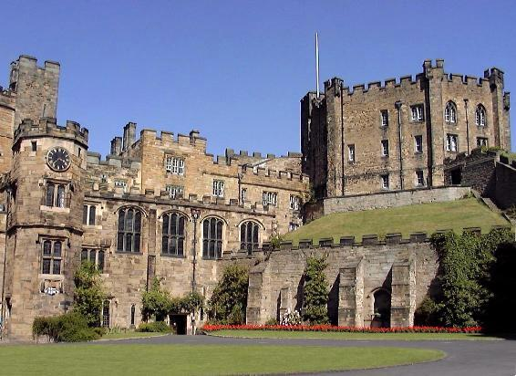
Building 1 Building 2
What do you notice about both buildings?
_______________________________________________________________________________________________________________________________________________________________________________________________________________
Are they impressive buildings? Why?
_______________________________________________________________________________________________________________________________________________________________________________________________________________
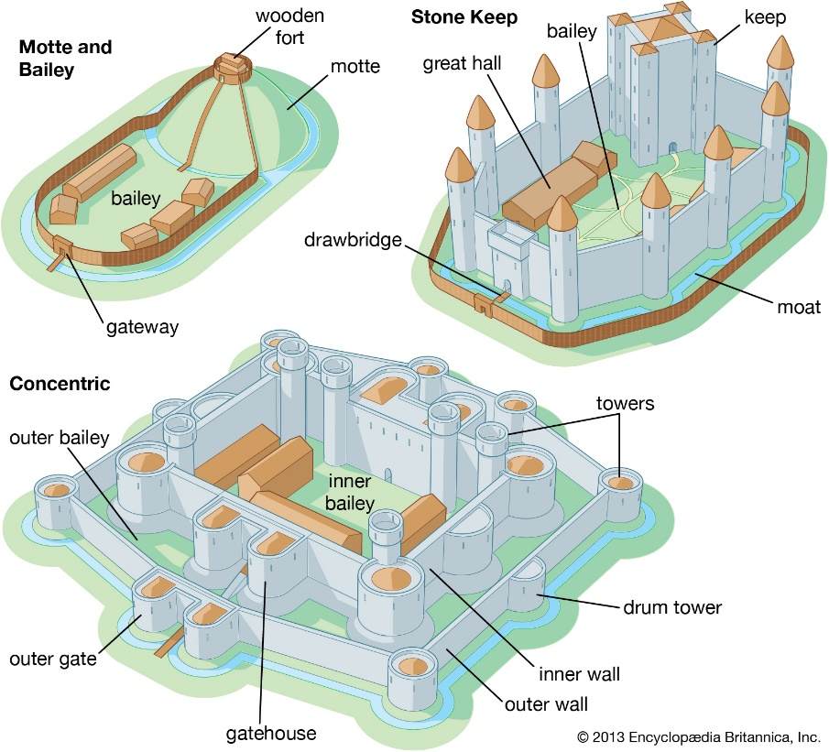
Types of Norman castles

Task 2 – Why did the Normans build castles?
Task 1 - Using a highlighter, identify as many reasons as possible why the Normans built castles:
The Normans knew that with only 10,000 soldiers in England, they would be at a disadvantage if the one and a half million Anglo-Saxons decided to rebel against them. To defend the land the Normans began building castles all over England.
The Normans built wooden castles at first because they were really quick to build. When William had been King of England he ordered everyone to build huge stone castles.
The Normans built their first castle at Hastings soon after they arrived in 1066. They looked for sites that made it more difficult for their enemies, such as on top of a steep hill.
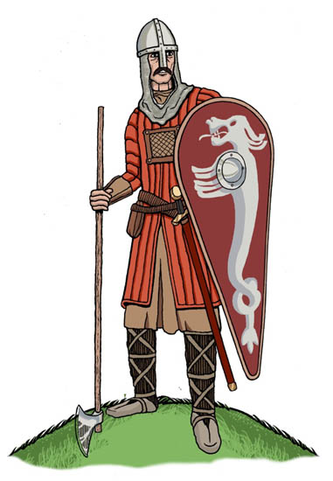
The first castles were built in the Motte-and-bailey style and made of wood. This was a mound with a castle on top and with a courtyard next to it. The courtyard was linked to the mound by a bridge. If enemies got inside the courtyard, the bridge could be pulled up to keep them away from the tower. The whole thing had a ditch round it, this was filled with water and became known as a moat.
Knights stayed in the castle when they were working as soldiers to protect it. Usually they would work for 40 days, and then have 40 days off when another knight would come and take their place. Knights had lots of weapons such as daggers, bow and arrows, axes and shields.
Castles were a sign of how powerful the Normans were. They could be easily seen. The castles warned the English that Norman soldiers were close by and that any attempts to fight back against them would be met with force.
Castles were a very good way for the Normans to keep control of the English people. There were a lot more English than Normans so the Normans wanted to scare them so they would do as they were told.
The Lord of the Castle and possibly his family would live in the safest part of the castle - the Tower or the Keep. Servants would have to provide food for the nobles (rich people) and soldiers. The soldiers were well paid and lived within the courtyard of the castle. Other people had different jobs in the castle such as the Blacksmiths, the stable hands and the kitchen staff.
William the Conqueror said that all the land in England belonged to him. William kept about a fifth of this land for his own use. The rest was given to the men who had helped him win the Battle of Hastings.

The castles gave the Norman soldiers a safe place to live. William had built a temporary castle at for his troops when they first landed in September 1066. This would have been a wooden motte and bailey castle.
The day to day running of a castle was done by a steward, whose jobs would include ordering food, organising repairs and looking after the prisoners. There would be lots of people reporting to the steward such as blacksmiths, carpenters, stonemasons, cooks and armourers.

Lesson 4 – Does it matter if people like you?
Task 1 – Video
If you have access to a computer, watch the video clip about revolts and resistance during William’s reign.
Link - https://www.bbc.co.uk/teach/class-clips-video/history-ks3-ks4-1066/zd32t39

Task 2 – The Harrying of the North
1. Between 1066 and 1070 there were lots of rebellions against William, especially in the north of England. William needed to prove that he was in control of the country | 2. William tried to put people in charge in the north who would keep control. He sent two people to rule there but both were murdered soon after. A man called Edgar decided to start a rebellion.
3. Edgar was supported by many people and they marched to York. William sent an army to stop them. His army was big and the rebels knew they could not win so they ran away and the rebellion was over | 4. As a punishment, William’s men burnt down whole villages in the north. People and animals were killed. Salt was put onto the land so that nothing would grow for years. Some people became cannibals.
Complete the storyboard on the Harrying of the North, drawing pictures to match the statements below
Lesson 5 – How do you get people to do what you want?
Task 1 – School hierarchy
Wherever we go, there is usually someone in control. This school is a good example.
Complete your own version of the diagram below, showing who is in control in the school.

DEPUTY HEADTEACHER
TEACHERS
HEADTEACHER
GUIDANCE MANAGER
STUDENTS
ASSISTANT HEADTEACHER

Task 2 – The Feudal System – how does it work?
Read the information about the feudal system below.
Once William had become King of England, he had to decide how he was going to govern the country. He didn’t want the old English nobles to keep their estates, because they would be too powerful and might try to overthrow him. Anyway, they had to make room for William’s supporters who had been promised land in return for helping him.

William was very careful not to just give land away. His supporters were rewarded, but they had duties to perform as well. This system of duties and rewards was known as the Feudal System. In Normandy when barons were given land they had to swear an oath of loyalty to the lord who was giving it. This was called doing homage. By swearing the oath, the barons agreed to provide knights (mounted soldiers) to guard castles or fight in wars for the king. The more land the baron was given, the more knights he had to provide.

The picture below shows a baron paying homage to the king. Paying homage meant that he promised to be loyal and to fight for him. When a baron was paying homage, he had to swear the following oath of loyalty:

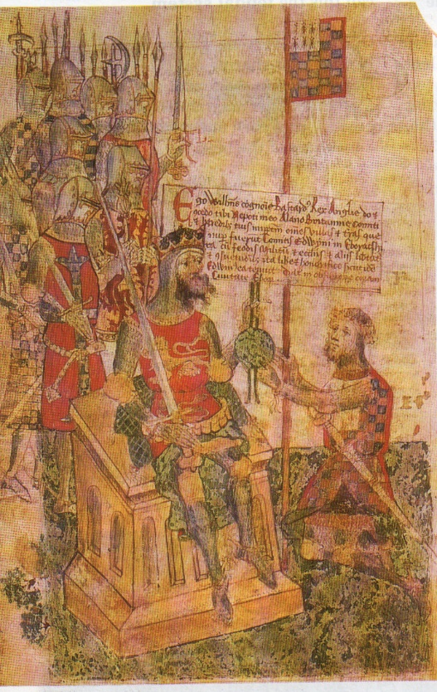

I become your man from this day forth. I shall be true and faithful to you for the lands I hold from you.

The barons sometimes had their knights living with them in castles. Usually, however, they gave some of their own land to their knights, who in return did homage and agreed to fight when asked. The knights kept some land for themselves and shared the rest amongst the peasants who farmed it. The peasants did homage to the knights who, in turn, promised to protect them.

In return for their land the peasants had to carry out various duties for the knights. They had to:
• fight if needed
• Not leave the knight’s land unless the knight agreed
• Work on their lord’s land for three days a week.
• Give gifts of chicken and eggs to their lord at Christmas and Easter.

The feudal system proved ideal for distributing the land of the newly-conquered England. William could have a large army whenever he liked, without the expense of keeping soldiers at his royal court. He also made sure that his supporters were rewarded, and at the same time loyal to him. See the diagram on the right for a summary of how the feudal system worked.

Now that you have read the information about the feudal system, complete the tasks below:
Tasks

1. Copy this passage into your book, filling in the gaps.

William did not want the ____________ nobles to keep their land. He wanted to give it to his _____________. As well as receiving land, the nobles had to swear an ___________ and agree to do ________________. William needed an army so the nobles had to promise to provide _______________ for him. The nobles already knew about this system because it was used in ________________. It was called the _____________ system.

2. Explain what the following were in Norman England:

a. a baron ________________________________________________________________________
b. a knight ________________________________________________________________________
c. doing homage _________________________________________________________________

3. Imagine that you were able to carry out a radio interview with the following people:
Your first question to them is ‘Do you think the Feudal System is fair?’
What answer do you think each person would give?
a. an English noble_________________________________________________________________
_________________________________________________________________
_________________________________________________________________
b. a Norman baron_________________________________________________________________
_________________________________________________________________
_________________________________________________________________
c. an English peasant ______________________________________________________________
_________________________________________________________________
_________________________________________________________________

Lesson 6 – What makes something useful?
Task 1 – Source work
Below are four sources that tell us information about the Norman period. For each source, see if you can identify:
- Who has written it?
- What is being said or discussed in the source?
- Where was the source written?
- Why was the information written, said or drawn?
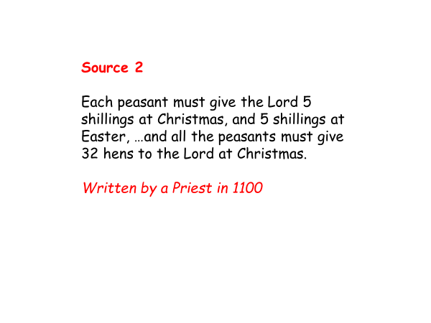
- When was the source written?
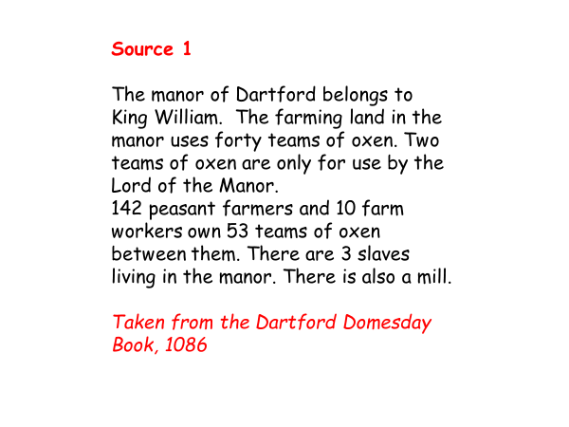

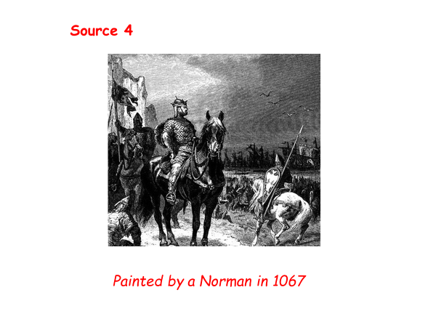
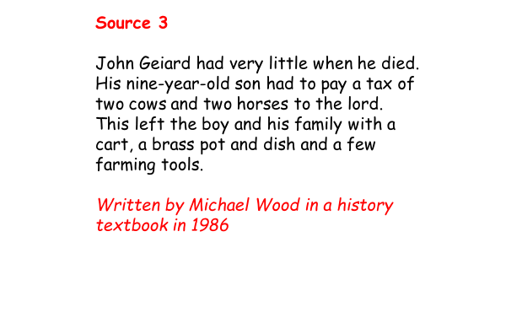

Task 2 – On the continuum below, plot each source from most to least trustworthy – think about why you might trust one historical source, more than another.
Trustworthy
Untrustworthy

Lesson 7 – Can you be a hero and a villain at the same time?
Task 1 – Hero or Villain
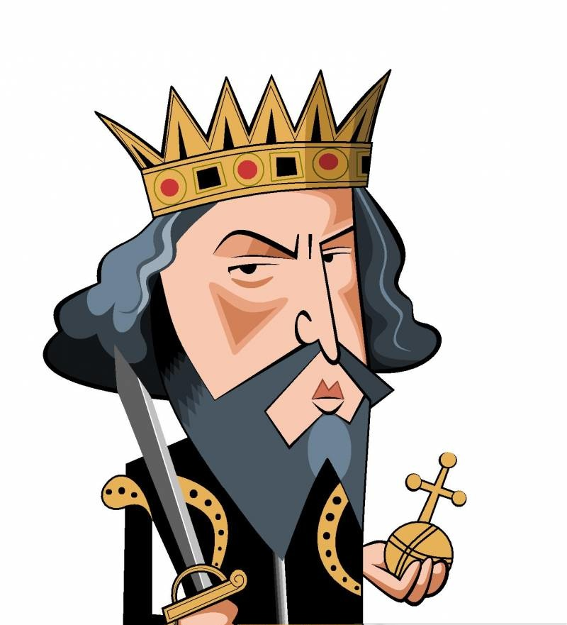
Read through the cards below and on the table on the next page, write down the statements that describe William as a hero or a villain on the correct side. The closer to the top it is, the more heroic/villainous it is. You can put some of the statements in the middle too.

William won the Battle of Hastings | William made the Domesday Book | 100,000 died in the Harrying of the North
All English Kings and Queens since 1066 have been descended from William | William shared England out among his Norman friends | William had a well organised army
Harold had to march over 500 miles before Hastings | William used a trick to win the Battle of Hastings | The Pope supported William
When William died his courtiers stripped him of his clothes and jewels | William was from Normandy, not from England | William used fear to control the English
William ruled England for 25 years | William crushed revolts all over England so he looked strong and powerful | William took control of England
William had over 90 castles built in England | The wind changed direction while Harold was fighting Hardrada | After the Harrying of the North William made sure that people could not grow crops there for years

Hero | Villain

Task 2 – Hero or villain? You decide!
Below, write a paragraph to explain whether you think William was a hero or a villain. Remember, you must support your judgement with evidence.
________________________________________________________________________________________________________________________________________________________________________________________________________________________________________________________________________________________________________________________________________________________________________________________________________________________________________________________________________________________________________________________________________________________________________
Assessed Task 1
Finish off the sentence starters to complete your first assessed task of Year 7.
Why did William win the Battle of Hastings?

One reason why William won the Battle of Hastings was due to his skill. There are a number of examples that meant William’s army was well skilled and trained such as _____________________
_________________________________________________________________________________________________________________________________________________________________________________________________________________________________________________________________________________________________________________________________________________________________________________________________________________________________________________________________.
This meant that William won the Battle of Hastings because______________________________
___________________________________________________________________________________________________________________________________________________________________________________________________________________________________________________________________________________________________________.

Another reason why William won the Battle of Hastings was because of the mistakes Harold Godwinson made. Harold and his army were troubled by many mistakes such as _________________
_________________________________________________________________________________________________________________________________________________________________________________________________________________________________________________________________________________________________________________________________________________________________________________________________________________________________________________________________.
Therefore, Harold’s mistakes led to William winning the Battle of Hastings because_____________
___________________________________________________________________________________________________________________________________________________________________________________________________________________________________________________________________________________________________________.

Overall, the most important reason as to why William won the Battle of Hastings was _______________________________________. This is because _______________________
______________________________________________________________________________________________________________________________________________________
______________________________________________________________________________________________________________________________________________________

