Paper 2 - Restoration England, 1660-1685
Part 1: Crown, Parliament, plots and court life

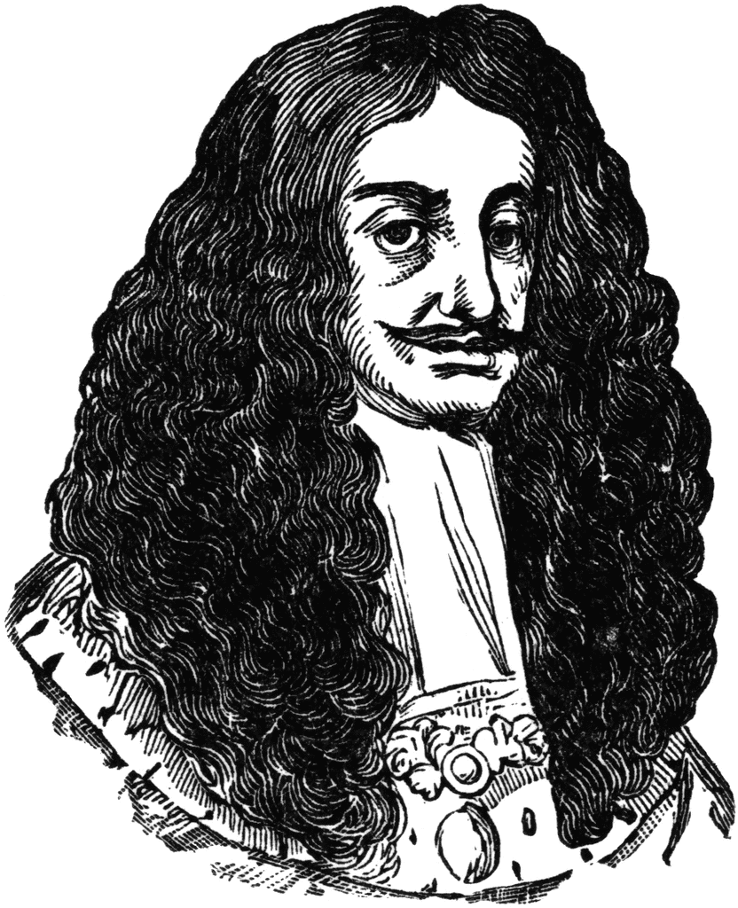

Name:__________________________________________

Pre-Restoration
Civil War – 1642 to 1648. It was fought between Parliament’s armies and those loyal to King Charles I. Oliver Cromwell, who was an MP and military commander led Parl and Charles was taken prisoner in 1648. MPs were unsure what to do with Charles I but after a trail, he was found guilty of treason and was executed in 1649.
Between 1649 and 1660 there was no king – this period is called the Interregnum. Cromwell dismissed Parliament and took on the title Lord Protector. Cromwell was a strict Puritan – he made it a crime to celebrate Christmas and he closed all the theatres and most of the pubs and inns across the country.
King in exile
Charles I’s son, Charles, had fled abroad. Although he was crowned king of Scotland, Cromwell’s men defeated Charles’s supporters and he was forced to escape.
Charles spent a lot of his time in France with his cousin, Louis XIV.
Louis XIV was an absolute monarch (total control over the state).
Charles liked a lot of Louis’s court in France and it later inspired him for his own palaces.
However, his time in France made him appreciate how he must balance his power with Parliaments.
TASK 1
What happened to Charles I (future Charles II’s father) in 1649?
_______________________________________________________________________________________________________________

Name two effects of Cromwell taking over and becoming Lord Protector
______________________________________________________________________________________________________________________________________________________________________________________________________________________________

Use the information on the previous page to help you complete the storyboard.
1. Charles relied on others help. He travelled around with little ________. | 2. Charles spent a lot of time with his cousin, __________. | 3. King Louis was known as the Sun King and his palace was ______ and ___________. | 4. Charles’s time at Louis court gave him ideas for his own future palace.
5. Charles wanted to return to ___________. | 6. England was currently being ruled by _____ ___________ who was an important civil war leader. | 7. C_______ was supported by Puritans who wanted England to be even more Christian. | 8. Cromwell fought those who challenged his a_________.  Stories emerged of slaughtering commited by Cromwell in Scotland and Ireland.

Restoration
- Oliver Cromwell died in 1658 and many MPs were sympathetic and considered restoring the king. From his base in the Netherlands, Charles issued the Declaration of Breda. Charles promised to:
- Keep peace in the Kingdom, to listen to Parliament, not to punish people for fighting in the Civil War, to tolerate religion and to pay the army.
- HOWEVER, Charles was not prepared to forgive those who killed his father.

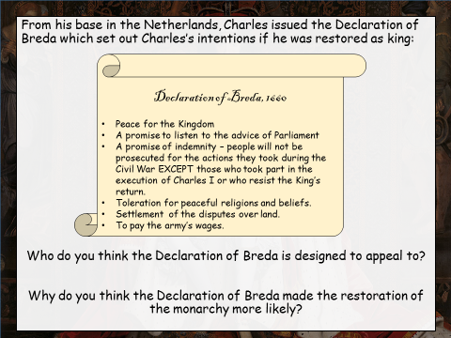
TASK 2 – Read through the Declaration of Breda and answer the questions below.
Q1_________________________________________
___________________________________________
___________________________________________
___________________________________________
___________________________________________
___________________________________________
___________________________________________
___________________________________________

Q2________________________________________
___________________________________________
___________________________________________
___________________________________________
___________________________________________
___________________________________________
___________________________________________
___________________________________________

TASK 3 - Charles’s challenges
The Civil War had divided England between supporters of the King and supporters of Parliament.
A number of well trained and armed soldiers who had not been paid were a threat to law and order.
The army needed to made smaller and brought under the control of the King or Parliament.
Supporters of the king had been punished by having their land confiscated. It was now up to Charles to heal the wounds.
Charles also had to deal with those that had put his father on trail and had him executed.
Dissenting religions had sprung up and Catholics had been fined and persecuted.
After the Civil war there was a great deal of religious difference.
Communities and families had been split and these wounds would not heal quickly.
Many soldiers in the army did not want to see the King restored.
As Royalists had lost some of their land, Charles returned this to them.
There was division in the Protestant faith between Nonconformist and Anglicans.
England was so religiously divided that Charles II would need to establish a religious settlement.
High taxes were needed to pay the soldiers’ wages.
Thousands had died in battle and homes had been destroyed.
The different Nonconformist faiths did not trust the Anglicans and wanted greater religious freedom.
Charles made a conscious decision to be a public monarch. This was an important part of the healing process.
Bishops had lost their jobs and cathedrals had been left empty and fallen into disrepair
Charles I said he was a Protestant but many of his actions were very Catholic (e.g. he married a Catholic).

Here are a list of the challenges
Charles II faced as he returned
to England. Using different colours,
try and categorise the different
challenges Charles faced and write
the different categories in the space
below.

- Civil War – communities and families had been split and these wounds would not heal quickly. Emotional scars, land taken away from people.
- Commonwealth/Cromwell – Eng completely changed. Eng now had a professional army that was powerful. The army had also not been paid and were a threat to law and order.
- Religion – Although Charles I claimed he was a Protestant, many in Eng felt he was a Catholic. There was also division in the Protestant church – Nonconformists did not like Anglicanism.
What did Charles do?

Army  - Soldiers were paid  - After they were paid they were disbanded and Charles created a new smaller army.  - Soldiers were also protected for anything they did during the civil war | Religion  - Even though Charles II wanted toleration of religion it did not happen.  - Parliament created the Clarendon Code which meant that strict Anglican Christian rules had to be followed.
English people after the war  - Any land taken from royalists after the civil war was returned to them to try and heal wounds. | Those who executed Charles I  - Indemnity and Oblivion Act 1660  - Those involved in Charles I’s trial and execution who had not fled were put on trail and hung.  - This included Oliver Cromwell’s dead body which was dug up so that the same punishment could be carried out on him.

Charles and Parliament
Clarendon Ministry (1660-67)
- Religion – number of STRICT laws called the Clarendon Code = hard to be anything other than an Anglican e.g. ’61 Corporation Act = public office holders swear allegiance to Crown and Church of England and ’64 Conventicle Act – no religious meeting involving more than 5 people (apart from Anglican).
- Charles was not happy – Clarendon Code a clear attack on religious freedom.
- Money - Aim to increase Brit wealth. Build new colonies and tax foreign goods. Parl paid Charles his annual grant. There were unpopular taxes however on the number of fireplaces
- Foreign Policy - 2nd Anglo Dutch War – v. unpopular. CII had run out of money. Dutch sail up the Thames and raided the Medway – v. embarrassing attack from a foreign rival = Clarendon Ministry removed from power.

Cabal Ministry (1667-1673) – made up of 5 people who disliked each other and spent a lot of time arguing.
- Money - Parl controlled Eng finances. MPs were unwilling to give money to a gov they did not support.
1672 – Crown admitted it could not pay its debts resulting in humiliation of Charles.
- Foreign Policy - CII entered another war (despite losing the last). Many believed the war was part of a plan to make Eng Catholic again. Secret Treaty of Dover = alliance with Catholic France. Parliament did not give Charles the money for war and it had to been abandoned.
- Religion - 1672 – CII issued Declaration of Indulgence – stated that Cath and Noncons could practise religion freely. DIRECTLY went against the Clarendon Code. Parl pressured the King and he backed down. Test Act passed in 1673 meaning no Catholics could hold position of authority.
Danby Ministry (1673-1679) – Cabal suspicious of him.
- Foreign Policy – Humiliated in foreign policy – delay in money from Parl for war with Fra & Neth. Also discovered secret negotiations between Danby and Catholic France. Danby was to be put on trial but CII wanted to avoid so ended Cavalier Parliament.
- Religion – Danby struggled to control Parl who wanted to make everyone Anglican vs. tolerant king.

TASK 4 – Summarise the information about each Parliament and write it in the space below.
Clarendon Ministry | Cabal Ministry | Danby Ministry
How successfully did Charles work with Parliament?
- Money – Received money from Parl annually – prevented conflict. However, CII didn’t always receive the full amount. CII had to give in to his requests for religious tolerance to secure money for wars.
- Foreign policy – Cath French vs Protestant Netherlands. Unhappy about Eng supporting Catholic country. Lack of money for war = conflict. Embarrassed CII by not providing money in time. Danby secret negotiations = For Pol that ended the
- Religion – Tolerance of Cath vs Strict Anglicanism. Fear of James being Catholic/CII supporting Catholics. Clarendon Codes too far but acceptance between both. Exclusion Crisis shows how far Parliament were prepared to go to stop a Catholic becoming king.

How successful do you think the relationship between Charles and Parliament was?
___________________________________________________________________________________________________________________________________________________________________________________________________________________________________________________________________________________________________________________________________________________________________________________________________________________________________________________________________________________________________________________________________________________________________________

Popish Plot
Causes
- Parl dominated by Anglicans. Using Clarendon Code, they wanted to make sure no other religions could dominate.
- Catholic conspiracies had existed for many years and concern emerged when people started thinking that Charles might make the country Catholic.
Events
- Kirby tells CII that people are plotting to kill him. Tells him to speak to Israel Tongue.
- Tongue told him 100 Jesuits (Catholics who try to convert Protestant) are in a plot to kill kim. CII did not listen, however, James hears and orders investigation.
- Titus Oates’s name keeps appearing in the investigation – appears before Privy Council.
- Very detailed and convincing – 43 allegations are made against groups and people.
- Protestant MP Edmund Godfrey’s (was present in Oates’s Privy Council meeting) murdered body discovered. Seems that Catholics are involved when Oates then accused 5 other Lords of being involved = MASS PANIC and ANTI CATHOLIC FEELING.
- Becomes apparent that Titus Oates’s story is a lie – evidence used was all forged/made up.
- Oates was arrested and imprisoned however 22 innocent people had been executed.

Consequences
- Even though it was a lie, the Popish Plot had serious consequences for Catholics.
- Anti Catholic feeling present all along. Shaftsbury keen to intro more anti-Catholic measures.
- Led to the Test Act = impossible for Catholics to serve in positions of authority.
- Set off the Exclusion Crisis – could the next king really be Catholic?

TASK 5 – Question and answers – without going back and reading through the Popish Plot again, try and answer the 5 questions below. Don’t worry if you give a wrong answer, as when you are reflecting and checking your answers, you can correct it.

- What was the name Kirby gave to Charles II?
__________________________________________________________________________________________________________
- What did the plot involve?
____________________________________________________________________________________________________________________________________________________________________________________________________________________
- Whose murder caused panic and attacks on Catholics?
__________________________________________________________________________________________________________
- When did it become clear that Oates’s story was a lie?
__________________________________________________________________________________________________________
__________________________________________________________________________________________________________
- How many innocent people were put to death?
__________________________________________________________________________________________________________
- What were the consequences of the Popish Plot?
__________________________________________________________________________________________________________
__________________________________________________________________________________________________________

Exclusion Crisis/Parliaments
- CII = 20 outside of his marriage. These children could not become king or queen. Without an heir, next in line was his brother James.
- James was part of Charles’s government but he converted to be a Catholic. Chose to give up his role as Lord High Admiral rather than give up his faith.
- Even though the Popish plot was false, it raised fears that CII wanted Eng to be Catholic.
First Exclusion Bill – Habeas Corpus Parliament
- May 1679 – Bill introduced to exclude James from becoming king next.
- Charles felt he had enough support in Parl for the Bill to fail – he was wrong.
- The bill passed but Charles dissolved Parl.
- The problem did not disappear and Charles’s oldest illegitimate son the Duke of Monmouth still held influence. As Parliament was closed there could be no exclusion of James.
Second Exclusion Bill – Exclusion Bill Parliament
- New elections were held – the Whigs did v. well.
- CII knew the Whigs supported excluding James, so CII delayed Parl meeting.
- 1680 – new bill introduced – Shaftesbury called on people to criticise the king.
- Charles dismissed Parliament again people thought there might be another Civil War.
Third Exclusion Bill – Oxford Parliament
- New elections held again. Relations between Charles and Parl the worst they have been.
- James accused of being a traitor.
- Final Exclusion Bill introduced – Charles closes Parl a week later.
- Shaftsbury arrested for high treason but because of angry public and little evidence, he is released.
- Tensions were high when CII became ill in 1682 – Shaftsbury plotted rebellions but ended up fleeing the country.
- 1685 – CII dies, converts to being a Catholic on his deathbed and James becomes king.

TASK 6 – Make notes on the Exclusion Crisis and the three Exclusion Bills

Rye House Plot

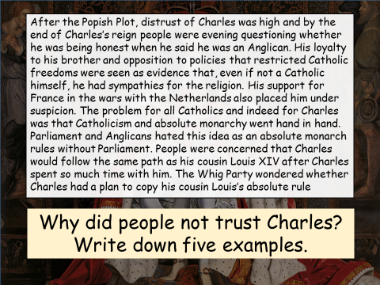
TASK 7 – give five examples of why people did not trust Charles II
1._____________________________________________
2.______________________________________________
3.______________________________________________
4.______________________________________________
5.______________________________________________

Causes of the Rye House Plot
- People did not trust CII – v. loyal to his Cath brother, supported Cath France, fear that CII wanted to copy his Catholic cousin Louis XIV of France and rule Eng as an absolute monarch (doesn’t listen to Parl)
Events
- Small group of men plot to kill CII and James – make Duke of Monmouth King.
- Plan? – ambush and kill CII & James at Rye House on their way home from Newmarket races.
However, they left early and no attempt to assassinate was made.
Consequences
- CII wanted to make an example of the plotters. Excuse to treat Protestant opponents harshly.
- Number of Protestants were executed and some were forced to leave Eng. Many more arrested.
- Plot gave CII chance to destroy opponents of his reign/his brother succeeding him.

Merry Monarch
Many celebrations when CII returned to Eng. Did he just want to have fun or planned for public image?
- Marriage – need for an heir meant he needed a suitable bride. Marries Portuguese Catherine of Braganza. Has Anglican and Catholic ceremonies. Catherine = Catholic = lack of trust. 3 miscarriages. Despite CII’s affairs, stayed married.
- Mistresses/illegitimate children – At least 20 illegitimate children. Gave them titles. Charles’s mistresses became high profile figures including Nell Gwynn. One mistress, Lady Castlemaine held so much sway she was called the ‘uncrowned queen’.
- Visible king – Dedicated a lot of time to public appearances/almost like a celebrity. They had to be carefully managed but were relaxed and informal. Court seemed much less formal than previous kings.
- Party time – Famous for parties and banquets. Mid-afternoon, hundreds of dishes with lots of wine. Parties and banquets established CII as the centre of attention/show off his and the country’s wealth.
- Sports, arts and sciences – much time and money. Founded Royal Observatory and supported Royal Society (scientific organisation). Also took an interest in theatre and architecture (Christopher Wren). Founded Royal Hospital Chelsea for retired soldiers. Enjoyed horse racing and spent a lot of time at the races.

TASK 8 – With one end being positive and another end of the continuum being negative, plot the statements above as to whether Charles II was a good king or not an explain why you have placed them there.

Acting like an idiot! Genius; great public image!

Charles’s Court
- Centre of Government and key offices but also the centre of English social life/fashion.
- Only way to affect decision making – being in Charles inner circle.
- Combination of politics and social life = CII’s court was full of rumour scandal and conspiracy.
- Style of rule and government heavily influenced by France.
- Privy Council – private matters, men who held positions in Gov. Advised king but couldn’t force him.
- Lord Chancellor – Chief legal officer = v. senior.
- Lord Treasurer – Resp. for finances.
- Exchequer – Collected money owed to the king – normally ran by a committee.
- King – Final say on matters and appointed ministers, but not completely free as had to keep opponents happy/avoid conflict with Parl.
Restoration architecture
Classics features were symmetry, columns, brickwork made to look like supporting columns, a covered porch with columns, geometric shapes.

Baroque Decoration
The inside of buildings started to become influenced by Baroque decoration. This used lots of carved wood, panelling and columns. Furniture, curtains and bedclothes were often made of expensive and brightly coloured velvets.

Court Fashions
Changes in clothing also reflected changes in relations with France and political currents in England. For instance, at the start of his reign large curly wigs and elaborate clothes reflected French fashions. Women wore lose revealing dresses. Charles then made changes so that long coat, waistcoats and short trousers over tights were worn. By the end of his reign the French had more influence again. Women’s fashion had become much more fitted. Men’s collars and cuffs began to grow as did their wigs.

The court of King Charles
The Royal Court was where the public and private life of Charles met. It was the centre if English social life and fashion, but it was also the centre of government. The Royal Court was the access point to the King, Charles had his favourites and they influenced his decisions. Favourites included his ministers, mistresses and friends. The Restoration saw positions of government become increasingly powerful The combination of politics and social life meant that Charles’s Court was always full of rumour, scandal and occasional conspiracy!
There were three different parts to the Court.
1 – The Household looked after the King’s food and lodgings.
2 – The Chamber was responsible for the public ceremonies at which the King showed off his wealth and power to the kingdom.
3 – The Bedchamber was staffed by those who looked after the King’s private life.

Rakes, reality and Restoration comedy
The Court was also packed with ‘wits’ or ‘rakes’. The ‘rake’ was a character often seen in Restoration comedies, political plays written and performed during Charles II’s reign.

The impact of the French Court
In many ways, Charles based his Court on that of his cousin, King Louis of France. The problem for Charles was that he was not an absolute monarch like Louis.

Patronage and Access
The King and his courtiers used the Court as a way of distributing patronage. This encouraged courtiers to try and set up the King with new mistresses. In return for receiving patronage, a ‘client’ was expected to support their patron and give favours in return. However, patronage could also lead to misfortune. If a patron suffered political defeat or disgrace, then this could lead to difficulties for clients.

Who had the power?
King – Had the final say on all matters and appointed his ministers.
Lord Treasurer – Responsible for all the Kingdoms finances.
The Privy Council – Key advisors to the King. There was an average of 60 members.
Lord Chancellor – Chief Legal Officer for the country.
The Exchequer – Collected money owed

TASK 9 – Use the information from the previous page to annotate your graphic organiser below.
TASK 10 - RESTORATION – PART I: CROWN, PARLIAMENT AND COURT LIFE EXAM QUESTIONS

Write an account of the ways in which the Restoration of the Monarchy affected England at this time. (8 marks)
*TIP* - Go back to TASK 3 and look at the categories you made for the issues that Charles II had to solve when he returned to England - *TIP*
Structure your answer as followed – Point Evidence Analysis…EA…EA Link

Interpretation A
Adapted from a Daily Telegraph review of a book about Charles I by Malcolm Gaskill, first published 4 October 2009
Energies suppressed in state matters ran wild in the bedroom. Charles liked riding and tennis, and lapped up jokes and gossip. But his passion was women and plenty of them. Nell Gwyn, sloe-eyed and streetwise everyone knows. What, though, of Barbara Castlemaine, the peer’s wife who bore Charles four children in as many years. This sleazy decadence and the court’s eye-popping extravagance, harmed the kings image.

How convincing is Interpretation B for informing us as to whether Charles II was a ‘merry monarch’? (8 marks)

*TIP* - Go to TASK 8 - read the information about Charles II being a merry monarch – use this information to help answer the question - *TIP*
Things to consider when answering this question:
- Why is the source CONVINCING? (What does the source tell and what other OWN KNOWLEDGE can we use to support this)
- Why is the source NOT convincing (What does the source miss out about Charles being a merry monarch – USE OWN KNOWLEDGE)
- Do you agree or disagree with this interpretation – identify how persuasive or accurate you believe the interpretation to be.

TASK 11 - Glossary – use your study guide and the internet to try and write definitions for the words below.
absolute monarch
Anglican
Cabal Ministry
Catholic
civil war
clergy
colony
House of Commons
Commonwealth
conspiracy
coronation
dissolve
divine right
effigy
Exclusion crisis
execution
exile
grant
heir
illigitimate
Interregnum
Jesuit
legitimate
House of Lords
noble
Nonconformist
patron
pauper
persecute
Pope
Privy council
Protectorate

Protestant
Puritan
regicide
republic
royal court
Royal Society
royalist
Tory
treason
Whig

