NAME:
Study Guide Restoration England 1660-1685 - Part two: Life in Restoration England

England in 17th century
It was the centre of political and economic life in England and was fats becoming one of Europe's most important cities. It's population was expanding fast:- 1650 population was 350,000 and 700,000 by 1700 (bigger than Paris).
London had 2 centres - City of London (in the east and was the economic centre) and Westminster (in the west and the political centre).

Crisis in London
The Great Plague 1665
Actual causes
Rats had a bacteria called yersinia pestis in their bloodstream. Fleas bite the rats and the bacteria passes to their stomachs. When the rat dies the flea jumps onto a new host - a human. The flea bites the human and their vomit infects the human's bloodstream with the bacteria and they develop the plague.
What people believed caused the plague
* punishment from God
* poisoning by bad air (miasma)
* alignment of stars and planets
* unbalanced humours (4 from the body - blood, phlegm, yellow bile, black bile)
Symptoms
Fever and headache, buboes (swellings in the neck, armpits or groin as the glands fill with pus), bleeding under the skin makes it look like there are huge black/blue bruises (called tokens), spasms as the nervous system is attacked- final signs before death.
Types of plague (unpredictable nature)
Bubonic plague caused by flea bites releasing yersinia pestis into the human's system. Pneumonic plague - it infected the lungs leading to coughing and bleeding from the lungs killing quickly.
Another form of the plague infected the brain killing in hours (called an invisible blow). Some victims of the plague did survive and recover.

TASK 1 – Using the information, fill in the boxes
BUBONIC PLAGUE
THE PLAGUE
Causes
Unpredictable Plague

Measures taken to deal with the plague
Privy Council and Corporation (London government)
TASK 2 – Read in the table below what the Privy Council did to help deal with the plague. Fill in how effective you think each action was, give it a mark out of 10 (10= excellent) and justify this rating.
Action | Mark /10 | Justification
- Privy Council & Corporation (London’s government) issued rules in 1665:-
- Searchers would carry white sticks so passers-by could identify them.
- Plague victims & their families were shut inside their homes for 40 days after the last sign of disease (had to be abandoned in London by August 1665 as too many).
- Each house was painted with a red cross & ‘Lord have mercy upon us’ on the outside.
- Special taxes and charitable collections were made to buy food & clothes for people who were ‘shut up’.
- Bill of Mortality (record of diseases killing people in London) was published to give people an idea of how quickly it was spreading.
- Incoming ships were held in quarantine for 40 days & travellers had to get a ‘certificate of health’ from a city official, doctor or priest.
- Searchers were appointed to inspect the bodies of the dead & search for plague infection.
- Pesthouses were proposed so sick could be sent out of the city (family to remain still shut up for 40 days). Pesthouses were expensive to build and run- only 600 places in London, they were very unpopular with neighbours scared of the disease spreading.
- People were ordered to clean the streets – remove foul smelling rubbish, livestock was banned from streets and ‘laystalls’ (pens for cattle to be sold or slaughtered) were torn down.
- Lodgers were banned to avoid overcrowding.
- After being ‘shut up’ houses were fumigated by burning strong smelling herbs, wood & brimstone (sulphur) & fires burned in the streets to dispel the miasma.
- Public funerals and celebrations were banned. Plague burials happened only at night.
- Large plague pits had to be dug with thousands of victims (churchyards were full). Each body was covered with a ‘winding sheet’& sprinkled with lyme. In Aldgate, one pit had 1,114 bodies in it.
Other measures to deal with the plague - Doctors and apothecaries
* over 40 pamphlets (leaflets) printed giving lots of different advice (e.g. No alcohol, avoid too much food)
* rebalance the humours (bleeding, purging - vomiting or use laxatives)
* 'Treacles' - medicines originally made from snake flesh supposed to drive out diseases. A book called 'Farrier's Dispensatory, listed 30 ingredients, mainly herbs and spices for a 'London Treacle'
* dried toads and the bottoms of live chickens placed on the buboes to draw out the poison
* tobacco was used to drive away the miasmas (bad air)
* use of 'amulets', objects to stop people catching the plague - e.g. A feather filled with mercury
Other measures to deal with the plague - People
* if rich, people moved away to the countryside (In July the King moved to Salisbury and in September to Oxford)
* The Lord Mayor had a glass box built around him so he could still meet people
* Most couldn't afford to leave and had to carry on as best they could
TASK 3 - Draw images in the box below to show how apothecaries and people tried to deal with the plague.

Impact of the plague
Deaths
* approx 130,000 died across England (can't be certain about the exact figures as only Anglican deaths registered)
* Bill of Mortality for 1665 in London recorded 68,500 plague deaths (but many think higher between 75,00-100,00, approx 25% of London population)
* more likely to die of the plague if young or poor
* the plague went as far north as Newcastle upon Tyne and continued to kill people until 1667
Economically
* short term - goods couldn't come into London, inns closed, farmers kept away from towns and country markets, drops in industrial production, some workers struggled to find work, others found their wages rose as there were fewer to harvest the crops
* the government was short of money:-
- they couldn't collect enough money in taxes (they were at war with the Dutch and this cost a lot)
- they got less in 'Customs taxes' as there was a drop in trade
- special taxes voted for by Parliament didn't raise as much was needed
Society
* normal rules broke down for a short time:-
- many clergy ran away from London
- priests who had previously been sacked (1662 Act of Uniformity) were reinstated.
Recovery
* Colchester's economy recovered fully by 1668 and its population by the mid 1670s
* London, people migrated from other parts of England to fill the jobs
* People remarried and had more children (increase in births and marriages after 1666)
* Government learned lessons (future epidemics ships would be quarantined)

TASK 4 – Read about the ‘Impact of the plague’ and fill in the venn diagrams below.

Horrifically Horrible
Possibly Positive

The Great Fire of London 1666

Why was London a fire risk?
* Crowded wooden houses in cramped, narrow streets
* Jetties (each floor of a building jutted out more and more- people in opposite buildings were so close they could even shake hands)
* highly flammable materials (oils, rope, wood etc) were stored in warehouses
* cooking, baking and heating was done with fire and flame
* in the weeks before the fire London's weather was hot and dry and on Sunday 2nd September a strong wind started to blow
Early modern fire-fighting
* Parish officers were supposed to buy and maintain fire-fighting equipment & store it in the church
* Equipment included :-
- squirts (early fire hoses hail ding about 4-5 litres of water, leather buckets, ladders, long poles with hooks + pick axes (to pull down buildings), early fire engines
* Fire fighters were needed, no one was trained. Magistrates 'pressed' men into helping- many volunteered (press ganged - forced to do something by magistrates
* fire fighters worked in 2 teams, lining the street between the water source and fire
* houses would be pulled down to stop it from spreading (firebreak)
Start and course of the fire
It started in the house of a baker, Thomas Farriner on Pudding Lane in the early hours of Sunday 2nd September 1666. Farriner denied failing to put out a fire in his ovens properly.
In the early hours of Sunday the Mayor of London, Thomas Bloodworth was woken up to be told of the fire but he refused to pull down houses around it. Strong westerly winds blew the fire quickly to other buildings and embers and sparks were blown into other streets. The King then ordered Bloodworth to take more decisive action (by which time the fire was out of control). The King put his brother, the Duke of York in charge of fighting (the Mayor was removed). On Monday, a large firebreak was made between the city walls and River Fleet but had little success and it continued through Tuesday. On Wednesday night the wind dropped and the fire could be put out. It still smouldered until the end of the week (when rain arrived).
What people thought caused the fire.
- some believed there was a group of arsonists going around setting fire to things
- Rumours circulated it was French agents had stockpiled weapons for the Catholics to use in a revolt – Catholic plot helped by the French (French were targeted by people)
- Robert Hubert, a Frenchman confessed to setting fire to Farriner’s bakery and buildings at Whitehall (the Parliamentary committee didn’t believe the evidence but he was still convicted and hanged)
- Punishment from God

TASK 5 - Using the information above, complete the table below.

 | Fuel | Heat | Oxygen
What made London a fire risk?

Which Restoration methods of fire-fighting tackled which parts of the fire?

How effective were these tools or techniques?

Impact of the fire
- Sir Christopher Wren (architect) and John Evelyn (diarist and artist)
Produced new designs for London's streets. Both took ideas from cities across Europe (grid layout, large public squares and piazzas). The King and Parliament liked the plans but these new designs would cost too much and the King couldn't afford to buy land to change street layout. The landlords kept the land and the street plans didn't change much.
- King's Proclamation, 13th September 1666.
Said rebuilding had to wait for new laws to be passed setting out the style and materials to be used in the new streets. Decisions had to be made about the layout of the new streets.
- Fire Court
Set up to settle disputes about who owned the land and whether tenants or landlords should pay for rebuilding. Disputes were often settled - if tenants rebuilt the rent was cheaper, if landlords rebuilt the rent was higher.
- Building Regulations 1666
In December 1666 Parliament passed two Acts setting out the regulations for rebuilding, and set up a commission to decide which London streets had to be altered or widened.
* the type of street determined the type of building that could take place there
* High streets were set up at 70-feet wide, but the narrowest alleyway had to be at least 16-feet wide
* only on 'high streets' were houses allowed to have balconies. On all other streets, bay windows, balconies, jetties and other projections were banned
* on each street the features and decoration of the buildings had to be 'uniform' (the same)
* buildings now had to be made of brick or stone. Wood would be used only for windows and door frames
* the largest houses, with four storeys, were allowed only on the main and high streets. The narrow alleys were only allowed two-storey buildings.
- Houses Rebuilt
1667- about 750 houses were built. Trade increased after the end of the Dutch War in 1667 and so did rebuilding.
1668- 1,500 houses were built.
By 1671, 85% of the 9,000 rebuilt homes had been completed.
Designs of houses didn't really change that much, wooden buildings were replaced. Some new buildings varied in style as architects, builders and owners put their own stamp on buildings.
- Churches and St. Paul's Cathedral
In 1670, it was decided that 51 churches would be rebuilt and Sir Christopher Wren was given the task of designing and building them. By the end of 1671, work on 20 of them had begun but the first would not be finished until 1679. Wren was also asked to redesign the new St. Paul's Cathedral, a Baroque design with a dome.
- London's Economy
Economic recovery was slow, the Royal Exchange was used less (it couldn't find enough tenants when reopened in 1671) as coffee houses were used more to do business. The 3rd Dutch War started in 1672 and trade slowed down. Some houses built after the fire stayed empty (only 55% occupied by 1673).
- Fire Fighting Regulations and Fire Insurance
New regulations about fire-fighting were introduced in London. The city was divided into 4 fire districts and in each district the parish officers had to check and maintain buckets, ladders, squirts and shovels. After the fire saw the introduction of fire insurance in London. It was Nicholas Barbon's idea and he also invented professional fire-fighting by employing teams of men to tackle fires in house that had been insured.

TASK 6 – Using the information above, draw a spider diagram to represent the impact of the fire

IMPACT OF THE GREAT FIRE

Restoration Theatre
* 1642 Parliament closed all theatres.
* August 1660 - Charles II allowed 2 new theatre companies (Thomas Killigrew led the King's Company at the Theatre Royal, Drury Lane and William Davenant led the Duke's Men at the Dorset Garden Theatre, near the Thames).
* Restoration Theatres attracted smaller and wealthier audiences than the Tudor times.
* Women were now allowed on stage. Actresses had a poor reputation (clothes were revealing, considered by many to be like prostitutes- some were and some were mistresses to the wealthy)
* New plays were shown every week or two weeks. It was fashionable to go. Samuel Pepys visited at least 338 between 1660-1669. Charles II attended once or twice a month and this encouraged attendance.
Types of plays
Shakespeare plays were performed but new plays were more popular. Two main types:-
* Restoration comedies (jokes, racy plots, revealing costumes for the actresses, clever witty arguments, heroes, heroines etc)
* Restoration tragedies (philosophical and moral dilemmas- normally heroic men, history, honour and betrayal)
Playwrights
Normally paid from the profits on the third night. Killigrew and Davenant wrote plays but also earned money every night from running Theatre companies.
Aristocratic playwrights - Duke of Buckingham, George Villiers wrote comedies (The Rehearsal)
Female playwrights - Aphra Behn produced fast paced plots, love affairs, naive heroines- women in corsets or dressed as men in breeches to show off their stockings. Her plays were very popular. She could be political .e.g. Supporting Tories in Exclusion Crisis, showing Whig politicians as hypocrites.
New Theatre techniques
* Proscenium arch (framed the action on the stage, props etc hidden in the wings, audience felt closer to stage)
* Sliding scenery allowed quick change of scene

TASK 7
Write at least 2 paragraphs explaining what was important about theatre during the Restoration
You could include:-
- New theatre techniques
- Role of women (actresses and playwrights)
- Different playwrights
- Nature/types of plays (comedies/tragedies)
- Numbers going to the theatre

Women - Roles and status
Attitudes
* Considered physically and intellectually weaker than men (men head of household)
* Some women found ways around the stereotype (Celia Fiennes, Aphra Behn etc). Lady Castlemaine and the Duchess of Portsmouth influential in politics

Marriage and births
* Marriage meant home and respectability
* Wealthy women were sought after because of their dowry (money given to the new husband by the new wife's father) so aristocratic men sought wealthy wives
* Lower classes could marry for love
* When married, women ran households (rich organised servants, houses, gardens etc). Many were financial experts and did the accounts
* The Queen's Closet Opened (a book giving advice on the duties of women), others produced were aimed at ordinary women
* No reliable birth control so lots of pregnancies. Many had more than 10 children.
* Childbirth was very dangerous, common for mothers to die from bacterial infection (puerperal fever). Midwives used traditional methods but men starting to become more involved. Hugh Chamberlen used forceps to assist the delivery (invented by his father and uncle), he made a lot of money from them but wanted to keep it a secret even blindfolded the mothers.
Legal Rights
When women married they lost all legal rights (property became their husbands), divorce was difficult (Parliament Act for each one), she would often lose any property she brought to the marriage and denied contact with her children. Annulment was easier if both sides agreed (decree from the court marriage was not legal).
Running a business
Many ran businesses (some with their husbands)- alehouses, breweries, book sellers etc. Constance Pley was a widow who expanded her sail making trade into an international business.

TASK 8 Using the information on women fill in theses gingerbread people.


Ways life improved or was positive for women
Ways life was unfair for women

Coffee Houses
* In 1650, the first English coffee house opened in Oxford but they soon spread to London.
* Coffee houses were now part of new trade and used 'exotic groceries' (coffee, tea, tobacco, spices, chocolate and sugar).
* By 1663, more than 80 coffee shops in London and 500 by 1700.
* Coffee houses became like places of business (lots of different traders). E.g. Jonathan's coffee house in Change Alley became a private stock exchange (as stock jobbers (someone who buys and sells shares for clients) and traders went there)
* Jonathan's was also popular with the scientific community and the Royal Society. Places where scientists and explorers could share ideas and knowledge
* Will's coffee house near Covent Garden was popular with poets, playwrights and actors
* Coffee house owners stocked up with pamphlets for people to read (penny for a coffee) - Penny universities (read about and discussed the news) - this allowed poorer classes to challenge and argue with the rich.
* In December 1675, Charles II tried to close down all coffee houses as during the Exclusion Crisis they became associated with the Puritans, against the King but there was a public outcry. Owners could reopen but only if they promised not to allow 'seditious talk' (plots against the King)

TASK 9
- What made coffee houses so threatening?
- Write an account of how coffee houses affected Restoration England (include at least two ways England was affected)

Science and royal patronage

Background and purpose

Charles II had the reputation of being a man with a keen interest in science and was Patron and Founder of the Royal Society.
In Nov 1660 a group of scientists decided to create a new scientific society (Robert Hooke, Henry Oldenburg and Robert Boyle). They followed the ideas of Francis Bacon (a Elizabethan scientific philosopher) – science based on observation, experimentation and finding scientific laws.
Solomon’s House was a society to improve the scientific study of nature. The plan was to employ a permanent research staff and to build laboratories with funding from the King. Inn 1662 King Charles II agreed to support a ‘Royal Society’ (early idea was Solomon’s House) and issued a Royal Charter (a legal document that creates an institution or company and allows the use of ‘Royal’ in the name). Charles was interested in science, studied mathematics, he even had a chemistry laboratory in his chambers at Whitehall and he had really keen interest in clocks. Charles II was short of money and lost some interest in the Society. To overcome its money worries it looked to attract members from the aristocracy or wealthy merchants.

What the Royal Society did

Robert Reeves and his sons made scientific instruments such as magnifying lenses, microscopes and telescopes (selling them to amateur scientists in the capital). Robert Hooke published Micrographia, which contained pictures and instructions on how to use a microscope (Samuel Pepys loved the book and encouraged many to buy microscopes). The Philosophical Transactions was the world’s first scientific journal, published in 1665. Published monthly, recording new ideas, demonstrations and included letters from scientists across the world. An experiment people were very interested in was - Boyle and Hooke’s Pneumatic Pump- to see the effect of a vacuum on things such as barometers, fire and even animals. The Society would apply patents and settle disputes. In 1675, there was a dispute between Robert Hooke and Dutch inventor, Huygens about who actually invented the ‘balance spring’ (part that enables pocket watches to keep the accurate time whilst moving). The Royal Society decided Huygen should be classed as the first inventor.

TASK 10

- How important was King Charles II to science during the Restoration period? (include ways he was and wasn’t important)
- Give at least 3 examples of why the Royal Society was so important in the Restoration period.

TASK 11 - Exam Style Questions

- Write an account of the ways in which the Great Fire affected Restoration England? (8 marks)

- TIPS - mention 2-3 factors AND use PEEAL for structure

Point (factor relevant to question)
Evidence (factual detail about effects)
Explain (explaining how this affected Restoration England)
Analysis/Link (how important judgement linked to question of ways affected e.g. major/minor effect)

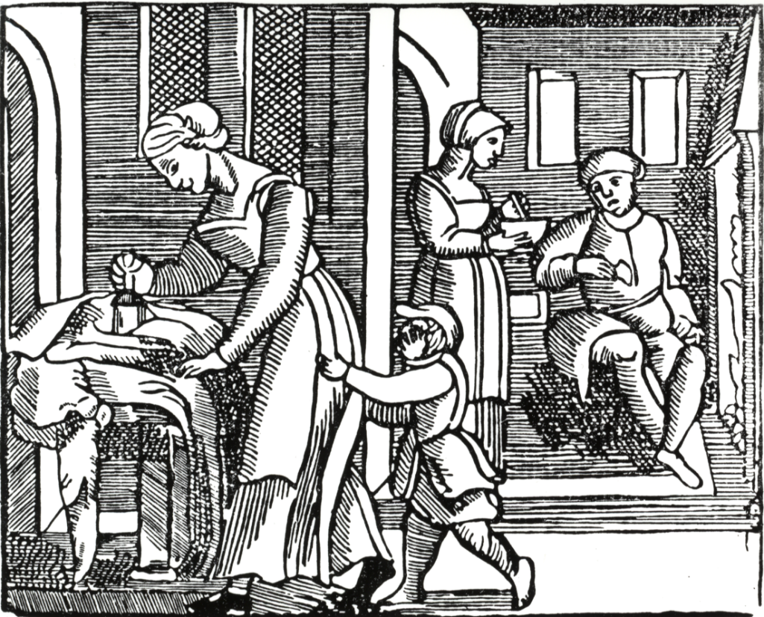 Interpretation A - A page from the ‘Good Housewife’ pamphlet, produced and distributed during 17th century

How convincing is Interpretation A about the role of women in Restoration England? (8 marks)
- TIPS - What does the source tell you about the role of women that is convincing? (Min 2 points)
- TIPS - What does the source NOT tell you about the role of women? (own knowledge)
- TIPS - Overall, does the interpretation give you a convincing picture of the role of women in Restoration England? (your opinion)
TASK 12 – GLOSSARY
Using information in the is booklet and researching on the internet, find out the meanings of the following:-
Yersinia pestis | Pesthouses | Alderman | Laystills
Press-ganged | Micrographia | Proscenium | Diurnals

