NAME:
Study Guide 2 Britain: Health and the people - Part two: The beginnings of change

The Renaissance
The Renaissance was a time of new ideas and fresh thinking. People began to challenge old beliefs, and put forward new theories.
- The Renaissance was a time of continuity and change. There was a rediscovery of knowledge from classical Greek and Roman times, Western doctors gained access to the original writings of Hippocrates. Galen and Avicenna. These had not been available in the medieval period. This led to greater interest in the Four Humours Theory.
- The renaissance also saw the emergence of science as we know if from the magic and mysticism of medieval medicine. People thought about how the human body worked based on direct observation and experimentation.
- This was partly because of the many new books that said that anatomy and dissections were very important. This encouraged people to examine the body themselves and come to their own conclusions about the causes of disease.
- People began to question Galen and other ancient doctors.
- Although religion was still very important the church no longer had so much control over medical teaching due to the Reformation.

Six key changes
Some knowledge of Western civilisation at the time of the Renaissance will help you understand the medicine of the Early Modern Age.
- Governments - such as that of Henry VIII - were strong and rich. The economy boomed and trade prospered. People could afford doctors.
- Artists, such as Michelangelo, Leonardo da Vinci and Titian, revolutionised painting - this led them to study the body in more detail, and was connected to improved knowledge of anatomy.
- There was a revival of learning. Universities established schools of medicine. The Renaissance saw the beginning of scientific method - which involved conducting an experiment, collecting observations, then coming to a conclusion. At first, scholars merely claimed that they were renewing the perfection it had amongst the ancient teachers', but soon they began to conduct experiments which led them to question the knowledge of the Greeks and Romans.
- The invention of the printing press by Johannes Gutenberg allowed new ideas to spread more quickly around Europe.
- The discovery of America by Columbus meant that new foods and medicines were brought back from the New World.
- The invention of new weapons, especially gunpowder, led to soldiers getting different sorts of wounds, which battlefield doctors had to deal with.

TASK 1 Draw pictures on the story board below to represent the Renaissance and its impact
Florence | Wealthy businessmen & traders | Ancient Rome and Greece
Translation of books | Questioning of things | Arts, music, literature and science
Rebirth | Impact on scientists, artists, explorers & doctors | 1451 Printing Press
Vesalius
- Born in 1514 and was a medical professor at Padua University, Italy.
- He believed that successful surgery would only be possible if doctors had a proper understanding of the anatomy.
- Vesalius was able to perform dissections on criminals who had been executed.
- He wrote books based on his observations using accurate diagrams to illustrate his work. The most important was the ‘Fabric of the Human body’ (1543).
- His works were printed and distributed around the world. Printing was invented in the 1440s. The first British printing press was in the 1470s. This meant books could be copied more easily. This allowed ideas to be shared and discussed. People could learn from Vesalius’s discoveries.
- Vesalius’ work helped to point out some of Galen’s mistakes. For example he showed that there were no holes in the septum of the heart.
- His findings encouraged others to question Galen. Doctors also realised that there was more to discover about the body because of Vesalius’ questioning attitude.
- The work of Vesalius didn't have an immediate impact on the diagnosis or treatment of disease. However, by producing a realistic description of the human anatomy and encouraging dissection, Vesalius provided an essential first step to improving them.
What did Vesalius do?
* dissected human bodies himself (not his assistants)
* researched bloodletting and discovered mistakes in Galen’s writings (doctors hadn’t wanted to challenge the established ideas of Galen on human anatomy)
* he discovered Galen’s mistakes were made as he had dissected animals and linked them to human anatomy
* his lectures were popular and encouraged dissection of the human body as a way to learn more
* he produced illustrated anatomy books (The Fabric of the Human Body 1543), precision drawings of the human body- skeleton, nerves, veins, digestion and reproduction
* he was criticised for saying Galen was wrong (had to leave job at Padua, later became doctor to Emperor Charles V)

Impact of Vesalius in England

1. By 1545, a book called ‘Compendiosa’ which copied all of Vesalius’ illustrations was printed by an Italian printer, Thomas Geminus. He used the text from a book, Surgery by Henri de Mondeville in 1312. Geminus sold his book as a manual for barber-surgeons in London to learn their trade. It proved very popular with 3 editions being published between 1545 and 1559. Later in 16th century, many copies of Vesalius’ actual book came to England (inspiring and influencing English surgeons).
2. Used ‘Renaissance’ approach questioning the human body to overturn centuries beliefs in Galen’s anatomy.
3. Basis for others to learn, he showed others how to dissect and discover more about the human body (Fabricius, Fallopians etc)

TASK 2 Answer the questions below
- How were the mistakes made by Galen explained?
- What was the Fabric of the Human Body (1543) and how was it different?
- What was Compendiosa and what evidence is there that it was popular in England?

William Harvey
- British doctor born in 1578. Studied medicine at Padua Italy, Italy. Then worked in London at the Royal College of Physicians.
- He became a physician to James I and Charles I.
- Harvey studies both animals and humans. He realised he could observe living animal hearts in actions and that his work would also apply to humans.
- Before Harvey, people thought that there were 2 kinds of blood and that they flowed through two completely separate systems of blood vessels. Galen’s idea.
- Harvey realised Galen was wrong. He thought that the blood must circulate round the body. He published his book ‘On the motions of the heart and blood’ in 1628.
- Harvey was a careful scientist who drew conclusions from methodical observations and experimentations.
- Harvey’s ideas, shown in his books, gave doctors a map of how the body worked. Not everyone believed his theories. It took a long time before doctors used them in their treatments.

TASK 3
Why Was Harvey so important?
Galen’s ideas under attack

2 facts on what Galen believed

2 ways he challenged Galen

Harvey’s theory of blood

At least 4 bullet points
about what Harvey
believed

Reactions to Harvey’s discovery

Write at least 3 bullet points

Ambroise Pare
- French barber surgeon born in 1510. Worked in a public hospital, then became an army surgeon.
- He treated many serious injuries caused by the war, this helped him improve surgical techniques.
- At this time, gunshot wounds often became infected. Doctors didn't understand why this happened or how to treat it. The usual treatment was to burn the wound with a red hot iron or to pour boiling water onto it. This often did more harm than good.
- During one battle Pare ran out of oil and resorted to a simple cool salve (type of ointment) instead. To his surprise the patients treated this way did better than the ones scalded with oil.
- Pare invented a method of tying off vessels with threads (ligatures). This was less painful so reduced the change of the patient dying of shock. However there was still a chance of infection.
- He also designed artificial limbs and improved the treatment of amputations.
- Pare published his ideas to enable other doctors to read about them. British surgeons used the methods of Pare and took inspiration from his work. Over time, his ideas helped improve surgical techniques.
- In 16th Century England, there was a number of surgeons who followed Pare’s Renaissance approach to surgery: these surgeons observed, questioned and experimented with new ideas. The most famous was William Clowes.
- Doctors resisted Pare’s ideas. He eventually became surgeon to the King of France and with his support his ideas started to be accepted.

TASK 4
Fill in the table below and answer the questions
What Pare did | How he helped

How important was Vesalius to Pare?
How can Pare be linked to medical progress in England? (Clowes)

Medical treatment
- Many doctors were reluctant to accept that Galen was wrong. This meant that they continued to use similar treatments to the Middle Ages, like bloodletting and purging.
- Doctors tended to focus more on reading books than treating patients.
- Doctors were still very expensive. Most people used other healers such as apothecaries or barber surgeons. Herbs were still the main ingredient in many drugs.
- Superstition and religion were still important. People thought the King’s touch could cure Scrofula. 1000s of people are thought to have visited King Charles I.
- Some people sold medicines that didn't work, and often did more harm than good - this was known as quackery. They had no medical knowledge.
- The introduction of the printing press helped ordinary people collect books on herbal remedies, such as the English doctor Nicholas Culpepper’s ‘the complete herbal’ (1653). Culpepper used plants and astrology in his treatments.
- Explorers on voyagers of discovery brought back new natural medicines. The bark of the Cinchona tree from South America contained quinine, which helped to treat malaria.
- From 1600 the College of Physicians started to license doctors to stop quackery.
- In the 1700s, electricity started to be used in some medical treatments, although it was rarely effective.

TASK 5 Add notes to the spider diagram below

Methods
Beliefs

DOCTORS

Impact of printing press and exploration
MEDICAL TREATMENT

Religion and superstition
Apothecaries
OTHERS

Barber-surgeons
Quacks

The Great Plague - 1665

Similarities to the Black Death
- Many treatments of the Plague were based on magic, religion and superstition, including wearing lucky charms or amulets, saying prayers or fasting,
- Bloodletting was still used, even though this probably made the plague worse - it created wounds that could get infected.
- Some people also thought that miasma caused the disease, so they carried posies of herbs or flowers to improve the air.
- Many people still believed that the plague was a punishment from God for their sins, the real cause was the fleas that lived on rats.
Differences to the Black Death
- Towns and parish Councils tried to prevent the spread of the disease. Plague victims were quarantined to stop them passing on the disease. The victim's house was locked and a red cross painted on the door.
- 'Bills of Mortality were published, to publicise the course of the disease.
- 'Examiners' and 'searchers' were appointed, who established whether members of a household had contracted the plague. If so, they then shut up the house for a month, and its inhabitants had to stay indoors.
- Surgeons' were appointed, who examined the dead to establish the extent of the plague.
- Areas where people crowded together were closed (e.g theatres)
- The dead bodies of the plague victims were buried in mass graves away from houses.
- Constables were appointed, who made sure no one left such houses.
- Bodies were buried at night in huge pits, and mourners were not allowed to attend.
- 'Pest houses' were set up, to quarantine sufferers.
- Householders were ordered to collect all waste, which was then removed by 'rakers'.
- Stray pigs, dogs, rabbits and cats were killed.
The responses to the plague came from local councils - they did more to try to combat the Great Plague than they had ever done for the Black Death. But there were no national government attempts at prevention.
The plague gradually began to disappear. Many people think the Great Fire of London in 1666 helped to wipe it out, by effectively sterilising large parts of London - it burned down the old, crowded houses, killing the plague bacteria.
TASK 6 Annotate the pictures below to show the different ways people tried to cure the Great Plague

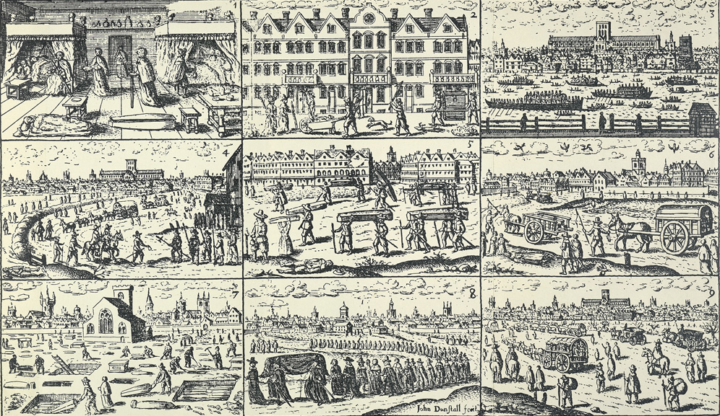

Doctors and surgery
- Many doctors in Britain trained at the College of Physicians, which was set up in 1518. Here they read books by Galen, but also studies recent medical developments. Doctors who trained at the college gained a licence, which separated them from the large numbers of quack doctors.
- However, a license didn't guarantee that a doctor would give the most effective treatment - sometimes an experienced, unlicensed doctor could be just as good.
- New weapons like cannons and guns were used in war. This meant surgeons had to treat injuries they hadn't seen before, forcing them to quickly find new treatments.
- Dissections became a key part of medical training in the 1700s.
- In the Middle Ages, there were two types of surgeons. There was a small number of professional surgeons, who trained at university and were highly paid. Then there were the barber surgeons. Surgeons were not respected compared to doctors.
- In the 1700s and 1800s, surgeons began to gain the same status as doctors. In 1800 the London College of Surgeons was created, which set training standards for the first time.
- Sydenham was an English doctor who was famous for recognising the symptoms of epidemic diseases such as scarlet fever and for classifying illnesses and medicines correctly. He was critical of quack medicine and also stressed the careful observation of symptoms.
- However, he dismissed the value of dissections and ignored Harvey’s discovery because it did not help with treating patients. He still used all the usual bleeding methods and often often advocated doing nothing and letting nature takes in course.

TASK 7 List the ways doctors and surgery a) stayed the same and b) changed
Ways doctors and surgery stayed the same | Ways doctors and surgery changed

John Hunter
- Well known surgeon and scientist. Hunter joined his brother at his anatomy school in London. Dissecting human corpses was a large part of the school’s teaching.
- Over 12 years he was present at more than 2000 dissections.
- Hunter became an army surgeon in France and Portugal and a popular surgeon and teacher in England.
- He made several important medical discoveries. He learned more about venereal disease and introduced a new approach to the treatment of gunshot wounds.
- In an operation in 1785, he introduced a new way to treat an aneurysm in a man’s thigh. Hunter tied of the blood vessel to encourage the blood to flow through the other vessels in the leg, preventing it from having to be amputated.
- He encouraged better approaches to surgery. This included good scientific habits like learning as much about the body as possible to understand illness, experimenting to find better ways to treat disease, and testing treatments (e.g on animals) before using them on people.
- Hunter’s pupils included doctors such as Edward Jenner. This meant that his methods were passed on, improving the way people conducted scientific research as a whole.

TASK 8
In what ways did John Hunter help medical understanding and knowledge progress?

How radical (extreme new ideas) was Hunter?
Hospitals
- In the 1530s Henry VIII closed down most of the monasteries. Since most hospitals had been set up and run by the monasteries, this also led to the closure of a large number of hospitals. As a result, Britain had relatively few hospitals until the 18th century.
- Before the 18th century, many hospitals focused only on caring for people. In the 18th and 19th centuries treating diseases became more important.
- From the early 18th century several charity hospitals opened, including the Middlesex infirmary, The London Hospital and Guy’s hospital. They were funded by the rich, and offered largely free treatment to the poor.
- By 1800 London’s hospitals alone were handling over 20,000 patients a year. Compared to 1400 when each of the 470 hospitals had room for only ten patients at the most.
- Only those who were likely to recover quickly were admitted - this was partly because of a lack of space and because the rise of contagious illnesses spreading. The ‘deserving poor’ had a greater chance of being admitted.
- Dispensaries provided free non-residential care to poor people. Medicines and non-surgical services from people like dentists and midwives were given without charge.
- Most poor people were treated in workhouses - large building that people went to it they could no longer look after themselves. Conditions were poor - from the 1850s a partially successful movement began to improve conditions in workhouse infirmaries.
- In the 19th century some hospitals were founded alongside universities or medical schools, including Charing Cross Hospital, University College Hospital and King’s College Hospital. These hospitals were used as training schools for doctors, and for conducting scientific research.
- Doctors liked the gain an official post at a hospital, because it gave them a better reputation and attracted wealthy patients.
- The types of treatments given in hospitals were still primarily based on the Four Humours approach of bleeding and purging.
- Cottage hospitals, run by GPs, opened from the 1860s. They provided care for people in rural areas.
- In the 18th Century specialist hospitals also opened for example, Bethlem for the mentally ill.
- The Foundling Hospital was also opened in 1741 to care for orphaned children.

TASK 9
In what ways were hospitals different before and after 18th century? 1. 2.

How were the poor treated? (show the range of treatments they could receive)
Florence Nightingale and improved nursing standards
- Studied to be a nurse in 1849. She helped nursing become a profession and disciplined.
- When the Crimean war broke out in 1853, horror stories emerged about the Barrack Hospital in Scutari, where the British wounded were treated. Sidney Herbert (the Secretary of War and a friend of her family) asked for Nightingale to go to Scutari to sort out the nursing care in the hospital.
- The army opposed women nurses, as they were considered inferior and a distraction. Nightingale went away, taking 38 handpicked nurses with her.
- Using methods from she has learned from her training in Europe, Nightingale ensured all the wards were clean and hygenic, that water supplies were adequate and that patients were fed properly.
- Before she arrived the death rate in the hospital was 42%. Two years later it had fallen to just 2%.
- Many of Nightingale's nursing practices were used in hospitals in Britain.
- In 1859, Nightingale published a book, ‘Notes on Nursing’. This explained her methods - it emphasised the need for hygiene and a professional attitude. It was the standard textbook for generations of nurses.
- The public raised £44,000 to help her train nurses, and she set up the Nightingale School of Nursing in St. Thomas’ Hospital, London.
- Nurses were given three years of training before they could qualify. Discipline and attention to detail were important.

TASK 10 Create a storyboard showing the key features of Florence Nightingale’s life

Jenner and Vaccination
- In the 1700s, smallpox was one of the most deadly diseases - in 1751, over 3500 people died of smallpox in London alone.
- At the time, the only way to prevent smallpox was inoculation. This was promoted in Britain by Lady Mary Wortley Montagu, who learned about it in Turkey. Inoculation was successful in preventing the disease but meant patients had to experience smallpox before they could become immune - some died as a result.
- It involved making a cut in a patient’s arm and soaking it in pus taken from a swelling of somebody who already had a mild form of smallpox.
- Edward Jenner (Born in 1749) was a country doctor in Gloucestershire. He heard that milkmaids didn’t get smallpox but they caught the much milder cowpox.
- Using careful scientific methods Jenner investigated and discovered that it was true that people who had had cowpox didn't get smallpox.
- In 1796 Jenner tested his theory. He injected a small boy, James Phipps, with pus from the sores of Sarah Nelmes, a milkmaid with cowpox. Jenner then infected him with smallpox. James didn't catch the disease.
- Jenner published his findings in 1798. He coined the term vaccination using the latin word for cow, vacca.
- Jenner faced some opposition to his vaccine:
  - Many people were worried about giving themselves a disease from cows.
  - Some doctors who gave the older type of inoculation saw it as a threat to their livelihood (they made a lot of money from inoculations).
  - One doctor, William Woodville, claimed that Jenner’s vaccination worked little better than inoculation, after several smallpox deaths occurred at his hospital.
  - When vaccination became compulsory in 1853, several groups were formed to campaign against it - they didn't like the idea of the government telling them what to do.
- But his discovery got the approval of parliament. In 1802 they gave Jenner £10,000 to open a vaccination clinic. And another £20,000 a few years later.
- In 1840, vaccination against smallpox was made free for infants. In 1853 it was made compulsory.
- The vaccine was a success - it contributed to a big fall in the number of smallpox cases in Britain.
TASK 11
What were the problems with the smallpox inoculation?

What was Jenner’s discovery?

What opposition did Jenner face?

OVERVIEW

How important were the following people to medical progress? – Vesalius, Harvey, Pare, Hunter and Jenner
Plot and justify your opinion on the continuum.

Utterly Unimportant
Immensely Important

PRACTICE EXAM QUESTIONS
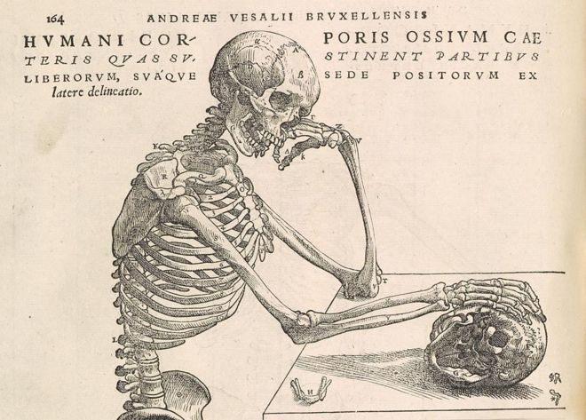
Tips
- What does it show about the work of Vesalius? How does this make it useful?
- Does it miss anything out about the work of Vesalius? How does this limit its use?
- Provenance – 5Ws – who, what, why, where and when? How does it make it useful? How does it limit its use?
- It is helpful to use content and provenance together
Source B – An illustration of the skeletal system in Vesalius’ textbook, a copy of this rare and important work can be viewed in the British Library in London
- How useful is Source B to a historian studying the work of Vesalius? (8 marks)

- Explain the significance of Pare to medical progress in 16th century (8 marks)
- Compare the work of Andreas Vesalius in 16th century and John Hunter in 18th century. In what ways are they similar? (8 marks)
Tips
- Note down the similarities that you find between the two
- e.g. what they specialised in, radical approaches to medicine, use of human dissection, publications, impact on medicine, challenges to established ideas etc
- Include at least 2-3 similarities between the two
- Include factual detail about both
- Explain how this makes them similar

