GCSE History Unit 2 Section A
Health and the People

STUDY GUIDE 1

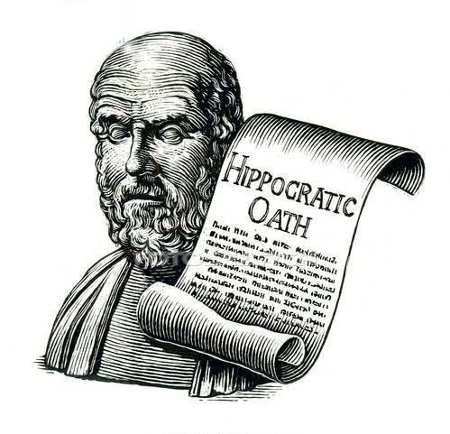

NAME:

Who are the significant individuals we will study in this topic?

Q1. Use the Internet to research each person and fill in the profiles below;

NAME; Hippocrates
COUNTRY;

EARLY LIFE;

MEDICAL IDEAS;

IMPORTANCE TO DEVELOPMENT OF MEDICINE;

NAME; Galen
COUNTRY;

EARLY LIFE;

MEDICAL IDEAS;

IMPORTANCE TO DEVELOPMENT OF MEDICINE;

Part 1: Medieval civilisation (roughly 1000-1500)

- In the 5th century AD, waves of barbarians such as the Goths, Vandals, Saxons and Vikings invaded Western Europe.
- Europe disintegrated into a huge number of small fiefdoms, each governed by a local lord, who protected his peasants - owned by him as 'serfs'. These tiny states could not afford universities for study, or public health systems.
- Communications were difficult and dangerous, so ideas travelled slowly.
- During the Dark Ages, the monasteries alone managed to hang onto learning and knowledge, and even the ability to read and write. Many of the medical ideas of the Greeks and Romans were lost at this time, and survived only in the Muslim cities of the Middle East.
- Similarly, technology was limited, and much of the advanced technical knowledge of the Romans was lost.
- Knowledge went into reverse in the west in Medieval times - many of the books of the Greeks and Romans were lost, and the knowledge they contained was replaced by guesswork and superstition.
- Even when universities developed, after 1100 - Montpellier, Bologna and Salerno had famous medical schools - lectures on anatomy were undeveloped. They consisted simply of a butcher pointing to the different parts of a body, while the lecturer read a text by an authority such as Galen.
Q2. Explain below, using the bullet-points on the previous page, why medical knowledge and understanding was SO BAD by 1100 AD. Mention at least two key points.

Disease was thought to have supernatural causes
- Many people believed that disease was a punishment from God for people’s sins. They thought that disease existed to show them the error of their ways and to become better people. Therefore, they thought that the way to cure disease was through prayer and repentance.
- Disease was also to be caused by evil and supernatural beings, like demons or witches. Witches were believed to be behind outbreaks of disease.
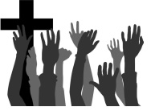
- Some people believed that diseases were caused by evil spirits living inside someone. Members of the church performed exorcisms, using chants to remove the spirit from the person's body.
The Church had a big influence on medieval practice
- Medieval Europeans believed in the Christian God, so politics and everyday life, as well as medicine, were dominated by the Roman Catholic Church.
- The Church played a big part in medical stagnation in the Middle Ages. It discouraged progress by:
  - forbidding dissection of human corpses
  - insisting that people agree with the writings of Galen
  - encouraging people to rely on prayers to the saints and superstition to cure them of disease
  - encouraging the belief that disease was a punishment from God - this led to fatalism and prevented investigation into cures
However, the Church did encourage people to go on Crusades, meaning that people travelled to the Middle East. Here they came into contact with Muslim doctors, who were significantly more skilled than their counterparts in Britain.

Astrology was used to diagnose disease
- Astrology is the idea that the movements of the planets and stars have an effect on the earth and on people. Astrologers in medieval England believed that these movements could cause disease.
- Astrology was a new way of diagnosing disease. It was developed in Arabic medicine and brought to Europe between 1100 and 1300.
- Medieval doctors owned a type of calendar which included information about where particular planets and stars were at any given time. The doctors then used this to predict how patient’s health could be affected.
- Different star signs were thought to affect different parts of the body.
- The Black Death was seen as a punishment from God. Guy de Chauliac, the Pope's doctor, blamed the Black Death on a conjunction of Saturn, Jupiter and Mars.
Some treatments in medieval Britain were based on less religious faith and more on natural theories and observation of the physical world.

Q3. Fill in the three columns below using the previous bullet-points;

What people believed about SUPERNAURAL causes | Why the CHURCH was so powerful regarding medicine | How ASTROLOGY was used to diagnose disease
Four Humours Theory
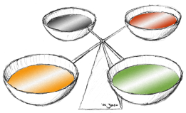
The Greeks developed the first rational system of medicine. The theory of the Four Humours was brought back to Western Europe via the Islamic World. Many medieval doctors based their diagnosis and treatment on this theory.
- The most famous Greek doctor was Hippocrates of Kos. He wrote: Sickness is not sent by the gods or taken away by them. It has a natural basis. If we can find the cause, we can find the cure.
- Hippocrates is often called the ‘Father of Modern Medicine.’ He made several key contributions to the development of medicine:
  - The Hippocratic Oath - Doctors would swear to treat patients and keep their records and symptoms in confidence.
  - Recording of symptoms - Hippocrates encouraged doctors to question patients, finding out detailed information about symptoms and to record them accurately. This would then lead to better treatments.
  - The Hippocratic Corpus - A collection of over 60 books written by Hippocrates and other Greek doctors, noting symptoms, treatments and their effectiveness.
  - Promoted the four humours - Hippocrates encouraged doctors to look for natural causes and cures of diseases, encouraging them to move away from supernatural beliefs. Hippocrates believed that the body was made up of four fluids - blood, phlegm, yellow bile and black bile. They needed to be in balance for good health.
- The Theory of the Four Humours was developed further by another Greek doctor, Galen, who was born in AD129 and worked for much of his career in Rome.
- Galen believed that diseases could be treated using opposites. He thought that different foods, drinks herbs and spices had a humour, which could balance the excessive humour that was causing the disease.
- The miasma theory was also incorporated by Galen into the Theory of the Four Humours. This became extremely popular in medieval Britain.
- The miasma theory is the idea that bad air causes disease when someone breathes it in. This bad air may come from human waste or dead bodies - anything that creates a bad smell.
- The miasma theory was so influential that it lasted until 1860s when it was replaced by the Germ Theory.
The Four Humours and miasma were both incorrect theories. But they assumed disease had a natural cause, rather than a supernatural one. This was important, was it suggested that people weren’t powerless against disease - they could investigate and take action against it.
- The work of Hippocrates and Galen was extremely influential in medical diagnosis and treatment.
- Hippocrates and Galen wrote down their beliefs about medicine. These were translated into Latin books, which were considered important texts by the Roman Catholic Church.
IMPACT;
- Hippocrates and Galen’s ideas were considered the absolute truth.
- Many of their ideas were taught for centuries after their deaths, including the incorrect ones. For example, Galen only ever dissected animals. Medieval doctors were not allowed to perform their own dissections so they continued to learn Galen’s incorrect ones.
- Some of Hippocrates and Galen’s ideas were so influential that they continue to be used today. The Hippocratic Oath and the belief that all doctors should observe their patients as they treat them.
Q4. Fill in the diagram on the Four Humours below, using the bullet-points on the previous pages;

Explanation of what the Four Humours said

Impact of Galen on the Four Humours

IMPORTANCE of the Four Humours

Islamic medicine
In the medieval period, Islamic medicine was miles ahead of European medicine. Arabic ideas eventually made their way to Europe - including knowledge of Galen and Hippocrates.
Arab doctors kept Classical Knowledge alive -
- While a lot of medical knowledge was lost in the West after the fall of the Roman Empire, medical ideas like the Four Humours and treatment by opposites were kept alive by Islamic scholars.
- Islamic medicine was generally more rational and evidence based than European medicine, partly due to their knowledge of classical medical texts.
- In the 9th Century, Hunain ibn Ishaq translated Greek texts to Arabic.
- This classical knowledge was eventually brought to Europe by Avicenna. He wrote the ‘Canon of Medicine’, which brought together the ideas of Galen and Hippocrates, and was the most important way that classical ideas got back to Western Europe.
- The crusades also made Europeans aware of the scientific knowledge of Islamic doctors.
- Islamic doctors also made several new discoveries.
- Abulcasis wrote a well thought-out book describing amputations, the removal of bladder stones and dental surgery - as well as methods for handling fractures, dislocations and the stitching of wounds.
- In the 12th Century, Avenzoar described the parasite that causes scabies and began to question the reliability of Galen.
- Ibn al-Nafis also questioned Galen’s ideas. He suggested (correctly) that blood flows from one side of the heart to the other via the lungs and doesn't cross the septum.
- However, because the Christian Church was at war with Islam, Muslim ideas spread only slowly to western Europe. The exception was the book by Avicenna.
Q5. Who helped medicine PROGESS the most, the Christian Church or Islamic? Use the previous info on the Church as well as the info on this page to add points below, write any ways both STOPPED progress around the outside of the stars;
ISLAMIC
CHRISTIAN CHURCH

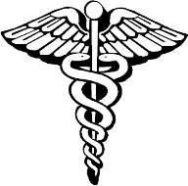
Treating disease

a. Prayer and repentance were major treatments
- Disease was believed to be a punishment from God, so sick people were encouraged to pray. The sick often prayed to saints. Medieval people also believed that pilgrimages to holy shrines could cure illnesses.
- Flagellants were people who whipped themselves in public in order to show God that they were sorry for their past actions.
- Many doctors had superstitious beliefs, some used astrology to diagnose and treat illness, or believed that saying certain words while giving a treatment could make that treatment more effective.
b. Bloodletting and purging aimed to make the Humours balanced
- Bloodletting and purging were popular treatments because they fitted with the four humours theory.
- If someone had too much blood inside them, the doctor would take blood out of their body through bloodletting - sometimes they would use leeches. Sometimes this would actually kill people (beliefs more important than observation)
- Purging is the act of getting rid of other fluids from the body by excreting - doctors would give patients laxatives.
c. Purifying the air was thought to prevent disease
- The miasma theory led people to believe in the power of purifying or cleaning the air to prevent sickness and improve health.
- Physicians carried posies or oranges around with them to prevent catching diseases.
- During the Black Death juniper, myrrh and incense were burned so the smoke or scent would fill the room and stop bad air from bringing disease inside.
d. Herbal remedies
- Remedies brought from an apothecary, local wise woman or made at home were all popular in medieval Britain and contained herbs, spices, animal parts and minerals.
- These remedies were either passed down or written in books explaining how to mix them together.
- Other remedies were based on superstition, like lucky charms containing ‘powdered unicorn horn’.
e. Treating disease
- People used lots of different healers
- Physicians were male doctors who had trained at university for at least 7 years. They read ancient texts as well as the writings from the Islamic world but their training involved little practical experience. They used handbooks and clinical observations to check patients’ conditions. There were fewer than 100 physicians in England in 1300 and they were very expensive.
- Most people saw an apothecary, who prepared and sold remedies, and gave advice on how to use them. Apothecaries were the most accessible for those who could not afford physicians.
- One of the earliest remedy books was the Anglo-Saxon manuscript ‘Leech Book of Bald (950).
- Most were men and trained through apprenticeships. There were also ‘wise women’, who sold herbal remedies.
Q6. Using the information above fill in the diagram below. 1 – most effective treatment etc and JUSTIFY inside the boxes;

Hospitals
- Most public hospitals were set up by the Church. There were few hospital, but they were popular and highly regarded.
- Between 1000 and 1500, more than 700 hospitals were started in England.
- The main purpose of the hospitals was not to treat disease, but to care for the sick and elderly. The hospitals provided its patients with food, water and a warm place to stay. Most hospitals were also more hygienic than elsewhere as they had developed water and sewerage systems.
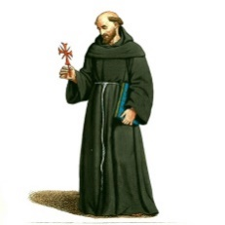
- Famous hospitals like St Bartholomew’s and St Thomas’ in London started life as church establishments.
- Some monasteries also cared for the sick, elderly or the poor.
- Most sick people were treated at home.
Q7. Use the Internet/textbooks to find out more about monasteries, mention cleanliness, water supply and physic gardens;

Surgery
- During the Middle Ages, surgery was left to barber-surgeons, not to trained doctors. Compared with doctors, barber surgeons were lower class medical tradesmen.
- It was a time of frequent warfare, and the constant fighting meant that surgeons' skills were much in demand. Perhaps as a result, surgery actually progressed in Medieval times.
- This is completely different from the normal picture of stagnation given to us about Medieval medicine.
- Medieval surgeons realised how to use wine as an antiseptic
- Some surgeons tried to find ways to reduce pain during operations. For example John of Arderne created a recipe for an anaesthetic in 1376 which included hemlock, opium and henbane.
- His surgical manual, Practica (1376), contained illustrations of his operations and instruments. It was based on Greek and Arab knowledge and his experience in the Hundred Year War.
- Medieval surgeons could do external surgery on problem areas such as facial ulcers and even eye cataracts. There was also, surprisingly, some internal surgery undertaken, eg to remove bladder stones.
- There was some further progress in dealing with infection after surgery. Heodoric of Luca encouraged wounds to be cleaned and bandages soaked in wine used to dress them. This challenged the idea of Galen’s that pus in a wound was a sign that it was healing.
- One of the most famous surgeons was the French Surgeon, Guy De Chauliac. His famous textbook ‘Great Surgery’ dominated English and French surgical knowledge for 200 years. He quoted Galen about 890 times.
- However, they still had no idea that dirt carried disease. Deep wounds still caused death from bleeding, shock and infection.
- A medieval surgeon might cure an epileptic patient by trepanning the skull to let the demon out.
- Cauterisation was a very common method of burning the wound to stop the flow of blood: it was usually done with a heated iron and immensely painful.
Who are the significant surgeons in this topic?

Q8. Use the Internet to research each person and fill in the profiles below;

NAME; Abulcasis

COUNTRY;

EARLY LIFE;

MEDICAL IDEAS;

IMPORTANCE TO DEVELOPMENT OF SURGERY;

NAME; John Arderne

COUNTRY;

EARLY LIFE;

MEDICAL IDEAS;

IMPORTANCE TO DEVELOPMENT OF SURGERY;

NAME; Hugh of Lucca and his son Theodoric
COUNTRY;

EARLY LIFE;

MEDICAL IDEAS;

IMPORTANCE TO DEVELOPMENT OF SURGERY;

NAME; Mondino de Luzzi

COUNTRY;

EARLY LIFE;

MEDICAL IDEAS;

IMPORTANCE TO DEVELOPMENT OF SURGERY;

Public health in medieval Britain
- Living conditions in towns were poor.
- Most towns were small. Houses were usually made of wood and were cramped together - overcrowding and fires were common problems.
- Between 1250 and 1530, the number of towns in England grew as the population rose.
- A lot of towns did not have clean water supplies or sewerage systems - waste was chucked into the street or into rivers to be washed away. Sewerage from latrines leaked into the ground and got into wells.
- Businesses and homes were not separated - Butchers, tanners and dyers threw toxic waste into rivers and residential streets. People had to get drinking water from rivers and wells that were contaminated.
- In the 13th century, a water channel called the Great Conduit was built to bring the clean water into London, as the Thames was getting too toxic.
- In 1388 the government ordered town authorities to keep the streets free of waste. Towns introduced public health measures to tackle waste, sewage and pollution and to create a clean water supply.
- York and London both banned people from dumping waste in the street. These cities also built latrines over rivers so that sewage could be carried away.
- London eventually banned any waste from being thrown into the Thames - carters were hired to collect waste and take it out of the city.
- Many towns, like York, ordered toxic businesses like tanners, butchers and fishmongers to move outside the city walls.
- People broke these rules and officials struggled to enforce them. People knew that dirty water was bad health were linked, but they didn’t really understand the risks. Town authorities didn't have enough money or knowledge to properly fix the issues.
Monasteries
- Healthier than towns. They had cleaner water and a good system for getting rid of waste.
- They separated clean and dirty water.
- Most were built near rivers to carry in clean water, if there was no river, man-made waterways were built.
- Monks had access to books on healing and they knew how to grow herbs and to make herbal remedies.
- Latrines were put in separate buildings.
- Sick monks were cared for in infirmaries. They would often have their own kitchen that served good meals and meat to help sick monks to recover.
- Some monasteries had hospitals that cared for the poor people. They also gave shelter to travellers. Benedictine monks believed that caring for the sick was the most important Christian duty.
- Why were they better at Public Health? - It was easier to create health living conditions in monasteries as they were wealthy. Monastery populations were also small and had one leader.
Q9. Which was better at health care; towns or monasteries? JUSTIFY.

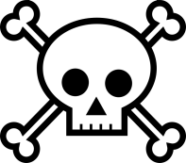
The Black Death
- The Black Death first arrived in Britain in 1348. People tried to limit its spread but couldn't stop the disease. Some historians think at least a ⅓ of the British population died as a result. There were further outbreaks throughout the Middle Ages.
- The Black Death was a series of plagues that swept Europe. It was really two illnesses.
  - The bubonic plague spread by the bites of fleas from rats carried on ships. It caused headaches and high temperature, followed by pus filled swellings on the skin.
  - Pneumonic plague was airborne. It attacked the lungs and would leave the victim coughing blood.
- The BD was spread by bacteria. This bacteria thrived in the stomach of fleas that lived on the blood of rats. When the rats died of the plague, the fleas moved on to humans.
- Death could be very quick for weaker victims. The Black Death spread quickly due to overcrowded ports and towns, and the disposal of dead bodies did not stop the plague from spreading.
- People didn't know what caused the Black Death. Some people believed it was a judgment from God. They thought the causes of the disease was sin, so they tried to prevent the spread of the disease through prayer and fasting.
- Some blamed humour imbalances, so tried to get rid of the BD through bloodletting and purging. Those that thought the disease was caused by miasma carried strong smelling herbs or lit fires to purify the air.
- Some people carried charms or used magic potions containing arsenic.
- Local governments tried to prevent the spread of the disease.
  - For example in Winchester people thought you could catch the plague from being close to the dead. When the town’s cemetery got too full the townspeople refused to let the bishop extend the cemetery in the town. Instead they insisted new cemeteries be built outside of the town.
  - The town of Gloucester tried to shut itself off from the outside world after hearing about the BD. Their aim was unsuccessful.
  - In November 1348, the disease reached London. In January 1349 King Edward III closed Parliament.
- The Black Death had huge economic and social consequences. Fields went unploughed. Food was not harvested and it rotted in the fields. Whole villages were often wiped out by the plague, but those who survived often faced starvation. Towns and cities also face food shortage was the nearby villages could not provide them with enough food.
- After the Black Death there were fewer workers around. This meant they could demand higher wages and move around to find better work. The cost of land also decreased, allowing some peasants to buy land for the first time.
- These changes threatened the power of the elites. The government created laws, such as the 1349 Ordinances of Labourers, to try and stop the peasants moving around the country.
- Another impact of the Black Death was that opinions of the Catholic Church changed, some of the churchmen were criticised for cowardice when they deserted their villages. This was balanced out by the number of priests who died. They lost a vast number of experienced clergy.
- Also due to the misunderstanding of the causes of the Black Death, there was widespread persecution of minorities such as foreigners, beggars and lepers.
Q10. Fill in the grid below using the previous bullet-points;

‘CAUSES’

ATTEMPTS TO STOP IT

CONSEQUENCES

NOTES;

Q11. Fill in the glossary, use the Internet/textbooks to help;

Avicenna | Bubonic Plague
Bleeding (as a treatment) | Miasma
Doctrine of signatures | Wound-man (1517)
Urine chart | Zodiac chart

Q12. Complete the exam-style questions;
Compare public health in a Medieval town with public health in a Medieval monastery. In what ways were they different? 8M

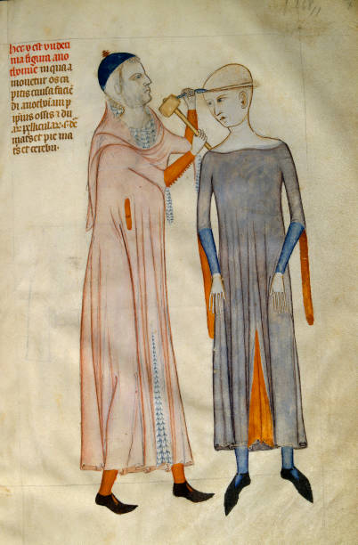
Study Source A. How useful is Source A to a historian in explaining why surgery was so dangerous in the 14th Century? Explain your answer using Source A and your own contextual knowledge. 8M

Source A. A medieval doctor cutting open a patient’s skull with a hammer and blade. An illustration from a 14th century French medical manuscript by Guy of Pavia.

