**GCSE HISTORY; UNIT 1 America 1920s and 1930s**

**STUDY GUIDE**

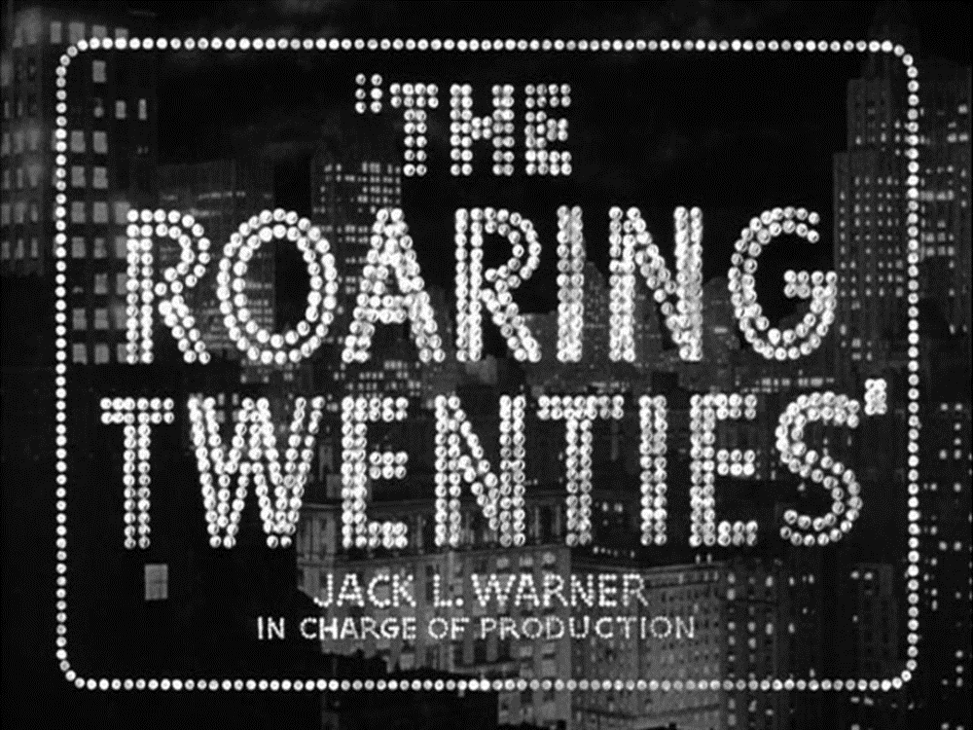

**NAME;**

**THE ROARING TWENTIES - USA in the 1920s**

**ISOLATIONISM**

* The USA lost over 100,000 Americans in WWI, they did not want to go to war again.
* USA refused to join the League of Nations – did not want to be the ‘world’s policemen’.
* Republican Warren Harding won the 1920 election by promising to return to ‘normalcy’.
* USA resumed a policy of isolationism (they remained separate from the world).

**A. CAUSES OF THE BOOM**

1. **Republican policies**: Fordney-McCumber Tariff, 1922 (taxes on goods imported from other countries so it’s cheaper to buy American) / low taxes (so people and businesses have more to spend) / rugged individualism (people being left to look after themselves)
2. **Mass production**: begun by Henry Ford who was using the assembly line by 1914, this made it much faster - and therefore cheaper – to produce goods, eg 93 minutes to produce a car. This meant lots more people could afford to buy things like washing machines, cars, vacuum cleaners, which made demand go up, leading to more jobs…etc.
3. **Advertising**: lots of new advertising techniques were used to persuade people to buy the new consumer goods – billboards, mail-order catalogues, newspapers and radios.
4. **Hire purchase and credit**: people could borrow money from the banks easily and they could also buy on HP (you pay a deposit, take the item home, pay it off in instalments).
5. **Stocks and shares**: companies could sell a share in their company on the Wall Street stock market. Prices rose by an average of 300% through the 1920s so people thought it was a good way to make money. Lots of Americans bought shares in the thinking they could ‘get rich quick’. Many shares were sold on the margin (they borrowed money to buy the shares confident they could pay it back).

***Q1. On the next page is a hierarchy ladder. Fill in the ladder with the above 5 reasons for the boom, with the least important at the bottom and most at the top etc. JUSTIFY why you have placed each one where you have put it. Down the side of the ladder try to draw links between the causes and explain how they link together.***

**What were the main reasons for the boom?**

**Very important**

**Not that important**

**B. POOR PEOPLE**

* 1929 1/3 of the nation’s wealth was shared by just 5% of the population. 71% of families had annual incomes of less than $2,500.
* **Black people**: about 10% of population but were seen as an inferior race & many lived in poverty, especially in the south.
* **Immigrants**: non-white North European immigrants were seen as a threat to American culture & living standards so were treated very badly.
* **Poor whites**: those working in old industries such as cotton mills & coal mines had very bad working conditions & very low wages. Children were also made to work sometimes.
* **Farmers**: overproduction led to low prices. Many fell into debt & lost their land.

**IMMIGRATION CONTROLS**

* Before WWI USA was known as a ‘melting-pot’ of races & nationalities.
* **1917 law**: immigrants must take a literacy test. This favoured northern Europeans.
* **1921 Emergency Quotas Act**: based on nationality, this allowed 3% of the number from that country who were in the USA in 1910. Favoured northern Europeans. **1924 National Origins Act** made these restrictions even tighter.

**BLACK PEOPLE & THE KKK**

* In the South segregation was legal so blacks & whites separated. In the 1920s 1 million people went to the north where conditions were a bit better, though blacks were still the lowest paid.
* The KKK reformed in 1915. They were racist whites who opposed blacks, foreigners, Catholics & Jews. 1920-25 KKK had about 5 million members, including judges & politicians. They met in secret at night, wore white robes to hide their faces & lit burning crosses to scare blacks. They sometimes beat or raped black people & in the most extreme cases lynching happened. The KKK ended in 1925 after a scandal.
* Jazz music was very popular. This had developed out of black music so it gave some black musicians a way of gaining self-respect & admiration, mostly in the north.

**Was everyone rich during the economic boom?**

***Q2. Fill in the boxes below with an explanation of how/why each group did not benefit from the boom.***

FARMERS

AFRICAN AMERICANS

PEOPLE IN THE SOUTH

UNEMPLOYED/IMMIGRANTS

**C. PROHIBITION, THE VOLSTEAD ACT, 1919-1933**

**Prohibition (1920-1933)**

Prohibition means a ban on the manufacture, sale and transportation of alcohol.

**Causes (Why was it introduced?)**

1. **Religious reasons**: pressure from Temperance (don’t drink) groups & Christian groups to ban alcohol because it was sinful.
2. **Social reasons**: Same groups also argued alcohol destroyed families and caused poverty and crime
3. **Economic reasons**: Workers would be healthier and more reliable.
4. **Patriotic reasons**: Brewers were often of German origin so during the 1WW drinking alcohol helped the enemy! Bolshevism (communism) was said to thrive on drink!

By the 1916 21 states had already introduced Prohibition.

1. ***– 18th Amendment introduced Prohibition. Made law by the Volstead Act in 1920***

**SUMMARY of Causes:** women & religious groups (eg Anti-Saloon League) believed ‘the demon drink’ (alcohol) was to blame for violence & poverty / many beer companies were German so during WWI people were told it was betraying your country to drink beer.

**How was Prohibition enforced?**

Levels of alcohol consumption fell by 30% in the early 20s and was quite popular in rural America. Urban areas were less keen.

The govt. ran information campaigns and Prohibition agents arrested offenders (Izzy and Moe made 4392 arrests!)

**Problems of enforcement:** Prohibition agents (special police) were very outnumbered & underpaid & some took bribes. Moe Smith was one of the few famous good ones.

**Ways around it:** moonshine (homemade alcohol) / bootlegging (smuggling it) / 200,000 speakeasies (illegal bars) across the USA.

**What were the consequences or effects?**

Opposite of those intended. Made consumption of alcohol more attractive. Turned ordinary Americans into criminals.

1. Not enough Prohibition agents so many got away with breaking the law
2. Moonshine – illegal alcohol brewed in home stills and by gangs. Dangerous, could lead to poisoning or death.
3. Bootlegging – making or importing illegal alcohol e.g. from Canada. Impossible to seal US borders
4. Speakeasies – bars in cellars and backstreets where illegal alcohol sold. Became fashionable. NY had 32,000.
5. Organised Crime – Gangs organised bootlegging and made fortunes. Al Capone made $60m p.a. Rivalry caused increase in violence e.g. St Valentine’s Day Massacre.1926: 130 gangland murders
6. Corruption: Gangsters like Al Capone became powerful figures and this led to corruption of the police and local politicians who were bribed by the gangsters.

**Effects – organised crime:** selling alcohol became big business as so many people were prepared to break the law. Gangs controlled much of the trade, eg Al Capone in Chicago who bribed police & politicians & employed about 1,000 men in a private army. There were 227 murders in 4 years – the most famous was the St Valentine’s Day Massacre in 1929 – but no-one was arrested for any of them.

***Boost to organised crime was the most important long-term effect of Prohibition.***

**Why was Prohibition repealed in 1933?**

*Drinking continued * Enforcement impossible * Brought law into disrepute

* Concern about violence and gangsters * 1929 Depression meant too expensive to enforce

* Could create jobs & tax revenue if alcohol made legal.

**1933: 21st Amendment repeals the 18thAmmendment. Prohibition ends.**

***Q3. Answer the following questions about Prohibition.***

1. **Why was Prohibition introduced, who wanted it and why?**
2. **How was Prohibition enforced?**
3. **How did Prohibition lead to corruption?**
4. **Who were the gangsters and how did they make so much money?**
5. **Was Prohibition a success or failure?**

**The Palmer Raids**

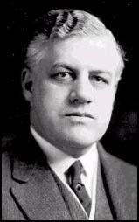

In 1919 Woodrow Wilson appointed A. Mitchell Palmer as his attorney general.   
Worried by the revolution that had taken place in Russia, Palmer became convinced that Communist agents were planning to overthrow the American government. His view was reinforced by the discovery of thirty-eight bombs sent to leading politicians and the Italian anarchist who blew himself up outside Palmer's Washington home. Palmer recruited John Edgar Hoover as his special assistant and together they used the Espionage Act (1917) and the Sedition Act (1918) to launch a campaign against radicals and left-wing organizations.   
  
A. Mitchell Palmer claimed that Communist agents from Russia were planning to overthrow the American government. On 7th November, 1919, the second anniversary of the Russian Revolution, over 10,000 suspected communists and anarchists were arrested. Palmer and Hoover found no evidence of a proposed revolution but large number of these suspects were held without trial for a long time. The vast majority were eventually released but Emma Goldman and 247 other people, were exiled to Russia.  
  
On 2nd January, 1920, another 6,000 were arrested and held without trial. These raids took place in several cities and became known as the Palmer Raids. A. Mitchell Palmer and John Edgar Hoover found no evidence of a proposed revolution but large number of these suspects, many of them members of the Industrial Workers of the World (IWW), continued to be held without trial. When Palmer announced that the communist revolution was likely to take place on 1st May, mass panic took place. In New York, five elected Socialists were expelled from the government.   
  
When the May revolution failed to happen, attitudes towards Palmer began to change and he was criticised for disregarding people's basic civil liberties. Some of his opponents claimed that Palmer had devised this Red Scare to help him become the Democratic presidential candidate in 1920.

**Q4. Answer the Qs below;**

1. Why was Palmer convinced communists were out to take over the American government?
2. What did Palmer and Hoover set out to do in 1917-1918?
3. What happened on 7th Nov 1919?
4. What was the result of this raid?
5. What happened on the 2nd Jan 1920?
6. Why was Palmer then criticised?

**Sacco and Venzetti**

The Sacco-Vanzetti controversial murder case in Massachusetts lasted from 1920 to 1927. Nicola Sacco and Bartolomeo Vanzetti, Italian immigrants who had arrived in the United States in 1908, were charged by the state with the murders of a paymaster and a guard and the theft of more than $15,000 from a shoe factory in South Braintree, Massachusetts, on April 15, 1920. The execution of Sacco, a shoe worker, and Vanzetti, a fish peddler, in 1927 caused world-wide protest.

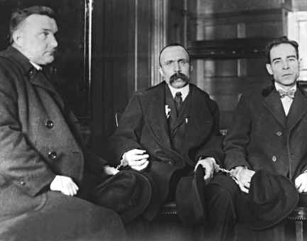

The trial took place in Dedham between May 31 and July 14, 1921. The state's case was based primarily upon two facts: Sacco possessed a pistol of the type used in the murders, and the accused when arrested were at a garage attempting to claim an automobile that had been seen in connection with the South Braintree crimes. What many regarded as inadequate evidence played a large part in the trial. Also, there was contradictory testimony from witnesses. The judge, Webster Thayer, and the jurors were accused of bias. When the jury returned a verdict of guilty, an outcry arose from socialists, radicals, and many prominent intellectuals throughout the world, who claimed that the two men had been condemned because they were guilty only of being immigrants and outspoken anarchists.

During the next six years, motions to submit new evidence and appeals for a new trial were frequently made and denied. In 1925, Celestine Madeiros, a man condemned to death for another murder, confessed to having been a member of the gang that committed the South Braintree crimes. In April 1927, however, the death sentence was pronounced for Sacco and Vanzetti. Appeals to the governor of Massachusetts, Alvan Tufts Fuller, induced him to appoint a committee composed of the president of Harvard University, Abbott Lowell, the president of the Massachusetts Institute of Technology, Samuel Wesley Stratton, and a former judge, Robert Grant, to investigate the trial and its aftermath. On August 3, the governor announced that, in accordance with the recommendation of the committee, he would sustain the death sentences. Several stays of execution followed, but on August 23, 1927, Sacco and Vanzetti were electrocuted.

***Q5. Answer the following Qs;***

1. What crime were the two immigrants charged with?
2. What 2 facts did the prosecution base their case on?
3. What bias might the judge have had?
4. What happened over the next 6 years?
5. What happened to Sacco and Venzetti?

**D. DEVELOPMENTS IN ENTERTAINMENT INDUSTRY**

Shown by trends in entertainment (in urban America) – 11% av. rise in real wages in the 20s and shorter working hours meant there was more time and money for leisure activities:

a) Cars: Many more Americans bought cars – changed lifestyle (leisure, places to live and work). Advantage of more freedom and creation of jobs but crashes, traffic jam, getaway cars etc.

b) Radio: 700+ stations broadcast popular music and adverts & sporting events & political broadcasts. Almost everyone listened to the radio.

c) Cinema: Industry developed in Hollywood first with silent movies & then talkies. By 1930 100m+ went to the cinema each week – escapism, fashions, behaviour. Cinema blamed for the decline in sexual morals. Hays Office set rules of conduct.

d) Jazz: new music made popular by black musicians in night clubs with new dances like the Charleston. Older generations appalled.

e) Sport: Became mass entertainment. More leisure time. Baseball (New York Yankees and the Boston Red Sox), boxing – popular world champion Jack Dempsey.

f) Settlement: Growing population – by 1930 more than half in cities. Tension between rural and urban America.

* Many people, especially whites, were better off in the 1920s & had more leisure time, this meant they spent a lot more money on entertainment.
* Jazz was popular, helped by the availability of radio. By 1929 over 10 million homes had radio.
* Sport also became more popular, especially baseball, boxing & American football. People had more time & money to watch sport & cars meant they could get to matches.
* Dancing was popular & new dances were developed eg the Charleston & Black Bottom.
* **Cinema**: by 1929 110 million people were going each week. Big film companies like Warner Brothers & MGM really boomed. In 1927 the first ‘talkie’ was released – *The Jazz Singer*.

**WOMEN**

* Young women gained more freedom, wealth & leisure time. Fashions changed, eg short skirts & hair, & they did things they had never done before eg smoking in public.
* Flappers were young middle –class girls who went out a lot & whose behaviour shocked their parents. But most women still believed they should get married, give up their jobs & look after their husbands & children.

*Q6. Summarise developments in entertainment;*

Entertainment

*Q7. Summarise developments for women;*

Women

*Q7. Which changed society the most; entertainment developments or flappers?*

**Did All Americans Benefit From the Boom of the 1920s?**

***Q8. Match the numbers to the letters to complete the sentences;***

|  |  |
| --- | --- |
| 1. Coal suffered from competition | a) $18 and women $9 for a 70 hour week, at a time when $48 per week was considered to be the minimum required for a decent life |
| 2. Leather and textiles suffered | b) the unemployed included many whites and an even greater proportion of black and Hispanic people |
| 3. In 1928 there was a strike in the coal industry in North Carolina, where the male workers were paid only | c) from new industries such as oil and electricity |
| 4. 42% of Americans lived below the poverty line | d) which means that it was led by ordinary families buying things for their home |
| 5. Unemployment remained a problem, | e) they did not have the money needed to pay for essentials such as food, clothing, housing and heating for their families |
| 6. The boom of the 1920s was a consumer led boom, | f) the demand for them was likely to begin to tail of. |
| 7. But with so many families too poor to buy such goods, | g) from competition with the development of new man-made materials. The also had to compete with cheap labour in the southern states |

**The BUST – The USA in the 1930s**

What are shares?

When companies want to grow and expand they invite investors to invest cash by purchasing a share of that company, a tiny percentage. When the company does well, the value of that share increases – and the investors receive dividends (a share of the profits). The investor can also sell on their shares and make more money from the sale than they paid in the first places – again making a profit.

The bad news is that companies not doing so well do not attract investment. Their share prices fall, and profits often follow without consistent investment and development. Shareholders then don’t get their dividends and when they come to sell their shares – often get less than they paid for them.

Why were Americans taking their chances in the 1920s by investing in shares?

* Due to the economic boom share prices continued to grow and grow as companies made huge profits selling consumer goods to the public
* Shares became an easy way to make money. Buy now and sell in a few months to make a nice profit.
* There were now more companies than ever to invest in – electricity, manufactured goods, consumer goods, entertainment.
* Banks were providing loans more easily – you could borrow money, buy shares, keep them for a while, sell them and make a profit and then pay back your loan.
* Demand for shares kept rising, keeping share prices artificially high.

***Q9. What did ‘on the margin’ mean? (use the Internet to find out if you do not know)***

**THE WALL STREET CRASH**

* **March 1929.** Economy is booming, Hoover promises ‘a chicken for every pot’.
* **September 1929**. Effects of overproduction mean industries are cutting back on production. This leads some to worry that share prices are too high so some people begin to sell.
* **24th October 1929**. 13 million shares were sold in one day & prices fell massively so no-one wanted to buy.

**Causes:**

1. **over-production** – companies were making more consumer goods than they could sell which then caused prices to fall and unemployment to rise.
2. **unequal distribution of wealth** – even though there had been lots of money in the 1920s it had not been shared out fairly, they rich had got richer and the poor often got poorer.
3. **high import tariffs** **on American goods** - meant that countries outside of the US made their own tariffs that made American goods too expensive to buy in the rest of the world. So when the domestic market became saturated there was nowhere else for the American companies to sell to.
4. **speculation on the stock market** – inexperienced people had invested heavily in the shares during the 1920s hoping to make some fast money. Once companies started to fall in value panic selling began and this then finally triggered the crash.

***Q10. Use the information about the crash to fill in some of the boxes below to show a downward spiral of the US economy.***

[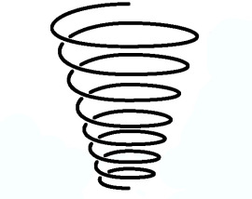](https://www.google.com/url?sa=i&rct=j&q=&esrc=s&source=images&cd=&cad=rja&uact=8&ved=2ahUKEwi3-pDyr7XZAhWEBsAKHfe0Ca8QjRx6BAgAEAY&url=https://godsgracegodsglory.com/tag/downward-spiral/&psig=AOvVaw0kMv-xEjI3iA1bkx_siZms&ust=1519246342790943)

Over-production

Tariffs helped cut off trade with other countries

**DEPRESSION & THE NEW DEAL - USA in the 1930s**

**THE EFFECTS OF THE DEPRESSION**

* **Business:** 1929-33 over 100,000 businesses went bankrupt. Others sacked some workers. By 1933 industry was producing less than 1/5 of what it had been before the Wall St Crash.
* **Unemployment:** 12 million people by 1932. Those still working often had to take pay cuts eg earnings in factories dropped from $28 a week to $22. Many people tried to get different jobs eg selling newspapers or apples on street corners or cleaning people’s shoes.
* **Farmers:** Farm income fell by 60% from 1929-33. In the mid-west conditions were made worse because over-farming had created a ‘dust bowl’. By 1933 approx 1 million people were travelling around America searching for work, many travelled illegally on the railways.
* **Homeless:** Many could not afford to keep their homes & shanty towns were created as homeless people built shelters on the edges of towns. These were called ‘Hoovervilles’.
* People with lots of shares lost a lot eg Vanderbilt family lost $40 million.
* Many had borrowed money to buy shares & could not [ay the banks back so their homes could be repossessed.
* Some investors committed suicide.
* Over 100,000 companies went bankrupt between 1929-33.
* Many banks went out of business.

**HOOVER & THE DEPRESSION**

Hoover believed government should not interfere in people’s lives (‘rugged individualism’) & so did not want to get too involved in the depression. He believed the recovery was just around the corner. He said “no one is actually starving”. He did do some things though:

**\*** Gave $4,000 million for building projects to create jobs eg building of Hoover dam

**\* Hawley-Smoot Tariff, 1930 –** 40% tax on goods imported from abroad to encourage people to buy American goods

**\* Emergency Relief Act, 1932 -** $300 million to help unemployed people

**\* Reconstruction Finance Corporation, 1932 –** gave loans of $1,500 million to businesses

THESE MEASURES WERE MOSTLY UNSUCCESSFUL (not enough money & not quickly enough).

***Q11. Summarise the effects of the depression into 5 key points;***









**NOVEMBER 1932 ELECTION – HOOVER Vs ROOSEVELT**

**Hoover lost: \*** He was blamed for the depression AND for not doing enough to solve it. The term “Hoovervilles” for the shanty towns was an insult to the President. A popular slogan for the time was “In Hoover we trusted, now we are busted”. Hoovers reluctance to get rid of Prohibition was also damaging to his reputation as it would have created thousands of jobs and win back support – as well as depriving gangsters of their livelihood.

* Treatment of Bonus Marchers - men who had fought in WWI wanted money they were owed & they marched to Washington to protest. The army was brought in to get move them on. They used tear gas & 2 babies died from the effects.

**Roosevelt won: \*** Promised to solve the depression

* Used radio to persuade people he was the best man for the job. Also used propaganda such as the “smilette” poster which mocked Hoover’s policy of Rugged Individualism. He also travelled across the country promising action and providing hope. He talked about providing leadership and action, without going into precise details.

* Was seen as very caring as he travelled around America listening to people

ROOSEVELT WON IN 42 OF THE 48 STATES GETTING 57% OF THE VOTE.

***Q12. Did Roosevelt win OR did Hoover lose? Which factor was more important? Explain.***

**ROOSEVELT & THE DEPRESSION**

Roosevelt became President in March 1933. The 1st part of his time in charge is called ‘The Hundred Days’ & he did lots to try & solve the depression. However many of Roosevelt's ideas were not new (some just copied Hoover's):

* **Fireside Chats**: he understood the power of radio & once a week would sit by his fire & talk to the American people on the radio. These were very popular & made people trust what he said.
* **Abolished Prohibition:** He said: ‘I think this would be a good time for a beer”.   This restored faith in the government because it stopped the humiliation of the government’s laws being openly ignored.  (It also increased the government’s revenues.)
* **Stock Exchange:** The Securities and Exchange Commission introduced rules for the Stock Exchange to prevent another Crash like 1929
* **Banking Crisis**: many banks went bankrupt during the depression. As soon as he became President Roosevelt closed every bank for 4 days & introduced the **Emergency Banking Relief Act.** Thisgave the government control over banks & promised that all money would be safe.
* **Currency**: FDR stopped people owning gold (they had to deposit it in banks), this made the banks give all the gold to the government and increased the price of gold from $20 to $35 an ounce. This stopped people hoarding/saving their money.

***Q13. What main things did FDR do during the Hundred Days to stop the depression getting any worse?***

**THE NEW DEAL**

1. **Relief Agencies;**

* **AAA (AGRICULTURAL ADJUSTMENT ACT) –** paid farmers to grow less so that prices would go up. Some food was also destroyed eg 6 million piglets killed (some said it was wrong to do this when Americans were starving). 1932-35 total farm income rose from $4.5 to 6.9 billion.
* **FERA (FEDERAL EMERGENCY RELIEF ADMINISTRATION) –** had $500 million to be used to help unemployed in each state, run by Harry Hopkins. But some unemployed people were treated really badly eg they were made to stand in long queues in very hot weather.
* **CWA (CIVIL WORKS ADMINISTRATION) –** set up to provide emergency help during winter of 1933. 4 million people got work on building projects, then it was closed down in the spring.
* **CCC (CIVILIAN CONSERVATION CORPS) –** unemployed men aged 17-24 were given work in national forests & parks by the CCC eg they planted 1.3 billion trees. They lived in camps & were given food & shelter & a small wage. About 3 million men were involved in total & they got experience & training. But this mostly just helped white men.
* **HOLC (HOME OWNERS LOAN CORPORATION) –** gave loans to home buyers. 300,000 were given each year so people could afford to buy homes.

1. **Recovery Agencies;**

* **PWA (PUBLIC WORKS ADMINISTRATION) –** had $3.3 billion to use on building projects so that people would have jobs (spending money to make money), eg PWA was responsible for building 50,000 miles of roads & 13,000 schools.
* **WPA (WORKS PROGRESS ADMINISTRATION) –** also set up to create work through projects. Usually had about 2 million workers who were each given a 1 year contract.
* **TVA (TENNESSEE VALLEY AUTHORITY) –** one of the biggest schemes, it wanted to build 20 dams through the Tennessee Valley to make the land better for farming. It also put hydro-electricity into an area with little electricity before.

1. **Reform Agencies**

* **SOCIAL SECURITY ACT –** gave old age pensions & unemployment money for the 1st time. Unemployment benefits were $18 a week for 16 weeks.
* **NRA (NATIONAL RECOVERY ADMINISTRATION) –** set up to improve working conditions eg fair wages, getting rid of children working. 557 codes were written that businesses were meant to follow.

**Q14. Which was more successful, Relief, Recovery or Reform?**

|  |  |  |
| --- | --- | --- |
| **Relief**  **Rating /10**  **This is because…** | **Recovery**  **Rating /10**  **This is because…** | **Reform**  **Rating /10**  **This is because…** |

**CRITICISMS OF THE NEW DEAL**

**Left Wing:** some believed the New Deal still wasn’t doing enough to help people eg black people were not helped much. Huey Long said more should be done to help poor people & Father Coughlin had a radio show with 30-40 million listeners where he said that more needed to be done to help.

**Right Wing:** others thought the New Deal was doing too much, that the government was taking too much control & Roosevelt was behaving like a dictator. Rich people were angry at paying high taxes.

**The Supreme Court:** said that some parts of the New Deal were illegal (unconstitutional) because they affected people’s rights eg the NRA. Roosevelt was furious & had to change some things.

**WAS THE NEW DEAL A SUCCESS**

YES! Roosevelt won 1936 election by even more votes / unemployment fell by half by 1937.

NO! In 1937 Roosevelt stopped spending as much & unemployment rose quickly to 10 million until he started spending again / business was still 25% less than it had been in early 1929.

IMPACT OF WWII – American did not join the war until 1941 but they did sell supplies eg the Lend-Lease Programme was introduced which supplied huge amounts of war materials to Britain. This led to the American economy recovering. From 1942 onwards unemployment fell to almost 0 as 12 million men had joined the army by 1945.

OVERALL - NEW DEAL WAS GOOD BUT IT WAS WWII WHICH SOLVED THE DEPRESSION.

|  |
| --- |
| How successful was the New Deal?Successes – 5Rs **1.  Relief**  Millions of people received relief, help with their mortgage, jobs etc. from the alphabet agencies.  **2.  Roads and buildings**  The WPA and the TVA provided valuable economic and social infrastructures, such as roads, airports, schools, theatres, dams etc.  **3.  Reform**  Roosevelt's new laws about social security/ minimum wage/ labour relations and trade unions survived and protected ordinary people’s rights and conditions.  **4.  Roosevelt** became the people's hero - he was elected four times.  **5.  Repercussions**  Democracy survived in America (unlike Italy and Germany).   The New Deal became a model of how a democratic government ought to behave - arguably influenced the British Welfare State of 1948.   And in 1998, when the Labour Government of Britain was trying to introduce new laws to help poor people, it called it: a New Deal. Weaknesses and Failings – 3Ds **1.  Did not end the Depression**  - indeed, Roosevelt's insistence on a balanced budget, healthy interest rates and ‘sound money’ may have helped to continue it.   Roosevelt had no new ideas how to end the depression – just Hoover’s schemes only bigger.   By 1935 he had failed to end unemployment (which was only down to 10.6 million), and – although unemployment fell to 7.7 million in 1937 – when Roosevelt tried to cut back government expenditure in 1938, it rose again to 10.4 million.   It is not really fair to criticise Roosevelt for this - no one at that time knew how to end the Depression - but the Depression did not end until the Second World War got production going again. |
|  |

**2.  Damaged Blacks and immigrants**

– in fact, many were laid off as a direct result of the New Deal’s attempts to give workers rights.

**3.  Determined Opposition (BRASS)**

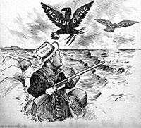a   **B**usinessmen hated the New Deal because it interfered with their businesses and supported workers’ rights.   Rich people accused Roosevelt of betraying his class.   Henry Ford hired thugs to attack his trade union workers.

b   **R**epublicans hated the expenditure, which they said was wasteful (‘boondoggling’ – jobs for the sake of jobs).  They believed that poor people were responsible for their own problems and that it was not the job of the government to look after them.   After 1938, Republicans took over the Senate, and Roosevelt was unable to get any more New Deal legislation through.

### c   Activists like Huey Long (Senator for Louisiana who started a Share the Wealth’ campaign to confiscate fortunes over $3m) and Francis Townsend (who campaigned for a pension of $200 a month) said it did not go far enough to help people.

### d   State governments opposed the New Deal, saying that the Federal government was taking their powers.

e   The **S**upreme Court ruled that the NRA codes of employers’ conduct, and the AAA programme, were illegal because they took away the States’ powers.   Because of this, in 1937, Roosevelt threatened to force old Supreme Court judges to retire and to create new ones; the crisis was averted when the Supreme Court reversed its decisions.

**Q15. New Deal; SUCCESSES Vs FAILURES; Make a list…**

**SUCCESSES FAILURES**

USA Word search

|  |  |  |  |  |  |  |  |  |  |
| --- | --- | --- | --- | --- | --- | --- | --- | --- | --- |
| N | O | I | S | S | E | R | P | E | D |
| V | S | K | C | O | T | S | L | X | B |
| S | M | R | N | Y | C | Z | A | D | O |
| R | A | E | E | H | R | T | E | L | O |
| E | D | V | F | T | A | O | D | K | M |
| P | S | O | X | A | S | Q | W | L | J |
| P | U | O | Z | R | H | G | E | R | U |
| A | C | H | W | I | U | I | N | J | M |
| L | A | A | L | F | K | Y | T | A | K |
| F | R | A | T | F | G | E | N | L | G |

CRASH TARIFF NEWDEAL

HOOVER BOOM FLAPPERS

GANGSTER DEPRESSION STOCKS

**Practice Questions;**

1. Describe **two ways** in which investors would make a **profit** from the stock market in the 1920s. (4 marks)
2. Which of the following areas of life saw the more **change** during the 1920s?

* The economy
* Society

Explain your answer with reference to both reasons. (12 marks)

1. **Why** might the authors of **Interpretation E** and **F** have a different interpretation about the immigrant experience in America in the 1920s. Explain your answer using **Interpretations E** and **F** and your contextual knowledge. (8 marks)

**Interpretation E**

I heard that there were some good jobs here in the United States and that good money could be made. We worked on tracks, taking up and laying down the rails, and doing all kinds of hard work. They only paid us £1.50 and exploited us without mercy, for they sold us everything very high. I don’t even like to deal with those *bolillos* (Americans) for the truth is that they don’t like the Mexicans.

***Elias Garza, from Mexico, describes his own immigrant experience in the USA in the 192s0; from a collection of autobiographical Mexican immigrant life stories (published 1931).***

**Interpretation F**

When I came here I knew nothing, couldn’t even speak English. I had a terrible job as a cleaner but one day a customer asked me if I wanted to help him in his restaurant. I worked my way up. Learning all the time, married an American woman and now I own my own restaurant. I’m a success – in fact, I believe any hard worker with common sense can make it here.

***Tony, a Greek-born restaurant owner, interviewed in 1939 for the federal Writer’s Project, a US government scheme.***