Britain: Health and the People
Part 4: Modern Medicine

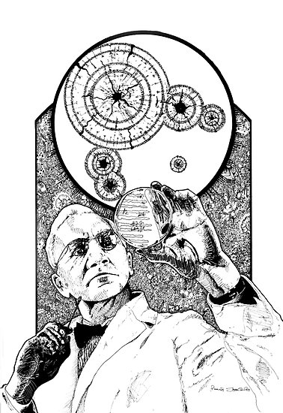

Name: _____________________________________________

Part 4: Modern Medicine
Penicillin
- Alexander Fleming saw many soldiers die of septic wounds caused by staphylococcal bacteria when he was working in an army hospital during WW1.
- Searching for a cure he identified the antiseptic substance in tears, lysozyme, in 1922 - but this only worked on some germs.
- One day in 1928 he came to clean up some old culture dishes on which h had been growing staphylococci for his experiments. By chance, a fungal spore had landed and grown on one of the dishes.
- Fleming noticed that the colonies of staphylococci around the mould had stopped growing. The fungus was identified was Penicillium notatum. It produced a substance that killed bacteria.
- Fleming published his articles between 1929 and 1931. However, nobody was willing to fund further research, so he was unable to take his work further. The industrial production of penicillin still needed to be developed.
- Since it is a natural produce, penicillin needs to be purified. A breakthrough was made by Howard Florey’s team in Oxford between 1938 and 1940 Ernst Chain, a member of the team, devised a freeze-drying technique which was an important part of the purification process.
- At first Florey and Chain didn't have the resources to produce penicillin in large amounts. Their patients began to recover, only to die when the penicillin ran out.

Florey knew that penicillin could be vital in treating the wounds of soldiers in WW2. British chemical firms were too busy making explosives to start mass production - so he went to America.
- American firms were also not keen to help - until America joined the war in 1941. In December 1941, the US government began to give out grants to businesses that manufactured penicillin.
- By 1943, British businesses had also started mass-producing penicillin. Mass production was sufficient for the needs of the military medics by 1944.
- After the war, the cost of penicillin fell, making it more accessible for general use.
- Fleming, Florey and Chain were awarded the Nobel Prize in 1945.
- Other antibiotics were discovered after 1945.
While individuals, like Fleming, Florey and Chain, were important in making the discovery of penicillin, it was a large institution like governments that funded it mass production.

TASK 1 – Transform the information above into a series of pictures.

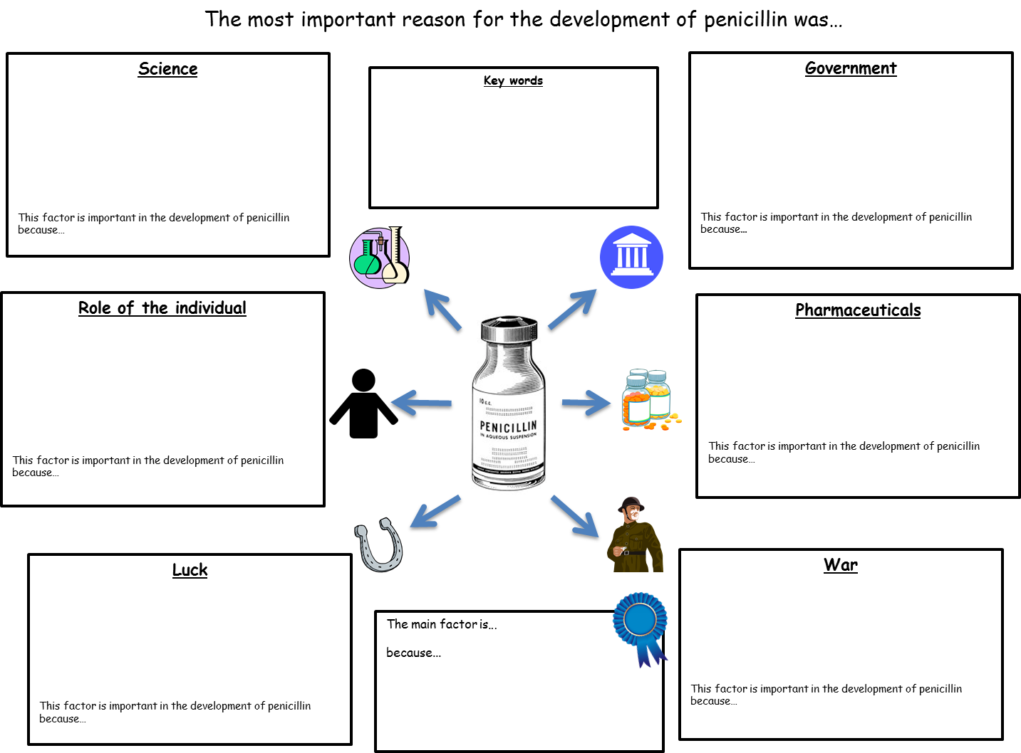
TASK 2 - Use information from the textbook pages to fill in the essay plan below
The impact of the First World War
The war gave surgeons opportunities to find new techniques for diagnosis and for carrying out more complex operations.
X-rays
- William Rontgen discovered x-rays in 1895. X-rays passed easily through soft flesh, but less well through bone.
- X-Rays were used from the start of WW1 to find broken bones, but the equipment included glass tubes that were unreliable and stopped working. Also it was located miles away from battlefields.
- William Coolidge had invented a more reliable tube in 1913. The ‘Coolidge tube’ is still used today.
- In 1914 the Polish scientist Marie Curie developed mobile x ray units which allowed doctors to transport X-ray equipment.
- The war also increased the number of radiologists. Curie and French scientist Antoine Beclere set up training schools to teach people how to use the equipment.
Transfusions
- The idea of blood transfusions were known from the 17th Century but they were rarely successful.
- In 1900, Karl Landsteiner discovered blood groups. Certain blood groups could not be mixed together as the blood would clot, blocking the vessels. This discovery meant doctors could perform more successful transfusions.
- During WW1 More blood was needed so they needed to find a way to store blood.
- In 1914, doctors found that sodium citrate stropped bloody clotting so it could be stored.
- In 1917, this discovery allowed the first ever blood depot to be set up at the Battle of Cambrai.
Plastic Surgery
- Doctors in France and Germany had been working on skin grafts techniques since before WW1.
- Harold Gillies set up a plastic surgery unit for the British Army during the war. He was interested in reconstructing facial injuries so that patients could have a normal appearance. He developed the use of pedicle tubes, and kept detailed records of his achievements.
- Gillies was work continued during WW2 by his assistant Archibald McIndoe.

Shell Shock
- The mental strain of war could cause psychological damage known as shell shock.
- Some shell shocked soldiers had panic attacks; others shook all the time or were unable to speak or move.
- To begin with, the British Army refused to believe that shell shock existed and many of the men were treated as cowards. However, by the end of the war there were so many cases of shell shock that it was officially recognised. Today the condition is known as post-traumatic stress disorder.

TASK 3 – What do you think was the most important development as a result of World War One?

______________________________________________________________________________________________________________________________________________________________________________________________________________________________________________________________________________________________________________________________________________________________________________________________________________________________________________________________________________________________________________________________________

Can you think of an acronym to help you remember the information about x-rays, blood transfusions, plastic surgery and shell shock? Use the space below to help you. E.g.

Shell shock –
COPP (Cowards, treated as. Officially known now as PTSD, Psychological damage, Panic attacks)

Modern treatments
- In the late 1800s, the chemical industries in places like, Britain, Germany, Switzerland and the US were booming.
- The late 19th and 20th centuries also saw the discovery of new drugs including aspirin (1899), insulin (1921), sulphonamides (1932) and penicillin.
- The chemical companies began to manufacture these drugs on a large scale, and make them available to a lot of people.
- The success of their mass-produced drugs in the 1940s helped the modern pharmaceutical industry take off.
- Pharmaceutical companies have played an important role in researching and developing new medicines. They also mass produce these drugs to sell worldwide.
- These companies have been important in during new diseases and research new forms of treatment:
  - Chemotherapy began to be developed in WW2, and pharmaceutical companies have been producing cancer drugs since the 1960s.
  - In 1981, doctors identified a new illness, AIDS, which was caused by the HIV virus. In 1987, pharmaceutical companies began mass producing a drug called AZT, the first approved drug to treat HIV.
- Drugs have to go through a series of clinical tests before they are given to patients. This is to make sure they work properly and have no side-effects.
  - In the 1950s, the drug thalidomide was released without proper testing. It was originally used as a sleeping pill, but it soon became popular among pregnant women as a treatment for morning sickness. Tragically, thalidomide affected women’s unborn babies, causing thousands of children to be born with underdeveloped limbs and other problems.
  - The government responded to this tragedy in 1963 by setting up a Committee on Safety of Drugs to make sure all new drugs were safe before being given to patients.
- Pharmaceutical companies have high costs for research and development of new medicines. Rare Diseases sometimes go under researched because companies tend to focus on treatments for common diseases that will make a lot of money.
- Antibiotic resistance is when a type of bacteria adapts so it is nt affected by antibiotics anymore, This resistance develops when doctors and patients overuse antibiotics - the more they are used, the more likely it is that bacteria will become resistant to them.
- Around 25,000 people in the EU die every year as a result of infections caused by antibiotic resistant bacteria.

Modern Treatments
Transplants
- In 1905 the first successful transplant of the cornea of the eye was performed.
- The first complete organ to be successfully transplanted was the kidney.
- The first heart transplant was carried out by the South African surgeon Christiaan Barnard in 1967. The patient only survived for 28 days - he died of pneumonia.
- Since the 1970s the development of drugs that stop the immune system from attacking the implant have become increasingly effective.
Surgery
- Advances in science and technology have led to improvements in the treatment of diseases like cancer. The discovery of radiation in 1896-98 by Antoine Henri Becquerel, Marie Curie and Pierre Curie led to the creation of radiation therapy.
- The development of lasers since the 1950s led to their widespread use in medicine in the 1980s. Laser surgery is used to correct vision problems, and lasers are also used in cancer treatments and dentistry.
- Advances in video technology led to the development of keyhole surgery in the 1980s.
Alternative treatment
- Mistrust of modern medicine and technology means some people use alternative therapies. For example acupuncture and homeopathy.
- Unlike mainstream treatments, alternative therapies are not based on evidence gathered from scientific research. As a result, there is little scientific evidence that alternative treatments work effectively, and some doctors think they might do more harm than good.
- However, some doctors are now working with alternative therapists to see if using a mix of alternative and mainstream medicine might result in benefits to the patients.

TASK 4 – Label your gingerbread person below with information from the two previous pages to identify advancements in treatment, surgery and disease (and the body)

Treatment
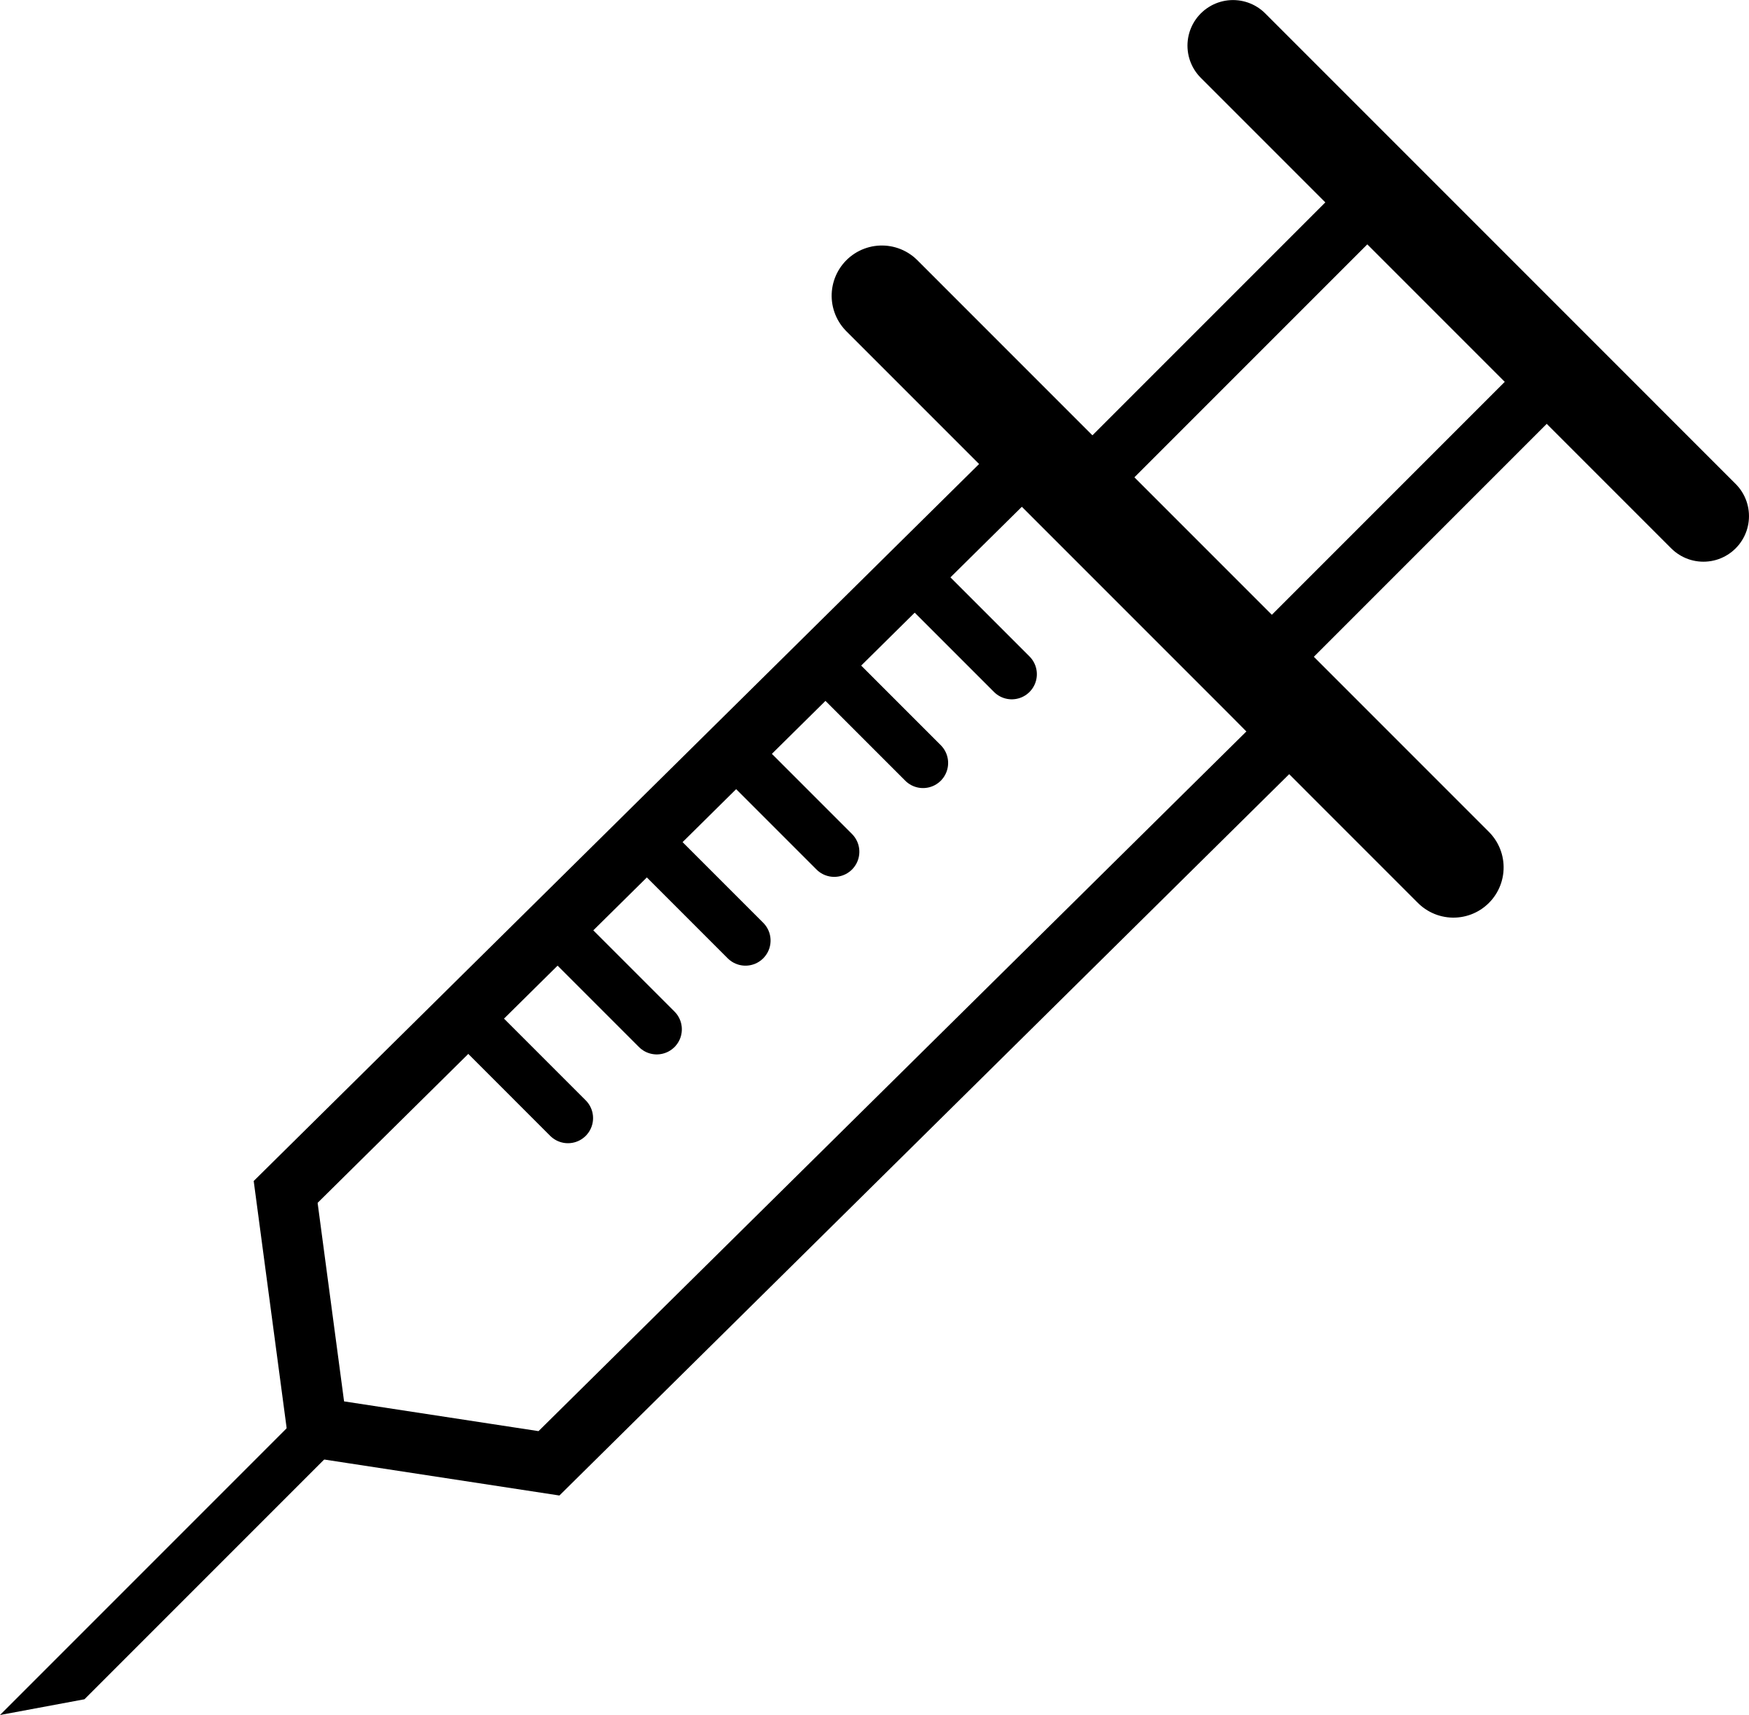
Surgery
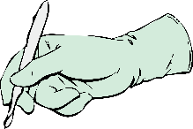

Disease

The Liberal Social Reforms
In the 19th Century, people believed government should have little involvement in public health. This all began to change after 1900, when the Liberal Social reforms were introduced to deal with poverty.
- Slums and other poor, overcrowded housing were all still common in industrial towns in 1900. The poor worked long hours for low wages.
- Many people couldn't afford doctors or medicine - they could barely provide their children with three decent meals a day.
- There was no unemployment benefit, or pensions for the elderly. Workhouses provided basic food and lodging in exchange for working long hours in brutal conditions.
TASK 5 – Complete the spider diagram below. You will have to use your booklet, notes and the internet to assist you

Why were living condition in Britain so bad at the beginning of the 20th Century?

What made people/government realise that conditions in Britain’s towns and cities needed to change?

2 reports showed how widespread poverty was:
- Booth’s report - Charles Booth’s 1889 ‘Life and Labour of the People in London’ showed that 30% of Londoners were living in severe poverty, and that it was sometimes impossible for people to find work, however hard they tried. Some wages were so low they were not enough to support a family.
- Rowntree’s report - Seeborn Rowntree had a factory in York. He didn't believe the problem was a bad there as living in London - so he did a survey of living conditions. His report ‘Poverty, a Study of Town Life’ (1901), showed that 28% of the people in York couldn't afford basic food and housing.
The lack of access to good health care meant that most people’s health was pretty poor. When the Boer War broke out in 1899, army officers found that 40% of volunteers were physically unfit for military service.
Booth, Rowntree and the Boer War showed that there was a link between poverty and ill health. The newly elected Liberal Government and its Chancellor, David Lloyd George realised it had to take action.
- 1906 - Free school meals introduced
- 1907 - Local Education Authorities started giving children at their schools free medical inspections
- 1908- Old age pensions were introduced for the first time - for people over 70. It was the first ever welfare scheme to be paid for by national taxes.
- 1909 - Labour exchanges were introduced to help unemployed people find work.
- 1911 - The National Insurance Act was passed. This introduced health insurance for workers - the worker, their employer and the government all contributed to a central fund that the workers could use for sick pay or to pay for a doctor.

The Liberal reforms were the first real effort by the national government to improve people’s living conditions as a way of improving their health. The reforms were a result of changing attitudes towards the role of the government, and changed people’s attitudes further.

TASK 6 – Using the information above and the internet, search for Liberal Social Reforms. Identify which acts/policies would have helped the health and wellbeing of the groups of people below:
Young people | Old people | Workers | Unemployed
Public Health and the World Wars
WW1 and WW2 broke down social distinctions and brought people together whose lives had been very separate.
- Raising armies has made government and military officials more aware of the health problems of the poor. Powerful people were more concerned with solving these problems when at war because they needed a strong army.
- The evacuation of children in WW2 increased awareness in richer rural communities of how disadvantaged many people were in other parts of the country.
- After WW2 people looked for improvements in society. Such feelings led to the 1945 victory for the Labour Party, which promised healthcare for everyone and full employment.
- Towards the end of WW1, Prime Minister David Lloyd George promised to tackle the poor-quality housing by building ‘homes fit for heroes’. Some new council houses were built in the 1920s and 1930s, but many of them were too expensive for the poorest families, who still lived in slums.
- During WW2, destruction from bombing and a lack of construction led to severe housing shortages, making the situation worse.
- After the war, the Labour government built 800,000 homes between 1945-51, In 1946, it passed the New Towns Act - this created completely new towns near major cities.
- Governments in the 1950s and 1960s demolished over 900,000 old, cramped slums - around 2 million inhabitants were rehoused.
- In 1961, a report called ‘Homes for Today and Tomorrow’ gave specific standards for new housing, including adequate heating, a flushing toilet and enough space inside and outside. This was the final step in tackling the issues of overcrowding, poor nutrition and poor waste disposal that had caused major public health problems.

TASK 7 – How did wartime and post-war Britain bring improvements to public health?

__________________________________________________________________________________________________________________________________________________________________________________________________________________________________________________________________________________________________________________________________________________________________________________________________________________________________________________________________________________________________________________________________________________________________________________________________________________________________________________________________________________________________________________________________________________________________________________________________________________________________________________________________________________________________________________________________________________________________________________________________

The Beveridge Report
- In 1942 William Beveridge published the ‘The Beveridge Report’
- In the report, Beveridge called for the state provision of social security ‘from the cradle to the grave’. Beveridge argued that all people should have the right to be free from want, disease, ignorance, squalor and illness. He called these the five ‘giants’.
- Beveridge said that the government had a duty to care for all citizens, not just the poor or unemployed. To achieve this. Beveridge suggested the creation of the welfare state - a system of grants and services available to all British citizens.
- The 1945 Labour government was elected with the promised to implement Beveridge’s proposals.
- One of their first acts was to pass a new National Insurance Act in 1946 to support anyone who couldn't work.
- The labour Party’s National Insurance Act went further than the one introduced by the Liberal Government - anyone could apply for Labour’s National Insurance without having to take a test to see if they were eligible.

TASK 8 – What was the Beveridge Report?

__________________________________________________________________________________________________________________________________________________________________________________________________________________________________________________________________________________________________________________________________________________________________________________
____________________________________________________________________________________________________________________________________________________

Draw the 5 giants that Beveridge established below:

National Health Service
- The National Health service was established in 1948. It was Beveridge's’ last proposal.
- Aneurin Bevan was the Labour Minister for Health who introduced the NHS.
- The government nationalised hospitals and put them under local authority control.
- Treatment was made free for patients.

Arguments for the NHS
- During WW2 the government took control of all hospitals, creating the Emergency Medical service. Its success led many to support the creation of the NHS.
- The NHS would make medical care free so it was accessible to everyone.
- The NHS guaranteed that hospitals would receive government money, rather than having to rely on charities for money.
Arguments against the NHS:
- Many Conservatives opposed the NHS as they believed the cost would be huge.
- Doctors saw themselves as independent professionals - they didn’t want to be controlled by the government. They also worries that they would lose a lot of income.
- Many doctors threatened to go on strike in protest against the NHS (the government finally convinced doctors by offering them a payment for each patient and letting them continue treating fee-paying patients)
Although many Conservatives were opposed to the creation of the NHS, they could not abolish it when they came back into power in 1951 - It was too popular.
The NHS increased the number of people with access to healthcare - the number of doctors doubled between 1948 and 1973 to keep up with demand. Today the NHS provides a range of health service, most of which are free and accessible to everyone.
In the long term, the NHS has contributed to a dramatic improvement in people’s health and a rise in life expectancy. In 1951, men could expect to live to 66 and women to 72 - by 2011 this had risen to 79 for men and 83 for women.
The NHS faces several challenges now…
- The increase in life expectancy means there are more older people in Britain today than there were in 1948, who are more likely to suffer from long-term conditions like diabetes and heart disease. They need regular medical attention and require a lot of NHS time and resources.
- Many people’s lifestyle choices are putting a strain on the NHS. Smoking, obesity and alcohol consumption call all harm people’s health and may require expensive treatment.
- Many modern treatments, equipment and medicines are very expensive, and the NHS has had to face rising expectations of what it can and should offer.
- As a result of all these factors, the cost of the NHS is rising rapidly - in 2015/16 the NHS budget was £116 million overall.

TASK 9 – Revision task

- Read through the information on the NHS and highlight the key information. Be selective, don’t highlight everything!
- Then in the space below, summarise your highlighted information into 10 key bullet points.
  - ________________________________________________________________
  - ________________________________________________________________
  - ________________________________________________________________
  - ________________________________________________________________
  - ________________________________________________________________
  - ________________________________________________________________
  - ________________________________________________________________
  - ________________________________________________________________
  - ________________________________________________________________
  - ________________________________________________________________

- To chunk down your information again, see if you can summarise your 10 bullet points into 10 words.
  - ________________________
  - ________________________
  - ________________________
  - ________________________
  - ________________________
  - ________________________
  - ________________________
  - ________________________
  - ________________________
  - ________________________

- Finally, and only using the 10 key words, try and repeat all the information on the NHS – teach it to a friend, a family member or even just talk through it by yourself!

Exam style questions

Explain the significance of the work of Alexander Fleming (8 marks)

- What impact did Fleming’s work have at the time?
- What is the impact of Fleming’s work today?

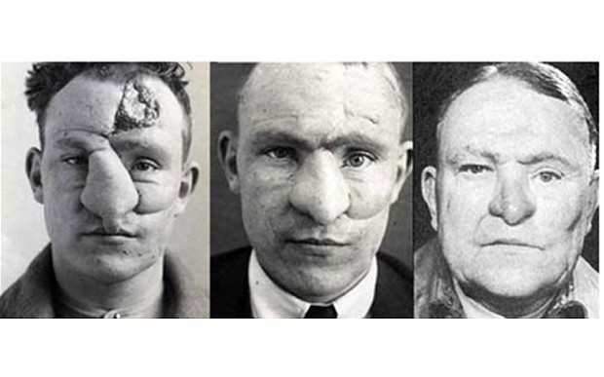
Source A – The development of plastic surgery, pioneered by Dr Harold Gillies on William M. Spreckley (above). Spreckley was admitted to hospital with a ‘gunshot wound nose’.

How useful is Source A to a historian studying the development of medicine
and surgery during World War One? (8 marks)

- Why is the source useful for telling you about WWI medicine?
- What does the source miss out?
- How reliable is the source?

Factors

Government:  - Government solutions to the plague in 1665.  - Public health measures in the 1880s  - Public health in 1900s  - Public health measures in the 1880s  - Introduction of the NHS. | War:  - Ambroise Pare  - Pasteur V Koch  - Blood transfusions  - Penicillin  - Evacuation during WWII  - X-Rays  - Introduction of the NHS  - Work of surgeons through the ages  - The fall of the Roman Empire | Religion:  - Supernatural treatment through the ages  - Medieval church medical learning  - Monasteries  - Galen  - Opposition to anaesthetics  - Opposition to Jenner
Communication:  - Clinical observation  - Medical books  - Printing press  - Development of penicillin  - Lister and carbolic spray  - Modern technology | Science and technology:  - Four Humours  - Vesalius’ Artists  - Renaissance  - Work of Pasteur  - Lister and Carbolic Spray  - Blood transfusions  - Robert Koch  - Magic Bullets  - Mass production of penicillin | Chance:  - Pare running out of boiling oil in battle  - Pasteur and the chicken cholera vaccine  - Simpson’s discovery of chloroform  - Alexander Fleming discovering penicillin

