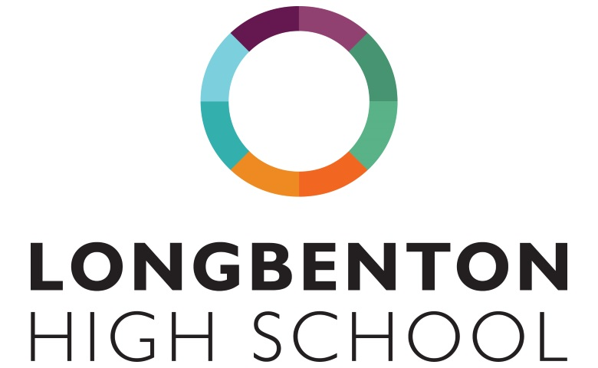
All Post-16 courses require students to have achieved five 9-4 GCSE grades, as well as the following subject specific requirements
Block A | Block B | Block C | Block D
Product Design Y12 (LHS) – a grade 4 in Maths and English and a grade 5 or above in a GCSE Design Technology subject. | Mathematics (LHS) – a grade 7 in Maths. | Chemistry (LHS) - a minimum of grade 6 in Chemistry or 66 in Combined Sciences plus a grade 6 in Maths. | Children’s Play, Learning and Development (LHS) – a grade 4 in Maths and English.
Photography (LHS) – a grade 5 or above in a creative subject. | Philosophy and Ethics (GSHS) - a grade 5 in English. | ICT (LHS) – a grade 4 in Maths and English. | PE (LHS) - a grade 4 in English and Maths and a grade 5 in a science subject.
Biology (LHS) - a minimum of grade 6 in Biology or 66 in Combined Sciences plus a grade 6 in Maths. | Food Science (LHS) – a grade 4 or above in English Language. Level 2 in Hospitality & Catering or GCSE in Home Economics/Food is desirable. | English Literature (LHS) - grade 6 in English Literature. | History (LHS) – a grade 6 in GCSE History.
English Language (LHS) – a grade 6 in English Language. | Art and Design (LHS) - a grade 4 in English and a grade 5 in Art or equivalent. | Medical Science (LHS) - a grade 5 in English and Maths and a grade 55 in Science. | Physics (LHS) - a minimum of grade 6 in Physics or 66 in Combined Sciences plus a grade 6 in Maths.
Business Studies (LHS) – a grade 4 in Maths and English. | Business Studies (GSHS) - including grade 4s in Maths and English | Geography (LHS) - a grade 5 in English, 4 in Maths and a grade 5 in Geography. | Music (LHS) - a grade 5 in English and a grade 5 in GCSE Music.
Mathematics (GSHS) - at least a grade 7 in Maths. | Single Health & Social Care (GSHS) – including grade 4s in Maths and English. Single and double award available. | Computer Science (Shared) – a grade 5 in English, 6 in Maths and a grade 6 in Computer Science. | French (Shared) – a grade 6 in French.
Performing Arts (GSHS) – Grade 5 GCSE in English Literature or Language. Level 2 pass in Performing Arts is desirable* | Psychology (GSHS) - a grade 5 in English, a 6 in a Science subject and a grade 5 in Maths. | Spanish (Shared) - a grade 6 in Spanish. | Geography (GSHS) - including at least a grade 5 in English, 4 in Maths and a grade 5 in Geography.
BTEC Music (GSHS) – Students must audition to be offered a place on the course as it requires a solid level of musical performance.* | Physics (GSHS) - a minimum of grade 6 in Physics or 66 in Combined Sciences plus a grade 6 in Maths. | Politics (GSHS) - including a grade 5 in English Language. Having studied GCSE History is desirable. | Chemistry (GSHS) - a minimum of grade 6 in Chemistry or 66 in Combined Sciences plus a grade 6 in Maths.
History (GSHS) - a grade 6 in GCSE History | English Literature (GSHS) – a grade 6 in English Literature. | Art and Design (GSHS) - a grade 4 in English and a grade 5 in Art or equivalent. | Media Studies (GSHS) - a grade 4 in English.
 |  | Biology (GSHS) - a minimum of grade 6 in Biology or 66 in Combined Sciences plus a  grade 6 in Maths. | BTEC Sport (GSHS) - a grade 4 in Maths and English. A grade 5 in English is desirable.
 |  | Sociology (GSHS) – at least a grade 5 in English.
Further Maths A level can also be studied in addition to A level Maths - this is taught separately to these blocks during enrichment time.
*BTEC Music/Performing Arts (GSHS) – Only one of these courses will run subject to student numbers

